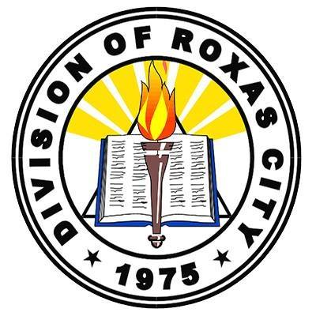Republic of the Philippines

Department of Education

Region VI – Western Visayas

Division of Roxas City

Roxas City District I

**President Manuel A. Roxas Memorial School—South**

City of Roxas

U.S. Peace Corps Host Country Agency Grant Completion Letter

Monica Collier  
Country Director

U.S. Peace Corps Philippines  
6/F PNB Financial Center, Macapagal Avenue, Pasay, Metro Manila

Dear U.S. Peace Corps—Philippines,

We are writing to update you on the successful completion of our PCPP-World Connect funded project, “Reaching underserved communities through a mobile community learning center.” The Mobile Community Learning Center (mCLC) project aims to enhance mobile teachers' instructional resources and strategies and expand learners' access to learning resources in the Roxas City Alternative Learning System (ALS). The project consisted of the construction of a mobile center that houses IT equipment, reading resources, and ALS modules. The Mobile Community Learning Center will be used indefinitely as an essential resource in the daily instruction of mobile teachers as they travel to underserved communities.

As part of the project implementation, the mobile teachers and PCV worked together to have the project accepted as an official innovation of the Department of Education Division of Roxas City. An orientation for the Division Office and a workshop-training for the ALS team were held to establish buy-in, action plan, and workshop instructional innovations permitted through the new resources. After the mobile center had been constructed, registered, and tested, the mobile teachers also led community-based orientations in three barangays where ALS operates to familiarize the communities with the project and advocate for ALS education.

The grant funds were primarily spent on construction and equipment. The three largest expenses covered 95% of grant-funded expenses and consisted of: (1) construction of the sidecar, (2) instructional equipment (e.g. laptops, portable projector, speakers, etc.), and (3) printing of ALS modules.

The stated objectives of the project were to:

* Build the Mobile Community Learning Center
* Orient beneficiaries and communities to its offerings
* Integrate the center and its resources into the daily field-based instruction of mobile teachers
* Increase community-based advocacy for the ALS program, and
* Improve learners’ access to learning materials and basic ICT skills

Through the work of the mobile teachers, Division Office, and PCV, all of these intended objectives were met. The center was built, orientations were held for various stakeholders (e.g. Division Office, local DSWD office, three barangays, primary ALS center learners), and the mobile teachers have been enthusiastic and proactive in their daily use of the center and its resources. The mobile teachers have gone above and beyond the original plans to ensure sustainable documentation and loaning of learning materials (e.g. modules, books). While delays in the construction of the sidecar resulted in insufficient time to fully quantify the response of learners to the mobile center, the mobile teachers have effectively integrated the resources into their daily fieldwork and thus are improving the instruction they provide to underserved communities. Some instructional innovations include the use of e-modules, basic ICT skills instruction, increased use of ALS modules and remedial reading materials, and audiovisual-based lessons.

The Division of Roxas City Alternative Learning System is grateful to the U.S. Peace Corps and World Connect for the support they have provided in making this project a reality. The mobile teachers of Roxas City will continue to use these innovative resources to improve the education they provide to the out-of-school youth and adults of their communities.

Sincerely,

________________________

Jelyn Joy Avelino  
EPS II and Mobile Teacher