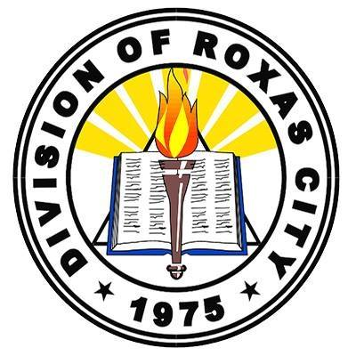Republic of the Philippines

Department of Education

Region VI – Western Visayas

Division of Roxas City

Roxas City District I

**President Manuel A. Roxas Memorial School—South**

City of Roxas

**Invitation to an orientation on the ALS Mobile Community Learning Center**

Brgy. Captain, Brgy. Adlawan  
Roxas City, Capiz

Dear Barangay Captain and Barangay Adlawan Community Members,

We are writing to invite you to an orientation on a new initiative of the Division of Roxas City Alternative Learning System that will operate within your barangay and improve the education received by your community’s out-of-school youth and adults. The Mobile Community Learning Center (mCLC) project aims to enhance mobile teachers' instructional resources and strategies and expand learners' access to learning resources in the Roxas City Alternative Learning System (ALS). The project consisted of the construction of a mobile center that houses IT equipment, reading resources, and ALS modules. The Mobile Community Learning Center will be used indefinitely as an essential resource in the daily instruction of mobile teachers as they travel to underserved communities.

The stated objectives of the project are to:

* Build the Mobile Community Learning Center
* Orient beneficiaries and communities to its offerings
* Integrate the center and its resources into the daily field-based instruction of mobile teachers
* Increase community-based advocacy for the ALS program, and
* Improve learners’ access to learning materials and basic ICT skills

In order to achieve the second objective, to orient beneficiaries and communities to the offerings of this new innovation, we hope to hold a short orientation in your barangay. The orientation will allow the mobile teachers to provide background information on the Mobile Community Center, demonstrate its resources, advocate for ALS in the community, and familiarize learners with this new resource.

In order to successfully carry out this timely orientation, we would kindly request availability for a one-hour orientation in your barangay hall between **May 15th and June 16th, 2017**. The mobile teachers of Roxas City ALS will be in contact to set a date for the occasion.

Thank you for your continuing support of the Roxas City ALS program and the futures of your community’s out-of-school youth and adults.

Sincerely,

________________________

Jelyn Joy Macate Avelino  
EPS II and Mobile Teacher