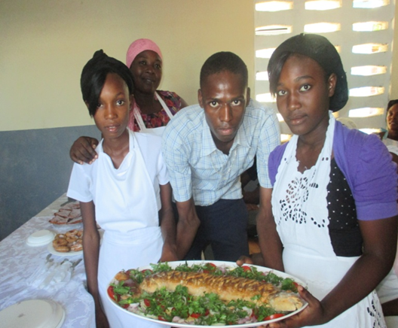

Merry Christmas to ACDED & World connect team

1. End of cycle festivities preparation

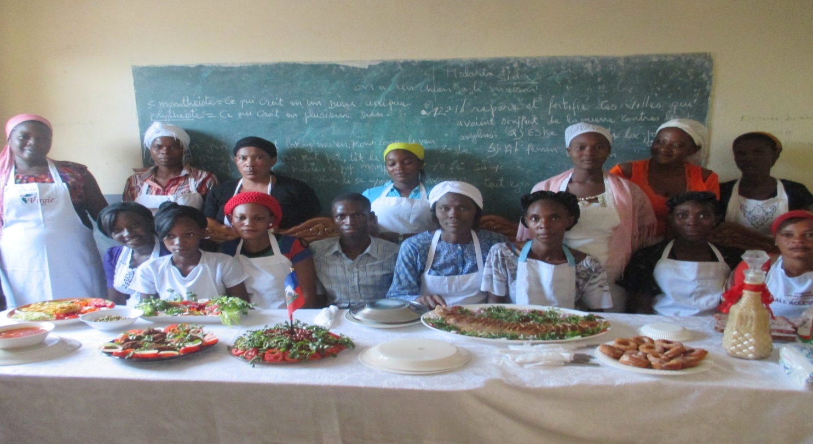

MESI ACDED THANK YOU WORLD CONNECT

1. Vulnerable women supported in cooking and baking training by the project: their realization for the end of cycle festivities.

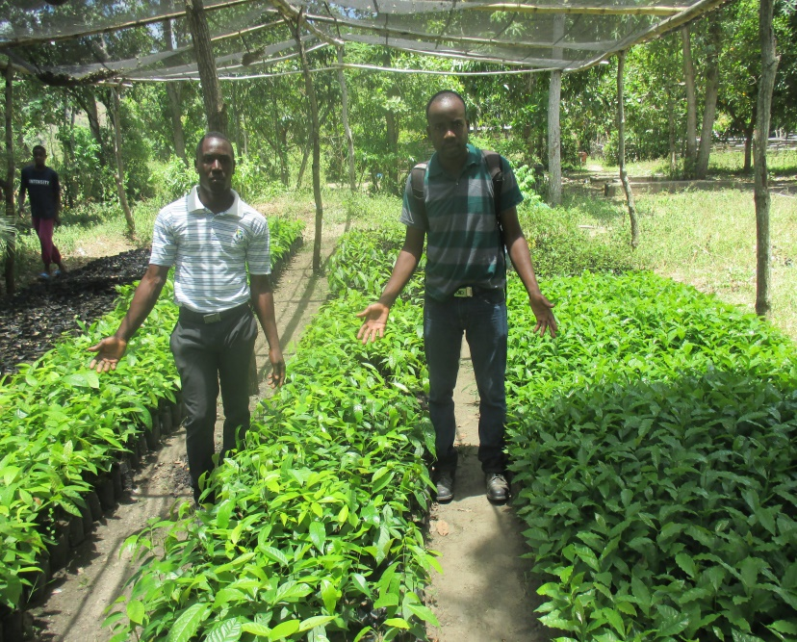

1. Seedlings distributed to beneficiaries

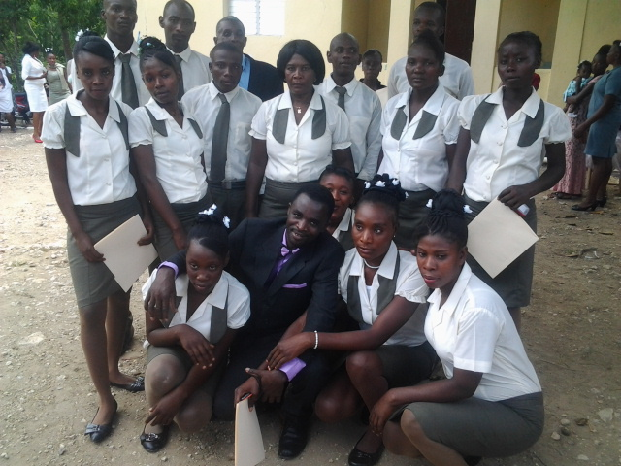

Thank you World Connect

1. Beneficiaries supported in Sewing training by the project. They are dressed with their own realization