Eco-Friendly SchoolYard Curriculum

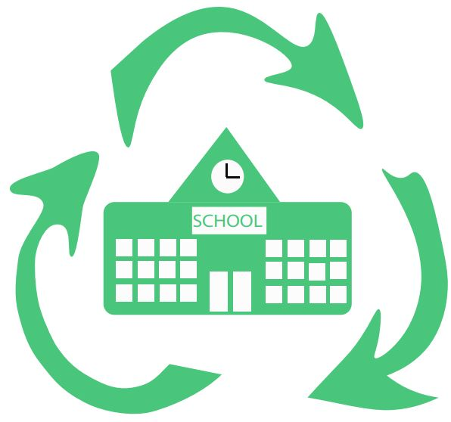



Funded by World Connect

In partnership with Municipality of Prrenjas and Peace Corps

**Table of Contents**

**Introduction** **3**

**Goals and Objectives** **4**

Goal 1: Increase the quality of life for Citizens 4

Goal 2: Rrajca School will have an active recycling Culture 4

**Methodology and Modifications** **5**

**Lesson Format** **6**

**Lessons** **7**

Taking care of planet earth 7

Recycling is my job 9

The Plastic Cycle 11

The basics of healthy eating 13

Identifying herbs, plants and their benefits 15

Plant a garden 17

How to Relax and Destress 19

**Appendix and Materials** **21**

Materials List 21

Annual Survey 22

# Introduction

Eco-Friendly School Yards is an initiative started by the Prrenjas Bashkia, funded by world connect and supported by local Peace Corps Volunteers. In 2018, the Rrajca school yard will be remodeled to include a community garden. Our hope is that the garden will become a vital part of the community. The garden will be designed as a relaxing place where community members can go to meditate, read a book or just chat with friends. Healthy fruits and vegetables will be planted in the garden to be shared with the community. Science teachers can use the garden for experiments by having students plant their own edible items and observe their growth. The physical health teacher can lead meditation and yoga classes beneath the trees. The social science teacher can lead community service projects to renew the garden before spring. As part of the Eco-Friendly school yards initiative this custom curriculum has been designed for local science and English teachers. It is intended as a place to start but the lessons are endless.

# 

# Goals and Objectives

The project has two main goals. Each of these lessons has an attached objective aimed to meet the goals of this project. The ultimate expectation is that teachers will use this curriculum to inform students on how to use the school yard garden and thus the project will become self sustainable.

## **Goal 1: Increase the quality of life for citizens of Rrajca**

|  |  |
| --- | --- |
| **Lesson Title** | **Objective** |
| The basics of healthy eating | Students will be able to describe a balance diet.  Students will be able to name three health benefits of a balance diet. |
| Identifying plants and their benefits | Students will be able to identify the plants in their garden.  Students will be able to state the health benefits of the plants in their garden. |
| Plant a garden | Students will be able to demonstrate their understanding of planting and taking care of a garden. |
| How to relax and destress | Students will be able to describe the negative effects of stress and name three ways of destressing. |

## **Goal 2: Rrajca School will have an active recycling Culture**

|  |  |
| --- | --- |
| **Lesson Title** | **Objective** |
| Recycling is my job | Students will be able to list the meaning of common recycling symbols  Students will be able to describe why you need to recycle correctly. |
| "The plastic cycle | Students will be able to describe the plastic cycle.  Students will be able to name three reasons recycling is necessary.  Students will be able to name ways to recycle when there is no recycling center. |
| Taking care of planet Earth | Students will describe why it is everyone’s responsibility to take care of the earth.  Students will create their own method of collecting recyclable materials. |

# Methodology and Modifications

Children of all ages learn by play. They learn best when allowed to participate in an activity and when the activity is hands on. These lessons are designed to be hands on while also working within a traditional albanian classroom.

Each lesson is designed to be 60 minutes while Albanian classrooms are traditionally 45 minutes. It is expected that the teacher will make modifications to fit their class. As such it was decided to add a few minutes in order to ensure enough material for each class. For example: While every class has a reflection these activities can actually be done any time after the lesson including as a writing assignment completed at home.

Introduction Explained - This curriculum suggests you engage students with the material from the very beginning. Introduction is where you review the most recent material and introduce the new. It's not necessary to build a connection between the two at this stage.

Instruction Explained - Instruction should be no more than 15 minutes long and only cover necessary material. Key to this section is predicting what misunderstanding might occur during the activity. For example, in the basics of healthy eating it is important to state that salt is necessary otherwise students viewing the salt and potato activity might believe salt must be avoided.

Activities Explained - Activities are meant to engage the student while allowing for further discovery or deeper comprehension. Instructions should be given ahead of time and a clear end time decided. It is well know that Albanian classrooms are expected to be mostly quiet and students seated. For that reason it may take students some time to adapt to being asked to move seats or work in groups. However, these skills are essential to allowing students to share their knowledge with classmates. If possible, move activities outdoors to allow for more space, decreased noise and higher participation. Make sure students bring all necessary materials.

Reflection Explained - Students often learn to follow the procedures without thinking critically. This will give the appearance of having learned temporarily but information is not retained long term. By giving students time to reflect in quiet we allow them to create lasting memories. It is of the utmost importance that there is no talking or interruptions during this time. The best place for reflection is outside in a quiet garden but a quiet classroom works as well. You might play a special piece of classical music during this time to help cue students on the importance of the moment. Alternately, you can make these reflections homework assignments.

Repetition Explained - Many terms are repeated throughout this curriculum. The human mind tends to forget what it does not use. By repeating terms, core concepts and activities over many classes students are more likely to remember them. More importantly, students will have time to develop deeper understanding every time the concept comes up.

# Lesson Format

|  |  |  |
| --- | --- | --- |
| **Title:** A short but descriptive title. | | |
| **Objective**: SMART Goal that says what the student will be able to do at the end of each lesson. | | |
| **Materials**:  Materials needed for the entire lesson. | | **Vocabulary**:  Words that should be pre-taught. After this lesson they should be added to a list of words to review. |
| **Introduction**: (What?) | This is where you will engage the learner.  *[Why is this important/valuable? Why does it have personal meaning?]* | |
| Time:  Materials: |
| **Instruction**: (What?) | This is where you will give a lesson on new material and tie it to previous lessons.  *[What is the information? What's important to remember?]* | |
| Time:  **Materials**: |
| **Activity**: (How?) | During the activity phaste you will assess students' understanding of the new material and provide scaffolding as needed.How will students apply the new material along with previous material? How will they show their grasp of the material (speaking, writing, reading, listening)?  *[How does this work? How does this fit with what students already know?]* | |
| Time:  Materials: |
| **Reflection**: | This section is to give time for students to reflect on their learning. They will write in a journal and then share their thoughts with the class. | |
| Time:  Materials: |
| **Wrap-up**: | Connect the lesson to the larger framework. And include suggestions for practicing during the week. *[What if I used this? What if I modified its application?]* | |

# Lessons

## **1: Taking care of planet E arth**

|  |  |  |
| --- | --- | --- |
| **Title:** Our responsibility: Taking care of planet earth | | |
| **Objective**: Students will describe why it is everyone’s responsibility to take care of the earth.  Students will create their own method of collecting recyclable materials. | | |
| **Materials**:  Annual Survey (appendix A)  Story of a vandal  Pencil and journal | | **Vocabulary**:  recycling, volunteering, Earth, responsibility, fault, vandal |
| **Introduction**: | Pass out the annual survey.  Directions: Do your best to answer these questions. This is a pre-test so you might not know all of the answer. If you do not know simply cross out the question or write a line. | |
| Time: 5 min  Materials: Annual Survey |
| **Instruction**: (What?) | **Story of a vandal**: In the middle of the night a vandal breaks into your house. They ate some of your food. The rest of the food they sprinkled dirt and chemicals on. They left trash all over the ground. They ripped up your garden. They put toxins in your pipes so that all of the water that comes out is bad to drink. They left as quietly as they came and no matter how hard you looked you never found them.  **Discussion: The objective of this discussion is to notice the difference between fault and responsibility. Sometimes bad things happen that are not your fault but it will be your responsibility to fix them.**   * Who's fault is it that your house is destroyed? * Whose responsibility is it to fix your house? (Students may say it's the persons’ fault so it is his responsibility. Ask: Who will fix the house if you never find this person?) * Will you just continue to destroy your house and poison your water because this person did it too? * Would you do this to another person?   **Connect**: Before you were even born people all over the world have been destroying your home - Earth. Many of you can not be blamed for the Ozone layer, air pollution, or plastic in the ocean. But this is your home and it is your responsibility to do everything you can to clean it. It's your job to make it livable for your family. | |
| Time: 20 mins  **Materials**:  Story of a vandal |
| **Activity**: (How?) | **Directions**: In a few weeks, we will plant a garden outside. For this garden we will use a lot of different recycled materials. As a class (or in groups) come up with a way to bring in and store recycled materials. We will need plastic bottles, plastic bags, cardboard and any other recyclable materials. Answer these questions:   * How will you collect the materials? * Where will you store the materials until use? * Will you sort them by type or keep them altogether? * How will you ensure the materials are clean?   As a class answer these questions. If you don’t know the answers today make a plan to answer them as soon as possible by assigning some students to be in charge. Have 3 students “volunteer” to be on the recycling commit for the class. | |
| Time: 20 mins  Materials:  Paper/ Markers |
| **Reflection**: | How did the story of the vandal make you feel? Is that how you feel when you see someone throwing trash on the ground? Explain why you think this is or isn’t the case. | |
| Time: 5 mins  Materials: journal and pencil |
| **Wrap-up**: | *Ask each student: How many materials will you bring in to recycle this week? What can you bring? How will you clean them?* | |

## 

## 

## 

## 

## **2: Recycling is my job**

|  |  |  |
| --- | --- | --- |
| **Title:** Recycling is my job | | |
| **Objective**: Students will be able to list the meaning of common recycling symbols  Students will be able to describe why you need to recycle correctly. | | |
| **Materials**:  Collection of plastic, paper, cardboard, metals etc.  (2) sets of recycling bins or labeled bags (Garden Safe plastic, unsafe plastic, paper, metal)  Print Outs : Recycling Symbols (appendix B), Types of Plastic (appendix C) | | **Vocabulary**:  Recycling, types of plastic, symbols, plastic cycle  **Reference**: http://www.homemadeforelle.com/plastic-containers-dangerous-health/ |
| **Introduction**: | **Discussion Review**: Why do we need to recycle? How did hard/easy was collecting recyclable materials? What did your families thing? | |
| Time:5 mins  Materials: NONE |
| **Instruction**: (What?) | **Recycling Symbols**: Paper, mental, and cardboard can almost always be recycled. (show recycling symbol) Plastic, however, is tricky.  Show “Recycling symbols” and “the types of plastic” chart or draw on chalkboard - Explain that plastic comes in many forms. Point out that type 2,4, and 5 have not been shown to be harmful. These are the best type for our garden. Type 1 is common for water bottles but has been shown to leach harmful chemicals into water when left in the sun. We can use it to make things as long as it does not come into contact with drinking water.  Type 7 is a combination of plastics. We don’t want this type in our garden because we do not know if it is safe. | |
| Time:  **Materials**:Types of plastic chart  Recycling symbols  chalk/chalkboard |
| **Activity**: (How?) | **Sorting Trash**  *(If possible, do this activity outside to give more room.)*  Directions: Split students into two or more groups. Spread the “trash” around the room. You can also use students recyclable material if they have not organized it. Each team lines up behind a starting position (in the class- each student can stay in their desk). One student from each team picks up a piece of trash and places the materials in the correct bin as fast as they can. As soon as they return to their starting position the next member can go pick up a piece of trash. The team with the most in their bin wins. | |
| Time:  Materials: “trash” and recyclable materials.  (2) sets of recycling bins or labeled bags (Garden Safe plastic, unsafe plastic, paper, metal) |
| **Reflection**: | Pretend you could make your own recycled material. What would it be? Where would it come from? How would you recycle it? How long would it take to decompose? | |
| Time: 5 mins  Materials: journal and pencil |
| **Wrap-up**: | *Draw a plastic symbol on the board. Changing the number quiz students what they would do with an item with this symbol - recycle, create something new, reuse for eating/drinking* | |

## 

## 

## **3: The Plastic Cycle**

|  |  |  |
| --- | --- | --- |
| **Title:** The Plastic Cycle | | |
| **Objective**: Students will be able to describe the plastic cycle.  Students will be able to name three reasons recycling is necessary.  Students will be able to name ways to recycle when there is no recycling center. | | |
| **Materials**:  Video: Plastic Cycle or Print Out (appendix D)  <https://www.youtube.com/watch?v=IwdUwffecsM>  An assortment of plastics or other recyclable material. (hopefully students have collected these)  Seeds for planting  Soil  Wire  Straight blade  tape | | **Vocabulary**:  Decompose  Plastic cycle  CO2  byproduct |
| **Introduction**: | **Write On board:** Where does plastic come from? Where happens to plastic after its used? (Discuss) | |
| Time: 5 min  Materials: Chalk  Chalk board |
| **Instruction**: (What?) | Decide if your students will watch the movie about recycling plastic or if you will explain the cycle to them.  Show or Draw the current plastic cycle compared to recycled plastic cycle.   * Material is collected from oil or another product. * Raw materials are used to make gas. What is left over is turned into plastic. Thus plastic is a byproduct. During this process CO2 pollutes the air. * The plastic is made into a useful product. * The product is used * The product is discarded. * The product is recycled (Start again at #3) OR the product makes it way to the ocean or a landfill.   Explain: Plastic that is not recycled ends up in the ocean, landfill or in the ground. It takes 450 to 1000 years to decompose. Large piece disrupt the ocean ecosystem. After a time, It breaks down into smaller pieces and is eaten by fish and other animals. If the plastic doesn’t move though their system the animals die.  This is why it is important to collect as much plastic as you possibly can and make sure it ends up in a recycling plant. If you have no recycling plant then you can recycle the plastic yourself. Recycling plastic is useful and often recycled things can be sold as a way to get money.  **5 ways to recycle**   1. Wash and store any plastic you use. Even shopping bags. 2. Use plastic to make plastic recycling bins. Put them around your school and encourage others to recycle their plastic. 3. Start a group that collects plastic and drives it to a recycling plant once a month. 4. If you see plastic discarded on the ground pick it up! Hold on to it until you find a place to recycle it. 5. Organize Plastic pick up days. Everyone goes out and collects plastic from the rivers and ground.   **5 Reasons to pick plastic up off the ground when you see it and recycle it**   1. It makes your environment cleaner and nicer. You wouldn’t leave trash around your house would you? 2. You keep your family healthy by keeping the toxins in the plastic from getting into your water supply or poisoning fish. 3. The plastic can be made into a new product that you can sell or use in your house. 4. You can sell the plastic to a recycling company. 5. Others will see your good example and follow. | |
| Time: 15 mins  **Materials**:  Chalk and chalkboard  Video projector or other way to show video |
| **Activity**: (How?) | **Upcycling Plastic:** Creating something useful with plastic  The garden we will make needs a few things - brooms, recycling bins, and pots for start plants. Can you make these?  Provide students with a variety of plastic materials, tape, wire and instructions to make a broom, recycling bin, a piggy bank, and pots. | |
| Time:30 mins  Materials: sortiment of plastics or other recyclable material.  Seeds for planting  Soil  Wire  Straight blade  tape |
| **Reflection**: | How can recycling make an impact on your life? How does it help your community? How does it help the world? | |
| Time: 5 mins  Materials:  Journal and pencil |
| **Wrap-up**: 5 mins | Have students share their creations with each other. Which of these do you think somebody would buy? | |

## **4: The basics of healthy eating**

|  |  |  |
| --- | --- | --- |
| **Title:** The basics of healthy eating | | |
| **Objective**: Students will be able to describe a balance diet.  Students will be able to name three health benefits of a balance diet. | | |
| **Materials**:  Knife  Potato  Water  Salt water  Two bowls  Coffee grounds, garlic cloves, hot pepper  Strong smelling soup  Food labels from prepackaged food.  Print Out: The Dirty dozen and Clean 15 (appendix E) | | **Vocabulary**:  Dehydrated, fruit, vegetable, fat, pre packaged, packaged, label, processed |
| **Introduction**: | **Experiment**: Fill two small bowls with water and mix salt into one of the bowls. Label both bowls so you know which one has the salty water. Cut a potato in half and place each half into a bowl with the cut side down. Leave for about 30 minutes and watch what happens. Ask students what they think will happen. (Answer: the salt water draws water out of the potato, causing it to shrivel. ) | |
| Time:  Materials:Potato  Water, Salt water  Two bowls |
| **Instruction**: (What?) | **Word Web:** At the center “Healthy Eating”  Ask students what they think of when I say Healthy eating. These become the outer circles. Fruits, vegetables, low sodium, protein, bread. The key to healthy eating making sure over 60% of what you is fruits and vegetables, while the rest is made up of grains and protein.Most vegetables have protein so you don’t need to eat meat to get it.  **Explain**: Most things are bad for us if we have too much of it. Somethings are bad for us if we have even a little. Let’s organize things based on if we should it them Often, Sometimes or Rarely.  Create a timeline effect. Bring in some food/food labels to add to the timeline.    **Salt and Sugar-** Should be used in small doses. Drinks like B52 have lots of sugar in them. Prepackaged food should be avoided because it tends to be high in both salt and sugar. Especially those croissants!  **The dirty dozen:** Notice that broccoli is on both sides of the chain. Broccoli it is part of the dirty dozen. The dirty dozen is a list of fruits and vegetables that are covered in pesitizes. You should only buy these organic.  **Bread:** While bread might be life it should only account for ¼ of your daily food along with and other grain. White bread or highly processed bread should rarely be eaten as it has a lot of sugar and very little fiber.  **Pesticides**: A lot of food has pesticides on it now. You should always wash your food with soup and water and let it dry before eating it. When possible choose plants without pesticides. This is called organic. Are garden will be organic as pesticides can make you sick and even cause cancer. | |
| Time: 20 min  **Materials**:  Food labels from prepackaged food.  Some fruits and vegetables or pictures of them  Chalk /chalkboard |
| **Activity**: (How?) | **Replanting:** Did you know a lot of what you eat can be replanted?  Vegetables are especially good at being replanted. I bought some today but how will we keep the bugs away without pesticides?  Coffee beans,garlic cloves, hot pepper are all ways to keep away bugs. Strong smelling soap will also work but you will need to wash this away before eating the vegetables.  **Directions:** Plant vegetables using the pots or plastic jugs collected from previous class. For each plant pick one method to keep bugs away - label the plant with the bug repellent you used (coffee grounds, garlic cloves hot pepper, soap). Later we will be able to observe which works the best! | |
| Time: 20 min  Materials:  Soil, previously made pots from lesson 3, vegetables to replant,  Jars or plastic bottles with water |
| **Reflection**: | What did you eat today? Do you think you ate well? If not what was missing. | |
| Time: 5 min |
| **Wrap-up**: | *Review the salt water vs. plane water potato.* Explain that just like the potato loses water when put in a salty solution,foods with lots of sodium can lead to dehydration in people. | |

## **5: Identifying herbs, plants and their benefits**

|  |  |  |
| --- | --- | --- |
| **Title:** Identifying plants and their benefits | | |
| **Objective**: Students will be able to identify the plants in their garden.  Students will be able to state the health benefits of the plants in their garden. | | |
| NOTE: In this lesson we will only teach the plants added during the first year of the garden. Feel free to teach the health benefits of more plants and herbs. For more herbs check out: https://www.epicurious.com/archive/seasonalcooking/farmtotable/visualguidefreshherbs | | |
| **Materials**:  Popsicle stick/ sticks/ plastic that can be used for labels.  Pictures of herbs and their descriptions (appendix F)  Resource: http://www.herbslist.net/ | | **Vocabulary**:  Herb, ginger, sage, apple mint, Chamomile, plant, dirt, ground |
| **Introduction**: | *Discussion: What herbs or plants do you use at home? Mountain tea for example is used to soothe a sore throat.* | |
| Time: 5 min  Materials: None |
| **Instruction**: (What?) | **For each herb or plant you plan to put in the garden teach how to identify them and their uses. These four herbs can all be dried and made into teas, cooked into food and have health benefits.**  **Ginger**: This herb is believed to lower cholesterol and may be helpful in treating diabetes and depression. Korean ginseng is a good immune system booster. **Sage:**  This herb is best known to prevent colds, aid rheumatism, and is especially effective against indigestion.  **Apple mint:** The mint leaves contains nutrients like iron, potassium, calcium, vitamin A and C which replenish our body. The flowers can be used to make tea which if consumed promotes digestion, cures many ailments such as intestine problems, stomach pain and refreshes the mind.  **Chamomile -**This plant is used for colic, indigestion, flatulence, bloating heartburn and to calm nervousness. Chamomile has anti-inflammatory, antifungal, antiseptic, antibacterial and antispasmodic properties. | |
| Time: 10 mins  **Materials**: pictures of each herb or real herbs. |
| **Activity**: (How?) | **Directions**; Hand out pictures of herbs or plants. Have students write the name of the plant on the back of the pictures as well as a description of its health benefits. Next they will tape the paper to a stick (or strong recyclable material) and cover it with clear tape or plastic to make it waterproof.  This protective barrier against the weather will allow the these labels to be placed in the garden.  If they finish early have them make more labels for other things in the garden. They should draw and color pictures for each label so that the younger children will know what it is. | |
| Time: 20 min  Materials:  Popsicle stick  Clear Tape  Glue  Pictures of herbs |
| **Reflection**: | Think back to learning about the plastic cycle. How can plastic be recycled to help you start your own healthy garden at home? Which plants would you plant and why? | |
| Time: 5  Materials: Journal and pen |
| **Wrap-up**: | *What would you like to plant in the garden? Encourage students to bring in their own planted herbs to put in the garden. Just remember that they need a label!* | |

## **6: Plant a garden**

|  |  |  |
| --- | --- | --- |
| **Title:** Plant a garden | | |
| **Objective**: Students will be able to demonstrate their understanding of planting and taking care of a garden. | | |
| **Materials**:  List of jobs  ALL of the materials created over the last classes (shovels, pots, pre planted plants) | | **Before the Lesson:**  Prepare a map of the would be garden.  Prepare the garden area so students can easily find where they should plant.  Prepare a list of jobs |
| **Introduction**: | *Have students collect all the materials they have been preparing - shovels, brooms, pots, planted herbs, planted vegetables ect. Each student should have at least one plant or material to be put into the garden.* | |
| Time:5 min |
| **Instruction**: (What?) | Show students the garden map. Explain that plants need to be planted according to the map and labels should be added to each plant. Demonstrate where to put the labels.  Assign each student a job and give them instructions for what to do when they finish. You might consider a sign up list.  **EXAMPLE JOBS:**  Planting herbs  Planting vegetables  Planting the trees  Outlining the herb garden with rocks  Outlining the vegetable garden with rocks  Watering all the plants once they are planted.  When students are done they should go to the front of the building and wait for the teacher. | |
| Time: 10 min  **Materials**:  Sign up sheet  List of jobs  Any materials that you need to hand out for specific jobs.  (For example you might have some students painting a fence.) |
| **Activity**: (How?) | Outside- Students plant a garden according to their job.  You should oversee the area but make sure students are doing most of the work. Students are more likely to take care of the garden if they plant it themselves. | |
| Time: 30 min  Materials: |
| **Reflection**: | How do you think this garden will make a difference in your community? How will you help to maintain the garden? | |
| Time: 5 min  Materials: journal and pencil |
| **Wrap-up**: | Give students a quick speech about the garden being for everyone and it being everyone's responsibility to take care of it.  *Example: This garden is yours, your families and your teachers. It is for everyone to benefit from and to maintain. That means that if you see a weed - pluck it, if you see trash - pick it up, and if you see some fruit - eat it! This is your garden. You took time to make it beautiful and I hope you take time to enjoy it as well.* | |

## 

## **7: How to Relax and Destress**

|  |  |  |
| --- | --- | --- |
| **Title:** How to relax and Destress | | |
| **Objective**: Students will be able to describe the negative effects of stress and name three ways of destressing. | | |
| **Materials**:  Calming music.  TED: How Stress can make you sick (optional video)  Yoga cards (appendix G) | | **Vocabulary**:  Relax, Destress, Yoga, stressors, muscles, tense |
| **Introduction**: | Ask students to write down what stresses them out and then how they relax during it. | |
| Time: 5 mins  Materials: paper and pen |
| **Instruction**: (What?) | **What is Stress?** - Show the video or explain  Stress is a useful response to short term stressors. It can make us stronger and even make us more creative. If stress lasts to long, is constant or comes back to often it can cause a lot of problems. People with chronic stress suffer from memory loss, anxiety, upset stomachs, and even muscle aches. This is because the hormones that trigger stress send messages for muscles to tighten up and get ready for a fight. If your muscles are always tight , they will get tired.  Destress is the act of calming your body to lower the amount of stress hormone in your body. One you face a problem: a test, someone yelling at you, a mistake you made - consider how you will destress.   1. Take deep breaths. 2. Concentrate on your surroundings. 3. Chewing gum - Surprisingly chewing gum can help you relax during a stressful task. 4. If you are angry or upset consider moving away from what is triggering the emotion. For example, if someone is bullying you try to leave. 5. Find someone to talk to about your stress. 6. Try to find the source of the stress and solve the problem.   As soon as you can attempt to relax. Relaxing takes a lot more time but it's necessary to give your body time to heal from stress.  **5 ways to Relax and Destress in the long term**   1. Spend time in nature! Take a walk or just sit outside. 2. Create a ritual to calm down. Drinking tea and reading a book will help you relax if you think it is relaxing. 3. Listen to calming music without lyrics 4. Have a cuddly pet! Cuddling with a dog can help you relax. 5. Laugh! Listen to a joke, watch a funny movie or hand out with a funny friend. | |
| Time: 10 min  **Materials**: Projector and video  Chalk / chalkboard |
| **Activity**: (How?) | Yoga - On way to relax is by doing yoga. It's also great exercises. While this activity can be done inside it is best done outside and in the garden students just created.  Directions: Using the yoga cards provided or another resource lead students through a number of yoga poses. Explain the benefit of each the class does it. | |
| Time: 30 min  Materials: Yoga cards |
| **Reflection**: | What causes the most stress for you? How can you handle this stressor? | |
| Time: 5 mins  Materials: Journal and pencil |
| **Wrap-up**: | *Anytime you are stressed you can come to the garden and practice your yoga, talk to a friend or take care of the garden itself.*  This is the last lesson in this unit. Have students share their thoughts and feelings about recycling, gardening, healthy eating and/or their reflections from other lessons. | |

# 

# Appendix and Materials

## **Materials List**

Before you start this curriculum make sure you have all the necessary items.Below is a list of materials not including the print outs in the Appendix.

**EVERY LESSON NEEDS**

* Pencils for every student
* Journals for every student

**Lesson 1:Taking Care of Planet Earth**

* Story of a vandal

**Lesson 2: Recycling is my job**

* Collection of plastic, paper, cardboard, metals etc.
* (2) sets of recycling bins or labeled bags (Garden Safe plastic, unsafe plastic, paper, metal)

**Lesson 3: The Plastic Cycle**

* Video: Plastic Cycle <https://www.youtube.com/watch?v=IwdUwffecsM> (optional)
* Sortiment of plastics or other recyclable material.
* Seeds for planting
* Soil
* Wire
* Straight blade
* Tape

**Lesson 4: The basics of healthy eating**

* Knife
* Potato
* Water
* Salt water
* Two bowls
* Coffee grounds, garlic cloves, hot pepper
* Strong smelling soup
* Food labels from prepackaged food.

**Lesson 5: Identifying herbs, plants and their benefits**

* Popsicle stick/ sticks/ plastic that can be used for labels.
* Pictures of herbs and their descriptions

**Lesson 7: How to relax and destress**

* Calming music.
* TED: How Stress can make you sick (optional video)https://www.youtube.com/watch?v=v-t1Z5-oPtU
* Yoga cards

## 

## Annual Survey (Appendix A)

Today’s Date: ________ Grade:______________

**Mark the statement that best fits you. There is no wrong answer.**

|  |  |
| --- | --- |
| **How Important is recycling? (check answer)**   * Not important * Somewhat important * Important * Very important | **How often do you sort plastics from paper when throwing them away?**   * Never * Occasionally * Usually * Always |
| **How often do you eat a fruit or vegetable during the long break? (check answer)**   * Never * Occasionally * Usually * Always | **How often do you buy a snack during the long break? (check answer)**   * Never * Occasionally * Usually * Always |

**Write three ways you can relax and/or relieve stress.**

1.

2.

3.

**Write the name of three plants and their health benefits.**

|  |  |
| --- | --- |
| Name of Plant | Health Benefits |
|  |  |
|  |  |
|  |  |

Appendix B - Recycling Symbols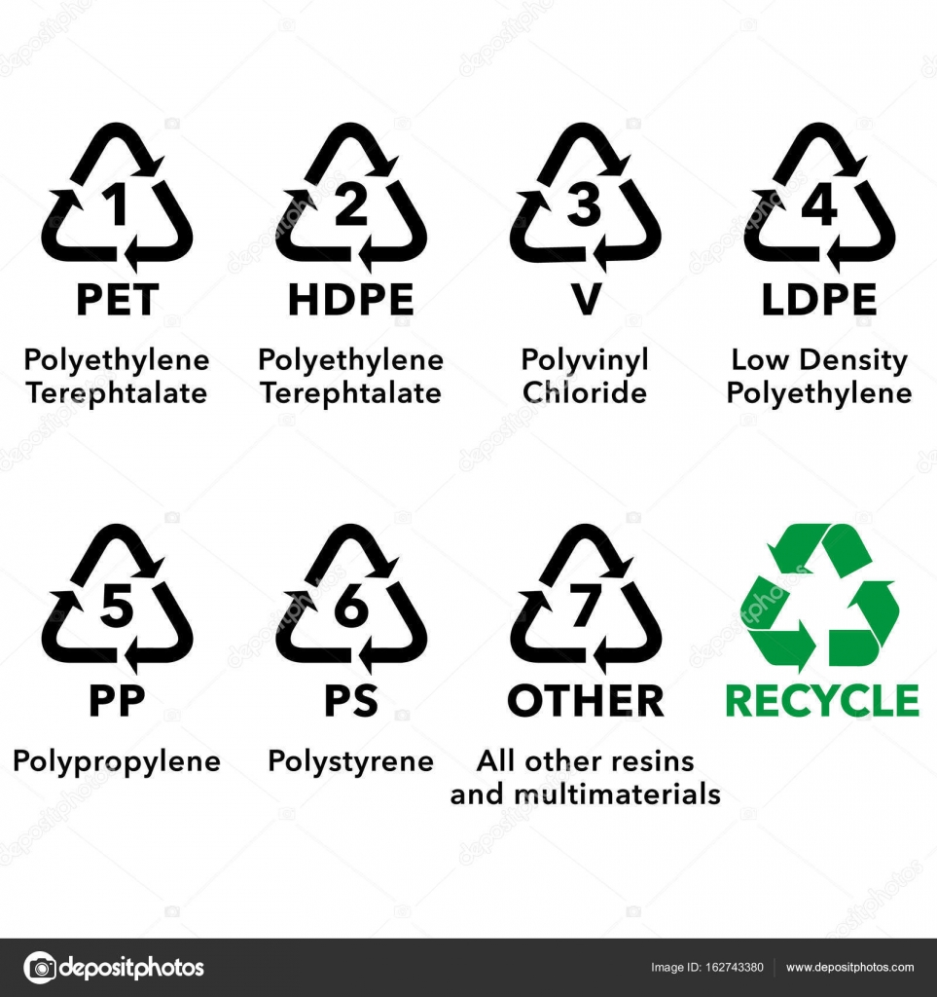

Appendix C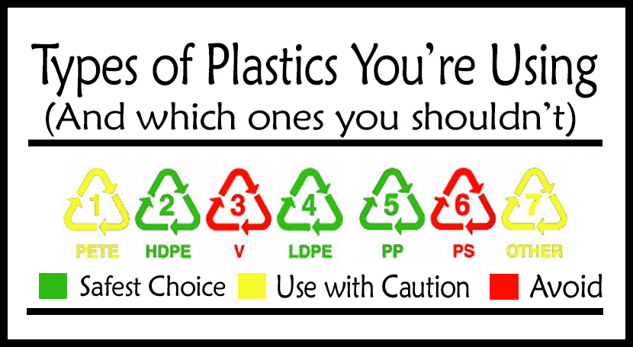

Appendix D- The Plastic cycle 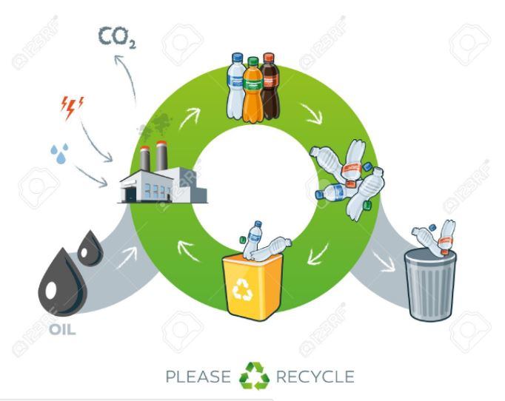

Appendix E

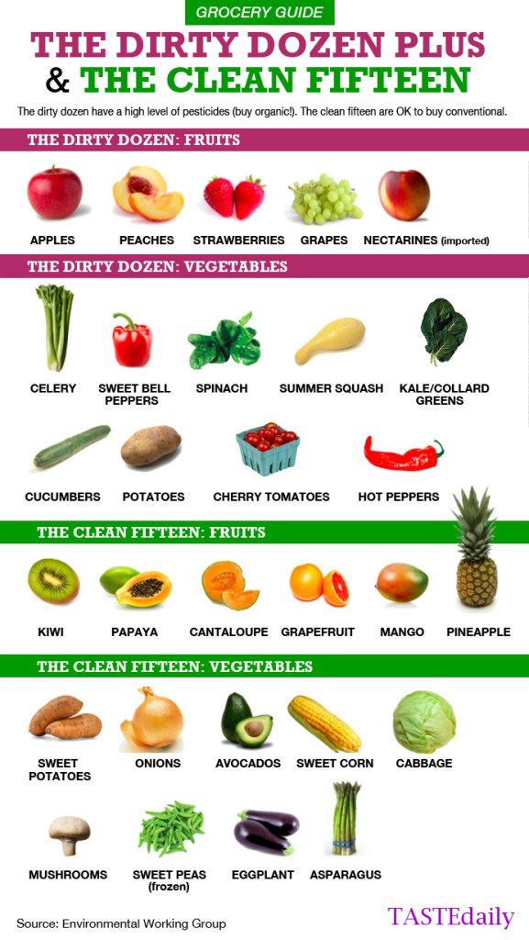

Appendix F: Description of Plants with Pictures

|  |  |
| --- | --- |
| **Apple Mint :**Grows to a height of 40 to 100 centimetres tall and spreads by [stolons](https://en.wikipedia.org/wiki/Stolon) to form [clonal](https://en.wikipedia.org/wiki/Cloning) colonies. The foliage is light green, with the opposite, wrinkled, sessile [leaves](https://en.wikipedia.org/wiki/Leaf) being oblong to nearly ovate, 3 to 5 cm long and 2 to 4 cm broad. They are somewhat hairy on top and downy underneath with serrated edges. The flowers develop in terminal spikes 4 to 9 cm (1.6 to 3.5 in) long and consisting of a number of whorls of white or pinkish flowers.  **Uses:** The mint leaves contains nutrients like iron, potassium, calcium, vitamin A and C which replenish our body. The flowers can be used to make tea which if consumed promotes digestion, cures many ailments such as intestine problems, stomach pain and refreshes the mind. |  |
| **Ginger**  **Ginger produces** [**clusters**](https://en.wikipedia.org/wiki/Inflorescence) **of white and pink** [**flower buds**](https://en.wikipedia.org/wiki/Flower_bud) **that bloom into yellow flowers.. It is a** [**perennial**](https://en.wikipedia.org/wiki/Perennial)[**reed**](https://en.wikipedia.org/wiki/Reed_bed)**-like plant with annual leafy stems, about a meter (3 to 4 feet) tall.**  Uses: This herb is believed to lower cholesterol and may be helpful in treating diabetes and depression. Korean ginseng is a good immune system booster. |  |
| **Sage**  **This plant's light gray-green leaves are soft and fuzzy, and its taste ranges from mild to slightly peppery with some touches of mint.**  **Uses:**This herb is best known to prevent colds, aid rheumatism, and is especially effective against indigestion. |  |
| **Chamomile**  ***M. chamomilla* has a branched, erect and smooth** [**stem**](https://en.wikipedia.org/wiki/Plant_stem)**, which grows to a height of 15–60 cm (6–23.5 in). The long and narrow** [**leaves**](https://en.wikipedia.org/wiki/Leaf) **are bipinnate or tripinnate.**  **Uses -**This plant is used for colic, indigestion, flatulence, bloating heartburn and to calm nervousness. Chamomile has anti-inflammatory, antifungal, antiseptic, antibacterial and antispasmodic properties. |  |

Appendix G: Yoga Cards

