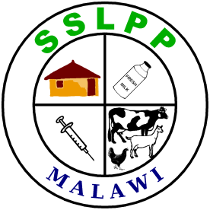 | Small Scale Livestock Promotion Program  SSLPP Training notes for Community Animal Health Workers
 | Unit 5: Pigs

Session 1: Introduction to pig production
Session specific objectives
At the end of this training session, each participant should be able to:
- describe the various ways under which pigs are raised in Malawi
- understand the importance of pigs for all purposes in Malawi
- explain the importance and benefits of improvement in the management of pigs

General Information on Pig Production
Exercise:
Discuss the reasons why people raise pigs (each participant should state reasons for the pigs that are raised in his/her area). Create a list that ranks the reasons from the most important to the least important. Consider the following reasons as well as any other reasons you think are relevant.
- Meat for consumption
- Income from sale of pigs
- Manure for crops
- Lard (pig fat) for cooking

Exercise:
Discuss the various ways of raising pigs in Malawi. Consider the categories shown in the table provided below:

Production System | Description
- High input production system | Intensive production accounts for less than 12% of the pig production in Malawi and a higher percentage of total output.  This type of producer is entirely commercial, uses exotic breeds like Large White and Landrace, feeds a prepared rationand follows good practices for herd health and management.
- Medium input production systems | Pig breeds are basically Landrace, Large White and crosses with indigenous species.  These pigs are housed full time.  Feed may be commercial rations, home-made rations, house refuse and industrial wastes.  Pigs may be kept part of their life in paddocks often with access to grazing. Balanced concentrates may be fed at times.  The pigs are brought indoors for farrowing, rearing and finishing to slaughter.
- Low input production systems (free range systems) | Pigs are basically indigenous breeds and are only occasionally housed.  The animals are generally on free-range scavenging system.  These however contribute over 50% of all pork consumed in Malawi.  Pigs roam at liberty and scavenge much of their feed. They are confined in huts at times and may be fed on swill, crop residues and banana chops.  This system is not recommended because it has a high risk of diseases including zoonotic disease (diseases which can infect both animals and man).

- These notes are concerned with the second system above, where pigs are housed full time and fed properly.

Exercise:
Discuss the inputs (everything that has to be purchased or built or obtained, including labour) for pigs under each of the production systems. Consider the following inputs:
- Labour
- Feed
- Housing
- Medicines and vaccines
- Transport for feed and transport for pigs
- Costs of slaughter

Exercise:
Discuss the outputs for pig production under each production system. Consider the following:
- The number of pigs sold each year for each breeding sow kept
- The quantity of meat produced and sold
- The total income derived for each sow kept
- By-products, ie manure and lard
- Losses from poor nutrition and disease
Discuss also the following aspects of each production system:
- disease in pigs
- health threats to humans from diseases in the pigs

Session 2: Housing for Pigs
Session Specific Objectives
At the end of this training session, each participant should be able to:
- Understand the basic principles of housing for pigs
- Describe how to build a suitable khola for pigs

Exercise:
Discuss the attributes of a good khola for pigs. Consider the siting, the size, the roofing, the eating and drinking area and general cleanliness within the khola.

General principles
- Siting of the khola should take into account several elements:
  - If there is a risk of theft, the khola might best be placed close to the house. Consider also whether the front of the khola should be facing the house.
  - Consider the risk of unpleasant smell from the khola. It should be in a position such that smell is not a major problem.
  - The khola should be sited on high ground so that it will not become muddy in the wet season.
  - The slope of the floor should be such that run-off will exit the khola and not accumulate inside.
- Pigs are creatures of habit. If they have adequate space, they will set aside a toilet area for defecating, separate from the area where they habitually eat. If they do not set aside such an area, it is usually because they are stressed through lack of space or they are suffering from some other problem to do with their management.
- The pig khola should include a closed area which is adequately ventilated but free from excessive draughts. Piglets need warmth and can suffer or die if they get too cold.

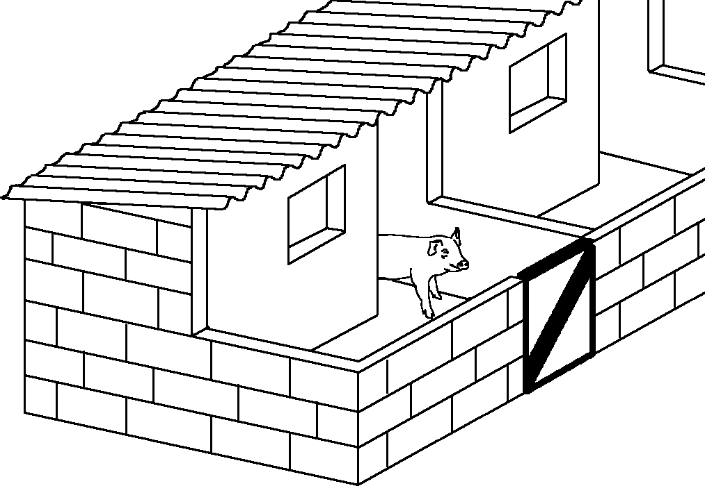
Pig khola suitable for one sow and piglets

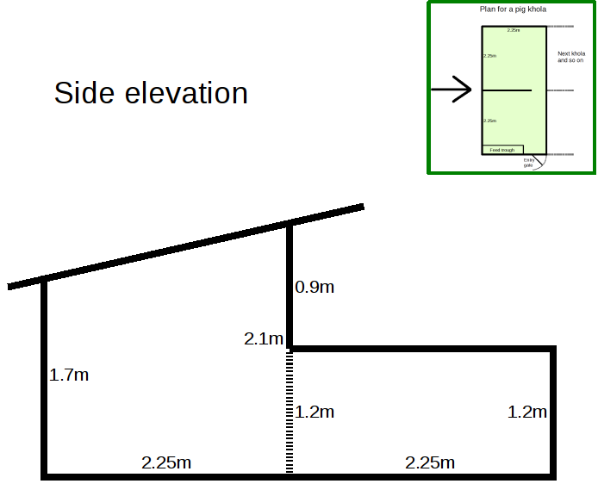  Side elevation of the pig khola |  | 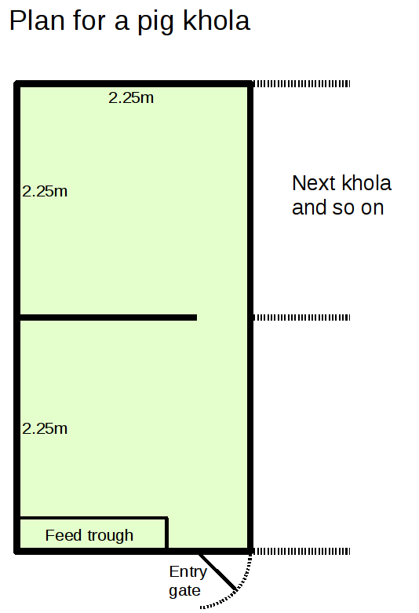  Plan for a pig khola (from above)

Double fencing
- The risk of the disease African swine fever is of particular concern for small piggeries. One step to reduce the risk of this disease is to create an outer perimeter fence for the entire piggery with only one entry/exit point. At that point, people entering the piggery area should be able to wash their hands with soap and water, and perhaps disinfectant.

Feed and water troughs
- Feeding troughs should be large enough so that all pigs can feed at once. The actual size of trough space will depend on the size of the pigs themselves. Cement troughs built into the housing structure have the advantage that they cannot easily be damaged or destroyed by the pigs.
- Water troughs should be deep enough that the pigs cannot spill or empty the contents. Again, they can be built into the structure of the khola.

Session 3: Feeding and Nutrition in Pigs
Session Specific Objectives
At the end of this training session, each participant should be able to:
- Understand the basic nutritional requirements of pigs
- Understand the differences in various feeds for pigs available in their local areas
- Describe the types of feeds available for pigs
- Know how to prepare proper feeding structures for pigs and formulate nutritionally adequate feed for pigs from local resources

How different feeds are important for pigs
Exercise:
Discuss what are the basic components of feed which are important for growth and health.

- Energy (in the form of carbohydrates and fats) is essential for growth. If feed is low in energy content, pigs need to eat more of it to grow well. If animals consume excessive energy, they get fat.
- Protein for early growth and for production of meat. Young animals need more protein in their diet than older animals
- Minerals and vitamins which are necessary for health and strength.
- Water - the most important component of all! Animals can stay longer without feed than they can without water. Clean water should always be available. It should be replaced regularly.

Which feeds have which nutrients
Exercise:
Can you name feeds which are high in energy? High in protein? High in vitamins? Where do pigs get the minerals which they need?

- In general, grains have high levels of energy. Pigs grow well when they are fed plenty of grain based feeds.
- All pig feeds have energy but some feeds which are good sources of energy and which can be easily obtained in Malawi include:
  - maize meal (mgaiwa) and maize bran (madeya, gaga)
  - rice, broken rice and rice bran
  - millet and millet bran
  - other feeds: cassava, sweet potatoes, potato peelings, sorghum
- All pig feeds also have protein but some feeds which are good sources of protein and which can be easily obtained in Malawi include:
  - soy bean (boiled or roasted to inactivate inhibitor)
  - beans, pigeon peas, cow-peas
  - cotton seed cake, sunflower cake, and ground nut cake (after oil extraction)
  - leucaena leaves (should not be more than 10% of the ration)
  - dried fish or fish meal
- Other feeds for pigs which are rich in vitamins include:
  - Potato vines
  - Bonongwe, Chamwamba, Blackjack (Chisoso), Khovani
  - Cabbages
  - Banana chops
  - Grass sods (these are especially good for iron intake)
  - Guava/Mango
- Commercial feed additives for pigs can be purchased. These products contain minerals and vitamins which are needed in small amounts in the ration. They are important in the rations of more intensive piggeries. The minerals and vitamins include:
  - iron (in several different substances)
  - methionine
  - mono calcium phosphate
  - lysine
- Commercial pigs are fed different rations at different ages as they grow. The make-up of these rations is specially designed to meet the requirements of pigs as they grow. There are rations for:
  - young piglets before they are fully weaned - creep ration
  - young piglets already weaned - weaner ration
  - larger pigs before they reach market size - grower ration
  - sow and boar rations
- Be aware that a pig should rush to eat its feed. Lack of interest in feed is a sign of ill health in pigs.

Example Rations for Piglets (2-7 weeks):
Raw material | Quantity
 | Ration 1 | Ration 2 | Ration 3
Maize bran | 70 | 63 | 70
Soya bean meal | 7 | 6 | 5
Cotton seed cake | 10 | 20 | 15
Fish meal | 7 | 5 | 4
Bone meal | 2 | 2 | 2
Ash with neither paraffin nor debris | 2 | 2 | 2
Red Soil | 2 | 2 | 2
Total | 100 | 100 | 100

Example Rations for Grower Pigs (8-13 weeks):
Raw material | Quantity
 | Ration 1 | Ration 2 | Ration 3
Maize bran | 61 | 53 | 68
Soya bean meal | - | 3 | -
Cotton seed cake | 20 | 12 | 26
Fish meal | 5 | 6 | -
Bone meal | 2 | 2 | 2
Ash with neither paraffin nor debris | 2 | 2 | 2
Red Soil | 2 | 2 | 2
Beer residues | 8 | 20 | -
Total | 100 | 100 | 100

- It is important that all the ingredients included in a ration are thoroughly mixed. If there is poor mixing, some pigs may not get sufficient of one ingredient while other pigs might get sick from eating too much of one component.

Session 4: Breeding and management of Pigs
Session Specific Objectives
At the end of this training session, each participant should be able to:
- Understand the basic principles of breeding of pigs
- Understand types of records for pig production
- Describe how to manage breeding for pigs
- Understand the basics of management of boars, sows and piglets
- Remove the needle teeth of piglets
- Castrate male piglets

The boar
- In general, do not house the boar in the same pen as the sows. Keep him separate until mating time. This will improve fertility.
- To avoid in-breeding, the boar should be replaced at intervals.
- Keep records of each boar to assist in avoiding in-breeding.

The sow
Exercise:
Undertake a field trip to observe the keeping of sows with a demonstration of heat detection.

Heat (oestrus)
- A female pig which has not farrowed is called a gilt.
- Age at first heat is about 5-6 months. At this age, the gilt will first come into heat. If nutrition is poor, the time of first heat will be delayed.
- If the sow does not get pregnant, she will come into heat about every 21 days.
- It is better to let gilts get a bit older before first mating. Avoid mating young gilts on the first or second heats. Age of the gilt at first mating should be 7-8 months.
- Signs of heat:
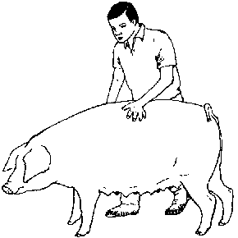
Heat detection
(Courtesy FAO "A manual for the primary animal health care worker")
  - Restlessness
  - Lack of appetite
  - Swelling of the vulva and clear mucous discharge
  - When the pig is pressed hard with the hands on either side of her back, she will stand still, showing she is ready to accept the male.
- Duration of heat is 12-36 hours.
- The sow is more likely to come into heat if she can smell a boar. If a sow is not coming into heat, it is sometimes useful to put a boar in the pen next to the sow. The smell of the boar helps the sow to come into heat. If nutrition is poor, this will probably not work. It works best when pigs are well fed.

Mating
- For mating, take the sow to the boar; do not take the boar to the sow.
- Mating should be done twice, the first at about 12 hours after the sow comes into heat and the second at about 24 hours.

Pregnancy and farrowing
- When the sow is pregnant, she will need good feed (16% protein) especially later in pregnancy. However, the sow should not be allowed to get very fat before giving birth.
- The term for giving birth in pigs is "farrowing".
- When the sow is ready to farrow, she will become restless. Farrowing should normally finish within 3-4 hours. Usually, the sow will not need assistance.
- New born piglets should start feeding soon after birth.
- It is a good idea to have a creep area for the piglets where they can get away from the sow. They can also be fed in this area so that the sow does not take their feed. There should be a low rail preventing the sow from getting into this area.
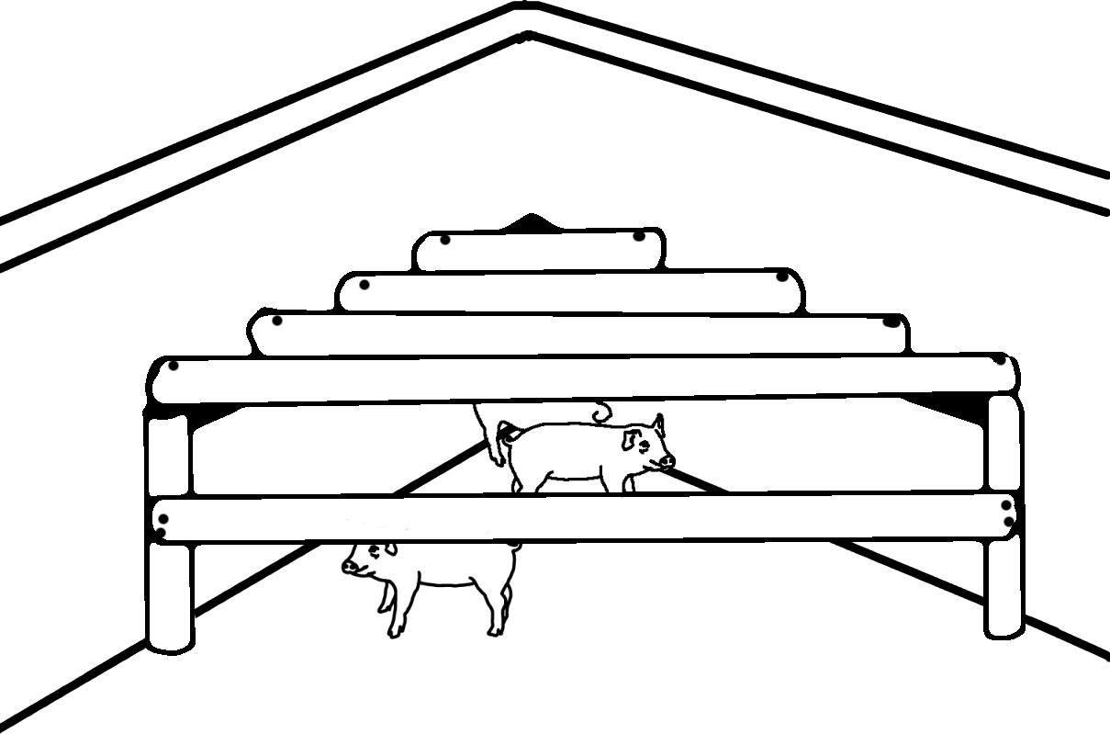
Creep area

Piglets
Exercise:
Undertake a field demonstration showing removal of needle teeth, iron injection, and castration of male piglets.

- Piglets will compete for the sow's milk. The weaker piglets will get less milk and may even die. The best teats are generally those closer to the sow's head. A good sow will have 12-14 teats.
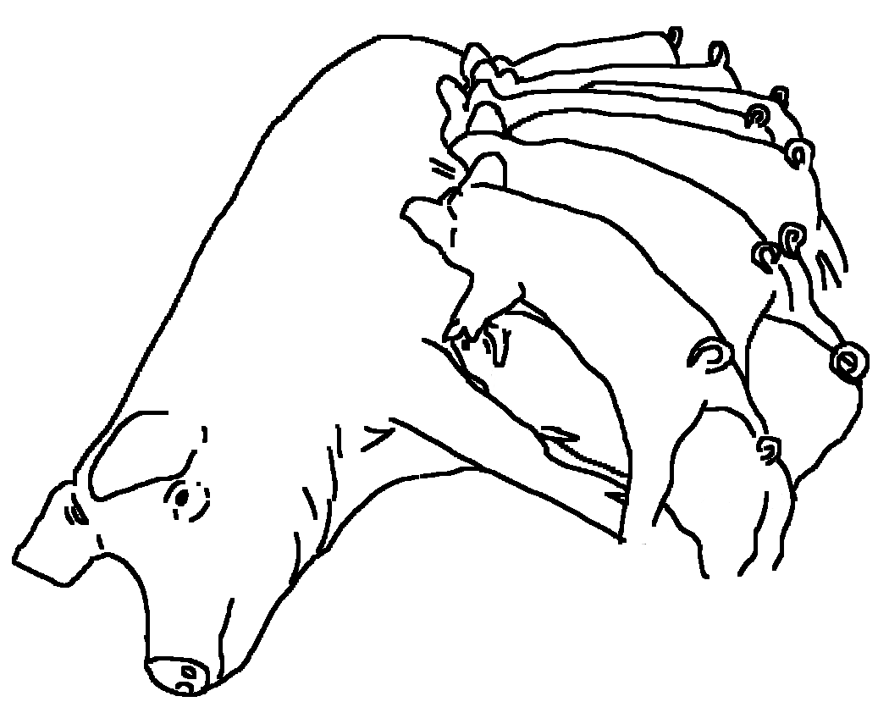
Suckling piglets
- Piglets have needle teeth which should be removed as soon as possible after birth. If the needle teeth are not removed, the piglets may damage each other as they compete for milk. They may also damage the sow's udder or teats as they struggle.
- To remove the needle teeth, first remove the piglets from the sow (or she may become aggressive trying to protect them). Then use tooth clippers or side-cutters to snip off the four needle teeth, two on the top jaw and two on the bottom jaw. Replace the piglets with their mother as soon as the operation is over.
- Keep the clippers clean. Wash the clippers with antiseptic or bleach between each piglet.

Iron injection
- Piglets housed in a khola need an iron injection to make sure they do not suffer from anaemia (insufficient blood). The iron helps the piglet to have adequate blood for healthy growth.
- Iron can be injected within one week of age.

Weaning
- Piglets will take an interest in solid food at about 1-2 weeks of age. From this age, the piglets should be encouraged to take solid feed as well as suckling from their mother. Piglets will continue to suckle until they are about 6-8 weeks of age. Piglets should be weaned gradually by increasing the quantity of solid feed. They should only be weaned completely when they are taking an adequate quantity of solid feed.

Selection
- Good piglets should be kept for breeding. Piglets selected for breeding should be those which are fast growing, healthy, and free from defects or deformities.

Castration
- Male piglets can be castrated if they are not needed for breeding. If boars are not castrated, they may fight. Castrated males are easier to handle. The meat of boars may also have "boar taint", a strong smell which many people find unpleasant.
- Piglets should castrated before they are weaned, best at an age of 2-3 weeks. Castration at a later age carries higher risks of blood loss, or infection of the wound.
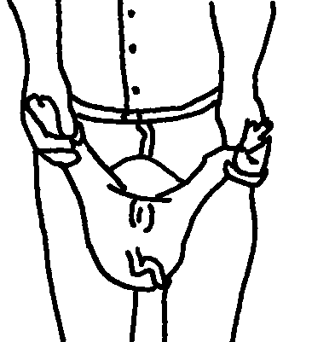
Restraining a piglet for castration
- It is best to castrate piglets in the cool of the early morning when there is less blood going to the testicle.
- Piglets for castration should be removed from the sow and restrained as shown in the diagram.
- Use a very sharp razor blade, a scalpel or a very sharp knife. Do not use blunt instruments because they will damage the piglet and cause infection.
- Clean the area around the testicles with soap and water and dry it. Then disinfect the area with iodine solution.
- Gripping beneath the testicle with the thumb and finger, make a cut 1-2 cm long in the scrotum so that the testicle pops out.
- Pull the testicle out gently so that you can cut the white cord. Do not cut the red blood vessel yet.
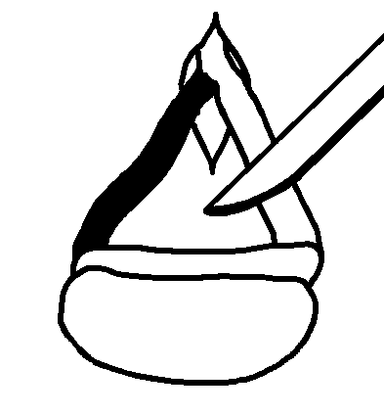
Cut the white cord first
- Gently pull the testicle further out so that you can twist it around several times. This will slow the flow of blood in the vessel. You can scrape the knife up and down along the blood vessel to cut it. This will reduce the blood loss. Do not pull on the vessel to break it as that will cause excessive bleeding.
- At all times, avoid contamination of the wound. Do not put your finger or anything else into the wound.
- Remove the second testicle in the same manner.
- Disinfect the open wound with iodine solution or stockholm tar.
- Place the piglet with the mother as soon as possible after castration. During the following week, check the piglet for any sign of infection of the wound. If there is infection, the piglet will not walk around or may be lame. If there is an abscess from infection, this can be punctured with a scalpel and drained to allow it to heal.

Ear notching of piglets
- If there are a large number of pigs, individuals can be identified by ear notching. This will facilitate record keeping and management.
- Ear notching is best done at 1-3 days of age. Either a sharp pair of scizzors or a specially designed notching tool can be used.
- The wound should be treated with a disinfectant after notching.
- The numbering convention recommended by SSLPP is illustrated below. (Some people use other conventions).
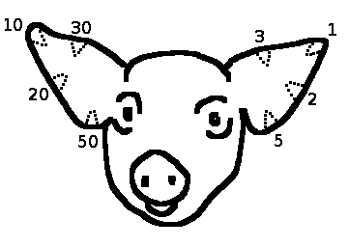
Ear notching - numbering convention
- To determine the number of the pig, the numbers for all notches are added together. The ear on the right above can thus show all numbers from 1 to 11. The ear on the left can show all the "tens" from 10 to 110. Thus this system can show all the numbers from 1 to 121.

Exercise:
What are the ear notch numbers of the pigs shown below?
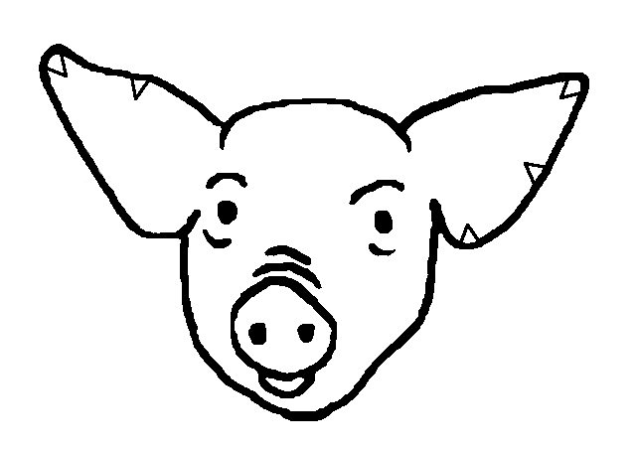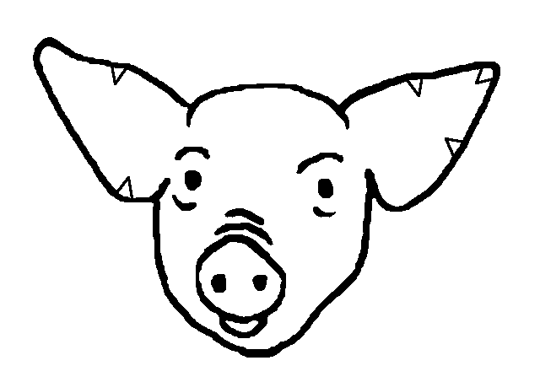
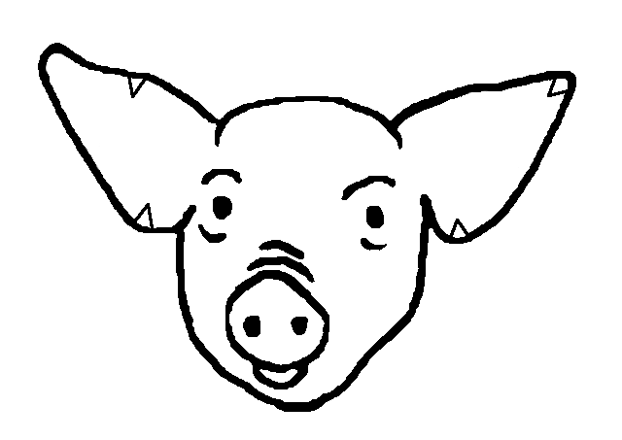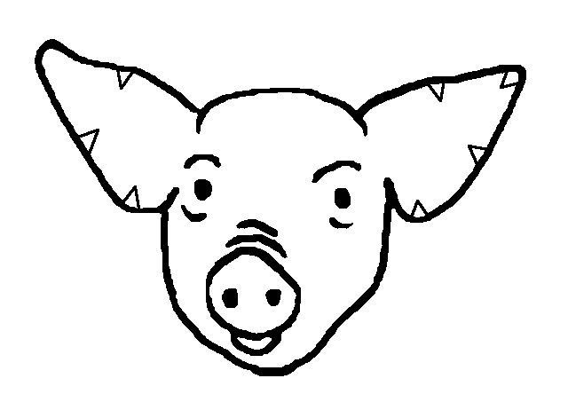

Session 5: Diseases of Pigs
Session Specific Objectives
At the end of this training session, each participant should be able to:
- Understand the common diseases of pigs
- Describe the signs, prevention and treatment of common diseases of pigs

General principles
- In most litters, there will be one or two pigs which do not do as well as their siblings. These slow growing piglets are called runts.
- Common signs of stress amongst pigs include poor body condition and tail biting.
- Sometimes important diseases like foot and mouth disease can infect pigs. If you suspect that a lot of pigs are suffering from a strange disease, you should report it immediately to your nearest alangizi.

Internal parasites
Internal parasites
Cause | There are several different types of worms of pigs.
Signs and symptoms | Worms can cause diarrhoea, poor growth and death. They can damage several of the internal organs of the pig including the intestines, the liver and the kidneys.  Some worms can infect humans if the pig meat is not cooked well.
Prevention | Pigs which are kept in a khola full-time are less likely to get worms.  The khola should be cleaned out thoroughly before a new pig is introduced.  Treatment of sows before they farrow will assist in reducing infection in the piglets.
Treatment | Worms in pigs can be treated with deworming drugs. Some deworming drugs are mixed with the feed and others are given as a drench or injected. Some deworming drugs are:  - Levamisole - in water or feed  - Albendazole, fenbendazole, or parbendazole - given orally or in feed  - Morantel citrate - given orally  - Ivermectin - by injection  - Piperazine - orally

External parasites
- Common external parasites of pigs include mange mites, lice and ticks.
Mange
Cause | Mange in pigs is caused by tiny mites which bite the skin and which may burrow into the skin making treatment difficult.
Signs and symptoms | Typically, mange causes itchiness and the pig will rub itself against walls and posts etc. There may be thickening, crusts or blotches on the worst affected parts of the skin.
Prevention | Segregate pigs so that the mites do not spread throughout the herd.
Treatment | Treatment of mange is by ivermectin injection or by special chemical washes (acaricides) such as amitraz.

Lice
Cause | Lice are larger insects which can be seen moving about on the pig's skin.
Signs and symptoms | They cause the pig to scratch but usually not as severely as mange.
Prevention
Treatment | Lice can be treated with insecticide washes, such as malathion or coumaphos.

Ticks
Cause | Ticks are visible like lice but they do not move about on the body.
Signs and symptoms | Adult ticks attach to the skin and suck blood.
Prevention | Pigs which are kept in a khola full-time are less likely to get ticks.
Treatment | They can be treated using special chemical washes (acaricides) such as amitraz. Individual ticks can be killed using paraffin (kerosene) or by touching them with a lighted cigarette or hot ashes.

Diseases caused by germs
African swine fever | One of the most important diseases of pigs in Malawi is African swine fever (chigodola cha nkhumba). This disease appears in a district and spreads, killing many pigs. The disease is spread in live pigs and pig meat.  If you suspect African swine fever anywhere in your district, you should report it immediately to your nearest alangizi.
Cause | The disease is caused by a virus which can be carried into a pig khola on things such as:  - live pigs  - pig meat  - people who have been near other pigs  - feed and scraps  - buckets, baskets and other equipment
Signs and symptoms | Many pigs die within a few days of the sickness first appearing in the herd.
Prevention | There is no vaccine to prevent African swine fever.  The only protection method is to keep pigs in their khola and prevent entry of persons, feed and equipment which have any contact with pigs outside.  When African swine fever is known to be spreading anywhere in your district, or in neighbouring districts, the following steps may assist:  - do not allow any live pigs anywhere near your khola  - do not move live pigs to another location and do not allow others to bring live pigs anywhere near your village  - do not allow pig meat to be brought anywhere near your village  - do not bring pig feed from anywhere where pigs are known to have been sick  - do not allow any persons from outside your village to go near your pigs  - if you have workers for your pigs, make sure they do not live near other people who have pigs; make sure they do not keep pigs of their own.
Treatment | None. There is no treatment for African swine fever.  If anyone says they have a remedy for African swine fever, they are wrong.

Erysipelas | Erysipelas (diamond skin disease) is a common disease of pigs.
Cause | Erysipelas is caused by a bacteria. Pigs get infected from other pigs which are carrying the bacteria.
Signs and symptoms | It can cause death or can make pigs chronically sick causing significant loss of production. Occasionally, the disease causes diamond-shaped blueish blotches on the skin.
Prevention | Treat all pigs with the disease. There is a vaccine which can be given to pigs to prevent the infection.
Treatment | The disease can be treated with penicillin if it is given early, before the pig gets very sick.

Scours
Cause | Scouring in piglets might be due to germs or it might be due to management errors.  Piglets sometimes get diarrhoea if they are weaned too early.  Scours might also be due to worms.
Signs and symptoms | Diarrhoea and weakness. This can kill the piglet if it is severe.
Prevention | Good management, correct weaning,
Treatment | Piglets should be given oral rehydration therapy. This will help them cope with the loss of body fluids.  Kaolin or bentonite can be given with the feed.  Antibiotics can be given but they will not be effective if the cause is a virus or dietary.

Review questions
- Why are free range systems of pig raising illegal and discouraged in Malawi?
- What floor area is required for one sow and her piglets?
- What are the basic components of feed which are important for growth and health?
- Name some feeds which are good sources of energy for pigs.
- Name some feeds which are good sources of protein for pigs.
- At what age will a gilt first show signs of heat?
At what age should a gilt be allowed to mate?
- What are the signs of heat in pigs?
- Why do we remove the needle teeth of piglets?
- Why do we castrate male piglets?
- At what age do we:
Remove needle teeth?
Castrate male piglets?
Wean piglets?
- What is a runt?
- How can we prevent worms in pigs?
- How can we treat mange in pigs?
- What should you do if African swine fever is present in your district?
- How would you try to prevent African swine fever from infecting your pigs?

Free range pigs are regarded as an opportunistic enterprise. This form of pig production is not recommended for Malawi. There is a law which actually makes free-range pig keeping illegal. The risk of disease is very high and some of these diseases affect humans. We will not discuss free range pigs here.

