**ECO-FRIENDLY SCHOOL FARMS PROJECT REPORT**

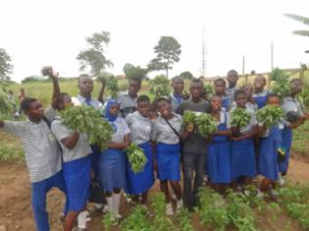

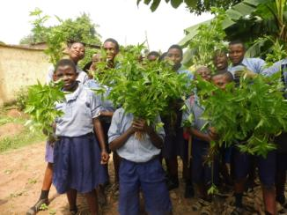

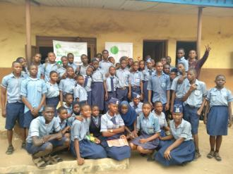

**INTRODUCTION**

With the soaring rate of socio-economic challenges faced by small holder farmers, children of school age are usually the most disadvantaged in the household. These children are faced with malnutrition and are usually unable to participate fully in school as a result of this and thus perform marginally in their academics. In spite of being raised in agrarian communities of Lagos State and having the benefit of education, children of small holder farmers have shown to contribute very little by way of innovation to the traditional farming practices. The education the children receive in school neither prepares them for highly skilled urban jobs nor improves their agricultural practices to become more successful farmers thereby propagating a cycle of poverty. The goal of this project was to provide school aged children in Ikorodu rural communities with hands-on field co-creation learning on environmentally friendly and innovative agricultural practices that would directly improve their nutrition and equip them with requisite sustainable agripreneurial skills. The project was carried out in three (3) public secondary schools in Ikorodu, Lagos Nigeria:

1. IKORODU JUNIOR HIGH SCHOOL, APEKA, IKORODU, LAGOS
2. ODOGUNYAN SENIOR HIGH SCHOOL, ODOGUNYAN, LAGOS
3. GOVERNMENT MODEL SENIOR COLLEDGE, OWUTU, LAGOS.

**PROJECT TEAM VISITATION TO SELECTED SCHOOLS AND SCHOOL SURVEY:**

On the 20th of November, 2018, the project team of Protectozone led by the project manager visited the three selected schools for the school farm project. The team introduced the project to the school authorities and also discussed on the time of training, number of school children for the training and days of the training. The school authorities were glad to have such a wonderful project being established in their schools and promised to give us full support to ensure the success of the project. Finally, the team inspected the site for the farm establishment which was given by the school.

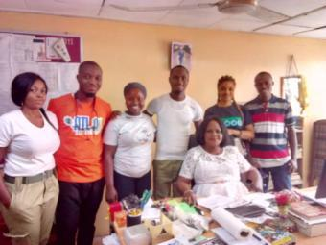

**Team with Government Model College School Principal**

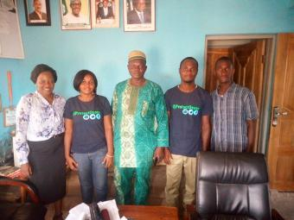

**Team with Odogunyan Senior High School Authority**

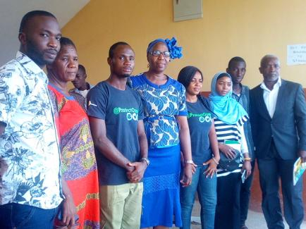

**Team with Ikorodu Junior High School Authority**

**INTRODUCTION OF PROJECT TO STUDENTS**

On the 3rd of December, 2018, the project team visited the schools in order to meet with the young farmers club members and also introduce the project to the. The students were excited about the project while 200 students showed interest in the project. They asked questions that were of concern to them about the project which was well answered by the project team.

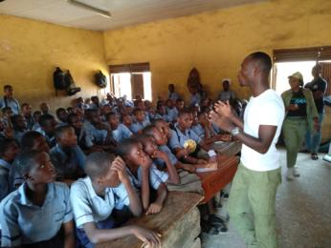

**Introducing School Farm project to students**

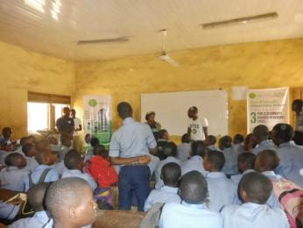

**A Male Student asking question**

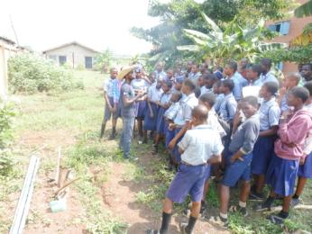

**Introducing School Farm project to students**

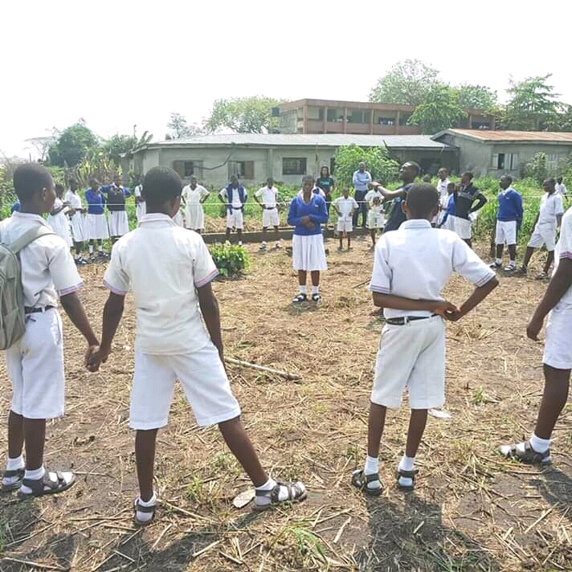

**Introducing School Farm project to students**

**DELIVERY OF PROJECT MATERIALS TO SCHOOLS**

On the 15th of December, 2018, the materials necessary for the successful completion of the project was delivered to each of the schools. The materials include:

* Vegetables crops and Fruit crop Seeds (Ewedu, Soko, Tete, Onion, Tomato, Egg plant, cucumber, okra, papaya, and carrot).
* Irrigation Kit construction Materials ( 5 units of 4inches pipe, 3 Units of 2 inches Pipe, Mosquito nets, Cutting saw, locally made coal pot, Perforating Pipe, Screw drivers, and gum).

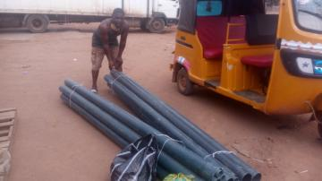

**Conveying Materials to schools**

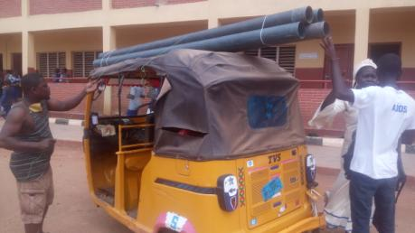

**Team in school to deliver materials**

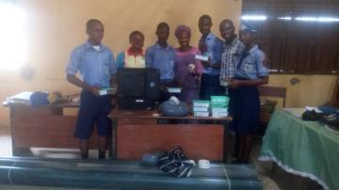

**Students with Young farmers club Leader pose with Materials**

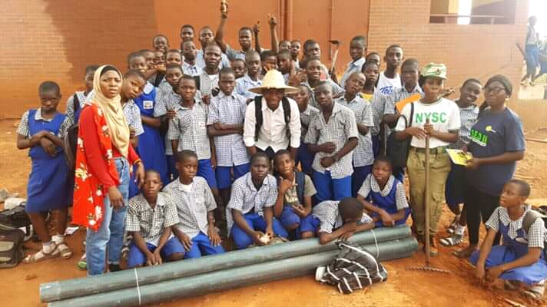

**Students with Young farmers club Leader pose with Materials**

**INTRODUCTION TO SUSTAINABLE ORGANIC FARMING**

On the 26th of January, 2019, the students were introduced to sustainable organic farming methods. They were taking on a field trip and trained on various soil management practices, crop management, origin of crops, botanical names and economic importance of the crops.

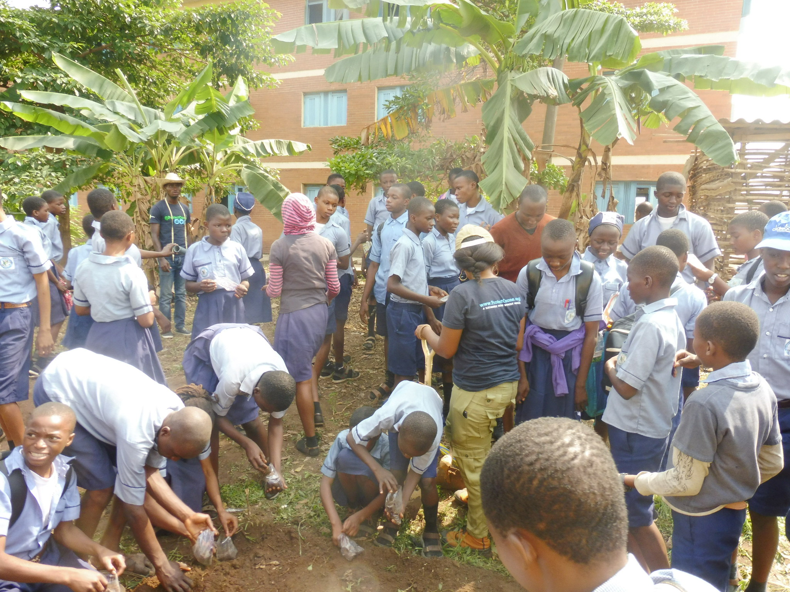

**School children working together on the field after training**

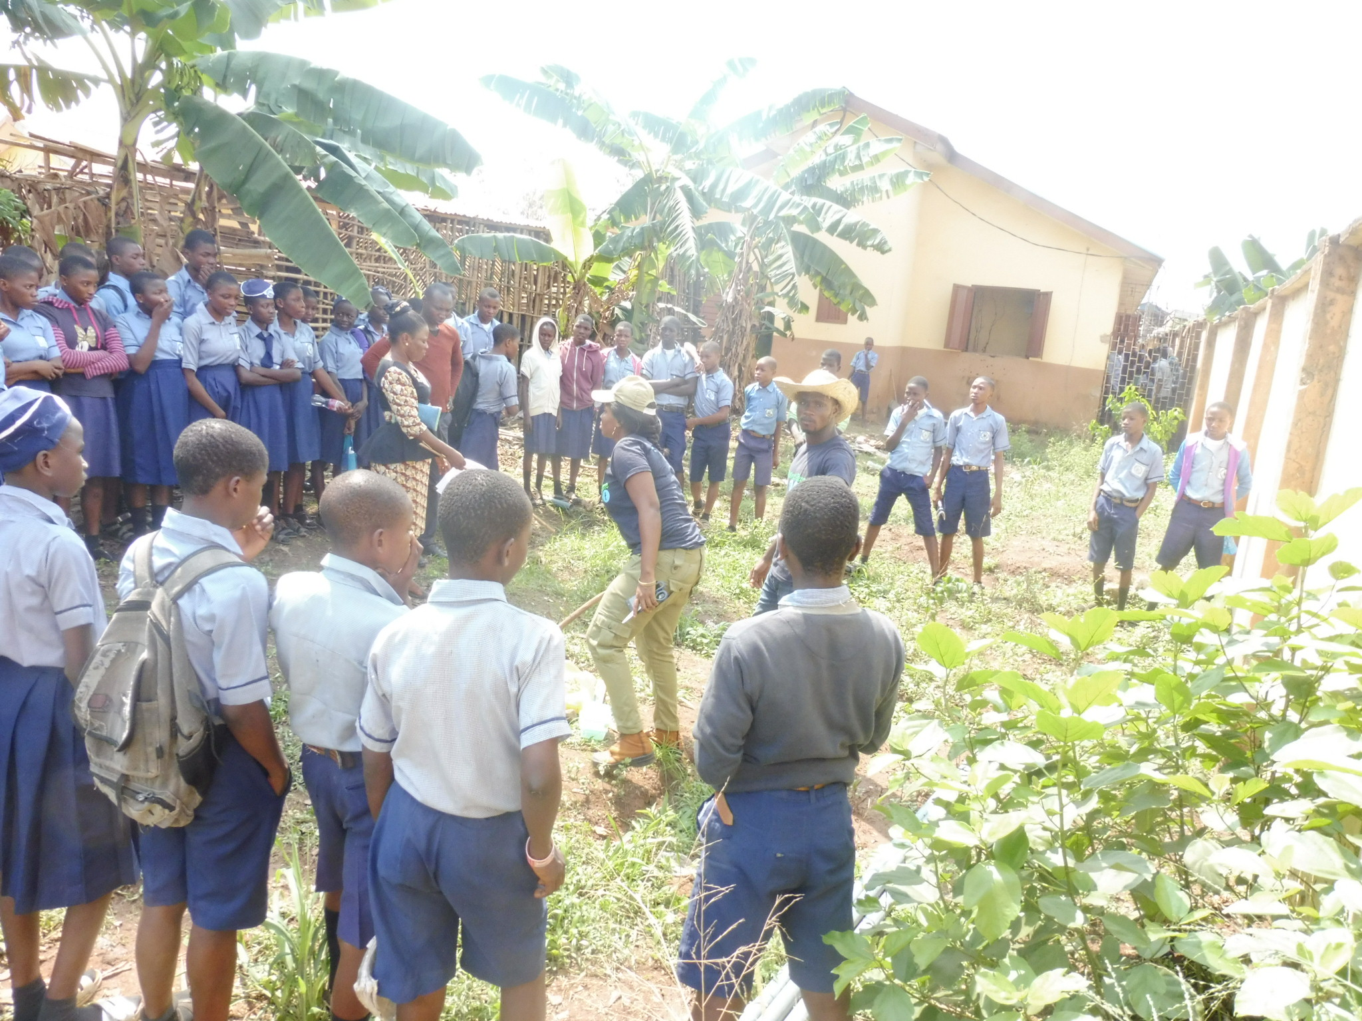

**Trainer Demonstrating Organic farming methods to children**

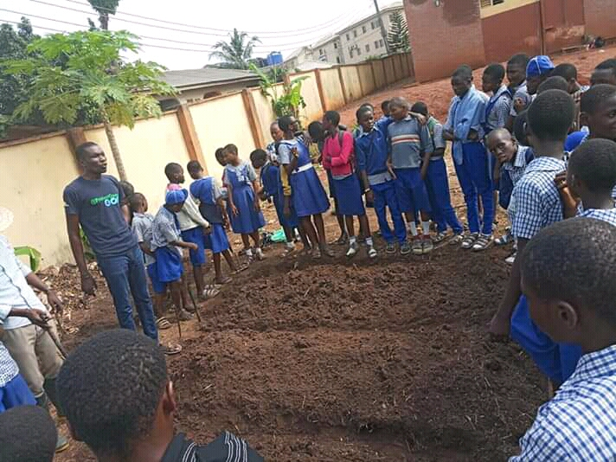

**Trainer introducing sustainable organic farming to the children**

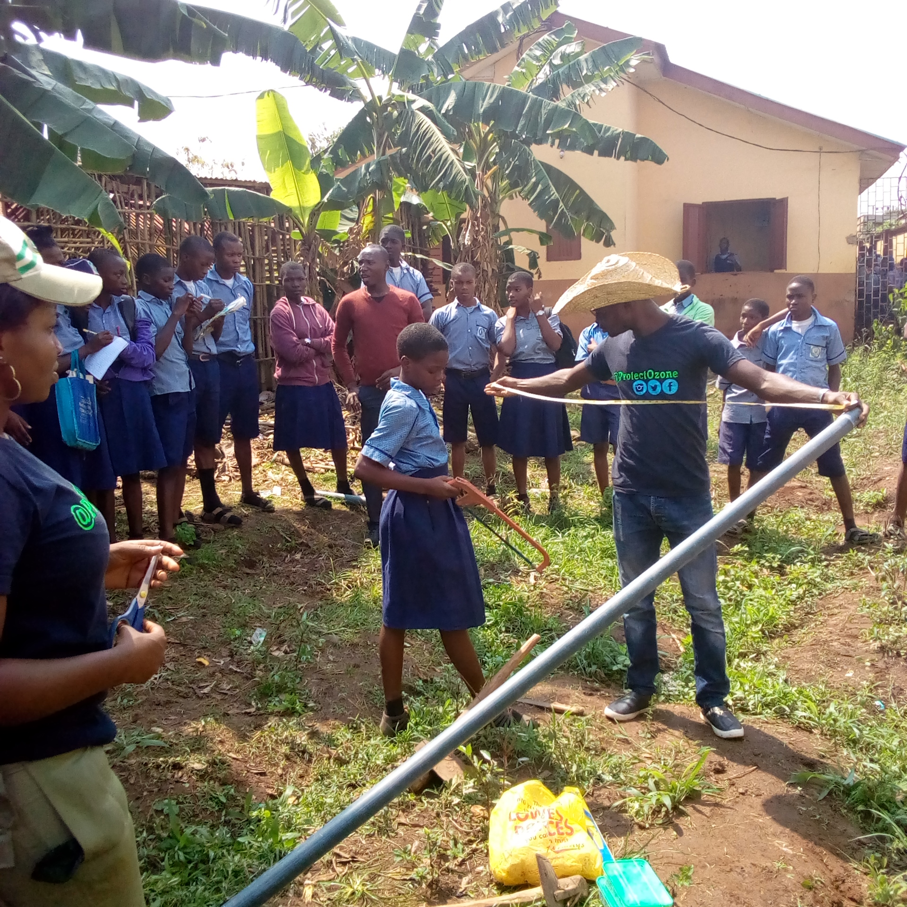

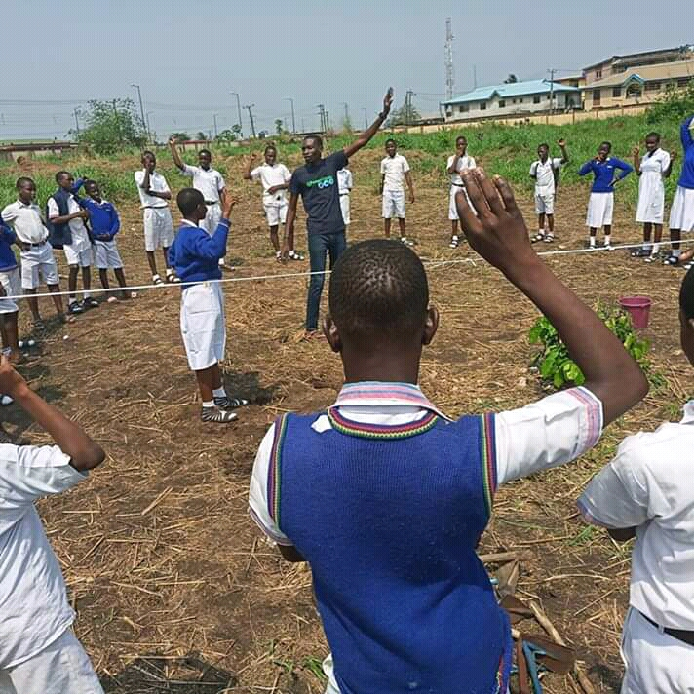

**Trainer introducing sustainable organic farming to the children**

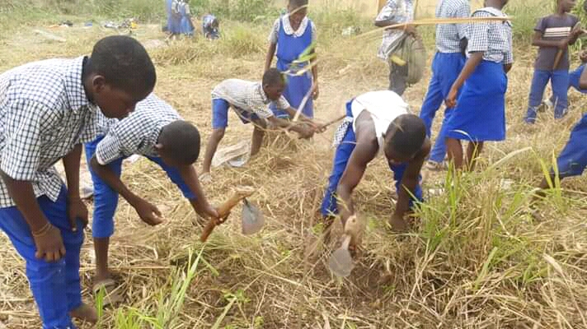

**School children working together on the field during training**