 

**Final Project Report on:**

**Women Led Honey Value Chain Development Project**

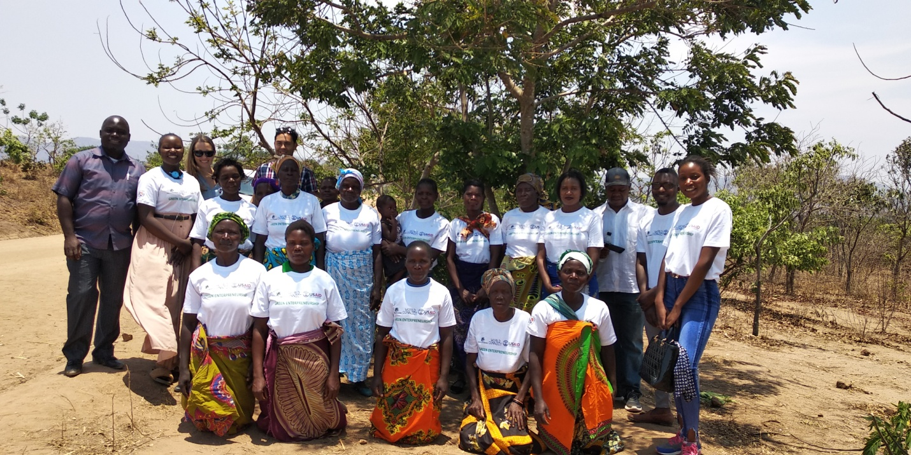

**Submission to**

**World Connect (Malawi office)**

**Submitted by:**

GREEN LIVELIHOODS

(In partnership with TAWINA)

P.O. Box 338, Lilongwe, Malawi

Tel.: +265111900855/+265 888 773 022

Email: [greenlivelihoods@yahoo.com](mailto:greenlivelihoods@yahoo.com)

[tawina@tawina.org](mailto:tawina@tawina.org)

[info@greenlivelihoods.org](mailto:info@greenlivelihoods.org)

Web: www.green Livelihoods.org

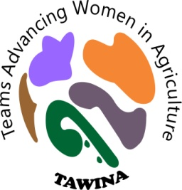

**February 24, 2019,**

1. **Project background information**

|  |  |  |  |
| --- | --- | --- | --- |
| Name of Award | Women led Honey Value Chain Development Project | | |
| Project Primary Focus: | Economic Opportunity Development and Women/Youth Empowerment | | |
| Project grant holder | Greenlivelihoods (GL) | | |
| Community implementing partner (co-creator) | Team Advancing Women in Agriculture (TAWINA) | | |
| Member / Donor | United States Agency for International Development (USAID) through World Connect. | | |
| Grant type | Accelerator Grants Competition | | |
| Country Office | Malawi | Project Number |  |
| Award Start Date | 1st May 2018 | Award End Date | 31th December 2018 |
| Award duration | 6 months | Award location | Dowa District, Malawi |
| Total Award Amount in donor currency | *US$ 3,602.00 (with 83% of donor funding contribution and 17% from Green Fund of GL affiliate)* | | |
| Target Groups and Locations | 100 women of productive age group in TA Mkukula in GVH Chauwa | | |
| Country Office Contact | *Project Lead – Hilda Mkupu Jemi, E-mail* [thildamkupu@gmail.com](mailto:thildamkupu@gmail.com)  *Finance Officer: Lazarous Phiri; Email:* [*lphiri@gmail.com*](mailto:lphiri@gmail.com)  *Executive Director: Madalitso Makwandu; E:* [*greenlivelihoods@yahoo.com*](mailto:greenlivelihoods@yahoo.com) | | |
| Partner Office contact | *Project field coordinator: Regina Mbeta,* [*Reginambeta93@gmail.com*](mailto:Reginambeta93@gmail.com)  *Finance officer: Elinna Mullwafu;*  [ellinalwitikomulwafu@gmail.com](mailto:ellinalwitikomulwafu@gmail.com) | | |
| **Project summary** | The women project focused on ‘(1) enhancing the value addition, marketing and cooperative development of honey value chain through farmer field school approach directly targeting 100 women member group in Dowa district. Specific expected outcomes included: (1) Enhanced active participation of women in honey value chain enterprise development (2) Increased income by 75% women headed households engaged in cooperative development by 2019. (3) Cooperative fund initiated; for graduation into a Women led Green Microfinance. | | |

1. **INTRODUCTION**

Women Led Honey Value Chain Project started its implementation in October 2018. This project is being implemented with two partnerships, Green Livelihoods (GL) and Team Advancing Women in Agriculture (TAWINA) in Dowa district, T/A Mkukula, Chibvala EPA in Mbalame village. The project is targeting 100 women that are in five groups/clubs (membership of 20 women per club) with its focus on economic opportunities.

**3.0 OBJECTIVES (LONGTERM VISIONING)**

The project’s main goal is to enhance the value addition, marketing and cooperative development of honey value chain through farmer field school approach. Specifically, to,

* Enhance active participation of women in honey value chain enterprise development
* Increased income by 75% women headed households engaged in cooperative development by 2019.
* Cooperative fund initiated; for graduation into a Women led Green Microfinance.

1. **ACTIVITIES AND EXTENT OF REACH SO FAR (PAST 6 MONTHS)**

**3.1 Beekeeping set-up phase**

The project intends to reach to 5 groups of over 100 women change agents in green enterpreuship. The project has managed to initiate the formation of 5 groups and one of the groups has been supplied with beekeeping starter-up kits of modern beehive suits. The project has Tikondane women club with 20 members hoping to reach out to those other women eager to start honey production in the remaining four groups and even beyond. The club has a forest with trees suitable for bee keeping and on the 19 October, 2018, we visited them just to appreciate where they will be doing their production and some rules the women implemented to be used for the effectiveness of the production. Tikondane women club was established in 2016 to champion women economic empowerment through village savings and loan functions that support financing small-businesses and green entrepreneurship has been earmarked to grow the business into formidable cooperatives that would be self-sustaining and scalable. Four other new other beekeeping women and youth led groups have been formed following the commission of the women led honey value chain development project pending scale-up resourcing.

**3.2 Learning from others: promoting peer co-creation among farmers**

On the 29th of October, 2018, these women paid a visit to one of the existing bee keeping Pumphunthe club, dowa district. This is one of the clubs doing well in this production and this was one of the groups that motivated the women to request this honey value chain project in their community. The aim of the visit was to appreciate what the club is doing in honey production. The visit was advantageous to them because they leant some basics on how to get bees into the bee hives, feed for the bees (maize bran + water + flowers), how to hang the bee hives, harvesting, issues of packaging and marketing.

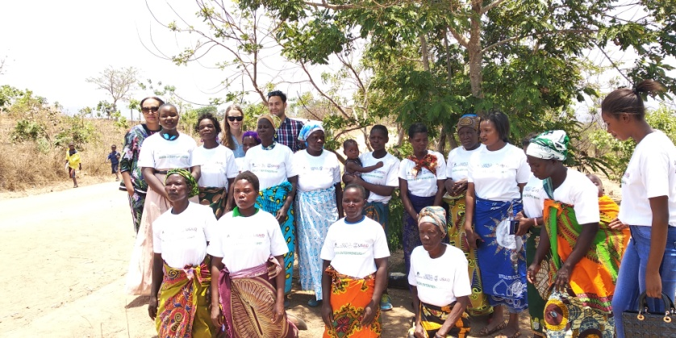On the 2nd of November, 2018, the project team had a field visit to the club with officials from USAID and World Connect where self-reliance discussions were held to ensure community led and owned programming is fostered. This club has been there since 2015, where they were producing soya beans for both consumption and sell. It has been their desire to venture into bee keeping but lack of expertise and starter-up financial capital was were some of the challenges to them. “We could just admire on other villages producing honey for the market and we kept asking ourselves on how to get such initiative’ the chairperson explained. So the coming in of TAWINA and Green Livelihoods has been a great answer to our desire”. The group has been doing Village Saving Loans where they are able to borrow some money to start some small businesses so the coming in of Women Led Honey Value Chain Project is deemed a growth factor in terms of income generation to foster investment into small-to-medium businesses. The following were community interventions under execution and their level of progress so far:

GL, World connect, USAID & community partners in discussion

* Tree seedling production and plantation into the community forest
* Fruit tree propagation and horticultural value chain development (to supplement beekeeping).
* Tree regeneration and forestry enterprise product development (i.e. fruit juice processing)
* Providing mentorship to new self-formed groups emulating from Tikondane group (Need for more support from Green livelihoods and TAWINA)

In the discussions, these were the lessons learned. Since the project started its implementation, there have been some challenges and one of the biggest challenges is that fellow women from the community are discouraging them on the project saying that they won’t sustain it. Their husbands are also discouraging them in that instead of taking care of them and children at home, they are spending time at the club. But despite all these discouragements, these women have stood their ground with anticipation that the project will change their families. “We believe to increase the money to the VSLs we do and this will enable us grow our businesses, be able to pay school fees and feed our children as we protect the environment” –one representative explained.

**3.3 Modern Beehive delivery and Installation to the first 20 women cohort**

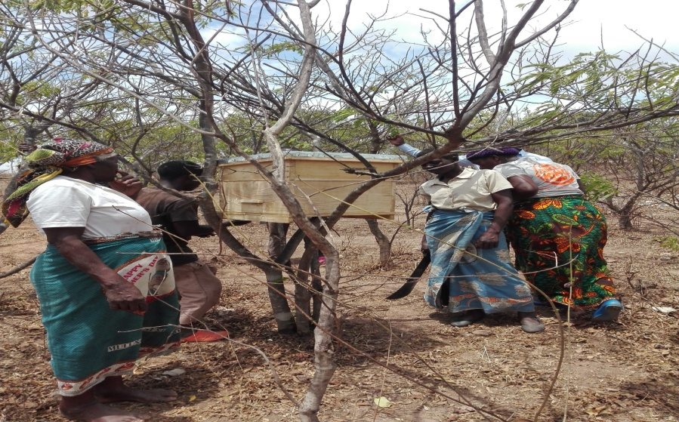On the 7th of December, 2018, a formal training on group dynamics and honey production management was facilitated by project staff and women community leadership. The training was facilitated by a representative Fredrick’s Honey: African’s Natural Honey from where we purchased the bee hives and staffs from Green livelihoods and TAWINA. The training took place in Mbalame village at the forest.

After the training, the bee hives were delivered and the women were very happy hanging the hives in their community forestry. These modern bee hives will enable them produce more honey compared to the standard hives simply because these already have wax which easily coax/attracts bees and it only takes few days for bees to enter in the hives. The woodlot has the potential to accommodate a 100 or more hives to which the group is strategizing to expand as business grow and self-finance.

Tikondane Women group hanging one of the modern hives

Tikondane club has started this production with 10 bee hives and the hives were hanged on the same date soon after the training. Hoping to have bees colonized in the hives in just a few days and probably having their first harvest in 3 months’ time (March) and with proper management of these hives, it is possible to harvest four times in a year.

**3.4 Key deliverables towards expected project outcomes**

Towards enchaining economic empowerment of women, the project has managed to initiate the community led economic development thinking and communities are demanding professional expertise from Tikondane group which has led to formation of other four beekeeping groups awaiting resourcing for modern beehives. The group with beehives has been linked to Fredrick’s Honey and Honey Products Industries (HPI) for honey marketing purposes while TAWINA is mentored by GL to farmer field school advisory services to directly to the 100 women who will be acting as change agents to other voluntary forming groups. This has achieved (1) Enhanced active participation of women in honey value chain enterprise development to 100% and (2) Increased anticipation for women headed households engaged in cooperative development (3) The co-creation had already initiated cooperative development thinking which will be concretized in the second phase of this project and Women led Green Microfinance will be established.

***Tree seedling production and plantation into the community forest***

Over 1000 assorted tree seedlings were planted by January 25 2019. The trees were planted in the communal forest where the beehives are hang. Both men and women from the village took part in the planting assignment with support from local leadership (chiefs) support.

***Tree regeneration and forestry enterprise product development (i.e. fruit juice processing):***

With the hanging of the initial 10 beehives, the community forest has added reforestation value as the trees are regenerating into beekeeping area (see pictures attached). The fruit juice processing has not yet started and the project intends to slot the activity into its second phase as expanded resource mobilization takes shape in the year 2019. High fruit vegetable production and processing i.e. tomato into tomato sauce is also being envisaged to be implemented by the women groups.

Additionally, a demonstration training was undertaken on beehives management and honey harvesting as dressed in protective wear/gear.

On the area of Fruit tree propagation and horticultural value chain development (to supplement beekeeping), Greenlivelihoods has partnered and linked the women group to Mwai Fruits Ltd for fruit tree propagation mentor-ship, awaiting the sourcing of seedlings for integration into the beekeeping and forestry development initiative.

1. **Conclusion and recommendations**

The women are very positive with the production, hoping to improve their economic livelihoods and venture into market led value chain development. The project has stirred the desire to invest more in green enterpreuship which challenges GL and TAWINA to do more resource mobilization for the scale-up and activity diversification including pursuance of commercialization processes for respective value chains.

Generally, there is a ‘hand out’ mentality among the women under Tigwirizane interventions groups – Need to foster group dynamics mentorship/training in the next years of pursuing interventions.

Group members act individually and yet see the groups as conduit for receiving development aid support – Group and association formation needed to promote farmer-to-farmer learning across the larger area that cover good performing groups. The group already works with one innovative farmer ‘Mr. Shadreck Stuart’ – who support the women on probono basis on beekeeping technical-expertise support. Future interventions therefore need to scope ‘innovative farmers’ and design associations around them to work as change agents towards cooperative development in respective mapped value chains.

The group tend to transact with closed tendencies to other non-group members to emulate the development thinking – Need to foster open door community learning and future project interventions should include having ‘innovation fairs or open days’ for community learning and innovation scale-ups.

Communities prefer to engage in diversified agro-based activities such as vegetables and horticultural value, or contract marketing on soya beans production (largely viewed to be implemented at individual level for aggregation during harvest season) – The women group was already searching for land to rent for group market driven farming with focus on tomatoes, cucumber & sugar beans plus green maize. Some of the group members indicated to have leant from *Chimwankhunda* cooperative on soya beans production and proceeding of cooking oil plus soya milk using a bulking group approach (“we want such interventions as well”).

The groups need to have a scale-up number of associative groups, increased number hives (suggested number at least 50 hives) and also diversified income sources plus promoting value addition especially on soya products – where finished products such as cooking oil, soya milk etc. were cited as dreamt examples*.*

Need to foster ‘long-term’ development investment with Greenlivelihoods & its partners’ co-creative partnership styles beyond dictated by donor support.

**5. Financial report**

|  |  |  |  |
| --- | --- | --- | --- |
| **EXEPENDITURE SUMMARY REPORT** | | | **Remarks** |
| **Income** | **USD** | **Local Currency (MK)** |
| World connect | 2,998.61 | 2,188,985.30 |  |
| **Total Income** | **2,998.61** | **2,188,985.30** |  |
|  |  |  |  |
| **Project Expenses** | **USD** | **Local Currency (MK)** |  |
| **Programmatic Activities** |  |  |  |
| *Purchase of bee keeping kit* | 2,739.73 | 2,000,000.00 |  |
| *Learning visit to already existing clubs* | 157.53 | 115,000.00 |  |
| *Training in group dynamics and business management* | 266.38 | 194,460.00 |  |
| *Site visit with development partners* | 226.03 | 165,000.00 |  |
| *Training in bee keeping farming* | 143.84 | 105,000.00 |  |
| *Transportation of bee keeping kit to the project site* | 68.49 | 50,000.00 |  |
| ***Total Expenses*** | ***3,602.00*** | ***2,629,460.00*** |  |
| Notes: World connect (WC) received and spent funds= 2998.61 (100% of received funds). Total budget spent on the project = 3602.00. This represents budget contribution of 83% from WC. While GL Fund excluding community contribution accounts for 17%. | | | |