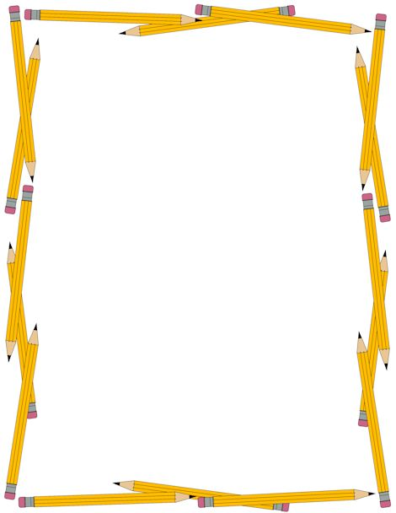

**Books are My Friends!**

***Ibitabo Ni Inshuti Zanjye!***

**1. Ask the teacher for permission before taking a book.**

***Saba mwarimu uruhushya mbere yo gufata igitabo.***

**2. Read one book at a time.**

***Soma igitabo kimwe kimwe.***

**3. Touch books with clean hands.**

***Kora ku igitabo ufite n’ibiganza bikeye.***

**4. Turn pages carefully so they do not rip.**

***Hindura urupapuro buhoro buhoro kidacika.***

**5. Do not write in, spit on, or hurt books.**

***Wikwandika mu igitabo, wicira mu igitabo, cyangwa uhinahine igitabo.***

**6. When you are finished with a book, return it to the bookshelf correctly.**

***Urangije gusoma igitabo, ugishira igitabo mu bubiko bwacyo neza.***

**7. Don’t steal the books! The books stay at school.**

***Wikwiba igitabo! Ibitabo bisigara ku ishuri.***