Pictures from Village Trainings
Photos taken by Falaye Danfakha

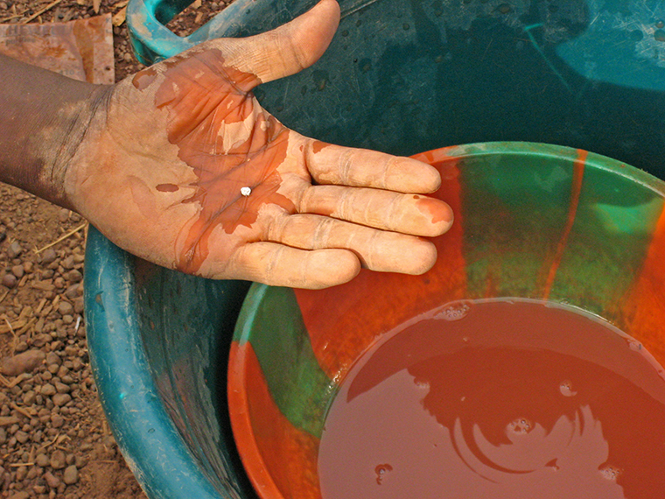
Mercury being used in the process of artisanal gold mining. This is a ball of gold coated in mercury prior to being burned.

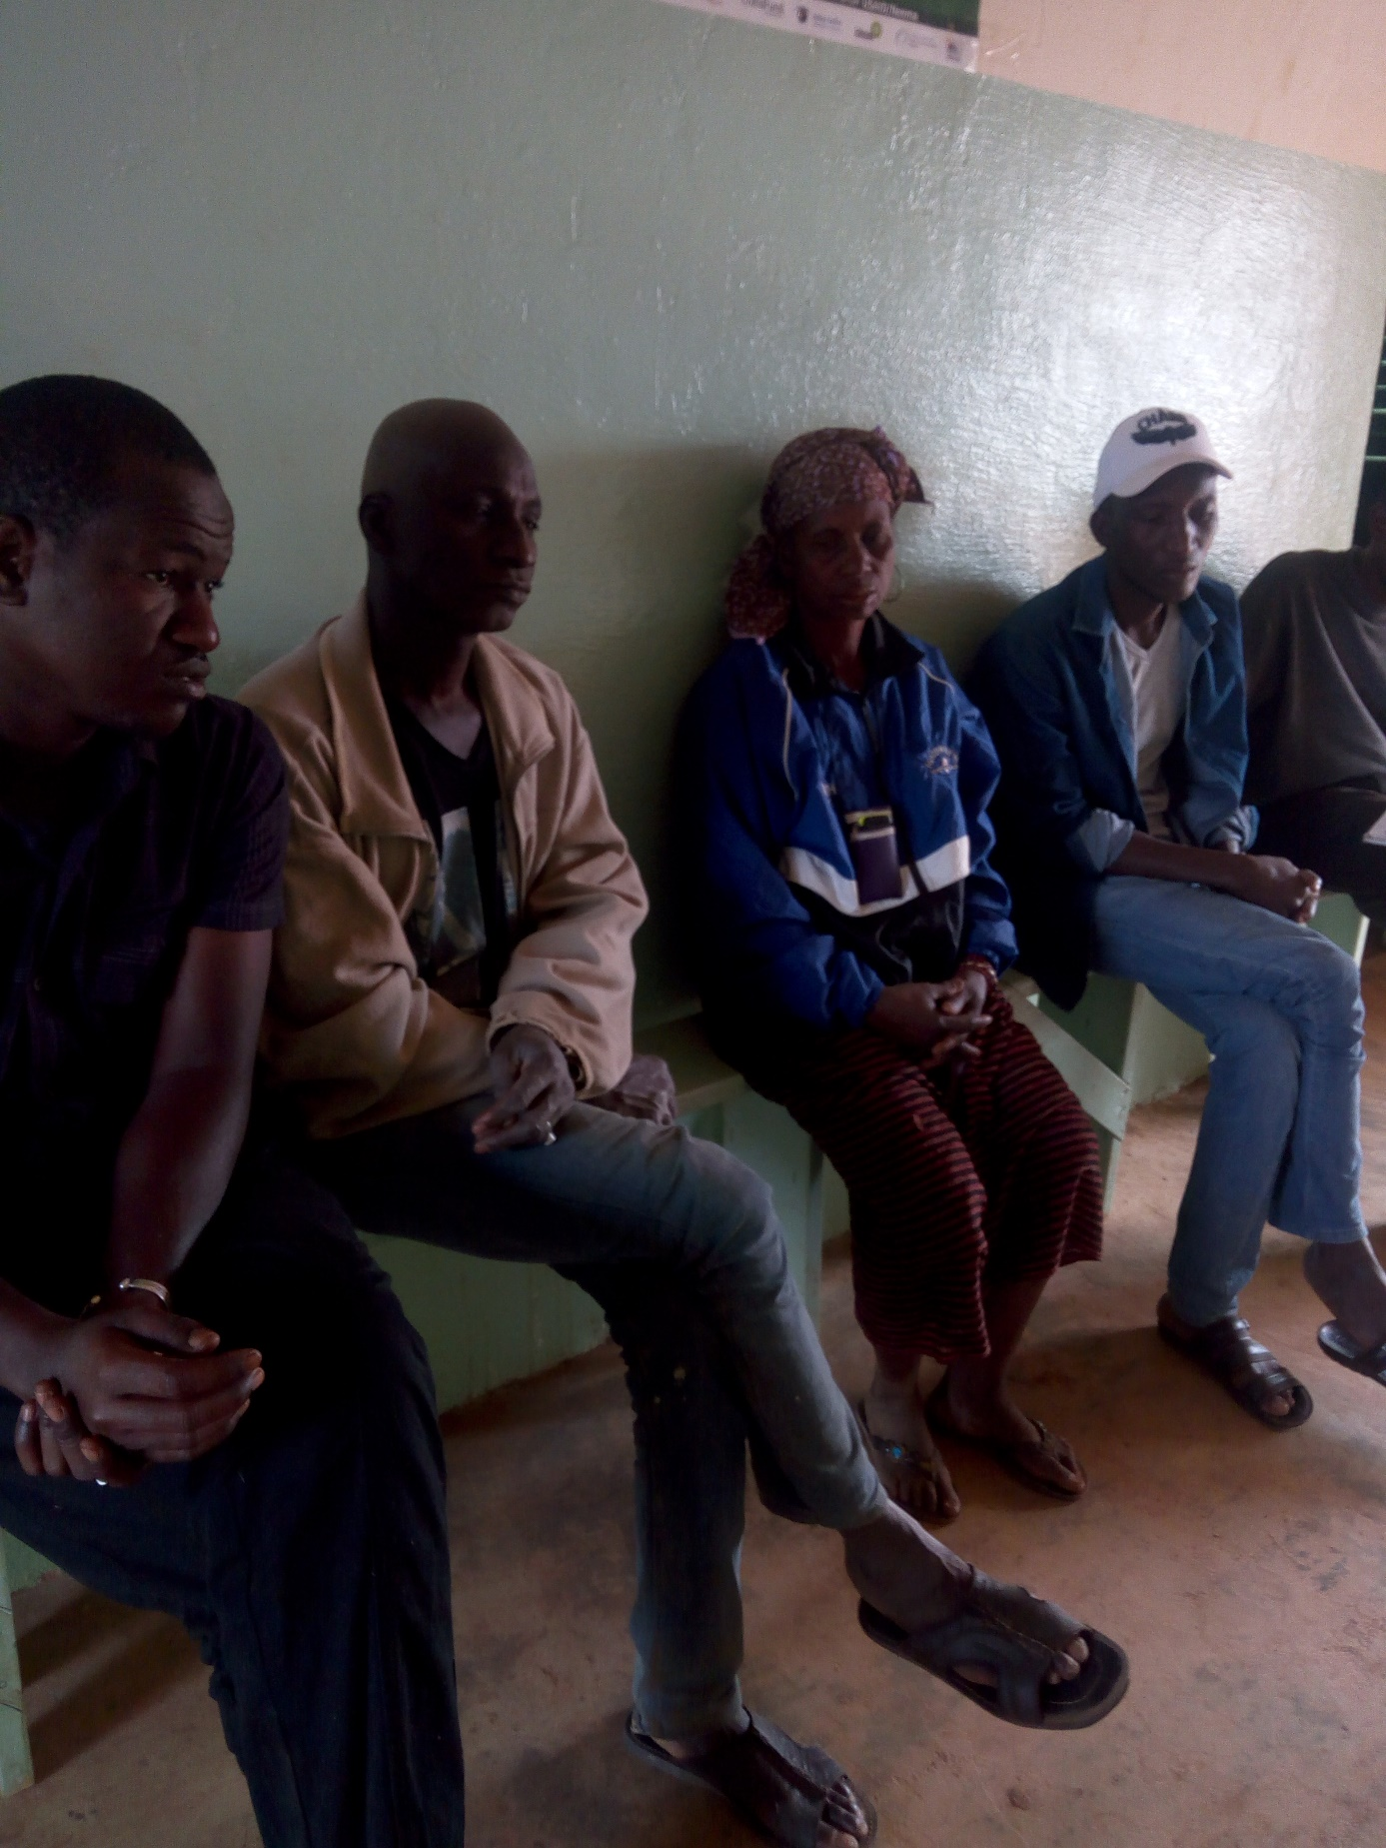
Participants learn about the negative health consequences of mercury use.

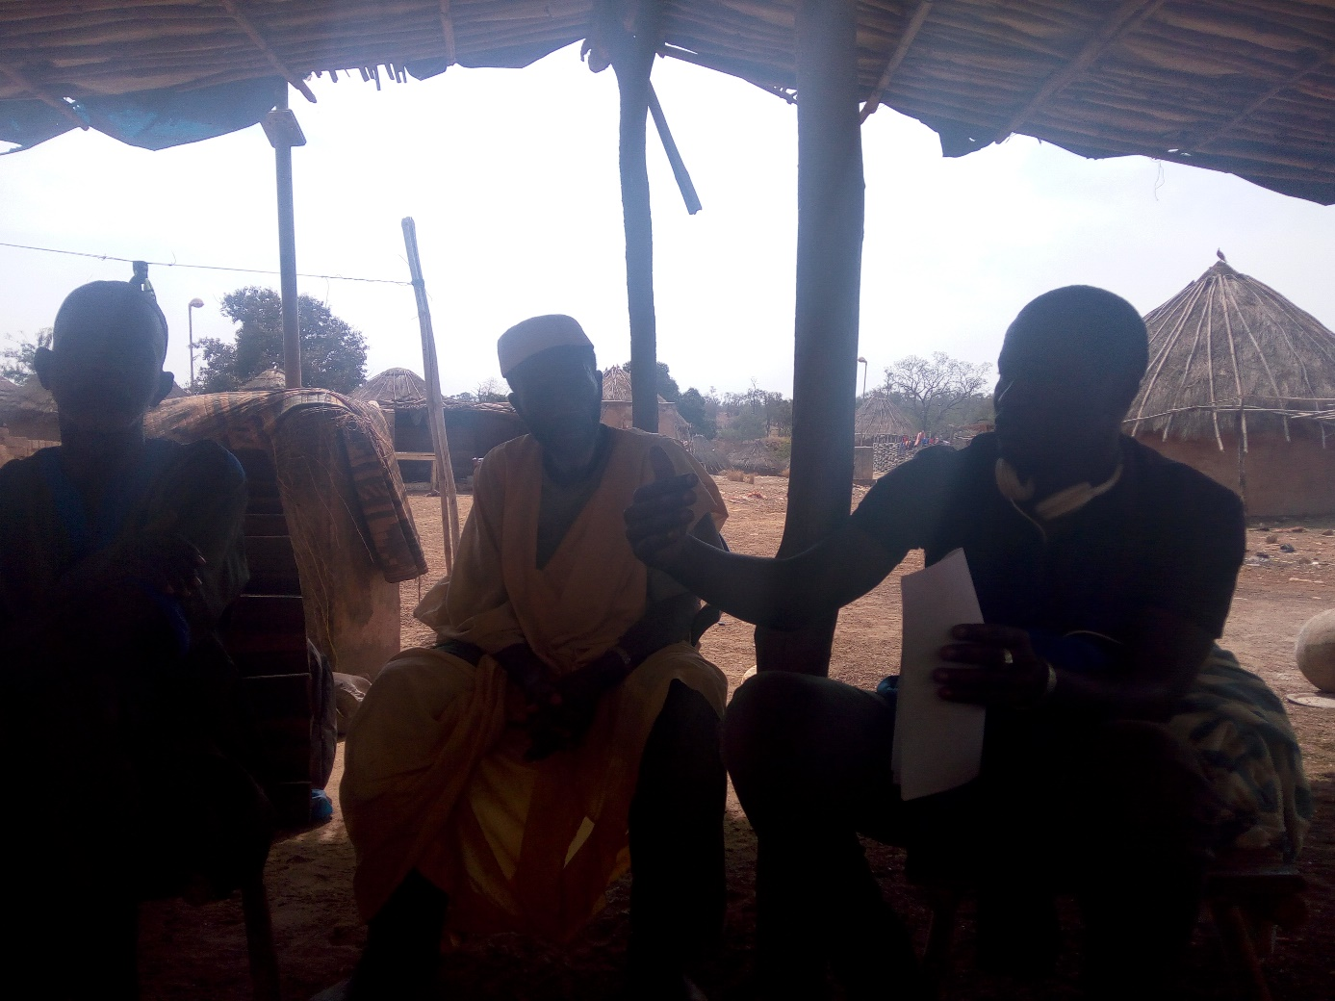
Falaye Danfakha explaining the dangers of mercury during a training.
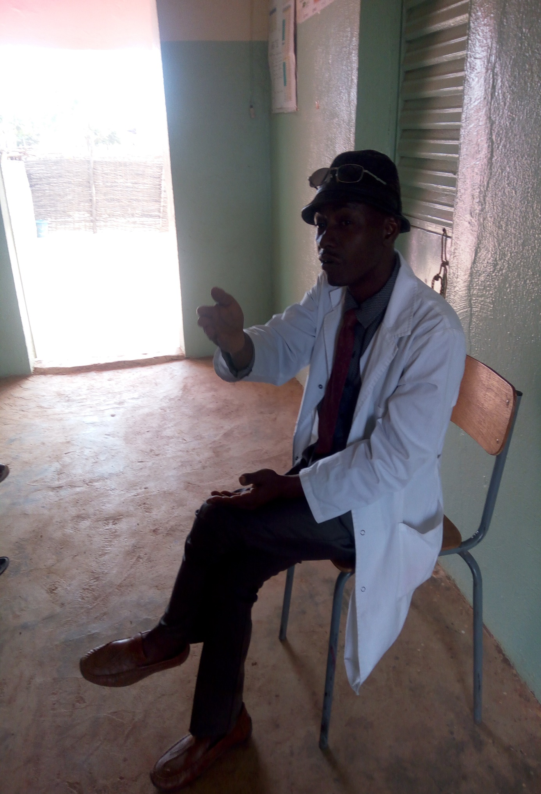
Tamba Cissokho explaining the harmful effects of mercury at the health post in Sambranbougou.
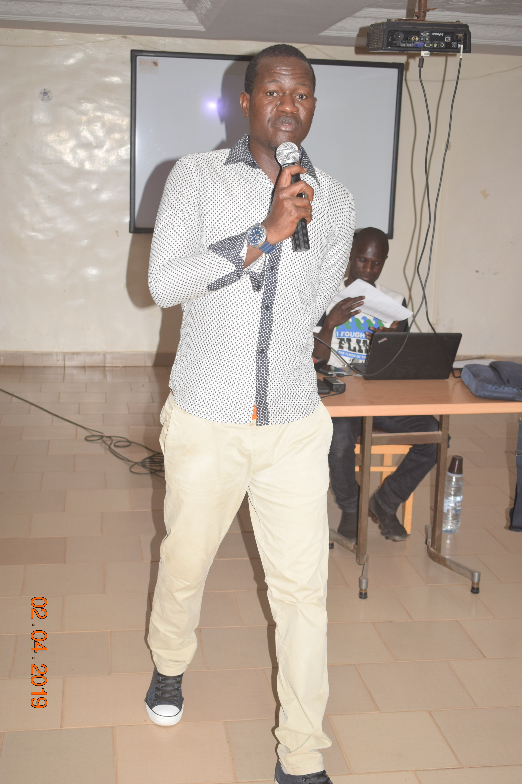
Falaye Danfakha explaining about roles and responsibilites

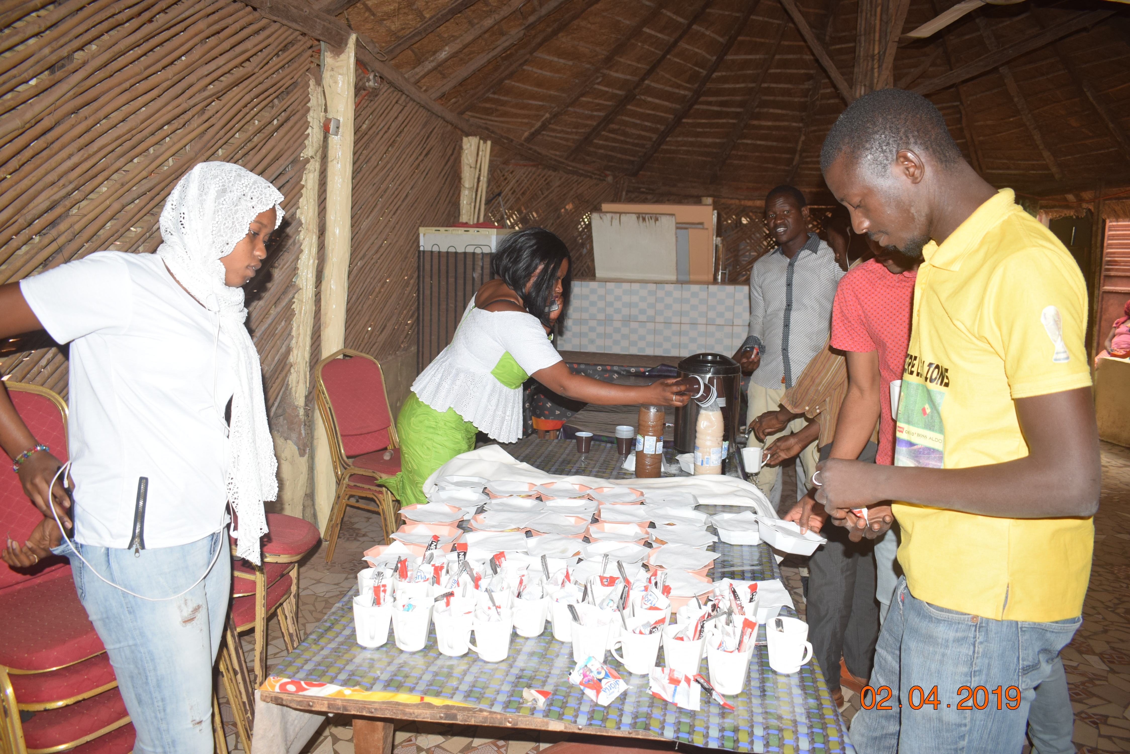
Break during training in Kedogou

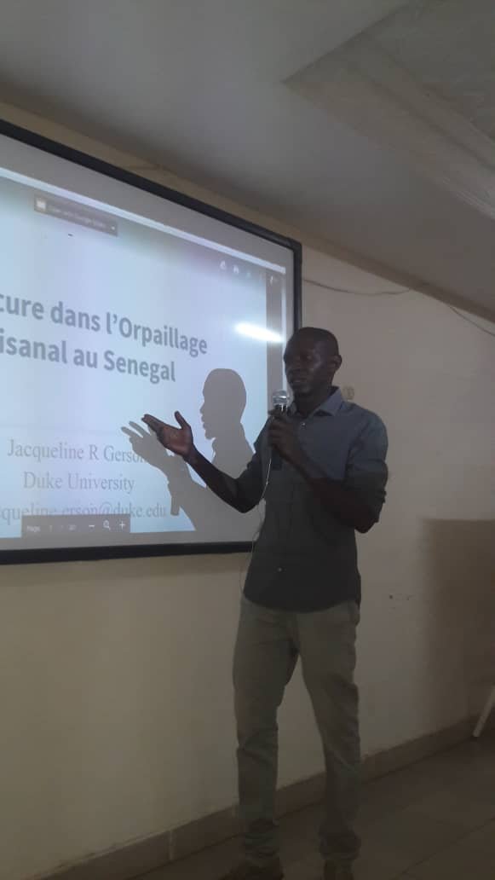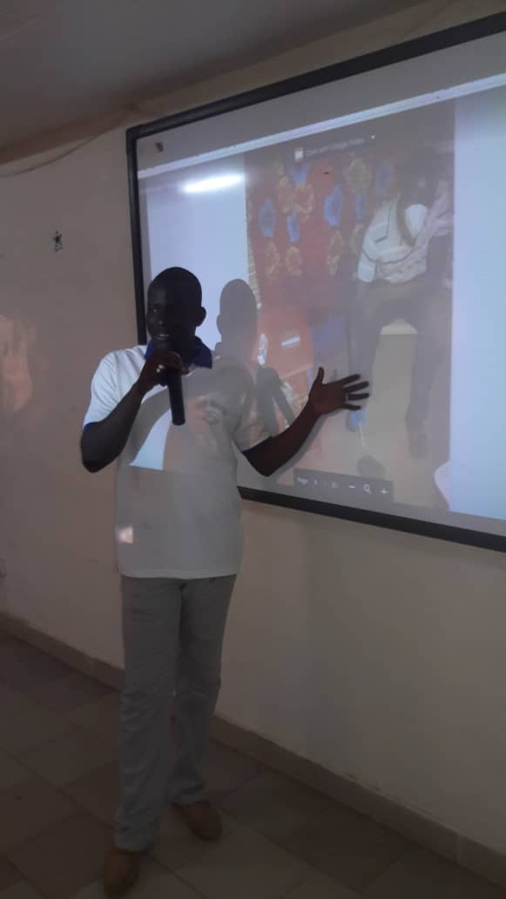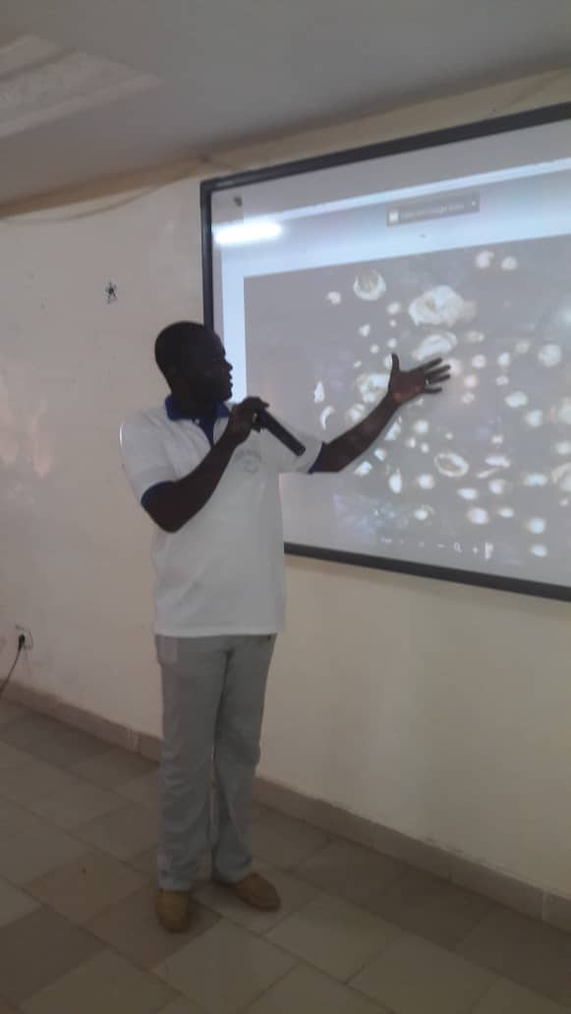
Explaining the dangers of mercury use in artisanal gold mining

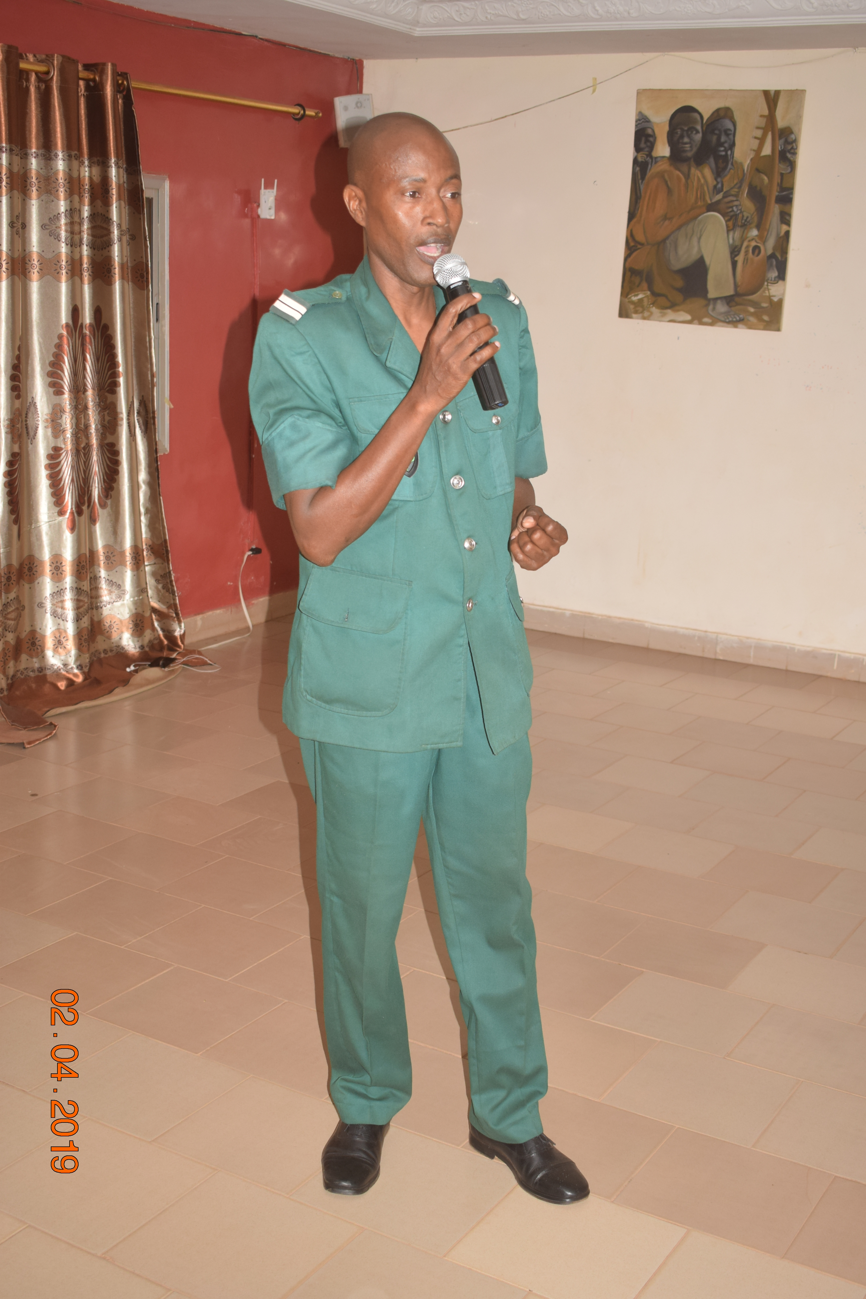
Lieutenant Sarr from Eaux et Forets discussing the impacts of deforestation

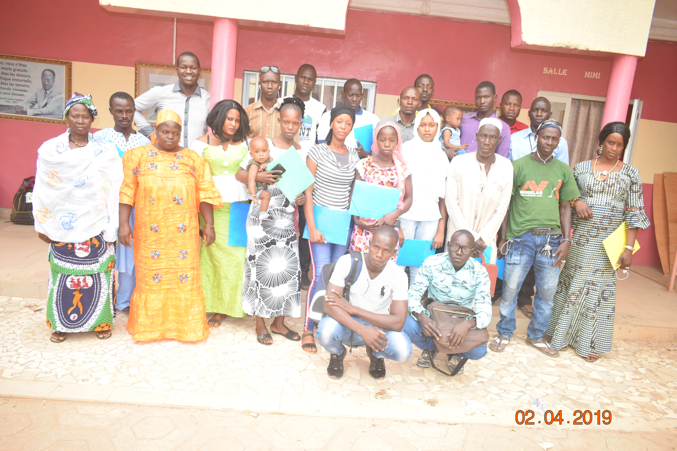
Training of trainers in Kedogou

