**Final Report Step 3 - Project Testimonials**

Instructions: This step is very important to us, as it helps us to identify successes and challenges as it relates to the participants themselves, in their own words. Please include testimonials from both men and women, and try to speak with people who might otherwise be marginalized or not heard. Include each person's first name, last name, gender, and age. If possible, please provide a photo of the person who gave the testimonial.

**Established Field Partner Testimonial #1:**

**What is the most significant change in your life since this project started?**



NAME:ELIZA WALALA

GENDER: FEMALE

AGE : 40

**Established Field Partner Testimonial #2:**

**How has this project impacted your relationship to the community and/or the participants?**



NAME : NALIE NEDI

GENDER: FEMALE

AGE: 38

**Local Leader Testimonial #1:**

**What is the most significant change in your life since this project started?**



NAME ; LASTON MALAYA

GENDER: MALE

AGE :50

**Local Leader Testimonial #2:**

**How has this project impacted your relationship to the community and/or the participants?**



**Participant #1 Testimonial:**

**What is the most significant change in your community since this project started?**



NAME : BLESSINGS MACHIRA

GENDER: MALE

AGE : 55

**Participant #2 Testimonial:**

**What is the most significant change in your family since this project started?**



NAME ; ESNARTH MATIKI

GENDER: FEMALE

AGE : 27

**Participant #3 Testimonial:**

**What is the most significant change in your life since this project started?**

*\*\*Photos and videos are incredible tools to help tell the story of your project. By sharing photos with World Connect, you are consenting to allow us to use your photos on our website and in print materials and that the subjects have passively consented to their image/likeness being used in this way. Please submit photos and/or videos with your progress report.*

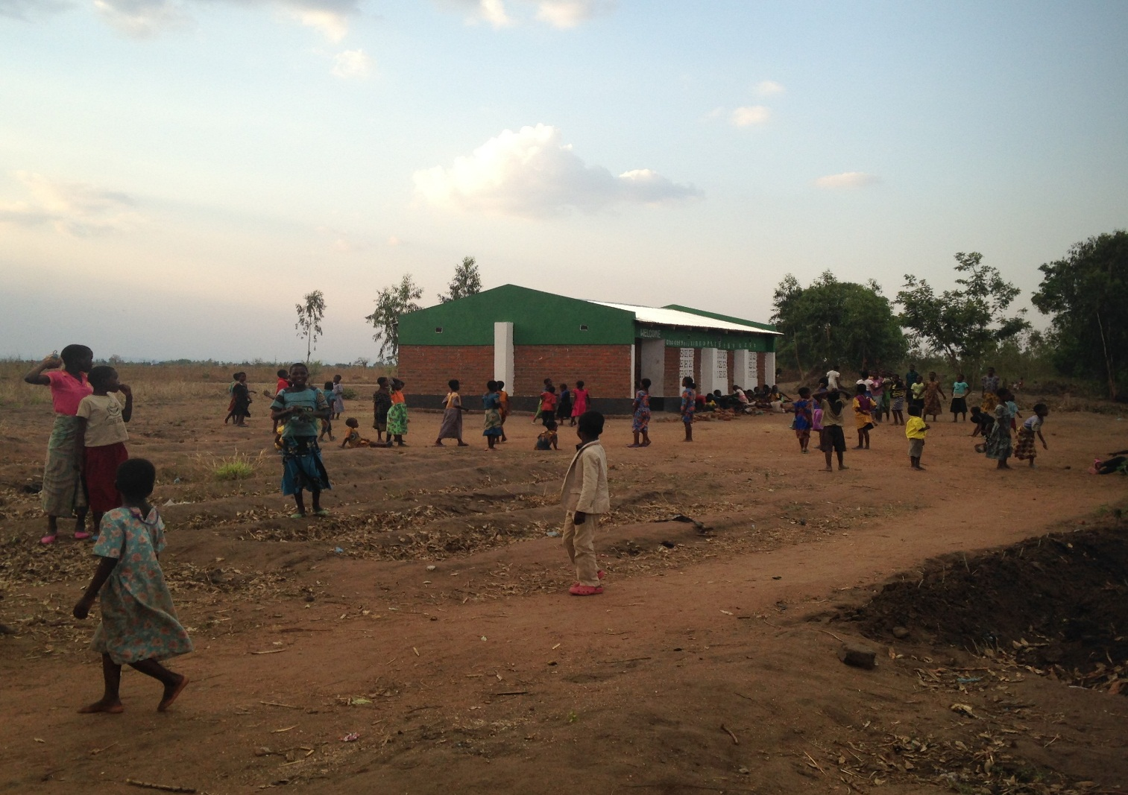

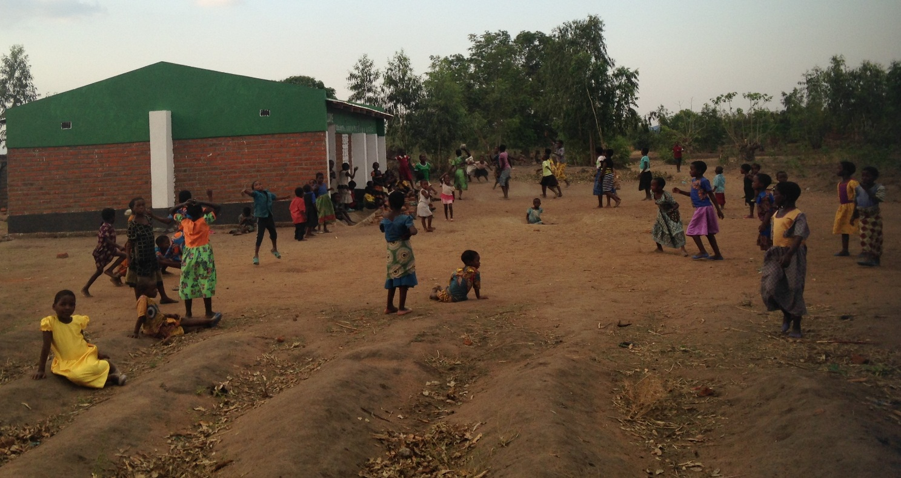

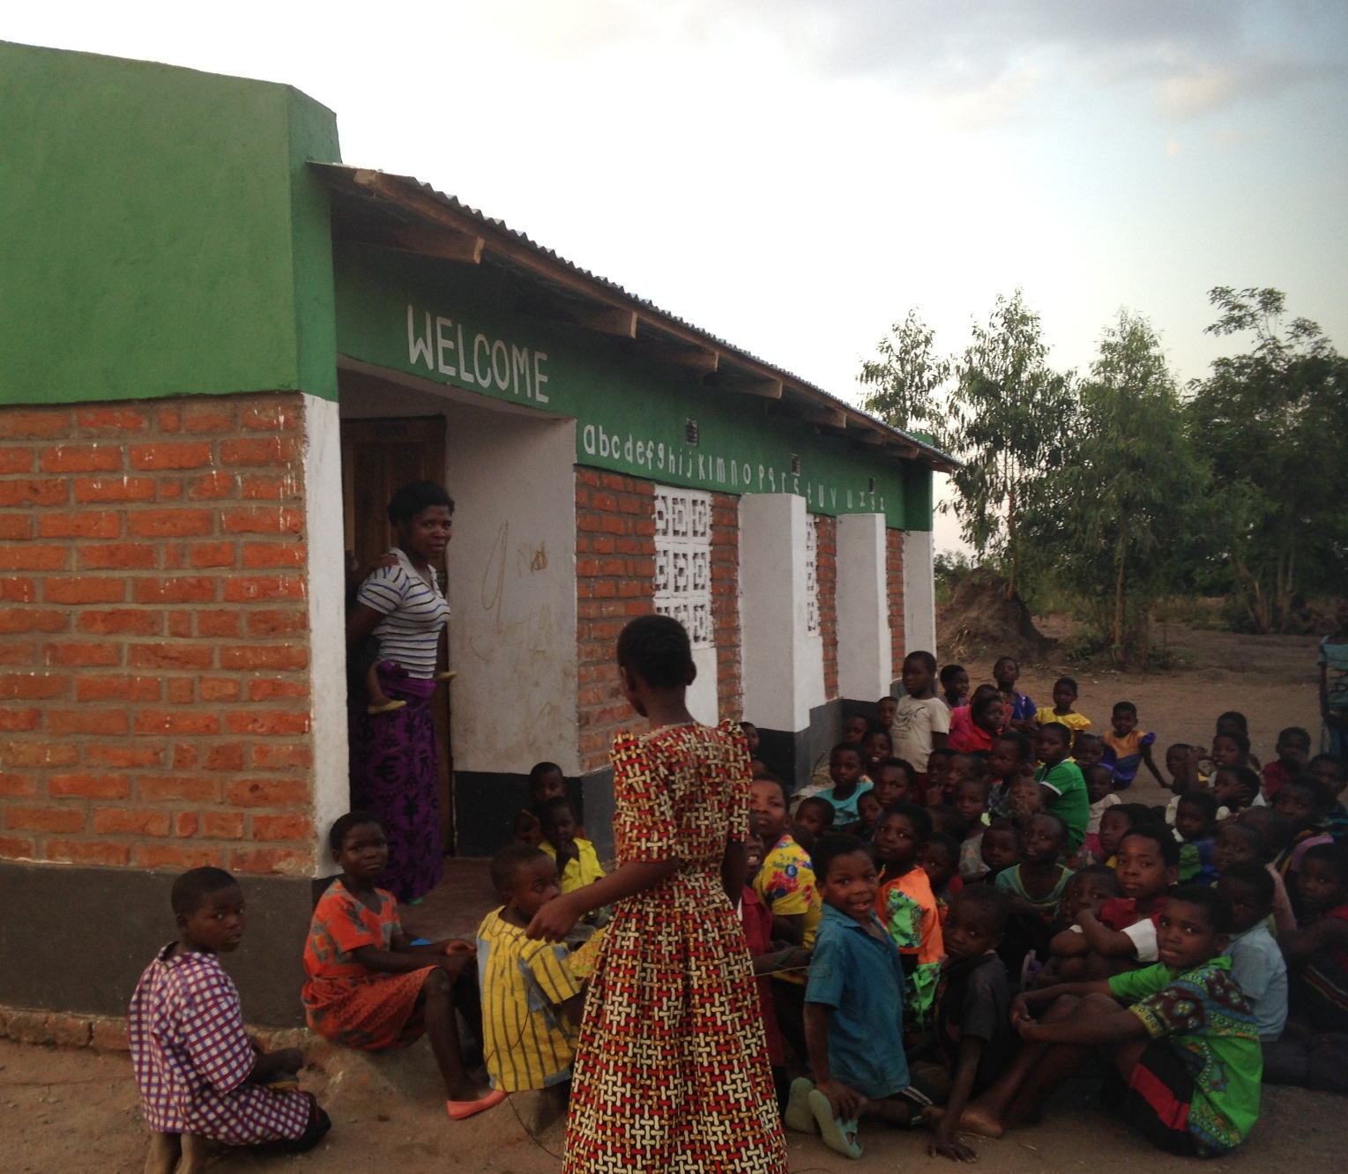

Videos of the handover ceremony

