**WOMEN ASPIRE NETWORK**

**RECEIPT**

Project: ___________________SHE THRIVES_________________________ Reference No. _

Activity: _____________________SEWING Account Code: _________

The amount of: (GHC)_______1000GHC-----------------------------------------

(amount in words)

As a **Cash Payment**  Cheque Transfer

For: ___________COST FOR LEARNING MATERIALS____________________________

**Received by:** ____________________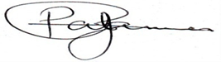___________

(signature)

Name: _____________________Araba Annan____________________-

Organisation/Individual: _______WAN______________________

Contact Number: _0244061507___________________________

Date: _30 th June,2023_______________________

***Prepared by: __________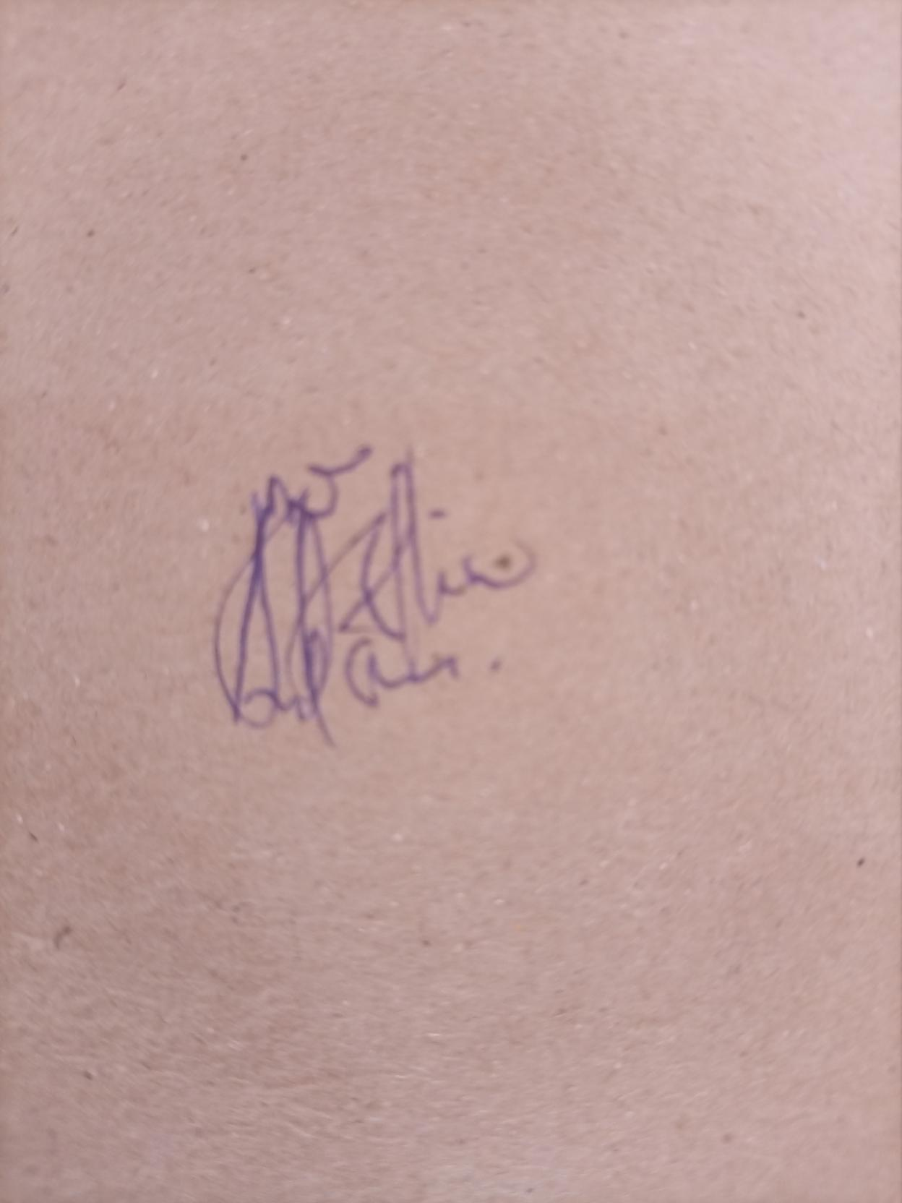_____________________________***

(signature)

Name: ____Michael Mireku____________________________________

Organisation/Individual: _________________WAN_________________

Date: __30th June.2023_________________________________________

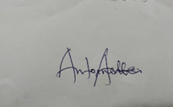

***Approved by:*** ___________________________________

(signature)

Name: ________Antoinette Annan______________

Organisation/Individual: _______WAN Board member_________________

Date: __30th June,2023_________________________________