**WOMEN ASPIRE NETWORK**

**RECEIPT**

Project: ___________________SHE THRIVES_________________________ Reference No. _

Activity: _____________________SEWING Account Code: _________

The amount of: (GHC)_______500GHC-----------------------------------------

(amount in words)

As a **Cash Payment** Cheque Transfer

For: ___________SESSION ON SUSTAINABILITY_____________________________________

**Received by:** ____________________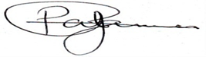___________

(signature)

Name: _____________________Araba Annan____________________-

Organisation/Individual: _______WAN______________________

Contact Number: _024406507___________________________

Date: _May 19th 2023___________________________

***Prepared by: __________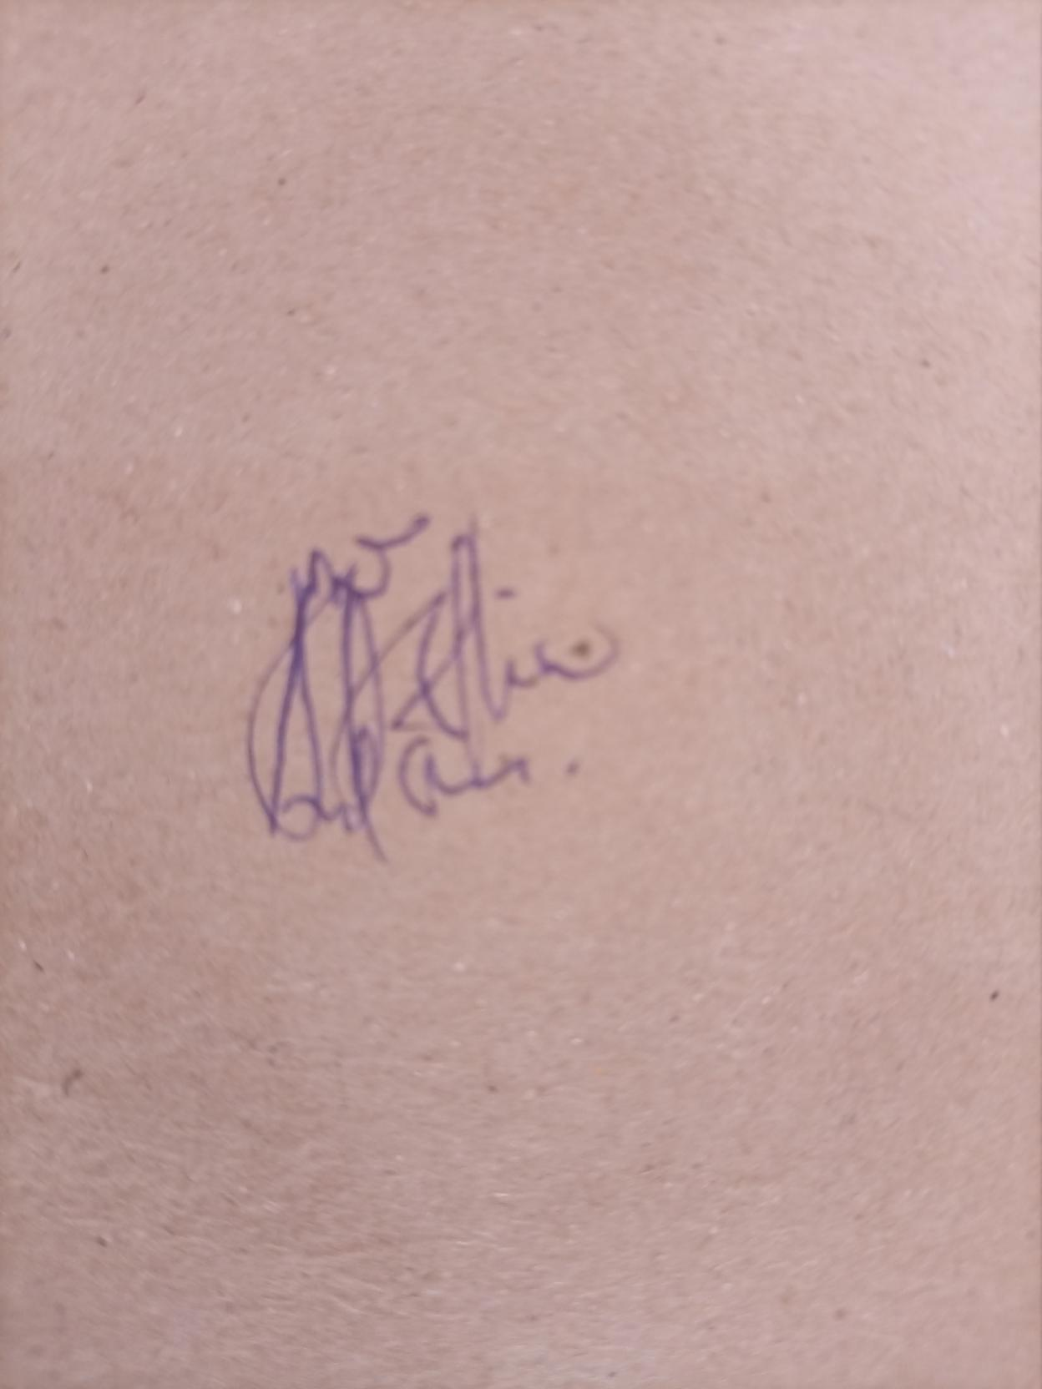_____________________________***

(signature)

Name: ____Michael Mireku____________________________________

Organisation/Individual: _________________WAN_________________

Date: ____ May 17Th 2023_________________________

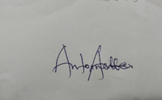

***Approved by:*** ___________________________________

(signature)

Name: ______Antoinette Annan__________________

Organisation/Individual: _______Board member_________________

Date: ____ May 19th2023_____________________________________