Verwendungsnachweis
Proof of Employment of Funds

zum
relating to the

Zuwendungsvertrag vom  Agreement dated | 7th October 2024
Projektträger  Project executing agency: | TUJYANEMO HDVC
Zuwendungsbetrag:
Amount of the allocation:31,910,000
Projekttitel:
Project title:

Transforming Lives of Vulnerable Children through Nutrition-Responsive Agriculture Interventions and Economic Empowerment of Women

A. Sachbericht
A. Final Report

Darstellung der Durchführung der Arbeiten oder Aufgaben, ihres Erfolges und ihrer Auswirkungen auf die Lebensumstände der lokalen Bevölkerung /
Description of the work or services performed, the results achieved and their impact on the local population

1. Description of Work and Services Performed
The project focused on nutrition-responsive agriculture, economic empowerment, and therapy services for children with disabilities. The following key activities were successfully carried out:

1.1. Training and Capacity Building
- 200 households were trained in permagarden techniques and nutrition-responsive agriculture to improve food security. 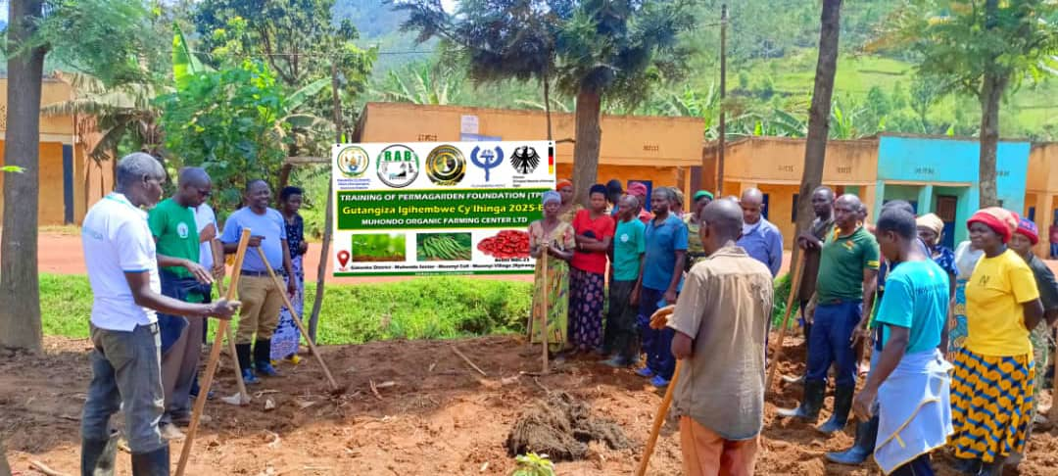
- Women received training in permagarden techniques and were given the opportunity to apply their knowledge by establishing gardens at home. This initiative aimed to enhance their agricultural skills, improve household nutrition, and create a sustainable source of income. By equipping families raising children with disabilities with practical solutions for food security and economic empowerment, the program contributed to their overall well-being while fostering resilience within the community.
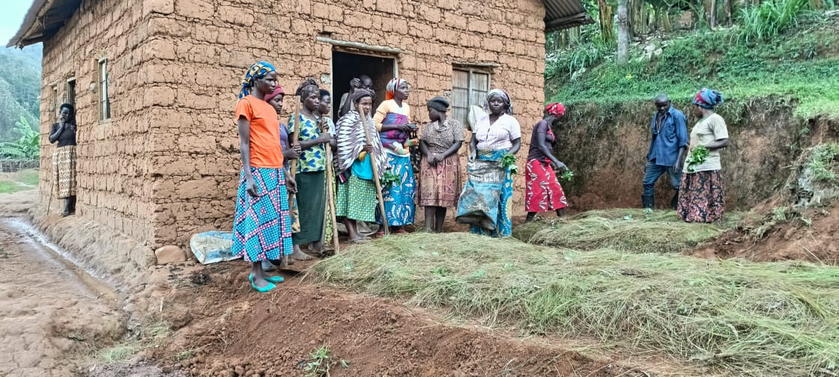

- 30 women received training in entrepreneurship, financial literacy, and cooperative formation to strengthen their economic independence.
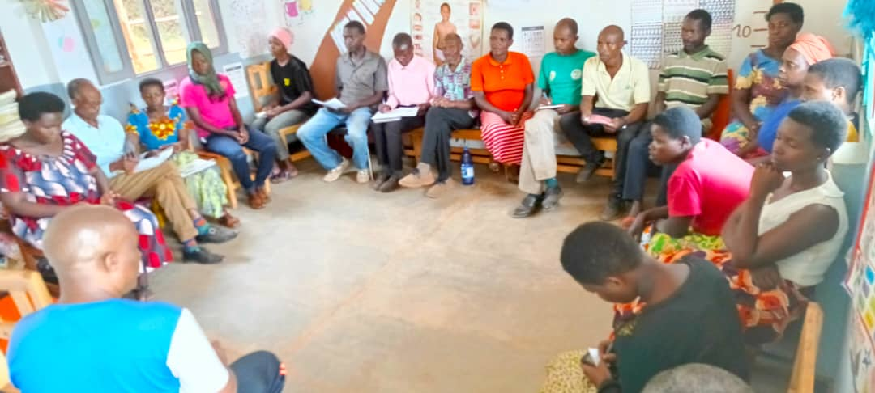

Women successfully established cooperatives in both Huro and Kabuga, enabling them to collaborate, share resources, and strengthen their economic activities. These cooperatives provide a platform for mutual support, capacity building, and sustainable income generation, empowering families especially those raising children with disabilities to improve their livelihoods and overall well-being.

1.2. Provision of Resources and Infrastructure Development
- 10 sewing machines were procured and distributed to trained women to support their income-generating activities.
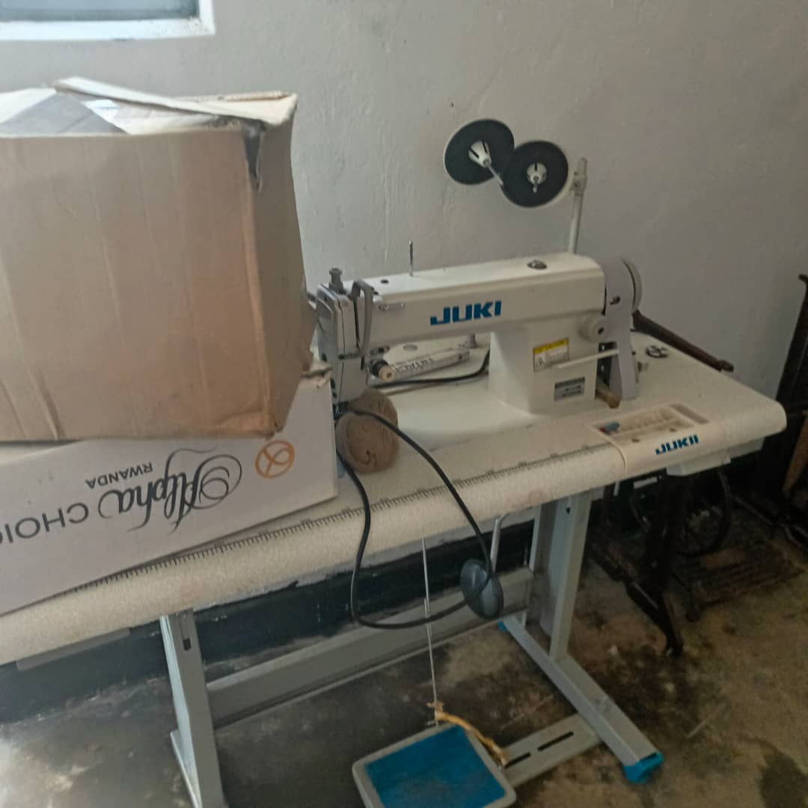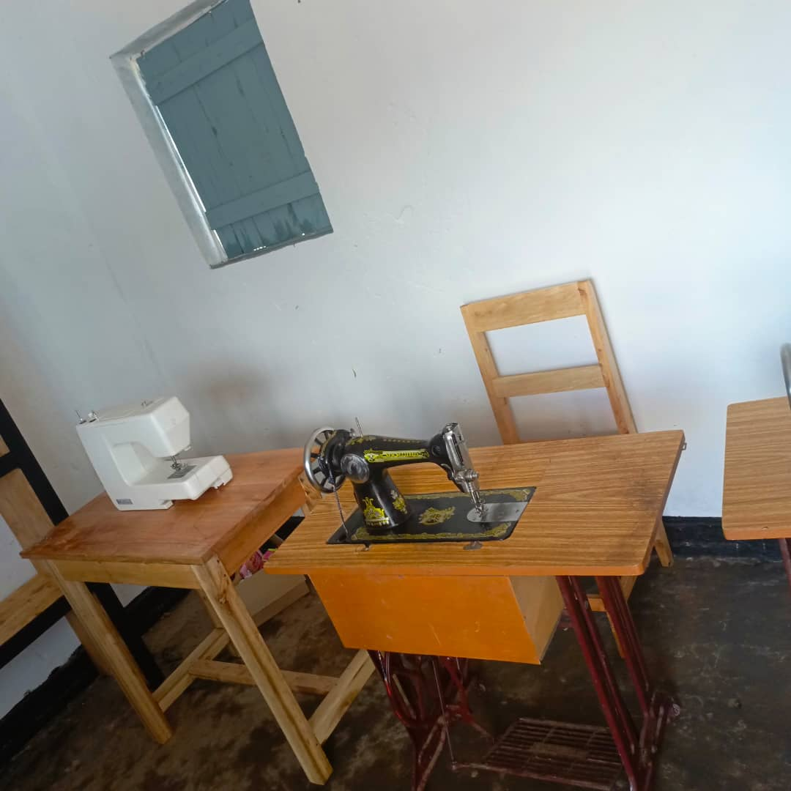
Women received training in sewing, equipping them with valuable skills that have enabled them to secure work and generate income. With their newfound expertise, they can now produce and sell various textile products, improving their financial stability and contributing to their families' well-being. This initiative has not only empowered them economically but also fostered self-reliance and community development.
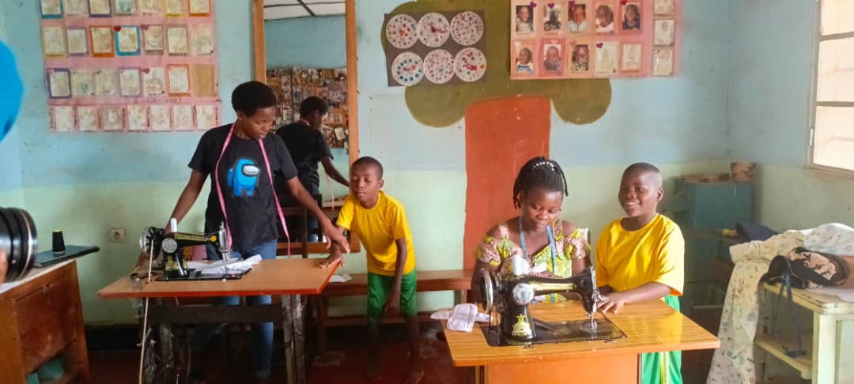
- A milling machine was purchased and installed, producing fortified flour for the community to improve child nutrition.
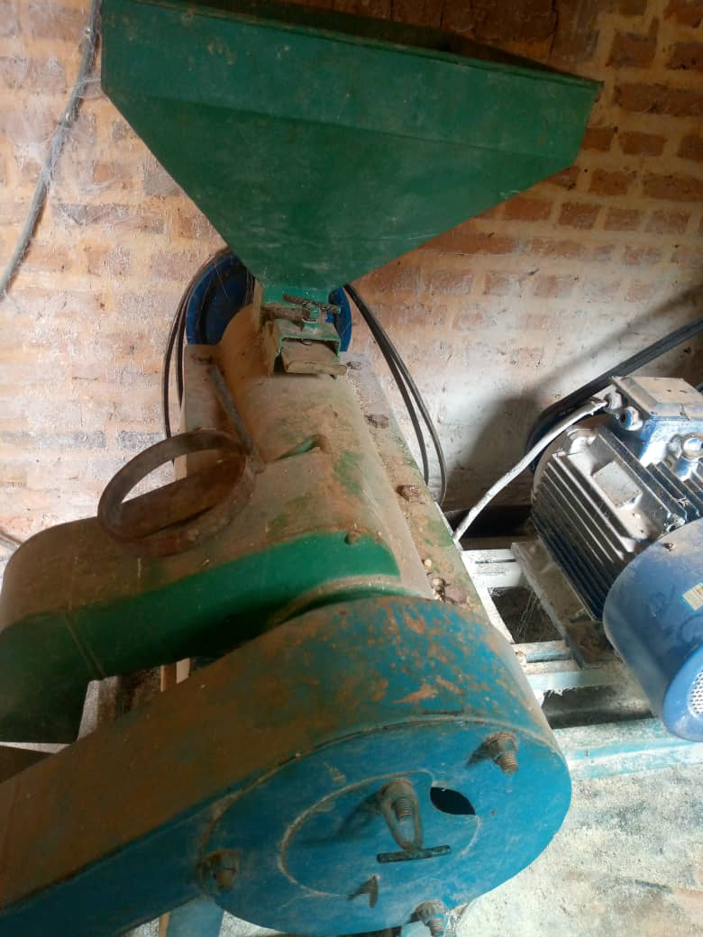

- Two therapy rooms are currently at the final stage of construction, with all materials available for completion. These rooms will provide essential rehabilitation services for children with disabilities.
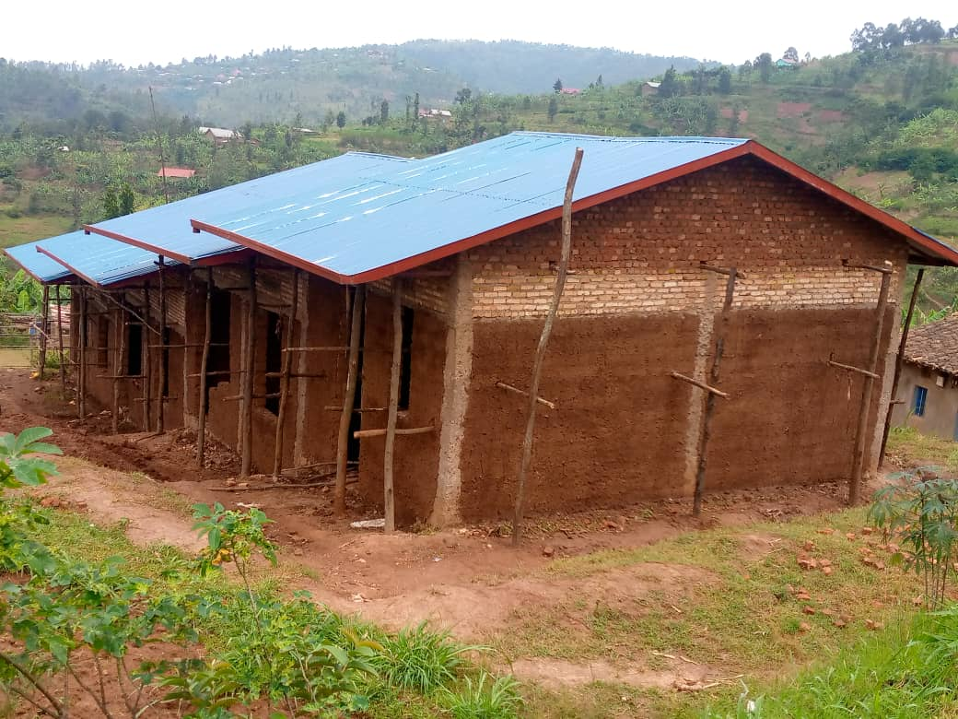

2. Results Achieved

2.1. Improved Household Nutrition and Food Security
Households successfully adopted permagarden techniques, growing diverse and nutrient-rich crops.
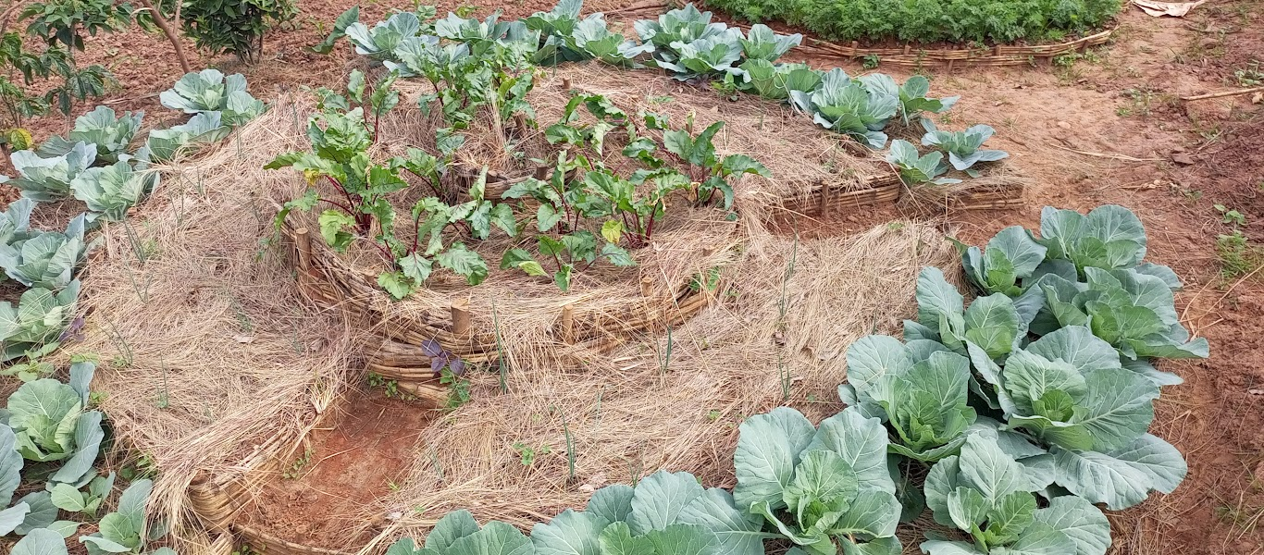
Families reported better access to fresh vegetables and improved dietary diversity.
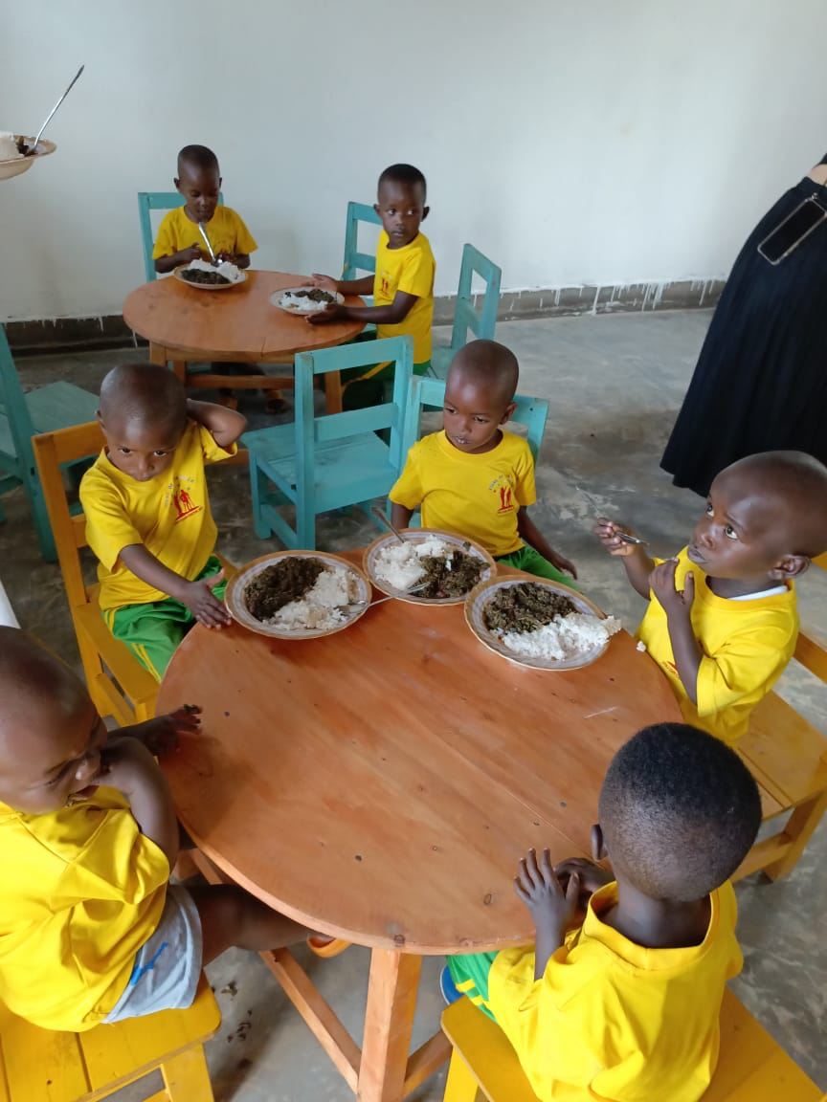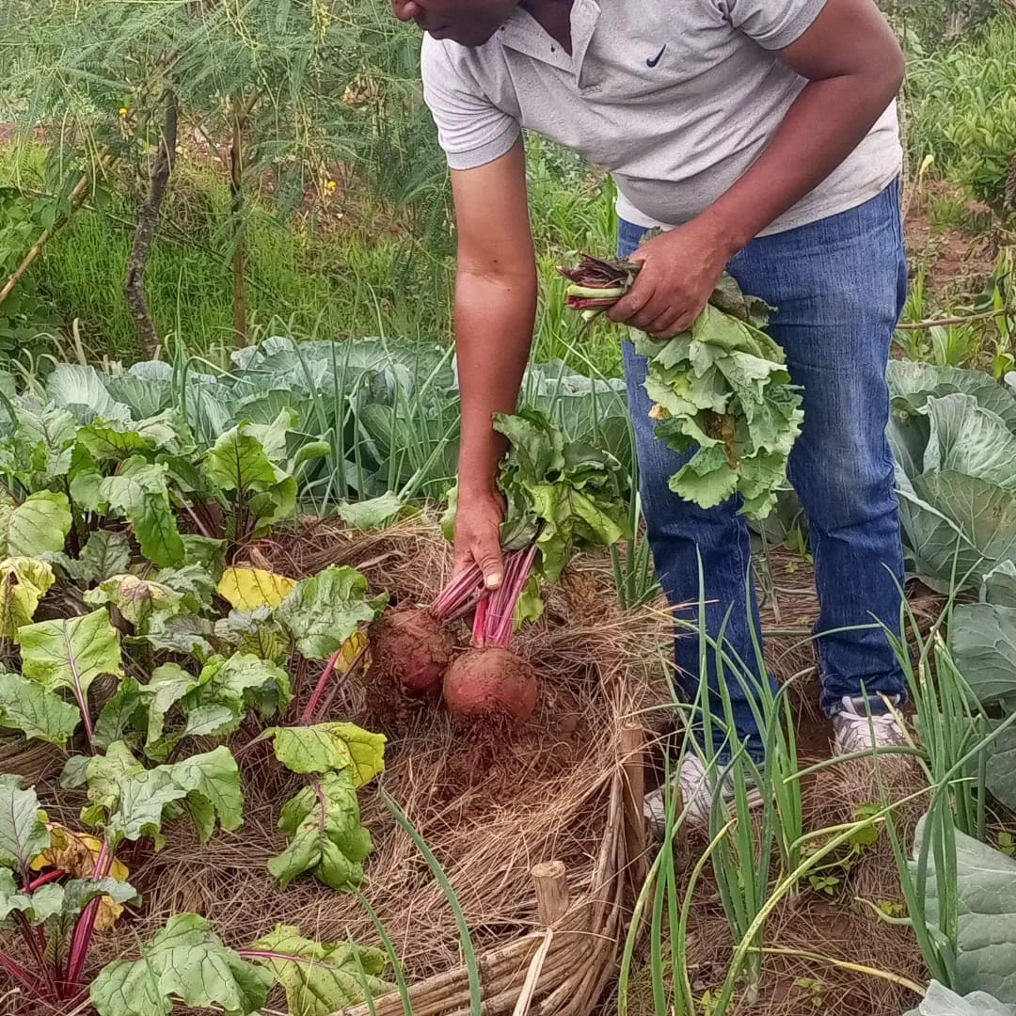

The milling machine has enhanced food availability and provided fortified flour, improving nutrition for children and pregnant women.
The milling machine has significantly improved food security by increasing the availability of essential grains and producing fortified flour, which plays a crucial role in enhancing nutrition, particularly for children and pregnant women. By providing access to nutrient-rich flour, the machine helps combat malnutrition and supports healthy growth and development. Additionally, it reduces the burden on families who previously had to rely on expensive or less nutritious alternatives, making a tangible impact on community well-being. This initiative not only promotes better health outcomes but also fosters economic opportunities by supporting local farmers and small-scale food processors.

2.2. Economic Empowerment of Women
Two savings groups were formed, helping women manage finances and invest in small businesses.In both Kabuga and Huro, women came together to form two savings groups, creating a supportive space where they can manage their finances, save for the future, and invest in small businesses. These groups have become more than just financial initiatives they serve as a source of empowerment, trust, and solidarity among members. Women who once struggled to access capital can now borrow from their collective savings to start or expand businesses, support their families, and handle emergencies with greater confidence. Beyond financial

benefits, the groups have fostered a strong sense of community, where women encourage and uplift one another, proving that economic empowerment goes hand in hand with social support and resilience.
Sewing machines enabled women to earn a stable income by producing garments for sale.
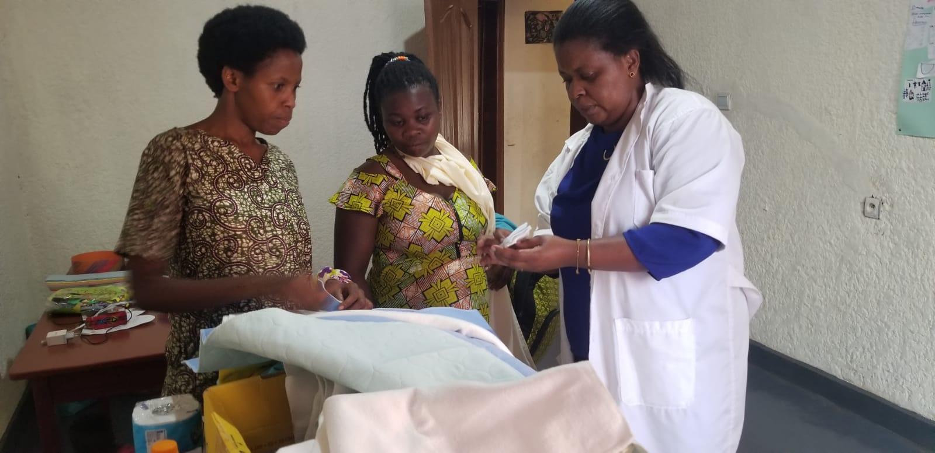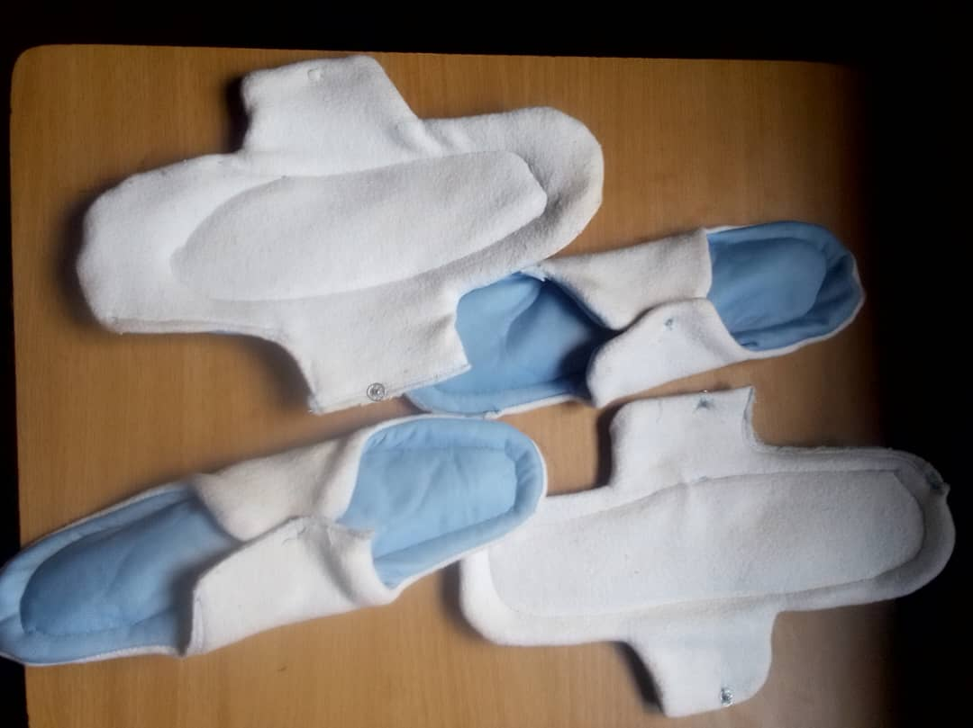
Sewing machines have provided women with the opportunity to earn a stable income by producing and selling garments, transforming their skills into a sustainable livelihood. With access to these machines, they can create clothing, school uniforms, and other textile products, meeting local market demands while improving their financial independence. Beyond income generation, this initiative has boosted their confidence, strengthened their role in the community, and empowered them to support their families more effectively. By turning sewing into a viable business, these women are not only securing their own futures but also contributing to the local economy.

2.3. Strengthening Therapy Services for Children with Disabilities
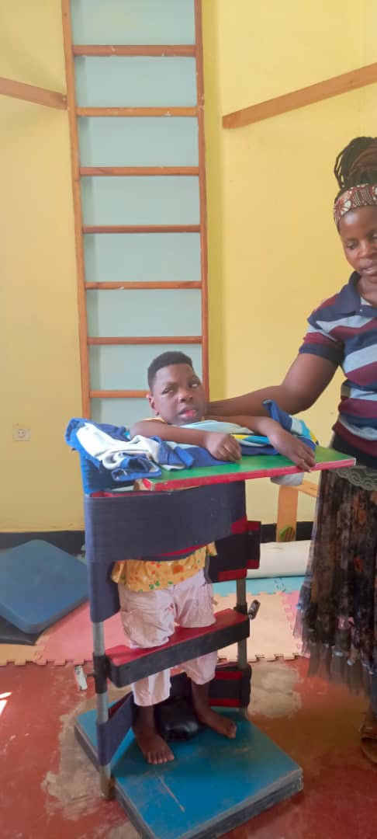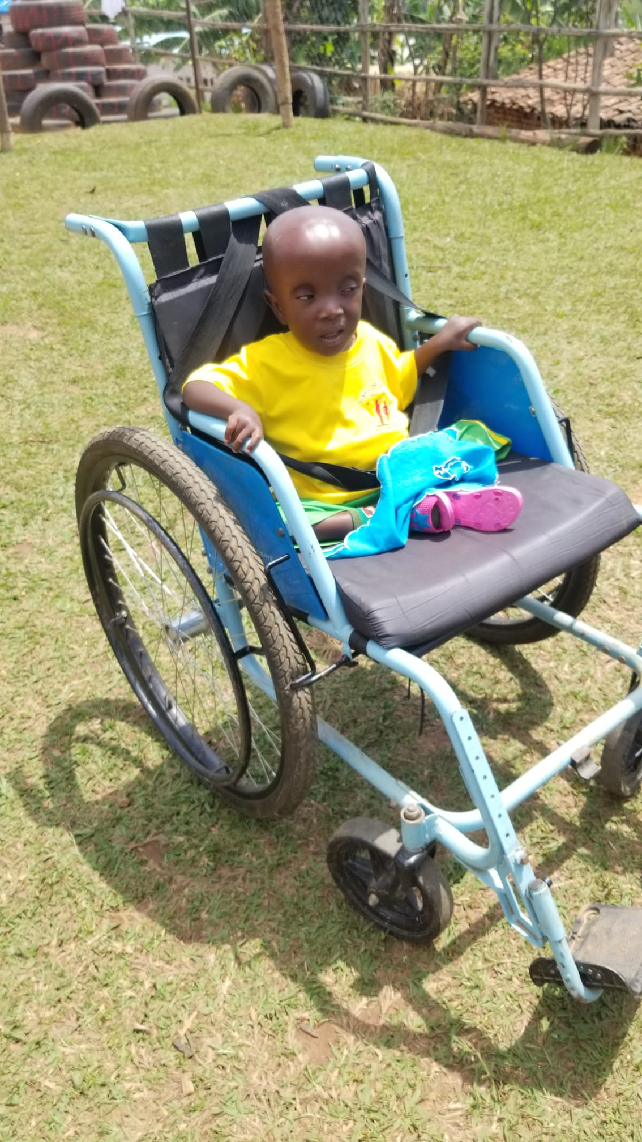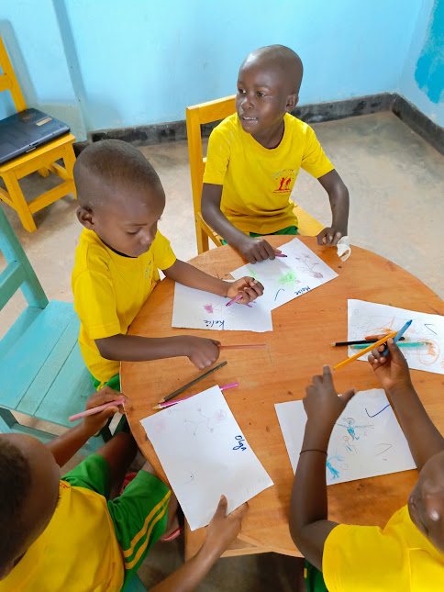

Parents have actively participated in awareness sessions highlighting the importance of therapy and rehabilitation for children with disabilities. These sessions have helped them understand how early intervention and consistent rehabilitation can improve their children's mobility, independence, and overall quality of life. By equipping parents with knowledge and practical strategies, they are now more empowered to support their children’s development and advocate for their needs. Additionally, these sessions have fostered a sense of community among parents, allowing them to share experiences, support one another, and work together toward creating a more inclusive and supportive environment for their children.

3. Impact on the Local Population

3.1. Sustainable Food Security and Health
Families now have a reliable source of food, reducing malnutrition and dependency on external aid.
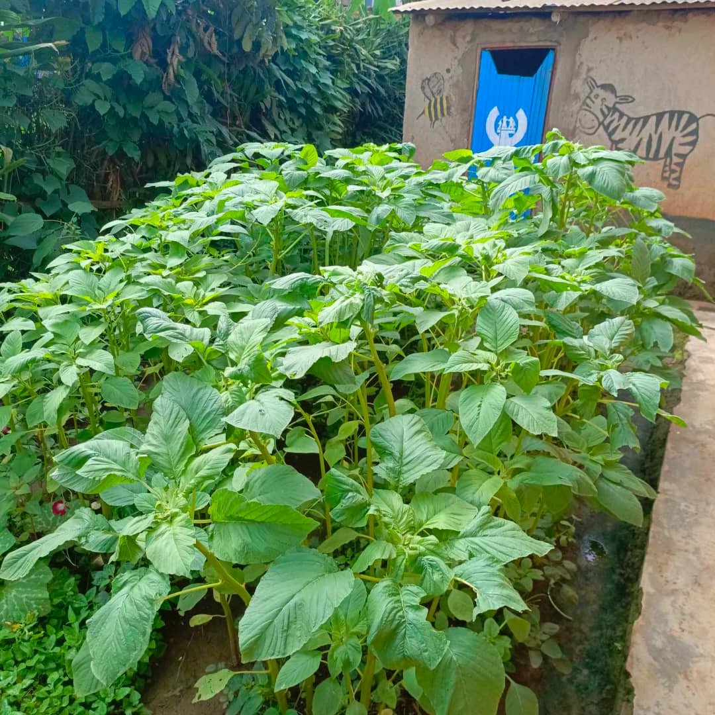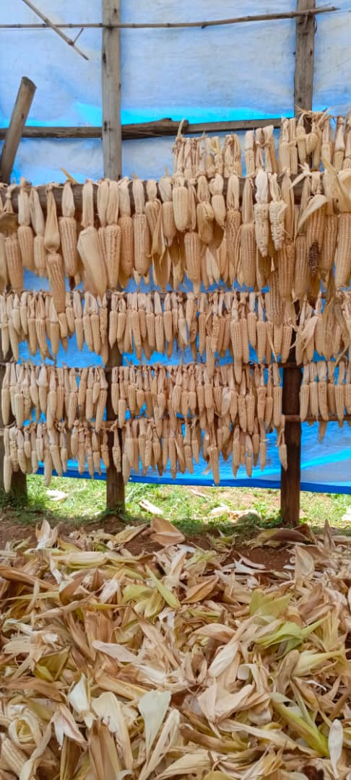
Community members are using sustainable agriculture techniques, ensuring long-term food production.

3.2. Improved Prospects for Children with Disabilities
Once therapy rooms are finalized, over 50 children will receive regular therapy services, improving their mobility and independence.
Families are now more aware of rehabilitation needs, ensuring children get proper care.

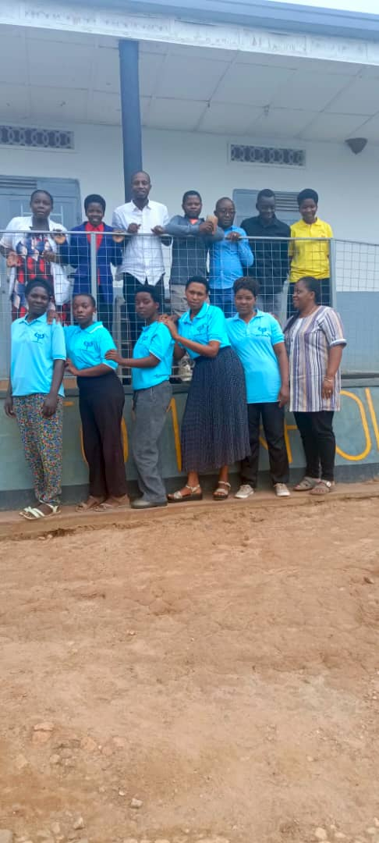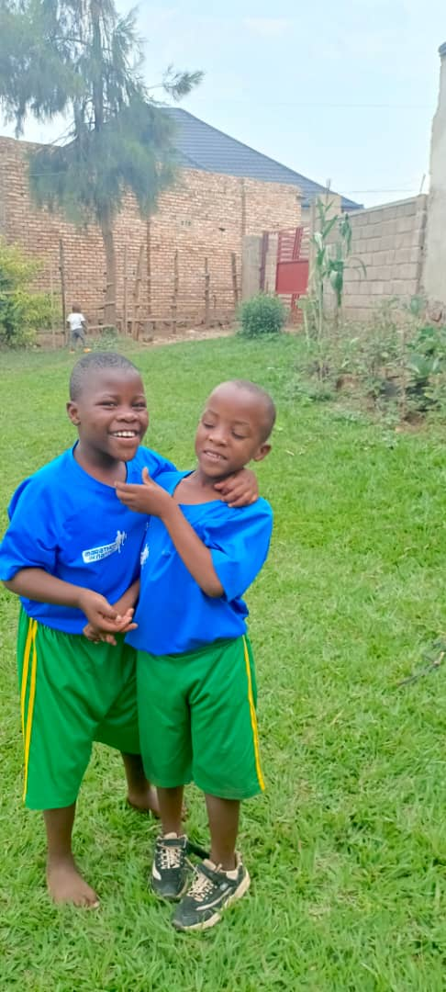

B. Aufstellung der Belege
B. List of invoices

1. | Einnahmen  Receipts | Euro / Landeswährung  Euro/local currency
1.1 | Zuwendung des Auswärtigen Amts  Allocation from the Federal Foreign Office | TUJYANEMO HDVC
1.2 | Sonstige Einnahmen  Other receipts
1.3 | Eigenmittel  Own funds | In kinds
 | Summe der Einnahmen  Total receipts | 31,910,000
2. | Ausgaben  Expenditures | 31,910,000
3. | Bestand / Mehrausgaben  Balance/additional expenditures | 0

Es wird bestätigt, daß die Zuwendung dem Vertrag entsprechend für das beantragte Projekt verwendet wurde und daß das Projekt wirtschaftlich und sparsam durchgeführt wurde.

It is hereby confirmed that the allocation was used for the project in accordance with the Agreement and that the project was carried out without undue expenditure.

Kigali | ,
Christine MUKESHIMANA

Unterschrift des Projektträgers
(signature project executing agency representative)

Ernest KARAGIRE

Unterschrift eines zweiten Projektverantwortlichen
(signature second project executing agency representative)

1 | 2 | 3 | 4 | 5 | 6 | 7
Lfd. Nr. des Belegs  Serial No. of invoice | Tag der Zahlung  Date of payment | Empfänger  Recipient | Grund der Zahlung  Purpose of payment | Einnahmen  Receipts  local currency | Ausgaben  Expenditures  local currency | Vermerke  Remarks
No 26 | 20/12/2024 | Muhondo Organic farming Center | Permagarden training and entrepreneurship | 4,100,000 | 4,100,,000 | Paid
No 0300 | 12/12/2024 | Buen Hardware tore co.ltd | Construction materials | 13,709,500 | 13,709,500 | Paid
No 015 | 8/12/2024 | Rambe Hardware LTD | Sewing machines, installation and transport to Huro and Kabuga | 1,500,000 | 1,500,000 | Paid
No 0260 | 8/12/2024 | AMANI STEEL | Milling machine ,installation of electric power of 3phases | 8,000,000 | 8,000,000 | Paid
No 4 | 14/01/2025 | Bizimana Andre and Habiyaremye Jean Baptiste | Engineer,labor and manpower, | 4,600,500 | 4,600,500 | Paid
Total |  |  |  |  | 31,910,000

