Latrine Project

PCV: Faith Umoh

Village: Keur Katim Diama

In the beginning of June 2015, my local counterparts, the Associate Peace Corps Director (APCD) Mamadou Diaw, and I met together to determine the final projects of my service. During this meeting, we all agreed that the community priority was to construct latrines. Currently the first phase of this project, which was to conduct a baseline survey, has been completed. There will be a total of three phases. The second phase will consist of community mobilization and sensitization through the WASH Voucher system. The third phase will be the construction of the latrines. Once the three phases are completed our goal is to see improvement in the sanitary conditions of the community by providing everyone in Keur Katim with a latrine.

**PHASE I**

*HE 045 Conducting Baseline Water and Sanitation Survey*

**METHODOLOGY**

The USAID Maternal and Child Health Integrated Program MCHIP 2005 “Household and Water and Sanitation” model was used to develop a baseline survey and also later translated into Wolof by myself with the assistance of Peace Corps Staff. Eleven questions/observations were chosen for the baseline survey. Each question/observation was paired with certain coding categories. The coding categories were chosen to help decrease the time used when conducting the surveys. A simple scantron was used to collect data. My counterpart and I went from compound to compound and spoke with the head of the house hold and the first wife. The questions that were focused on WASH and child care were answered by the mothers and the questions that were focused onlatrines were answered by the head of the household. The community members of Keur Katim were very open to participating in the survey. In one week, my counterpart and I surveyed 51 households, which is more than two-thirds of my community. Out of the 51 households that we spoke to, only one family had a very well-constructed latrine that was 7m deep. Everyone else that we spoke to expressed interest in constructing a new latrine.

**RESULTS**

|  |  |
| --- | --- |
| 1. **Do you have soap in your household?** |  |
| Yes | No |
| 40/51 | 11/51 |

**Notes**: 78% of the community said they have soap in their household and 22% of the community said they do not have soap in their household. Towards the middle of the survey, I found it challenging to ask this question. Initially most of the mothers answered “No” to this question, possibly with the hopes of receiving a free bar of soap. However, when my counterpart asked a follow up question about whether or not they use soap for washing themselves and their clothes they then said “Yes”. This information is necessary to understand the current hygiene in the community. A solution for the 22% of the community who said they do not have soap in their household would be to introduce wood ash as a supplement to soap because wood ash is affluent in the homes and could produce a higher quantity.

|  |  |
| --- | --- |
| **Have you used soap today or yesterday?** | |
| Yes | No |
| 40/51 | 11/51 |

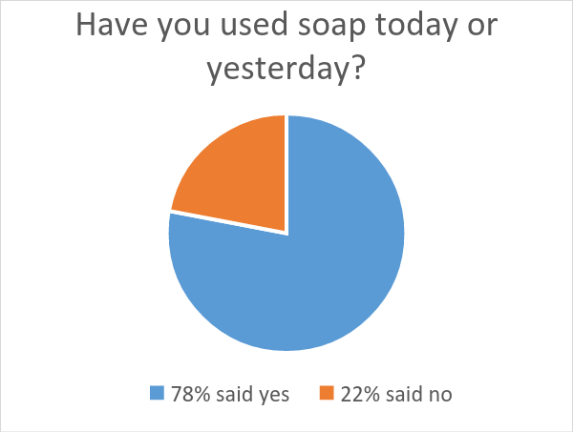

**Notes**: 78% of the community said they used soap today or yesterday and 22% of the community said they did not. It is important to know if the community members are using soap on a daily basis to understand their hygienic habits. The findings from the reportshowing that 22% of the community is not using soap on a daily basis is alarming. This information will be used for strategizing what topics to teach during the WASH formations.

|  |  |  |  |  |  |
| --- | --- | --- | --- | --- | --- |
| **When you used soap today, what did you use it for?** | | | | | |
| Washing clothes | Washing my body | Washing my children | Washing hands after defecating | Washing hands before preparing food | Other (washing dishes) |
| 44/51 | 36/51 | 29/51 | 3/51 | 1/51 | 33/51 |

**Notes:** 86% of the community reported using soap to wash their clothes. 71% of the community reported using soap to wash their body. 65% of the community reported using soap to wash dishes. 57% of the community reported using soap to wash their children. Only 6% of the community reported using soap after defecating. 1% of the community reported using soap before preparing food. Alarmingly, out of the 51 households, none of them reported using soap in the following areas: w*ashing hands before feeding children, washing hands after cleaning their child, washing hands before eating.* Only three people reported to have washed their hands after using the restroom. This information is very helpful as we enter into the next phase of the latrine project. There will need to be a heavy emphasis on these areas during the sensitization formations.

|  |  |  |  |  |
| --- | --- | --- | --- | --- |
| **When your child passed stool, where did he/she defecate?** | | | | |
| Used sanitary facility | Used potty | Went outside the premises | Went in his/her clothes | In the fields |
| 2/51 | 14/51 | 4/51 | 1/51 | 30/51 |

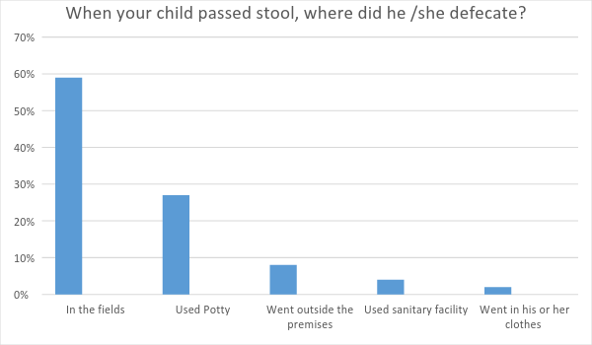

**Notes**: 59% of the mothers reported that their children defecated in the fields. 27% of the mothers reported that their children utilized a potty to defecate. 8% of the mothers reported that their children defecated outside the premises. 4% of the community reported that their children defecated using a sanitary facility. 2% of the women reported that their children defecated in their clothes. This report shows the severe lack of hygiene practiced in the community. I will present to the community that there be a requirement for the mother to attend all WASH formations along with another member of the family to ensure that WASH is being practiced correctly in the households.

|  |  |  |  |  |  |  |
| --- | --- | --- | --- | --- | --- | --- |
| **When your child passed stools, where were the feces disposed?** | | | | | | |
| Dropped into toilet facility | Water discarded outside | Disposed into solid waste/trash | Somewhere in the yard | Outside premises | Buried | Did nothing/left it there |
| 12/51 | 1/51 | 1/51 | 11/51 | 1/51 | 1/51 | 22/51 |

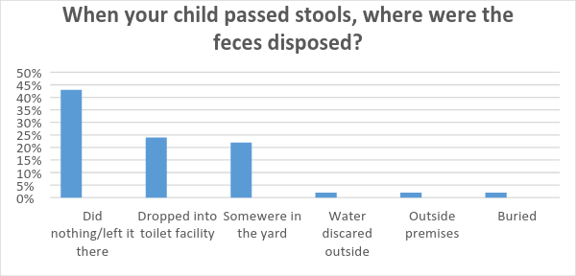

**Notes**: Again, we see here that 42% of the community did not do anything with their child’s feces. 22% disposes the feces in the latrine. 21% of the community leaves the feces in the yard and later sweeps the feces to later dispose in the bush. 2% of the community either uses water to discard the feces, buries the feces, or throws it outside the premises. Again, this data highlights what topics the sanitization will need to focus on during the WASH formations.

|  |  |
| --- | --- |
| **What kind of toilet facility does this household use?** | |
| Simple Pit Latrine With Slab | No facility, Field, Bush, Plastic Bag |
| 23/51 | 28/51 |

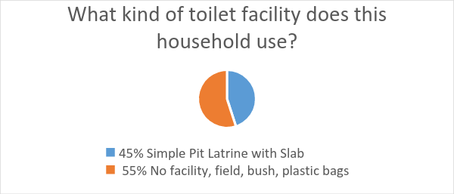

**Notes:** The pie chart demonstrates that 45% of the community has simple pit latrines. These latrines are located either in the backyard of the compound or placed in the middle of several compounds for all to share. Although 45% of the community has latrines, a little over half of the latrines have been reported to be full. Out of all the latrines that I have visited most of them were surrounded by animal manure with dense vegetation in the path. The location of the latrine can be hard to get to during the raining season because of flood and mud . Also, all the latrines are used for more than 10 people. 55% of the community reported to not have any facility but instead uses the field to defecate or their neighbor’s latrine.

|  |  |  |  |
| --- | --- | --- | --- |
| **Can you show me where you usually wash your hands and what you use to wash your hands?** | | | |
| Inside/near toilet facility | Inside/near kitchen/cooking place | Outside yard | No specific place |
| 7/51 | 9/51 | 3/51 | 24/51 |

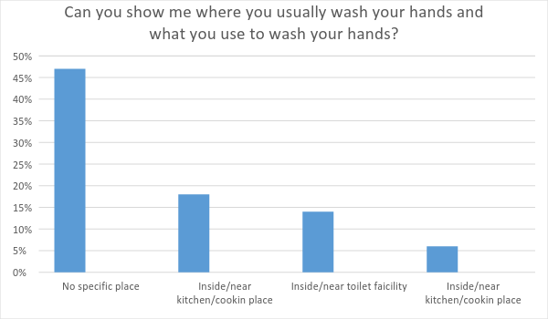

**Notes:** 47% of the community report to have no specific place where they wash their hands. 18% of the community reported to wash their hands inside/near kitchen/cooking place. 14% of the community reported washing their hands near the toilet facility. During the WASH formations, each member of the household will learn how to construct a “Tippy Tap” and will be required to build one in their house before the latrine is constructed.

**Conclusion**

We surveyed a total of 51 households that represent 780 people and is estimated to be more than 2/3 of the community. The average household has a total number of 15 people. Everyone in my community was very pleased to learn that I will be working with them to do a latrine project. The baseline survey revealed to me that there are actually more latrines than I expected in my community. However, I was still surprised to learn that most latrines were either full or shared by several compounds. The information collected on the daily WASH habits of the community members will be used to prepare a WASH/Latrine formation. Below you will see the tentative timeline for the rest of this latrine project and subsequent trainings.

**PHASE II**

**Latrine Voucher**

In order to have a latrine constructed, the head of the house hold must complete the latrine voucher. Two members from the household must attend all WASH formations, latrine care, all planning meetings, and construct a “Tippy Tap.” I have not yet determined the total number of formations. Secondly, they will be required to do the following: pay the mason, dig their own hole, bring sand and gravel from the fields, and help with transporting materials. My counterpart worked with the mason to get the labor cost down to 7.500FCA per latrine. Since we are looking to construct an estimated 60 latrines, I think we should hire 2-4 masons to make sure the work can be done in a timely manner. Lastly, I plan to use the grant to cover the cost of materials.

**MRE**

*The following data sheets will be used for this project:*

* HE 45: Conducted baseline water and sanitation survey
* HE 47: Constructed or improved water and sanitation system
* HE 62: People in households having access to latrines
* HE 202: Community members attending wash behavior change communication- number of individuals receiving BCC/IEC (behavior change communication) outreach promotion wash

*The following will be used to follow up*

* HE 49: Trained people to build hand washing stations and to correctly clean their hands with soap and water at the station
* HE 53: Household members using the hand washing station
* HE 52: Household having hand washing station with soap and safe water

**Tentative Timeline**

* August
  + Determine the cost of the latrines
  + Village meeting with Aziz to discuss latrine project and determine the total number of latrines that will be constructed
* September
  + Turn in grant
  + Prepare for trainings and maybe have Adji come by to train the health workers
* October
  + Wash Formations
  + Grant fully funded?
* November
  + Purchase materials
  + Latrine preparation meeting
  + Begin latrine constructions
* December/January
  + Latrine construction
* March
  + Baseline survey to see if WASH practices and latrine care have been adapted
  + Close of project

**HE-045**: Conducted Baseline Water and Sanitation Survey: Number of community diagnostics conducted that assess baseline water and sanitation access and behaviors

**Purpose:** Latrine Baseline Survey

Head of Household:_____________

Number persons in Household: _____________

|  |  |  |
| --- | --- | --- |
| **No.** | **Questions, Observations and Filters** | **Coding Categories** |
|  | Ndax am nga sabu ci sa ker?  Do you have soap in your household? | YES 1  NO 2 |
|  | Ndax jefandikou nga sabu tey walla demb?  Have you used soap today or yesterday? | YES 1  NO 2 |
|  | So jefandikowee sabu tey walla demb, lan nga ko jefandiko?  When you used soap today or yesterday, what did you use it for? IF FOR WASHING MY OR MY CHILDREN’S HANDS IS MENTIONED, PROBE WHAT WAS THE OCCASION, BUT DO NOT READ THE ANSWERS.  (DO NOT READ THE ANSWERS, ASK TO BE SPECIFIC, ENCOURAGE “WHAT ELSE” UNTIL NOTHING FURTHER IS MENTIONED AND CHECK ALL THAT APPLY) | WASHING CLOTHS A  WASHING MY BODY B  WASHING MY CHILDREN C  WASHING CHILD’S BOTTOMS D  WASHING MY CHILDREN’S HANDS E  WASHING HANDS AFTER DEFECATING F  WASHING HANDS AFTER CLEANING CHILD G  WASHING HANDS BEFORE FEEDING CHILD H  WASHING HANDS BEFORE PREPARING FOOD I  WASHING HANDS BEFORE EATING J  OTHER X  (SPECIFY) |
|  | Sa doom, fan la gin tankam?  When [*name of child*] passed stool, where did he/she defecate? | USED SANITATION FACILITY 11  USED POTTY 12  USED WASHABLE DIAPERS 13  USED DISPOSABLE DIAPERS 14  WENT IN HOUSE/YARD 15  WENT OUTSIDE THE PREMISES 16  WENT IN HIS/HER CLOTHS 17  OTHER 96  (SPECIFY)  DON’T KNOW 98 |
|  | Bi sa doom gin sa tank, fan la watchet? Fan la ko defe ?  When [*name of child*] passed stools, where were the feces disposed of? (IF “WASHED OR RINSED AWAY”, PROBE WHERE THE WASTE WATER WAS DISPOSED OF. IF “DISPOSED”, PROBE WHERE IT WAS DISPOSED OF SPECIFICALLY. | DROPPED INTO TOILET FACILITY 11  RINSED/WASHED AWAY  WATER DISCARDED INTO TOILET FACILITY 21  WATER DISCARDED INTO SINK OR TUB CONNECTED TO DRAINAGE SYSTEM 22  WATER DISCARDED OUTSIDE 23  DISPOSED  INTO SOLID WASTE/TRASH 31  SOME WHERE IN YARD 32  OUTSIDE PREMISES 33  BURIED 41  DID NOTHING/LEFT IT THERE 51  OTHER 96  (SPECIFY)  DON’T KNOW 98 |
|  | Fan ngay dem por gin sa tank?  What kind of toilet facility does this household use?  (CHECK ONE) | FLUSH/POUR-FLUSH TOILET  TO PIPED SEWER SYSTEM 11  TO SEPTIC TANK 12  TO PIT 13  TO ELSEWHERE 14  TO DON’T KNOW WHERE 15  VENTILATED IMPROVED PIT LATRINE (VIP) 21  SIMPLE PIT LATRINE WITH SLAB 22  PIT LATRINE WITHOUT SLAB/OPEN PIT 23  COMPOSTING/DRY TOILET 24  SERVICE OR BUCKET LATRINE (WHERE EXCRETA ARE MANUALLY REMOVED) 25  HANGING LATRINE 26  NO FACILITY, FIELD, BUSH, PLASTIC BAG 27 |
|  | Fan?  Where is this toilet facility located? | INSIDE OR ATTACHED TO DWELLING 1  ELSEWHERE INSIDE YARD 2  OUTSIDE YARD 3 |
|  | Natta nit, gin sa tank ci sa ker?  How many households share this toilet facility?  (ASK REGARDLESS OF LOCATION) | |  |  | | --- | --- | |  |  |     Number  NOT SHARED 01  10 OR MORE 10  DON’T KNOW 98 |
|  | Ndax men nanu gis fo len koy defe ?  May I see the toilet facility? | YES 1  NO 2 |
|  | TOILET FACILITY OBSERVATION: OBSERVE ACCESS TO THE FACILITY; ARE THERE OBSTACLES IN THE PATH, ARE THERE SIGNS OF REGULAR USE?  FOR TOILET FACILITIES IN THE DWELLING ONLY CATEGORIES “G, H, I, X” APPLY. | DENSE VEGETATION IN ITS PATH A  WASTE OR DEBRIS IN ITS PATH B  MAJOR CREVICES OR POTHOLES IN ITS PATH C  MUD IN ITS PATH D  PATH IS CLEAR E  PATH WELL WORN AS SIGN OF REGULAR USE F  ENTRANCE IS CLEAR/DOOR NOT LOCKED G  ENTRANCE IS OBSTRUCTED H  FACILITY IS LOCKED I  OTHER OBSERVATION X  CANNOT ASSESS Z |
|  | TOILET FACILITY OBSERVATION: IS THERE FECAL MATTER PRESENT INSIDE THE FACILITY - ON SEAT, FLOOR, DOOR OR WALLS (HUMAN OR ANIMAL)? | YES 1  NO 2  CANNOT ASSESS 8 |
|  | Fan ngay raxas sa loxo? Lan nga jefandiko por raxas sa loxo?  Can you show me where you usually wash your hands and what you use to wash hands?  ASK TO SEE AND OBSERVE | INSIDE/NEAR TOILET FACILITY 1  INSIDE/NEAR KITCHEN/COOKING PLACE 2  ELSEWHERE IN YARD 3  OUTSIDE YARD 4  NO SPECIFIC PLACE 5  NO PERMISSION TO SEE 8 |
|  | OBSERVATION ONLY: IS THERE A HANDWASHING DEVICE SUCH AS A TAP, BASIN, BUCKET, SINK, OR TIPPY TAP?  THIS ITEM SHOULD BE EITHER IN PLACE OR BROUGHT BY THE INTERVIEWEE WITHIN ONE MINUTE. IF THE ITEM IS NOT PRESENT WITHIN ONE MINUTE CHECK NO, EVEN IF BROUGHT OUT LATER. | YES 1  NO 2 |

|  |  |
| --- | --- |
| Head of Household:____________________ | |
| # persons in Household:  _______ | |
| 1 |  |
| 2 |  |
| 3 |  |
| 4 |  |
| 5 |  |
| 6 |  |
| 7 |  |
| 8 |  |
| 9 |  |
| 10 |  |
| 11 |  |
| 12 |  |
| 13 |  |

|  |  |
| --- | --- |
| Head of Household:____________________ | |
| # persons in Household:  _______ | |
| 1 |  |
| 2 |  |
| 3 |  |
| 4 |  |
| 5 |  |
| 6 |  |
| 7 |  |
| 8 |  |
| 9 |  |
| 10 |  |
| 11 |  |
| 12 |  |
| 13 |  |