**Come join us!**

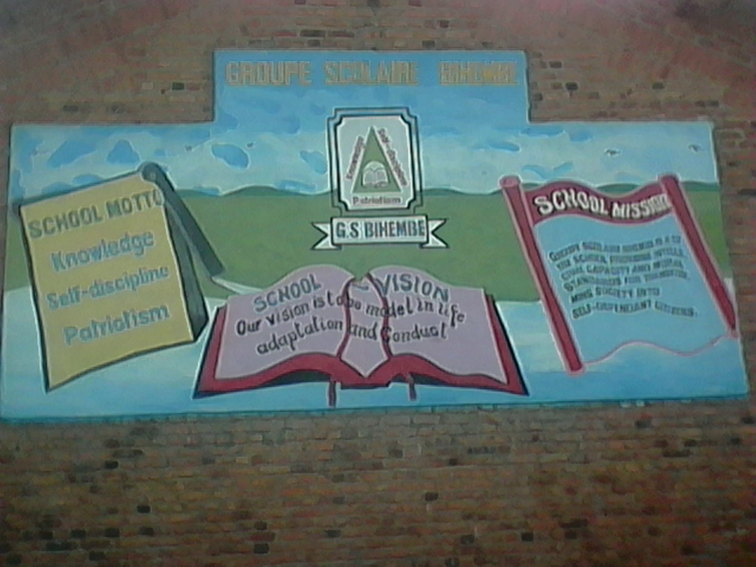

Groupe Scolaire Bihembe would like to invite you to our library opening celebrations!

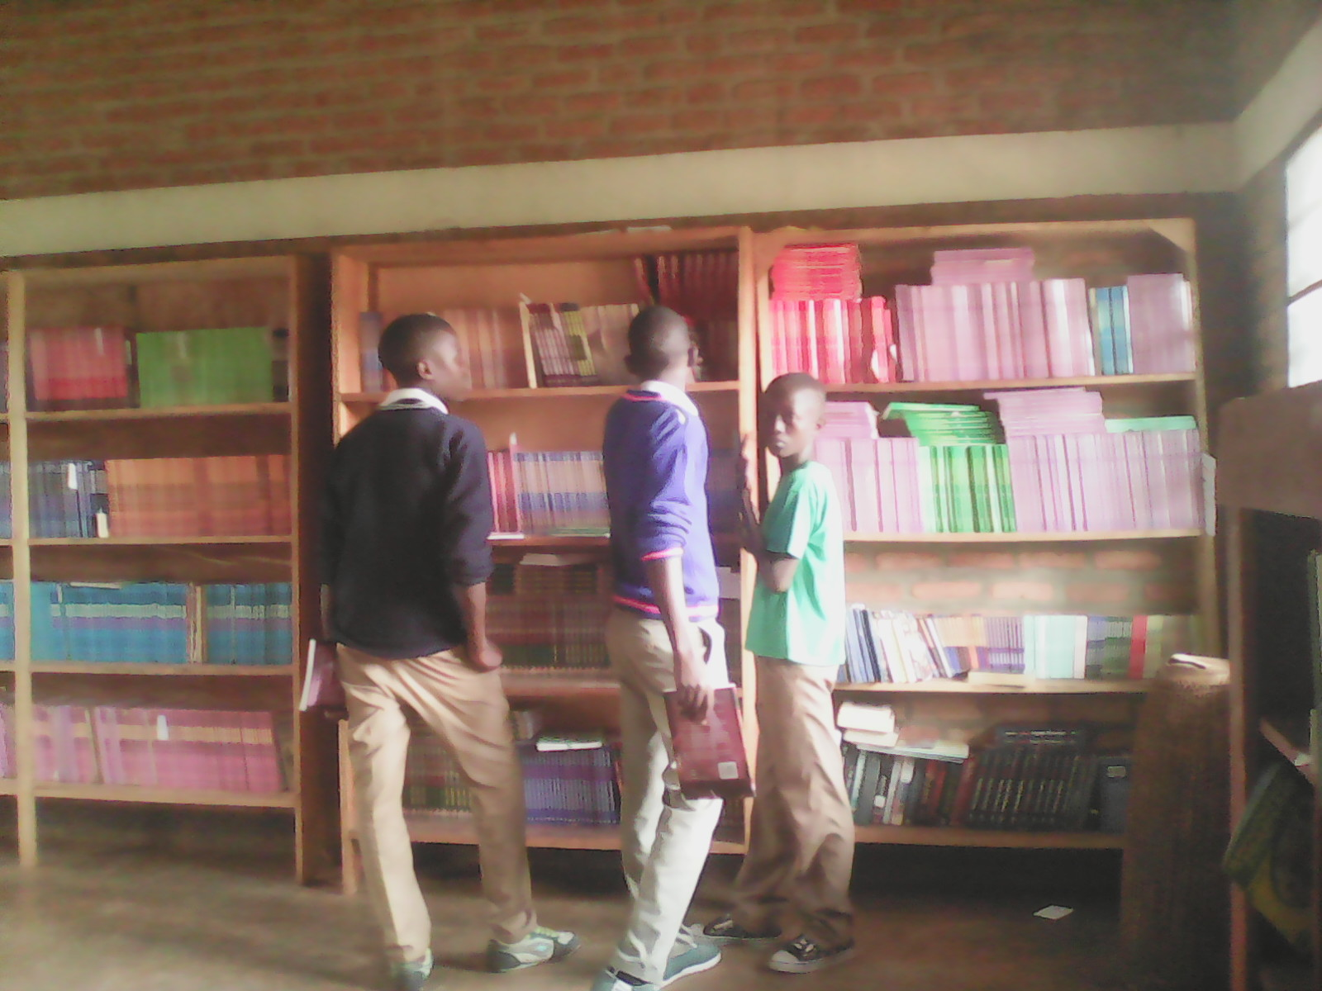

**Date:** Thursday, 31st March 2016

**Time:** 8am-2:00pm (Scheduled activities begin 10:30)

8:00 - 10:00 Tabled activities and library tours

10:30 - 11:30 Speeches

11:30 - 12:30 Student Presentations (dances, poetry, sketches)

12:30 – 1:30 Exodus Band

**Meeting place:** Groupe Scolaire Bihembe in

Nyakaliro Sector

Rwamagana District

Eastern Province

Rwanda

**For more information or to RSVP please contact:**Kirsten Nuber (Education Volunteer and Literature Teacher)  
Phone: +250 789 538 706 +250 738 538 706 Email: [kirstennuber@gmail.com](mailto:kirstennuber@gmail.com)



Proudly Supported By

