**PICTURES OF STUDENTS AT MSAZI SCHOOL**

Pictures show front view of the teachers house to be completed and its back view.

The bricks kirn is available for completion activities.

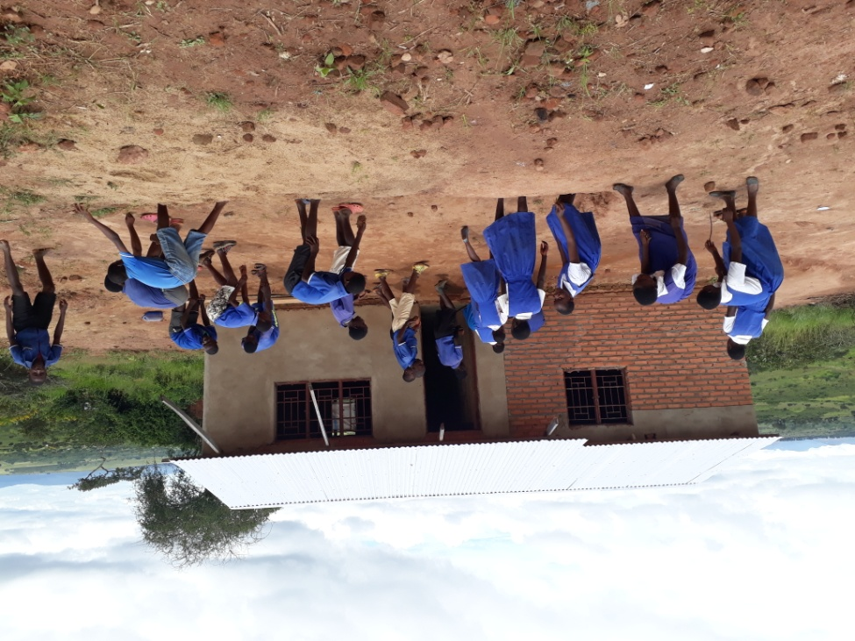

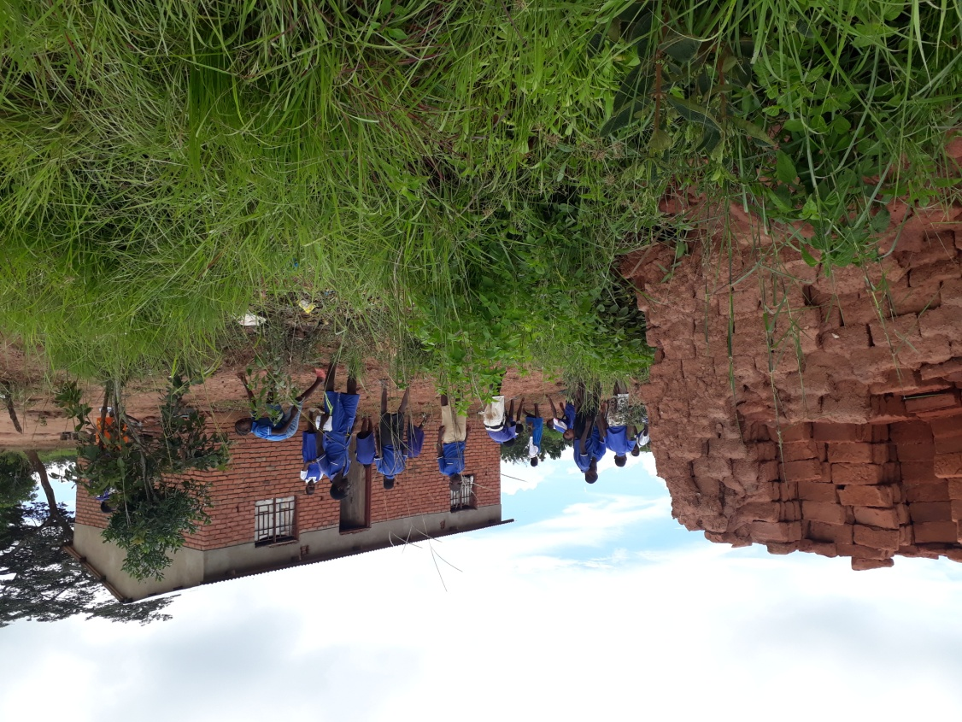

**PICTURE BELOW ARE A PERMANENT AND TEMPORARY CLASSROOM BLOCKS**

