

**« Une association de défense et de promotion des droits de l’enfant ».**

Site internet : [www.ajdc-rdc.org](http://www.ajdc-rdc.org), E-mail : [ajdclu@gmail.com](mailto:ajdclu@gmail.com), [basimiseshabani@gmail.com](mailto:basimiseshabani@gmail.com)

Téléphone: (+243) 99 27 49 653, 85 344 84 74, (+243) 818262190

**Appendix A: List of Recipients and pictures**

**1. NAMES :GLOIRE NABUNINI (OVC)**

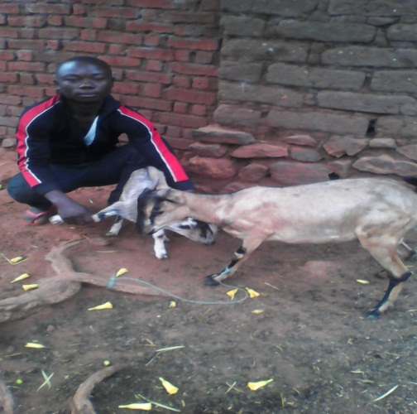-age: 14 years

-Sex: M  
-Source of income: Farming  
- Is it the first time to raise the goat?YES  
-Number of people in his family: 6 people  
-Number goats received: 2 goats  
**- Short biography:** Orphan of father and mother 2 years ago, he hadvery difficulties in school. AJDC identified him as a vulnerable child needed its support.  
___________________________________________________________________________

**2. -NAMES: IBRAHIM KABAYU (ESFGA)**

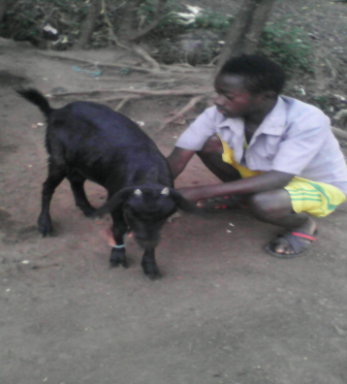Age: 16 Years  
-Sex: M  
- Source of income: Agriculture  
- Is it the first time to raise the goat? Yes  
-Number of people in the family: 4 people  
-Number goatsreceived: 2 goats  
**- Short biography:** He joined the Mai Mai militia commander BIKOTWA. He stayed there for two years. He often fought against rebel groups operating in South Kivu province in the DRC, and against the FARDC (Armed Forces of the Democratic Republic of Congo - the regular army).

**3.-NAMES: INNOCENT NARUGANDI (ESFGA)**

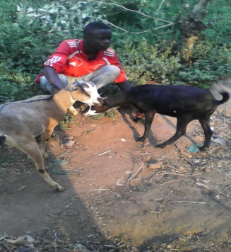 Age: 17 Years  
-Sex: M  
- Source of income: Farming  
- Is it the first time to raise the goat: Yes  
-Number of people in his family: 2 people  
-Number of goats received 2: goats  
**- Short biography:** "I was coming from fields with my brother when we met six militiamen of Congolese Rally for Democracy. I managed to escape but they beat my brother to death. I was seriously affected by his death. In order to revenge, I joined the Mai Maimilitia.

**4.-NAMES:APENDEKI MUGAMBWA (OVC)**

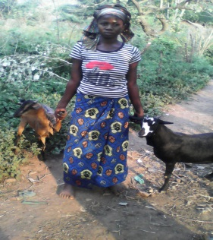-Age: 20 years  
-Sex: F  
- Source of income: Farming  
- Is it the first time to raise the goats: Yes  
-Number of people in family: 3 People  
-Number of goats received: 2 goats  
**- Short biography:** Orphan of father and mother 4 years ago, she is single and head of household. She is in charge of schooling of his younger brothers and sisters.

**5.-NAMES:ELIYA CHIBALONZA (OVC)**

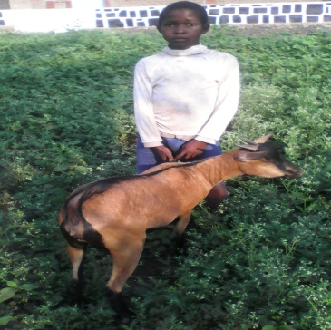Age: 12 Years  
-Sex: M  
- Source of income: Small Business  
- Is it the first time to raise the goat?: Yes  
-Number Of people in his family : 6persons  
-Number goats received : 2 goats  
**- Short biography:** Orphan of mother, he leads a very difficult school life. AJDC identified him as a vulnerable child in need of support  
________________________________________________________________________

**6.-NAMES:MUSEMA BUKENI (OVC)**

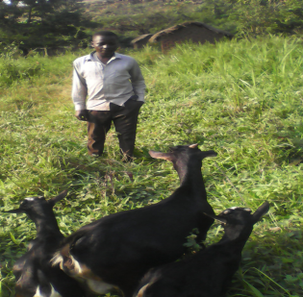-age: 12  
-Sex: M  
- Source of income: Small livestock  
-Is it the first time to raise the goats: NO  
-Number of people in family: 4 people  
-Number goatsreceived: 2 goats  
**-Short biography:** vulnerable boy born in a poor family. AJDC has selected him to support high school.

**7.-NAMES: BULOZE MUTALALWE (OVC)**

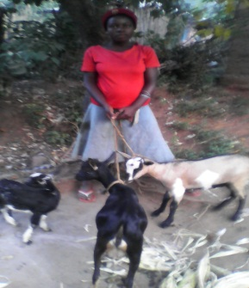- Age: 16 Years  
-Sex: F  
- Source of income: Housework  
- Is it the first time to raise goats? Yes  
-Number of people in his family: 5persons  
-Number goatsreceived: 2 goats  
**- Short biography:**Victim of rape by several armed people, she became pregnant.

**8.-NAMES: FIKIRI KASHONGO (OVC)**

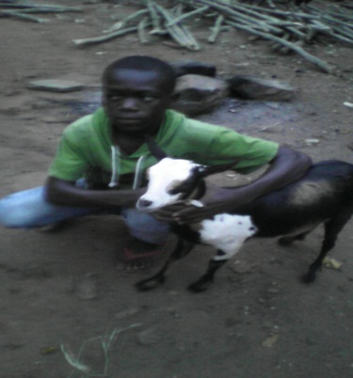Age: 14 Years  
-Sex: M  
- Source of income: Agriculture  
- Is it the first time to raise goats: NO  
-Number of people in family: 4 people  
-Number goats received: 2 goats  
**- Short biography:**Vulnerable born in a poor family

**9.-NAMES : MAPENZI RUBONDO (ESFGA)**

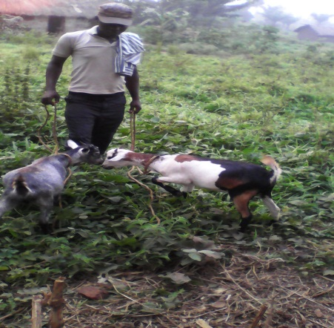

-age: 18 years  
-Sex: M  
- Source of income: Tailoring  
- Is it the first time to raise goats?: Yes  
-Number of people in his family: 9 people  
-Number goatsreceived: 2 goats  
**- Short biography:** She joined Armed Forces for Legitimate Local Self-Defense based inMuhungu village of high Mountains of Uvira, South Kivu province in the DRC, for he had no other means of subsistence. While in the military, he once fought and was proud to defend his village.

**10.-NAMES : EPIC BISIMWA (OEV)**

* Age: 13 years  
  -Sex: M  
  -Source of income: Agriculture  
  -Is it the first time to raise goats?No  
  -Number of people in his family: 6 people  
  -Number goats received: 2 goats  
  **- Short biography:**Vulnerable child born in a poor family. AJDC is supporting his high school

**11.-NOM :AMIRI KASOME (OEV)**

-age: 14 years  
-Sex: M  
-Source of income: Small Livestock  
- Is it the first time to raise goats?No  
-Number of people in his family: 5 people  
-Number goats received: 2 goats  
**- Short biography:**Vulnerable boy born in a poor family.

**12.-NOM : NANGAVU ATHANASE  (ESFGA)**

- age: 15 years old  
-Sex: F  
- Source of income: hair cutting  
- Is it the first time to raise goats?: No  
-Number of people in the family: 7 people  
-Number goats received: 2 goats  
**- Short biography:** She joined Armed Forces for Legitimate Local Self-Defense based inMuhungu village of High Mountains of Uvira, South Kivu province in the DRC. While in the military, she was forced to become the "wife" of the commander.

**13.-NAMES : KIBONGE KATETE (ESFGA)**

* Age: 18 years  
  -Sex: M  
  -source income: Bakery  
  - Is it the first time to raise goats?: No  
  -Number of people in his family: 9 people  
  -Number goats received: 2 goats  
  **- Short biography:**He joined the Mai-Mai commander of Kininga Lupengo village in highlands of Uvira, South Kivu province in the DRC. "Our village was not secured by the regular armed forces so I thought I would defend it. I spent 3 years with the Mai-Mai group. Even if I have not hurt or killed anybody, I fought once and I was proud to defend my village.

**14.-NOM : FLORIBERT MUHAGATI (ESFGA)**

-age: 16 years  
-Sex: M  
-Source of income: Teaching activities of his father  
- Is it the first time to raise goats?: Yes  
-Number of people in family: 4 people  
-Number goats received: 2 goats  
**- Short biography:** He joined the Mai-Mai commander of KiningaLupengo village in highlands of Uvira, South Kivu province in the DRC. "Our village was not secured by the regular armed forces so I thought I would defend it. I spent 2 years with the Mai-Mai. Even if I have not hurt or killed anybody, I fought once and I was proud to defend my village.

**Done at Lubarika, July 25th, 2016  
  
AJDC for DR Congo  
  
BASIMISE SHABANI Thierry  
Coordinator**