

**« Une association de défense et de promotion des droits de l’enfant ».**

Site internet : [www.ajdc-rdc.org](http://www.ajdc-rdc.org), E-mail : [ajdclu@gmail.com](mailto:ajdclu@gmail.com), [basimiseshabani@gmail.com](mailto:basimiseshabani@gmail.com)

Téléphone: (+243) 99 27 49 653, 85 344 84 74, (+243) 818262190

***Appendix A : List of beneficiaries and pictures with goats received***

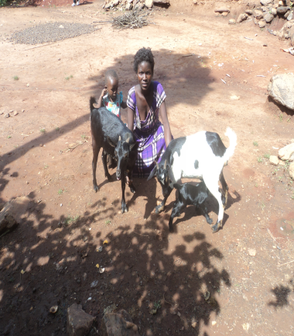**1. HURUMA BERSHI (ESFGA) E**nfan**t S**orti **des F**orces **et G**roupes **A**rmés (Child out of armed forces and groups)

-age: 18 years

- Sex: Female

- Source of income: Agriculture

-is it the 1st time to rear goats? Yes

- Number of persons in the family: 2 persons

- Number of goats received: 2 old goats and the new born baby

**Short biography:** Huruma Bershi, 18 years old joined in 2011 armed group called FALL (Forces Armée sd’Autodéfense Locales Légitimes e.i. Local armed forces for legitimate self-defense) located at Kahungwe, village of Hight mountains of Uvira, Province of South Kivu, DRC.She joined armed forces out of poverty, searching for survival. During 3 year in the army, she was compelled to become a wife of a commandant of the armed group FALL. ***« Sometimes, my so called husband could let me be sexually abused by other soldiers »***, She said. Thanks to the program of AJDC of withdrawing children from army, she was rescued and followed vocational training in tailoring in a workshop belonging to AJDC.

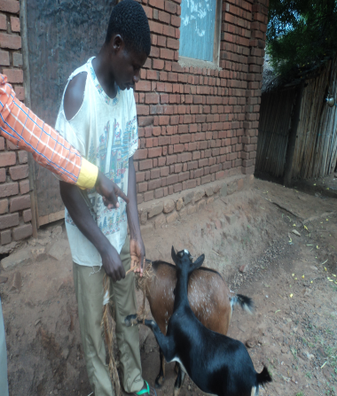**2. BONANE REMY (ESFGA)**

-Age: 20 years

- Sex: Male

- Source of income: Animal rearing

- Is it the 1st time to rear goats? : No

- Number of persons in the family: 4 persons

-Number of received goats: 2

- **Short biography:** Remy Bonane joined Maï-Maïarmed group at the age of 13. He stayed in the army for 3 years. He used to fight against other armed groups and against also regular army of DR Congo. He reported to have killed many people included children. « I killed people just to survive because I could not do otherwise ». When exited from army, AJDC provided him few goats and ForgottenSong has completed the efforts of AJDC. He is now married and father of 3 kids.

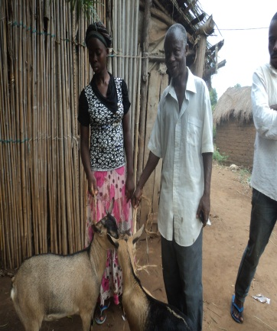**3. NYOTA SHENDWA (ESFGA)**

-Age: 18 years

- Sex: Female

- Source of income:agriculture

- Is it the 1st time to rear goats? Yes

-Number of households: 5persons

-Number of received goats: 2

**Short biography: NyotaShendwa**, joined Maï-Maï armed group in 2012 called RassemblementCongolais pour la Démocratiee.i.Rally for Congolese Democracylocated in High Mountains of Uvira. He reported: « I was coming from gardens with my older brother and we met 6 militias of Mai-Mai. I managed to run away but my brother was beaten until he died. I joined the armed group to revenge my brother because I could not bear his death. Life conditions in armed groups were very severe. We could not get what to eat and wear. I interrupted school and stayed in armed group for 1 year. Now, thanks to AJDC, I reintegrated normal life and gardening provides me enough income for living. My dream is to join regular army to secure my country ».

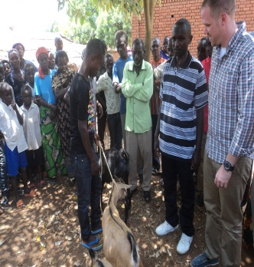**4. SAMUELI KAMBARAGATA(ESFGA)**

- Age: 17 Ans

- Sex: Male

- Source of income: Agriculture

- Is it the 1st time to rear goats? Non

-Number of households: 07 persons

- Number of received goats: 2

**- Short biography:** At the age of 13, Samuel joined armed group and served as militia escort and a fighter. When he exited from army, he reintegrated school and in complete high school in 3 years.

______________________________________________________________________

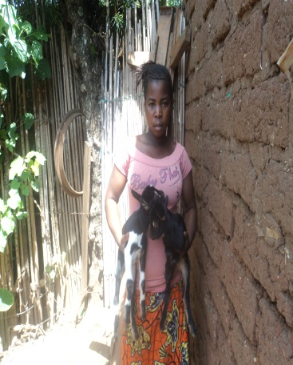**5. DELICE BACHOKE (OVC)**

-Age: 17 years

- Sex: Female

- She received a new born goat (born on April 23rd 2013

- Source of income: Business

- Is it the 1st time to rear goats? No

-Number of household: 5

-Number of received goats: 2 old goats and a twin of new born goats

**-Short biography:** Delice was not enrolled in armed groups. But, she was identified by AJDC as an orphan and vulnerable because of poverty and lost both parents in 2014

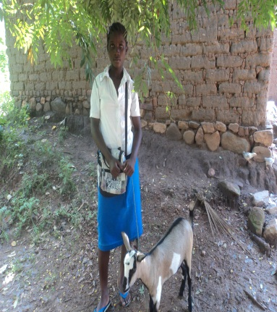**6. ANGE MUSAFIRI (OVC)**

-Age: 15 years

- Sex: Female

-source of income: agriculture

- Is it the 1st time to rear goats?Non

-Number of household: 3 persons

-Number of received goats: 2

**Short biography:** Ange was identified by AJDC among vulnerable children to be assisted because she was abducted and raped by unidentified armed group soldiers when she went in the bush in search for firewood.

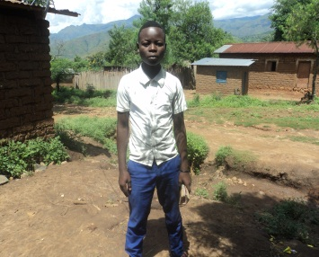**7. BISHINGANINE BUKENI (ESFGA)**

- Age: 17 years

- Sex: Male

-source of business: business

- Is it the 1st time to rear goats? Yes

-Number of households: 6 persons

-Number of received goats: 2

**- Short biography:** In 2013, Bukeni joined the Mai-Mai group of Kininga commander in Lupengo village highlands of Uvira. He reported the following. «Armed robbers came to loot in my village. They stole $ 500 from my family and forced me to have sex with my sister of 15 years. I was very disturbed. The whole village has been informed and everyone laughed at me and insulted me. I was very ashamed. So, to avoid humiliation, I joined the Mai-Mai armed group. I stayed there for 2 years. I suffered a lot, because I could not go back because I was afraid that the mockery resumed. I did not dare return to my family, but thanks to the advocacy work of the JDC, I could finally go home.

__________________________________________________________________________

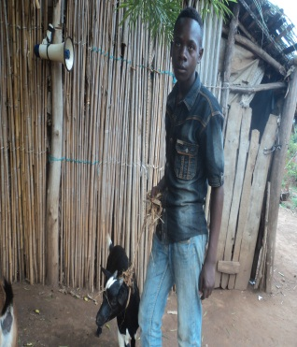**8. ALBERT KINESHA (OEV)**

-Age: 15 years

- Sex: Male

- Source of income: animal raising

- Is it the 1st time to rear goats? No

-Number of households: 11 persons

- Number of received goats: 2

**-Short biography:** Albert is a total orphan. Both parents were fighters and perished at the same time in Bihari area. He was then rescued and assisted by AJDC

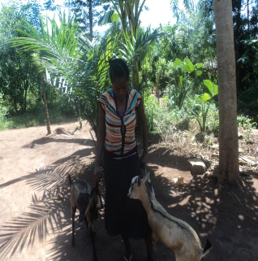**9. ASHUZA MIRINDI (ESFGA)**

- Age: 16 years

- Sex: Female

- Source of income: agriculture

- Is it the 1st time to rear goats: Oui

-Number of households: 6 persons

-Number of received goats: 2

**-Short biography:** After the death of her parents, Mirindi joined Maï-Maï armed group where she labored a lot without payment. Thanks to AJDC, she was released from the militia and is now free. She works as an employee of AJDC in the gardens of maize and coffee plantations.

________________________________________________________________________

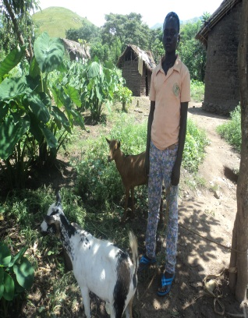**10. YOTEMEMA KWIBE (OVC)**

-Age: 15 years

-source of income: Agriculture

- Is it the 1st time to rear goats?: Oui

-Number of persons in the family: 6 children

-Number of received goats: 2

**- Short biography:** Kwibe was born in an HIV infected parents. By providence, he is the only one to be safe (not to be infected) in the whole family.

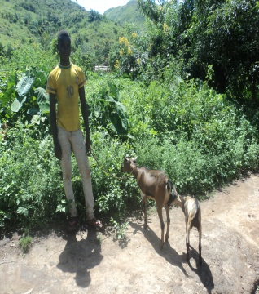**11. MABADILIKO SAFARI (ESFGA)**

- Age: 17 years

- Sex: Male

- Source of income: business

- Is it the 1st time to rear goats? Yes

- Number of persons in the family: 08 persons

-Number of received goats: 2

**- Short biography:** Safari joined Mai-Mai armed group in 2011 searching for a refuse. Indeed, he reported: “when I was coming from the gardens with my sister of 12 years, we came across to 2 soldiers belonging to Rwandan rebels. They strongly tied me up and whipped me severely and then raped my sister one after another. In order to avoid that such situation happened again in our village, I decided to join Mai-Mai group in order to protect people. I stayed there for 2 years and I fought 3 times against Rwandan rebels.

**12. MUSAFIRI KAKURU (ESFGA)**

-Age: 16

- Sex: Male

- Source of income: Agriculture

- Is it the 1st time to rear goats? : No

-Number of persons in the family: 06

-Number of received goats: 2

**- Short biography:** Kakuru joined Maï-Maï armed group of Kininga commandant in Lupango in order to protect his village against other groups who used to come for looting in his home area. He stayed in the group for 2 years and cared for soldiers with his fetishism practices that he learnt from an older man of his home village. He declared to be very respected by soldiers and commandant also. When he left the group, he stopped fetishism practices and converted into Christian believer.

_______________________________________________________________________

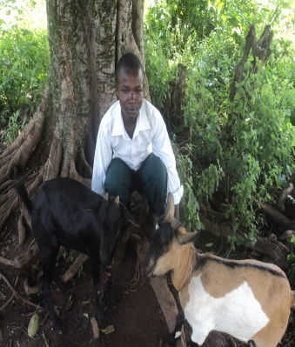**13. BATUZE BUKANJA (ESFGA)**

- Age: 18 years

- Sex: M

-source of income: raising animals

- Is it the 1st time to rear goats? No

- Number of persons in the family:

- Number of received goats: 2

- **Short biography**: At the age of 13, BUKANJA joined Mai Mai armed group of Kininga commander after that another armed group attacked his village and killed his mother. “I joined Mai-Mai group to run after those who killed my mother in order to reveng”, he declared.

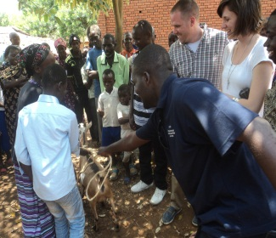**14. BUSHAMBALE LUVIRI (OVC)**

- Age: 14 years

- Sex: M

-source income: Pastry

- Is it the 1st time to rear goats? : No

- Number of children in the family: 3

- Number of received goats: 2

**-Short biography:** Luviri is an orphan and born in a poor family.

__________________________________________________________________________

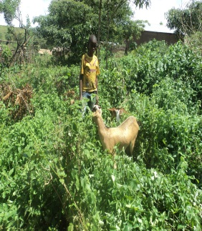

**15. MAPATO KALIMBA (ESFGA)**

- Age: 15 years

- Sex: M

- Source of income: Tailoring

- Is it the 1st time to rear goats? Yes

-Number of persons in the family: 7 persons

-Number of received goats: 2

**-Short biography:** Kalimba joined Maï-Maï commanded by Kaninga in Lupango. He reported the following: “I was jobless and my parents were very poor. I was just idling in my village while other children were at school or in gardens. I decided to joined the above mention group and served for 2 years as a cook. I used to be sent by the commandant to look for marijuana. I was very enthusiastic in fighting, courageous and proud to defend my village. Outside of combat, thanks to my weapon I could extort money from anyone and send an adult to fetch water.

When I left the group, thanks to AJDC, I learnt tailoring and I am living out of that.

___________________________________________________________________

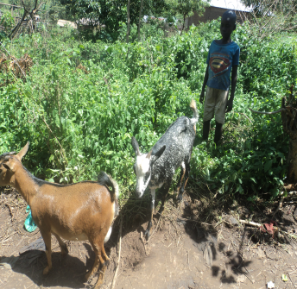**16. MAITAJI KATULA (OEV)**

- Age: 14 yeas

Sex: Male

-source of income: pigs raising

- Is it the 1st time to rear goats? Yes

- Number of persons in the family: 4 Persons

-Number of received goats: 2

**-Short biography:** He is born from vulnerable family made of physically handicapped persons.

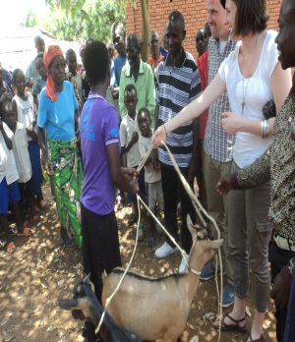**17. FURAHA SAMUELI NZELE (ESFGA)**

- Age: 16

-source of income: cows rearing

- Is it the 1st time to rear goats?  Oui

- Number of persons in thefamily: 5

-Number of received goats: 2

**-Short biography:** She joined armed group of Major Kinga when she was 14 and stayed there for 2 years. She decided to leave militia and reintegrate school in order to give good example of other child soldiers that there is no life in the militia.

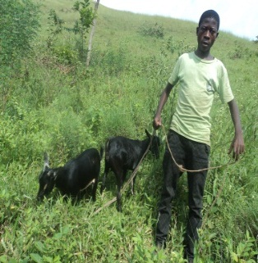**18. MUGISHO TORWA (ESFGA)**

-Age: 15 years

-source of income: Agriculture

- Is it the 1st time to rear goats: Yes?

- Number of persons in the family: 3 Persons

- Number of received goats: 2

**- Short biography:**

He joined the Mai-Mai militia of Major Kininga at the age of 10 after FDLR combatants (Democratic Liberation Forces of Rwanda) have raped his mother and killed his father before in front of him. "I wanted to revenge": this is the reason of joining the group. Today, thanks to school reintegration program of AJDC, he is studying in Lubarika and is intending to become a high official in the DRC.

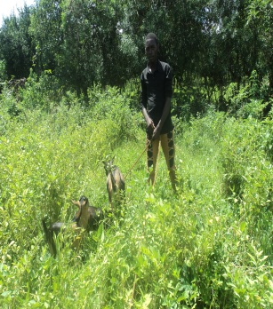**19. YOHANA MUKANIRWA (ESFGA)**

- Age: 19

- Sex: Male

-source of income: Tailoring

- Is it the 1st time to rear goats: Yes

- Number of persons in the family: 4 persons

- Number of received goats: 2

**- Short biography:** Yohan Mukanirwa, 15 years old, joined Maï-Maïarmed group led by Commendant Kininga in Lupengo, village High Mointains of d’Uvira. He reported the following: “Our village was not secured by regular army of DR Congo and I decided to join armed group to secure my village. I stayed in the army for 2 years. Even though I never harmed of killed anybody, I once fought for my village and I was proud to defend it. It is thanks to our intervention that Democratic Front for Liberating Rwanda was chased away from our village. When AJDC came to explain to our leaders that keeping children in army is illegal, I decided to quit armed group. I now earn my life out of haircutting”.

___________________________________________________________________

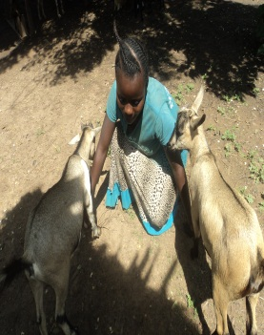**20. ZAWADI KWIBE (ESFGA)**

- Age: 16 years

- Sex: Female

- Source of income: Chickens and duck raising

- Is it the 1st time to rear goats? : Yes

- Number of persons in the family: 9 persons

- Number of received goats: 2

**- Short biography:** Zawadi Kwibe joined Mai Mai group at 12 years in search for survival means. During the fight at Munaniera, she killed 2 armed ladies and declared: "I moved like a snake and shot them. I do not want to remember that, because it makes me cry”. She reintegrated school in Lubarika and would like to become a tailor.

___________________________________________________________________

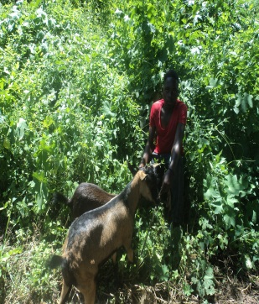**21. SHUKURU MATHIAS (ESFGA)**

-Age: 17 years

- Sex: Male

- Source of income: Agriculture

- Is it the 1st time to rear goats: Yes?

- Number of persons in the family: 8 persons

- Number of received goats: 2

**- Short biography:** “Following the rape of my sister by foreign armed groups (FDLR), my sister became ill and died two months later. After her death, I joined the Mai-Mai group because I was angry. When, five months later we spotted a camp of FDLR, I was eager to do battle. I was the first to open fire. I managed to kill an enemy soldier. I was very happy. After the militia, I became a farmer and am earning money out of that”.

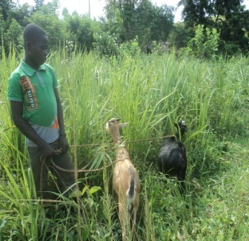

**22. AHADI KININGA (ESFGA)**

-Age: 15 years

- Sex: Male

-source of income: Teacher

- Is it the 1st time to rear goats: Yes?

- Number of persons in the family: 3 persons

- Number of received goats: 2

**- Short biography:** He joined armed group of Maï-Maï commanded by Galagala à Lupengo. “When I saw the wounded and the dead, I got scared and decided to leave the Mai Mai group”.

__________________________________________________________________________

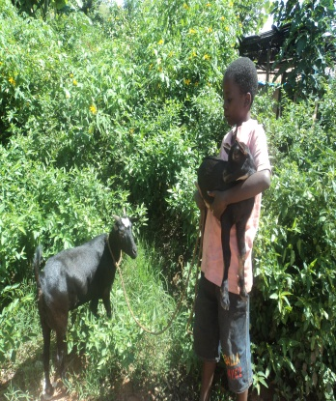

**23. TEGEMEYO MBIRIZE (ESFGA)**

-Age: 13 years

- Sex: Male

- Source of income: hunting wild animals

- Is the 1st time to rear goats? : Yes

-Number of persons in the family: 7 persons

-Number of received goats: 2

**- Short biography:** Mbirize joined Mai Mai group after that another armed group attacked his village and killed his mother. He also got separated from his father and until now, he ignore whether he is still alive or dead. So sad to him.

**24. MUSEMA BUKENI (EAFGA)**

-Age: 13 years

- Sex: Male

- Source of income: Mixed hairstyle

- Is it the 1st time to rear goats? Yes

- Number of persons in the family: 7 persons

-Number of received goats: 2

**- Short biography:** He joined FALL- Local armed forces for legitimate self-defense-. Each night, he was watching over the village and during the day, he could go to fetch water. He one time participated in the fight against robbers coming from Kahungwe. Holding kalachnikov gun, he run after them for four hours. He could not feel any fear because he was well armed.

**25. TUMUSIFU NAKAGE (OVC)**

-Age: 13 years

- Sex: Male

- Source of income: Fishing

- Is the 1st time to rear goats: Yes?

-Nombre de personnes dans sa famille : 10 persons

-Nombre de chèvre reçus : 2

**- Short biography:** At theage of 11 years, she was abducted by armed group in order to cook for soldiers. He was released thanks to AJDC lobbying.

**26. ESPOIR MUTWALI (OVC)**

-Age: 13 years

- Sex: Male

- Source of income: Bakery

- Is the 1st time to rear goats? Yes

-Number of persons in the family: 6 persons

- Number of received goats: 2

**- Short biography:** He is handicapped

**27. BARAKA MUKONGO (OVC)**

- Age: 13 years

- Sex: Male

- Source of income: Agriculture

- Is it the 1st time to rear goats: Yes

-Number of persons in the family: 3 persons

-Number of received goats: 2

**-Short biography:** Born in a poor family

**28. SADIKI KITAMBO (ESFGA)**

- Age: 13 years

- Sex: Male

-Source of income: business

- Is it the 1st time to rear goats? : Yes

- Number of persons in the family: 5 persons

- Number of received goats: 2

**- Short biography:** Recruited at 6 years old, he served as a cook before becoming a real fighter. He used carry weapons and fight against FDLR in Lubarika

**29. HEKIMA MAGEGA (OVC)**

- Age: 13 years

- Sex: Male

- Source of income: Animal rearing

- Is it the 1st time to rear goats? : Yes

-Number of persons in the family: 7 persons

-Number of received goats: 2

**- Short biography:** Born in poor family

**30. ZUHENA SAMUELI**

-Age: 13 years

- Source of income: Pastry

- Is it the 1st time to rear goats? Yes

-Number of persons in the family: 8 persons

- Number of received goats: 2

**- Short biography:** Born in a poor family and he is being look after by neighborhood.

Lubarika, le 19/05/2016

For AJDC RD Congo

**BASIMISE SHABANI Thierry**

Coordinator