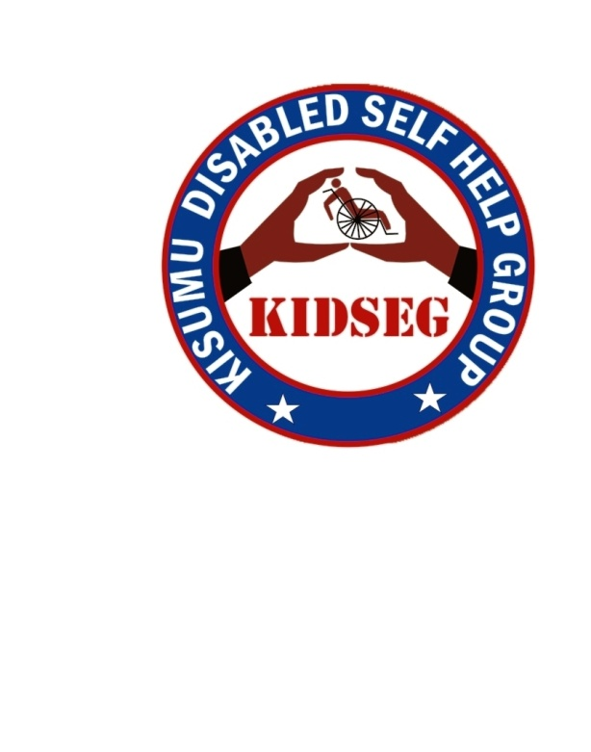

KISUMU DISABLED SELF HELP GROUP

KIDSEG ANNUAL PROGRAMME REPORT 2017

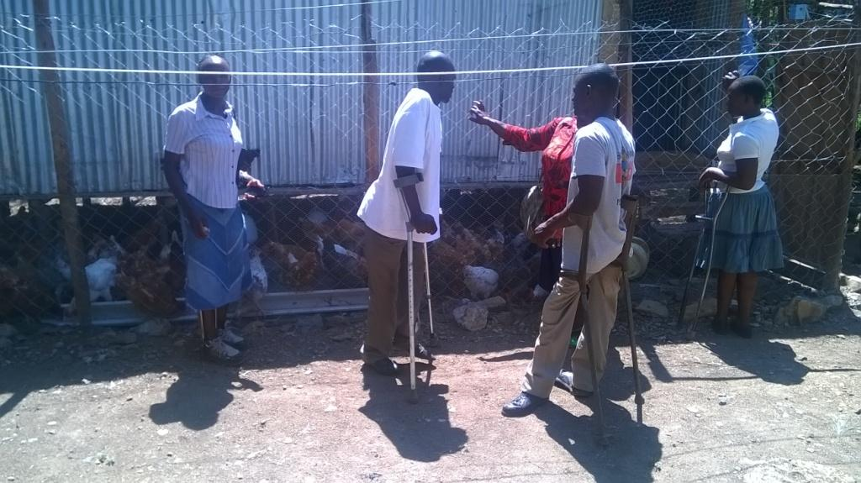

KIDSEG
P.O.Box 8080 – 40142
Kisumu, Kenya
Email: info@kidseg.co.ke / info_kdishg@yahoo.com
Website: www.kidseg.co.ke

Written by
KIDSEG BOARD
Contact person: Joseph Omondi, Programme Coordinator, Cell phone: +254733917683

Table of Content
Page
Introduction ………………………………………………………………………………………… 1 - 2

2017 Programmes and Activities ………………………………………………………………. 3 - 10

Donor funded programmes ………………………………………………………….. ………… 3 - 7

Social Enterprise Investment …………………………………………………………………… 3

Behavior change communication targeting young people with disability ……………….. 4

HIV prevention strategy, 2017 ……………………………………………………………………. 5

HIV prevention project funded by social enterprise investment fund …………………… 6

Integrated health and livelihood programme for young people with disability affected
and infected by HIV/AIDS ......................................................................................................... 7

Self funded programmes …………………………………………………………………………… 8
- Human rights awareness campaigns............................................................................
- Home based health care ……………………………………………………………………
- Mobility device distribution …………………………………………………………………
- Children programme .....................................................................................................
- Income generating activity ………………………………………………………………….
- Monitoring and Evaluation ………………………………………………………………….

Our 2018 Focus ………………………………………………………………………………………… 9

Strategic plan 2016 – 2019 ……………………………………………………………………………. 9

KIDSEG website ……………………………………………………………………………………. 9

Acquiring a van for transportation …………………………………………………………………….. 10

Local and international collaboration ………………………………………………………………… 10

About KIDSEG …………………………………………………………………………………………… 11

Financial statement as at 31 December 2017……………………………………………………… 12 - 13

Photo gallery …………………………………………………………………………………………….. 14

Introduction
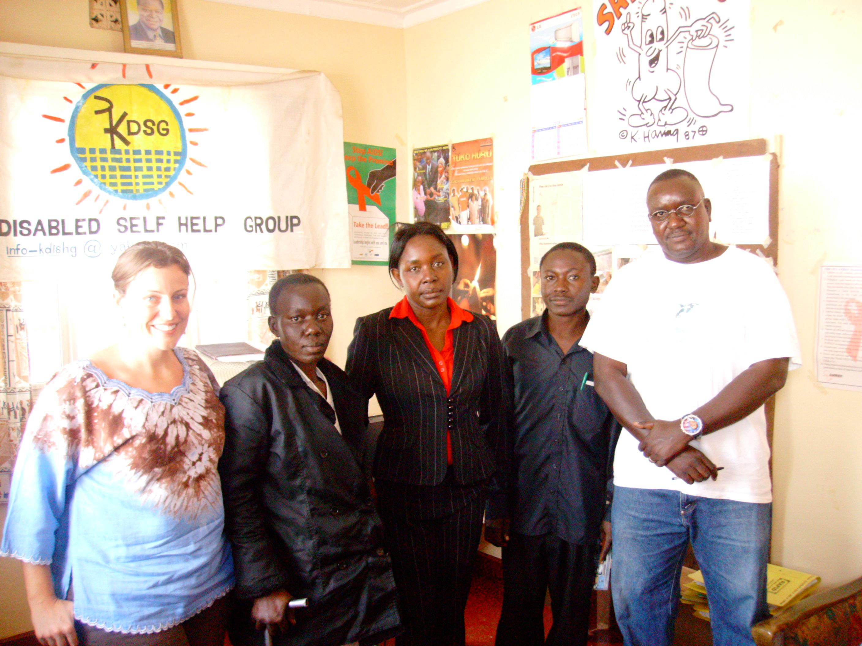
The Chairperson, Mildred Auma

Ever since I was elected by the board members to spearhead the development of Kisumu Disabled Self help Group, with the support of my fellow board members and the entire KIDSEG fraternity, I have seen the once less vibrant organization transform into a more vibrant and programmatic organization sensitive to the issues of people with disabilities. KIDSEG has continued to grow with new innovative programs and collaborations supported by various local and international partners. The year 2017 has been a blessed year and I thank God that we were able to partner with various donors who funded our various community focused projects that has seen many young people with disabilities empowered. In the year 2017, we continued to focus mainly on projects that would enable our organization to be self sustaining and slowly detach itself from complete donor dependency. Funding from the MTV Staying Alive Foundation came at the right time when we were struggling to raise funds to support our HIV prevention programme. This funding has enabled our organization to engage in agri-business focusing mainly in funding of our HIV prevention programmes now and in the future. Many well-funded initiatives already support a broad spectrum of accepted interventions for treatment and prevention of HIV in sub-Saharan Africa. But very few initiatives have addressed the need to develop game-changing, replicable, self-sustaining projects that can galvanize young people in Africa in the fight against HIV. The funding from Mercury Phoenix Trust was also God sent. Through this funding, we were able to reach out to many young people with disabilities with behavior change communication messages, using many strategies like peer education training and outreaches, VCT promotion forums, community dialogue forums, exchange visits, and condoms / IEC materials distribution to enable us create more awareness and prevent new infections among this vulnerable group. During our community outreaches, we realised that poverty is a major setback towards fight against HIV. We therefore developed a project proposal that would ensure that young people with disabilities affected and infected by HIV are able to not only get income to uplift their living standards but also get psycho-social support to cope up with challenges. Education is one of the fundamental aspects of human economic growth. We realised that many people with disabilities are illiterate because of the discrimination they went through during their early childhood. This has contributed to high level of poverty among this category of citizens and therefore we saw the need to ensure that we also focus our programmes on adult literacy skills development to address this need. Providing mobility devices to people with disabilities have been one of our main activities in the previous year and we intend to continue with this activity to ensure that people with disabilities are able to move around and conduct their businesses with dignity. We were able to partner with Elizabeth Okhungu Children Foundation to widen our donation outreach. Through this organization, we were able to reach many institutions supporting children with disabilities.
All this has been made possible by our supporters and funders both locally and internationally whose continued efforts has ensured that KIDSEG makes a difference and lives up to its motto: ‘Life beyond disability’. I sincere THANK all our supporters and may GOD bless you to continue serving humanity.
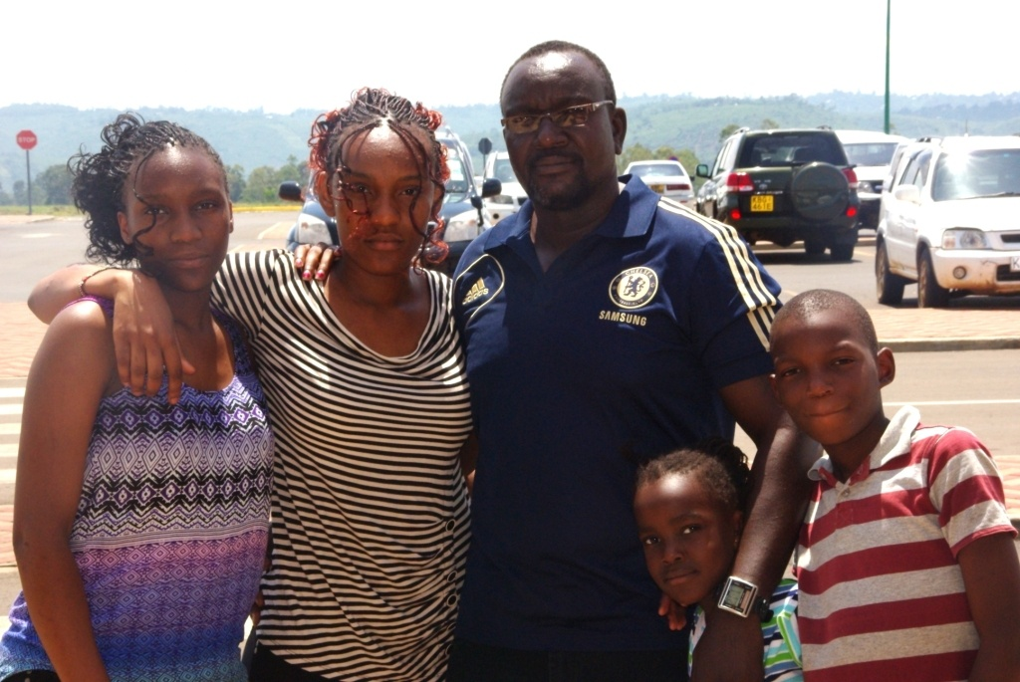
The Programme Coordinator, Joseph Omondi

KIDSEG is a community development organization that was founded in 2002 and registered in 2003 by young people with disability who had a common vision, to ensure that all people with disability within their community are empowered socially and economically. The mission of this organization is therefore to engage in activities that promote dignity and support to young people with disabilities in Kisumu City through promoting social and economic empowerment so as to be able to participate actively and meaningfully in community development issues. We have been doing this through facilitating income generating activities, technical skills building, health education and civic empowerment. In 2016, we got funding from our long time donor partner, the MTV Staying Alive Foundation to establish a poultry project in which we purchased 840 commercial layer chickens. This project has been implemented successfully and has enabled us to fund 40% of our HIV prevention activities from the profit made. The success of this project enabled us to secure the second funding in the year 2017from the same donor to scale up on the project. We were able to expand the fowl run and increased the commercial chicken layers from 620 to 1,320. This has resulted in a steady rise in profit margin. We expect that when the project phases out after one year, we will be funding at least 50 % of our annual HIV prevention activities budget. We continued implementing our HIV prevention project through the support of our donor partner Mercury Phoenix Trust to enable us reach as many young people as possible with BCC to prevent new HIV infections among this vulnerable group. . We trained young people with disabilities as peer educators who are currently reaching out to their peers through community outreach sessions. So far, we have managed to reach over 3,000 youths in general with BCC messages, counseling, human rights awareness and life skills development. This has been made possible by community volunteers which comprises of a network of key community stakeholders and our members. We have continued to conduct community dialogue forums which bring together our beneficiaries and key community stakeholders to deliberate on issues disempowering disabled people. The forums have been convened in four locations. Our VCT forums continue to bring together disabled youths and stakeholders to deliberate on issues of HIV/AIDS at the community level. Our anti stigma and discrimination campaign, helped to promote acceptance of PLWHIV and this was achieved through the use of opinion leaders and elders to achieve this objective. We managed to distribute free mobility devices to disabled people within the County. This was done in partnership with Churches and other development partners. We have continued to focus on children with disabilities partnering with development partners like Elizabeth Okhungu Children Foundation to make this programmes a success. Funding from NASF has enabled us to support young people with disabilities infected and affected by HIV/AIDS through agri-business. Through this funding, we purchased an egg incubator which has been able to hatch over 1,000 fertilized eggs. 10 disabled youths benefitted from this project and are currently running their own chicken businesses. We have continued to provide them with psycho-social support. Our internal income generating activities has continued to support our office maintenance and funding of our other projects. . We believe that we will be able to achieve more both programmatically and in strengthening our organization in the coming year, 2018. I therefore appeal to our current donors to continue partnering with us so that we are able to address some of the gaps identified during implementation which are critical for sustainability. I also appeal to our potential donors to support our new programmes all focusing on addressing social and economic challenges faced by people with disabilities. We as an organization intend to focus more on strengthening of our existing network and building more partnership for sustainability and continuity. I thank all our donors for their continued support, without them, we would not have achieved our objectives.

I would like to thank all our supporters, volunteers and community in general for their immense contribution which has enabled us to continue serving our targeted population and realize our objectives.

2016 Programmes and Activities

Organizational capacity strengthening interventions on governance, strategic planning, programme design and implementation
- Development of strategic plan and action plan process
- Development of resource mobilization and fundraising strategy
- Development of monitoring and evaluation system

Narrative report
This project was funded by Kenya Community Development Foundation. As a result of the participatory involvement of members/key stakeholders in the strategic planning process, the project has been able to build a team from within and outside the organization that understand the challenges facing the organization as well as the direction the organization is heading. Participatory involvement of beneficiaries and stakeholders in planning has made them more knowledgeable and conscious about issues of disability, more assertive about the activities of the organization and are currently holding the organization accountable. The organization is currently working very closely with a network of organizations working on disability issues in the County, while highlighting the plight of people with disability. This has led to increased recognition as well as visibility.
The organizational strategic plan document is has been important in guiding the organization in terms of which alliances to build, and potential funding partners/donors. The members of the organization are already engaged in initiatives aimed at sustaining its activities. A number of funding agencies have been approached with positive expectations. This project has already phased out.

Planned activities
- Organizational review and reflection on the governance, programming, resource mobilization and sustainability structures; procedures for board constitution, succession planning, and skills strengthening of the board members and staff on resource mobilization and corporate governance.
- Development of an organizational strategic plan
- Skills strengthening of staff on result based project management
- Establishment of an M&E system.

Planned output
- A functional board; appropriately constituted with adequate representation of community diversity and skills for contributing to the organization’s mission and vision steering
- Organizational strategic plan developed
- 2 strategic stakeholders’ forums conducted
- Adequately skilled staff designing and implementing sustainable community driven programmes
- Functional M& E system in place

Achieved output
- The skills of board members and staff have been built on resource mobilization.
- Through consultations with key stakeholders with support of our partners, we are reviewing our constitution to make it better to suit our new status since we will soon be registering as a community based organization, fully rebranded. We have already identified men and women with skills to be our board members. These are people who will bring in new ideas and energy to make our organization more vibrant and be able to attract bigger funding for growth.
- A four year organizational strategic plan has been developed for the year 2016 – 2019. We are currently on a serious fundraising and resource mobilization campaign to fund this plan.
- 2 strategic stakeholders’ forums were conducted during the strategic plan development process.
- 3 of staffs are currently passing on the knowledge and skills they have to other members and staff however, we still see this as a gap that needs to be addressed. For a more comprehensive skill building, we will require technical support from our partners.
- We are currently working on orienting our staff on M&E system; we acknowledge that the system must be understood and used by all our staff and members.

HIV prevention strategy, 2016
In our HIV prevention programme, our policy is to ensure that the gains made towards reducing the HIV prevalence rate among people with disability is maintained and more efforts put towards eradicating HIV completely a sentiment that is shared by like minded organizations Worldwide. There is still a lot to be done in order to achieve the national HIV prevention objectives set by the National AIDS Control Council hence realize the beyond zero campaign slogan. According to the report released by National AIDS Control Council in Kenya HIV County profiles 2014, Kisumu County has a population of 1,059,053. 134,826 are PLWHIV, with a prevalence rate of 19.3% with women higher at 20.6% than men at 17.8%. It states that over the years, women living in the county have been more vulnerable to HIV infection than men and so there is need to scale up HIV testing in the County, to counsel and reduce the risk for those who test negative and to link those who test positive to care and treatment programme and to improve access to and uptake sexual and reproductive health services for girls and women.
More needs to be done on HIV prevention intervention targeting young people with disability. According to Kisumu County Government data, disabled population is 2.01% is higher than the national disabled percentage of 3.46%. 1.86% has visual disability, 1.02% hearing disability, 0.64% speech disability, 2.11% physical and self care disability, 0.47 mental disabilities and 0.43% with other disabilities.
According to the report by the Kenya AIDS Response Report, 2014, Kisumu County has 113,000 PLWHIV, with a prevalence rate of 19.3%. A survey done by Handicap International reports that, awareness of HIV/AIDS among people with disabilities stand at 91%compared to a national awareness of an average of 99.3%. It also indicates that that HIV testing among people with physical disability is at 44% and that 14% of young people with physical disabilities aged 15 to 35 years who are sexually active recorded multiple partners in six months preceding the survey. This clearly shows that there is need to champion programs aimed at addressing specific vulnerability to infection of this age group of young people with disabilities through mainstreaming HIV/AIDS/RH and human rights intervention and policies, availing consumable information materials to the disabled at the community level. More emphasis needs to be put in HIV education and awareness and must target the most vulnerable groups aged between 15 years and 35 years where irresponsible sex and partner trust is most common.

Our HIV/STI prevention programme has realised huge successes which can be supported by evidence based results both qualitative and quantitative. Handicap International conducted a study in Kisumu and two other major towns to establish the impact of HIV/AIDS among people with disabilities and the results of interventions. The study showed that organizations focusing on preventing new infections of HIV among people with disability have done a tremendous job given that HIV awareness among this category of people stand at 91% but also emphasized that for the gains already made not to be reversed, more efforts needs to be put on education on HIV prevention to create more awareness.

Behavior change communication targeting young people with disability

Activities carried out
- Peer education training
- VCT promotion forum
- Community dialogue forum
- Capacity building session on HIV/AIDS
- Local exchange visits
- Partnership building and networking
- Peer education community outreaches
- Monitoring and Evaluation

This project has been funded by Mercury Phoenix Trust. The aim of this project is to reduce the prevalence rate of HIV infections among youth with physical disability aged 15 to 35 years in Kisumu by mainstreaming human rights and reproductive health issues. The project was designed to enhance the skills of youths with disability on issues of HIV, Reproductive Health and Human rights and support them to conduct formal and informal HIV prevention activities and human rights awareness at the local level. It focuses on involving the disabled youths in human rights awareness advocacy, campaigns against HIV/AIDS within the community, increasing adoption and continued use of safer sex practices while promoting partnerships at the local and international level through stimulating dialogues and discussions on their risk behavior and risk settings within the community.
We started our project implementation process by first making entry into the community to identify key allies and stakeholders to be involved in the programme. We also intended to build relationships and credibility between the organization and the community all aimed at establishing projects infrastructure. We also held our own sessions as members of the organization so as to build a common understanding of the objectives and conceptual framework, as well as solidarity and collaborative spirit among members of the organization. We needed to know well where the community stands in terms of HIV/AIDS and also to learn more about common perceptions and practices regarding HIV and disability before engaging in serious trainings. During our sessions, we highlighted the problem and broke silence. We used a persuasive, non-threatening and engaging language in our trainings with the youths, employing participatory training methodologies. During our sessions like VCT promotions we involved other organizations like Liverpool VCT, Victory post test group, County Government of Kisumu, Ministry of Health, National Council of Persons with Disabilities and Constituency AIDS Coordinating Committee. This has added ingredient to our work since we have accessed IEC materials, condoms, HIV testing kits apart from sharing of skills and experiences. The same stakeholders were also mobilized to participate in community dialogue forum, a platform that brings together different stakeholders to identify issues affecting young people with disabilities that increase their vulnerability to HIV infection and chat way forward. We organized a visit to Umoja Disabled Self help Group and Victory post test group for learning and experience sharing.
Our organization participate in at least two stakeholders meetings per quarter focusing on addressing issues related to HIV among the adolescents and other social and economic empowerment programmes targeting young people with disabilities.
This project is still running and more activities shall be implemented in the coming quarters of the year 2017.
Peer education training
Peer education is one of the strategies that we employed in this project for preventing HIV and other STIs among our target population, youths with disabilities and other youths in general who are indirect beneficiaries. We trained 30 youths with disabilities as peer educators to increase awareness, impart knowledge and encourage behavior change among this category of community members. The main workshop was done in a hired hall which was the formal peer education training while the informal community peer education is now being done in the course of every day interactions. This training enhanced spirit of collective consciousness among the participants, building their skills on issues of HIV/AIDS and peer education. The training provided space for volunteers to articulate their vision and perspectives for the advancement of the rights of PWDs. During the training, we challenged perception and addressed stigma and discrimination within the community. We heightened the problems and broke silence around HIV/AIDS and disability to stimulate an open and free discussion. Peer educators’ monitoring forms were distributed to the trained peers to facilitate their field work reporting during community outreaches.

Peer education community outreaches
Based on their training skills, our volunteer peer educators have developed a level of trust and comfort with their peers who have allowed them to be open to discussion of sensitive topics. Through the community peer outreaches, our volunteers managed to access more youths with disabilities and other youths in general who had limited interaction with the traditional health programme. The trust among our volunteers and their peers has enabled them to develop a sense of collective action that has resulted in them learning from each other. Peer education outreaches resulted in more that 200 youths with disabilities and 300 none disabled youths being reached with behavior change communication messages. 1000 condoms and 500 IEC materials were also distributed during the outreaches. We will need to conduct refresher trainings to our peer educators volunteers to enhance their level of skills. We will have to continue supervising our volunteer peer educators in order to ensure that the objective of the outreach programme is maintained. Some of our peer educators have to travel some distance within the project area and may need to get transport reimbursement. This has already been discussed and shall be implemented. Retaining of our trained peer educators is crucial to our project effectiveness and sustainability.

Local exchange visits
The exchange visit was at Umoja Disabled Self help Group. This group works with young people with disabilities focusing mainly on economic empowerment. Through the exchange visit, we were linked with other young volunteers who would support our projects as volunteers. We were able to learn a lot about table banking and revolving fund from the organization. This is important since poverty plays a big role in increased vulnerability to HIV infection among young people with disability. We intend to use this to encourage young people with disabilities to form table banking groups for economic empowerment. We also identified some of the resources from them that we could use to improve on our community service like some of their members with technical skills that would benefit young people with disabilities.

Community dialogue forum
The entire 30 stakeholder, local opinion leaders and disabled youths who were on board agreed that there is an urgent need to come together and fight a common war all geared towards preventing new infections within the community. There was testimony among non disabled youths who shared that they are now getting involved in many disabled youth projects. We identified some unique issues that affect disabled youths which expose them to HIV/AIDS infection and were able to discuss and find a way forward with the relevant authority present during the forum. Strategies have been developed to help the youths by the stakeholders; The NGO/CBO body is currently working on the best way to bring youth serving organization together to highlight issues affecting them and come up with an all inclusive way forward. Documented changed perception/testimonies. The forums helped us to come up with local strategies for addressing HIV among disabled youth; working with influential stakeholders, forming and coordinating informal learning groups within the community, and referring and reporting cases of sexual exploitation on disabled youth.

VCT promotion forum
The main aim of our VCT promotion forums was to impart knowledge and awareness of VCT services within the community. Knowledge and awareness of VCT refers to ability to know one’s HIV status and locations where VCT services are offered. It also provided information on what these VCTs offers and updated knowledge about new VCT sites within the community apart from sero status. As part of the effort to improve knowledge and attitude related to VCT, KIDSEG managed to distribute 4,000 English language VCT brochures, out of which 3,000 were for youths and 1,000 for adults. 4,000 condoms were also distributed. During the forum, opinion leaders and elders invited were asked by youths and PLWHAs to urgently work on a strategy that would stop stigma and discrimination against PLWHAs. The leaders responded that an action plan is already in place to curb this vice within the community as it is against the law. 102 youths have so far been counseled and tested for HIV.

Social Enterprise Investment
- Poultry project

This project has been funded by MTV Staying Alive Foundation. The aim of this project is to invest in agri-business with an aim of using the profits to sustainably fund HIV prevention projects targeting young people with disabilities. This project is being implemented at Orongo in semi urban area of Kisumu County. The agri-business focuses on egg production via the process of raising poultry layer birds from day old chicks to the point of lay for the purpose of producing table eggs using small scale confined system in which chicken are left to roam freely but confined in a fowl run. Initially, we are currently having 720 layers which was our first year target then we intend to increase capacity with time. The activities in the first four months involved construction and equipping of fowl run, store, caretaker’s room, office and also feeding and vaccination of the chicks. The project has been designed in such a way that it will integrates livelihood activities with multiple component of community-based reproductive health programmes that will target young people, focusing mainly on young people with disabilities on HIV prevention intervention. Thus, our approach in addressing our target group’s reproductive health needs, are designed to be culturally appropriate in the local context, sensitive to the expressed needs of the youths and built on the strength of local institutions.
The project will address HIV prevention among the youth by employing strategies and models that focus on behavior change communication. It will focus on provision of correct and accurate information to increase knowledge and skills of the youth in HIV prevention and sexual reproductive health. It will work towards focusing the attention of community leaders on the health needs and concerns of the youth in relation to HIV/AIDS. In order to support PLWHIV, the project will employ one HIV positive youth to work as the poultry farm caretaker.
It is expected that once stable, the IGA component of this project will support the organization to sustain its HIV prevention activities hence reduce dependancy on external support by 70%, which has affected organizational HIV prevention activities due to inadequacy and inconsistency. This project is still running and more activities are expected to be implemented in the coming quarters of 2017.
Integrated health and livelihood programme for young people with disability affected and infected by HIV/AIDS
- Purchase of local eggs and computerized digital thermostat egg incubators
- Training of disabled youths affected and infected by HIV/AIDS in poultry management and entrepreneurship skills
- Mentorship and psycho-social support programme for the affected and infected youths
- Networking forum
- Monitoring and Evaluation

This project has been funded by Nederlands Albert Schweitzer Fonds. Young disabled youths affected and infected by HIV/AIDS are faced with a lot of socio-economic challenges and this increases their vulnerability to HIV/AIDS and therefore, this project was designed to provide them with social-entrepreneurship skills through integration of reproductive health into livelihoods efforts. It will focus on building their capacity by providing them with skills required to start and sustain their businesses. They will be given tutorship, psycho-social support and mentorship throughout the project life. The project will acquire an egg hatchery/ incubator. The targeted youths will then be trained on poultry management. Each youth will be given a chicken coop and the hatched 50 baby chicks after training for free. After a year, the youth are expected to have earned enough income to construct a coop of their own and buy baby chicks. Another 15 youths will then be enrolled in the programme. Monitoring and technical support will be continuous. So far, the project has managed to purchase a computerized digital thermostat incubator with a capacity to hatch 528 fertilized eggs. The project is still running and more activities shall be implemented in 2017.

Self funded projects

Human rights awareness campaigns
Discrimination is one vice that people with disability have continued to go through within their communities. This lowers their self esteem, making them feel like lesser human beings. This is one vice that needs a collective effort to eradicate. We ensured that our advocacy forums acts as avenues for building and strengthening partnership apart from pushing for legislation and policies that will liberate people with disability from this vice.

Achievements
We formed advocacy groups whose aim is to put pressure on relevant authorities to ensure that legislation and policies that safe guard the rights of persons with disability are implemented to the latter.
The groups managed to conduct 4 advocacy forums at the County level. This brought on board different representatives from different sectors within the County. Through our special groups representative at the County assembly, different groups representing people with disabilities managed to come together and draft a bill that would ensure equal distribution of resources and respect to people with disabilities. This bill will promote social inclusion.

Home based health care
Our HBHC activities run concurrently with community outreaches. HBHC are done by our volunteer home based care givers. These activities focus on people disabled due to illnesses like stroke or through accidents and also the ones born disable and need palliative care. During the visits, we also train PLWHIV and their families on business entrepreneurship skills that will enable them to increase their income level to be able to eat well to boost their immunity. As a way to giving back to the community, we provide eggs from our poultry farm to PLWHIV to add to their nutrition hence boost their immunity and be able to control opportunistic diseases. This year, we managed to visit 131 families of the affected and infected.

Mobility Devices Distribution
This is a project that was born out of good working relations with our stakeholders. For sustainability of our projects and enhancement of service delivery, building of networks, structures and linkages within the community has been one of our most successful best practices. It is through such networks and structures that we got contact of David Talbot of Crutches 4 Africa through Rotary Kisumu. Since then, we have partnered a lot in terms of distribution of crutches to people with physical disabilities in different locations within the City of Kisumu. This year, we managed to distribute 2 brand new wheel chairs to the ones in serious need, 200 crutches, 20 walking aids, 15 walkers and 4 support sticks. 90% of people with disabilities in the two Districts we cover have at least a new mobility device ranging from crutches, walkers, wheel chairs and walking canes. Joyland Special School has been one of the institutions of the handicapped who have benefited a lot from this noble initiative.

Children programme
in our children focused programme, we ensure that we reach as many children as possible aiming at activities that make the vulnerable children feel that they are part of the community and are loved. in partnership with Elizabeth Okhungu Children Foundation, we organize a routine feeding days for street children and in homes for children with disabilities. In 2017, we managed to organize feeding days for Sigomre home for children with disabilities in which we also distributed mobility devices like wheel chairs, walking sticks, walkers and crutches. we also organized feeding days for street children in different bases within the central business district of Kisumu City. Over 500 children were fed and given warm blankets and clothes.

Income Generating Activity
This project produced 71 sets of seats made from water hyacinth and papyrus reeds, 402 mats made from the same raw materials and 514 baskets and handbags made from waste polythene. This shows how our organization is not only committed to making profit for its own sustainability but also working hard towards addressing issues of environment. Our poultry project is still running on well and the profit made is used partly for office running cost and fund some of our projects, partly to fund our micro credit project and the rest is reinvested back for sustainability. The micro credit project continues to benefit women with disabilities with loans for development. We have already leased a land in which we are using to expand our income generating activities.

Monitoring and Evaluation
Development of case studies was very fundamental during projects assessment process;

‘Ever since I knew Kisumu Disabled Self help Group, my life has changed so much. I am doing business of selling second hand clothes in Manyatta area. I was unable to get enough capital to boost my business and also did not have any skills to run business effectively and get profit. I was then introduced to Kisumu Disabled self help Group. I came to learn that this group has so many programmes that seek to empower young people with disabilities socially and economically. I was enrolled in their HIV prevention programme and entrepreneurship programme. I was later trained as a peer educator and then trained in business planning and management. I gained so much through the programmes of this organization. Iam now a peer educator conducting community peer education outreach sessions as a do my business. I was also given loan to boost my business and with entrepreneurship skills that I have, I now run my business professionally and getting profit and saving. I thank Kisumu Disabled Self help Group and its donors empowering me. If a woman is empowered, the whole community is empowered. ‘- Beatrice Anyango, aged 29 years

‘I graduated from Joyland Special School in the year 2014. Since then, I have been engaged in small businesses which were not doing well at all. Employment and especially if you are person with disability is next to impossible here. In order to make ends meet, I had to accept intimate friendship from men who could provide for me. These men exploited me sexually then dumped me although during the relationship, they could provide something to enable me take care of my basic needs. I was so miserable, hopeless and felt worthless. Early last year, 2016, I met a friend whom we were with at Joyland Special School who introduced me to one of executive committee member of Kisumu Disabled Self help Group. From that day, my life changed and I started thinking positively and having hope in life. I was recruited and trained as a peer educator. During the training, I realised that I have been careless with my life and was at risk of contracting HIV and other STIs. I am now a responsible peer educator reaching out to my peers with BCC messages and have also known my HIV status. I have also been enrolled in their micro finance programme and have managed to get loan to boost my business. I am transformed and happy; thanks to Kisumu Disabled Self help Group and the donors who have supported these projects. ‘ - Jackline Oduor, aged 21 years

All our projects were implemented on schedule as planned. There was no diversion from original plan although budget had to be adjusted in some activities because of exchange rates. These projects have worked towards creating and maintaining sustainable local structures on the ground which will be exploited in the coming years for awareness and sustainability. Lessons learnt and gaps identified will be used to design future programmes.

Our 2018 focus

Strategic Plan 2016 - 2019
We will be focusing more in implementation of our planned programme and activities as per the strategic plan. We intend to mobilize resources and raise more funds to enable us achieve our objectives as we planned. The KIDSEG Board will have the overall responsibility for the implementation of the Strategic Plan. Specific measurable targets and indicators in addition to the ones in the implementation matrix will be developed for each objective and reported in yearly operational plans. We will continue to monitor our Strategic Plan by these objectives and supplement with additional monitoring including community based rapid surveys. These surveys will measure changes in prevalence, uptake of services, quality of life, stigma and discrimination among others. Mechanisms will be put in place for constant and consistent feedback. Information from the regular review will be used to serve as an information tool in communication projects successes. The effective implementation of the activities outlined in the Strategic Plan will largely depend on the availability of human, financial and institutional resources. The sustainability of the response will depend on an efficient monitoring process in the areas of institutional strengthening and service delivery. Monitoring will ensure that activities are being implemented according to the plan and that KIDSEG staff, CBOs and stakeholders contribute to the accomplishment of goals. Effective monitoring and evaluation tools have been developed and customized for each intervention. These tools will identify strengths and weaknesses in the response projects and activities and identify areas that need more resources or redirection of resources.

Rebranding and developing a website
Kisumu Disabled Self help Group shall be rebranded in 2017. Our identity, strategies and focus area shall remain the same. The reason for rebranding is because we realized a while back that we had grown away from our original status as a self help group into a more vibrant and bigger organization. We were no longer the small and confined self help group we started out as, so we needed to update our brand to match our new status as a community based organization with a much bigger mandate, larger network and wider programme coverage area. The rebranded KIDSEG shall then be called Kisumu Disability Empowerment Programme (KIDEP). Communicating to the World about our projects is one very important aspect of resource mobilization for our organization. We are currently looking for a partner to support the development and hosting of our website.

Programmes
We intend to scale up our HIV prevention programme by training more peer educators as per our strategic plan 2016 – 2019 focusing more on behavior change communication among young people out of school by widening and intensifying our peer education community outreach sessions. We also intend to come up with more innovative ways of improving on our income generating activity to increase production and profit. We will also be focusing more on programmes that address issues affecting children ranging from lack of education to child abuse. Education is one factor that empowers people with disabilities by building their self esteem. The number of illiterate people with disabilities is still very high and this is attributed to discrimination against them during childhood hence denying them the opportunity to join formal learning. Therefore we intend to focus also in providing literacy skills to the illiterate people with disabilities and this will be done in partnership with Government sponsored adult education programme. Advocacy will also be strengthened to ensure that the rights of people with disabilities are not taken for granted but given as legislated in the Kenyan Constitution. In our children programme, we have a better plan for the street children. Apart from the feeding and donations, we look forward to partnering with other development organizations that we support us in ensuring that as many children as possible are removed from the street, go through rehabilitation, taken to school and absorbed within the family unit of the community. Many of these children have families but have ran away from home due to poverty, hostility within the families and peer influence.

Acquiring of a van for transportation
In order to effectively and efficiently deliver our services to our target population within the community, we will need means of transportation. A van will be ideal to effectively meet the transport needs of our organization. This is because of the transport challenges we face during our community outreaches and delivery of mobility assistive devices. A van will be able to carry passengers and equipments at the same time. It will also be ideal for our mobile VCT services, community outreaches, distribution of mobility devices, transporting poultry farm produce of disabled people to market and response to humanitarian needs of the communities. Our ideal van is one that is spacious enough to accommodate human and equipments while at the same time be able to move well in our roads which are not all that smooth, dusty, muddy and be able to maneuver the flood prone areas.

Our programmes focus on people with disabilities who are scattered in nature with a lot of needs. Our projects have increased which means that we have to move even more. Most of our implementers are people with physical disabilities who are faced with mobility challenges. Our roads are bad especially the access roads in slums where most of our target population is and it has become a big challenge to maneuver with wheel chairs especially during rainy season. It is therefore expensive to hire vans to transport our members and equipment to various project destinations. Our poultry project also need delivery of eggs to market places, transportation of manure, feeds and saw dust.

Local and International collaborations
KIDSEG will continue to offer valuable resources contributions. KIDSEG will also continue to explore and strengthen other networks with like minded organizations in pursuit of its mission and vision. Collaboration has been and will always remain our most valuable aspect in our programming.

Supporters
MTV Staying Alive Foundation
AMREF – Africa
National AIDS Control Council
Mercury Phoenix Trust
Nederlands Albert Schweitzer Fonds
Constituency AIDS Coordinating Committee
Ministry of Health
National Council of Persons with Disability
Crutches 4 Africa
RSSAF
Kitchen Table Charities Trust
Kenya Community Development Foundation
Association of people with Physical Disability
Disabled people organizations
St. Charles Boromeo Church
District Social and Gender Office
District Development Office
Ministry of Agriculture
County Government of Kisumu

Governance
Executive Committee
Mildred Auma Odanga - Chairperson
Phenny Akoth - Secretary
Joseph Omondi – Treasurer
Caroline Anuro - Member
Florence Achieng - Member

Staff
Joseph Omondi – Programs Coordinator and Executive Committee Ex official
Beatrice Atondi – Finance officer
Margaret Owiti – Project officer
Velona Ouma - Intern

About KIDSEG
Kisumu Disabled Self help Group is a community development organization, non-partisan, non-political, non-profit making organization based in western Kenya. KIDSEG started its operations beginning of 2003 as a non-profit self help group. We recognize that successful community initiatives sponsored locally or internationally depend on an enabling system that builds community capacity. An executive Board of 8 members runs the Organization. The Board composition includes members who are recognized for their leadership in their respective fields of activity.
The organization works closely with the relevant government ministries at all levels, other NGO’s/CBO’s, Aid and development agencies whose interest concerns promotion and improvement of quality of life for men and women in rural and urban poor communities. Since inception the organization has been able to implement the following projects: civic education and awareness programs, leadership development, community health projects and social entrepreneurship programmes.

Vision: To see a society where people with disabilities are healthy and are actively involved in development initiatives.

Mission: To involve people with disabilities in activities that promotes dignity and well being through engaging them in advocacy, information dissemination and socio-economic empowerment programmes

Values

Hard work: This is one of the driving forces for our organization. The successes of our programmes are all bestowed on accelerated efforts.

Integrity: Honesty, transparency and accountability among our members and volunteers has ensured openness amongst us and this has made our work easy.

Respect: This is one thing that we have encouraged our members and volunteers to observe. This has promoted full participation

Team work: A united organization will always bear success. We as an organization have ensured that all our work for the community is well coordinated.

Innovation: Initiating new and unique ideas in our programmes has ensured that our programmes are derived from the needs of our target category of the community addressing issues that have been overlooked by other organizations.

KISUMU DISABLED SELF HELP GROUP

STATEMENT OF FINANCIAL POSITION AS AT 31 DECEMBER 2016
2016
Kshs
NON – CURRENT ASSESTS
Furniture & fittings 40,000
Computer, Printer and Accessories 68,000
Equipments 25,000
Public Address 65,000
Telephone Mobile ______20,000
218,000
CURRENT ASSETS
Cash and cash equivalents ___510,049
510,049
TOTAL ASSETS 728,049

CURRENT LIABILITIES
Accounts payable 30,000
Trade payable 188,000
218,000
ACCUMULATED FUNDS AND LIABILITIES
Accumulated funds 510,049
510,049

TOTAL FUNDS AND LIABILITIES 728,049

KISUMU DISABLED SELF HELP GROUP
INCOME AND EXPENDITURE FOR THE YEAR ENDED 31 DECEMBER 2016
2016
Kshs
IGA INCOME 3,689,200
DONATIONS AND OTHER COLLECTIONS 4,050,648
GROSS INCOME 7,739,848

EXPENDITURE
ADMINISTRATION AND ESTABLISHMENT 7,229,799
TOTAL EXPENDITURE 7,229,799
________
NET SURPLUS FOR THE YEAR 510,049

CASH FLOWS FROM OPERATING ACTIVITIES
Net surplus for the year 510,049
Adjustment for depreciation _ -___
Operating profit before working capital changes 510,049
Decrease/ Increase in trade & other payables -
Cash generated from operations 510,049
Net cash flows from operating activities 510,049

Cash flows from investing activities
Value addition on the building __-___
Net cash flows used in investing activities __-___
Net decrease in cash and cash equivalents 510,049
Cash and cash equivalents at the beginning of the period __ -___
Cash and cash equivalents at the end of the period 510,049
Photo Gallery 2016

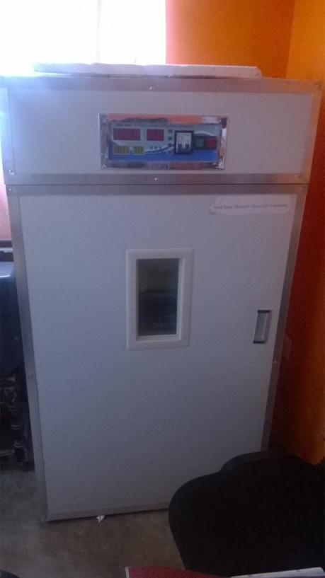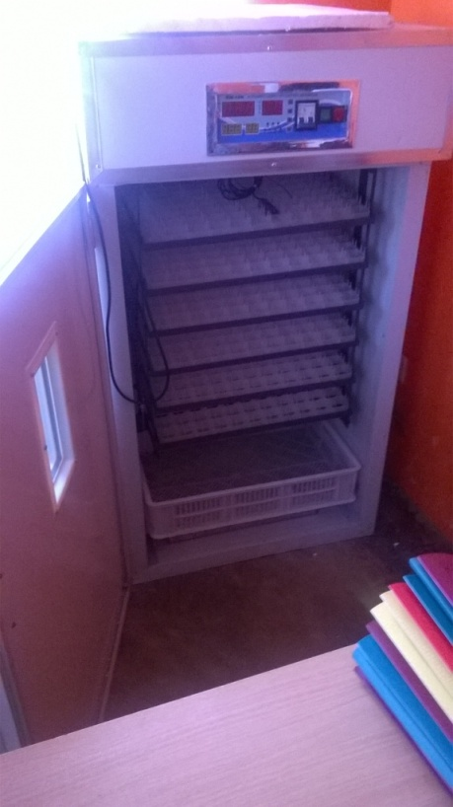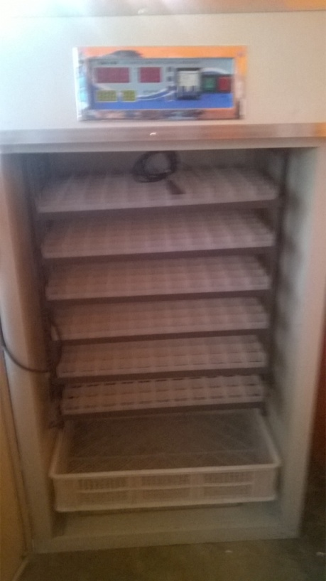
Incubator acquired for agri-business targeting young people with disabilities

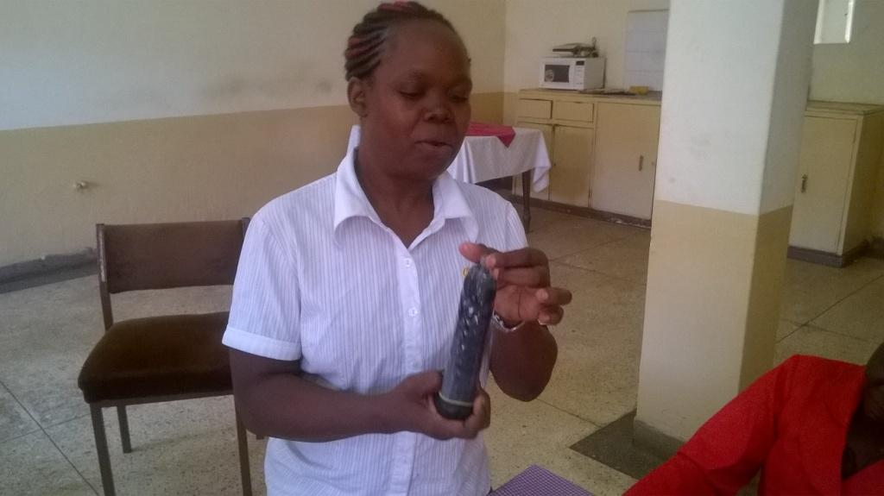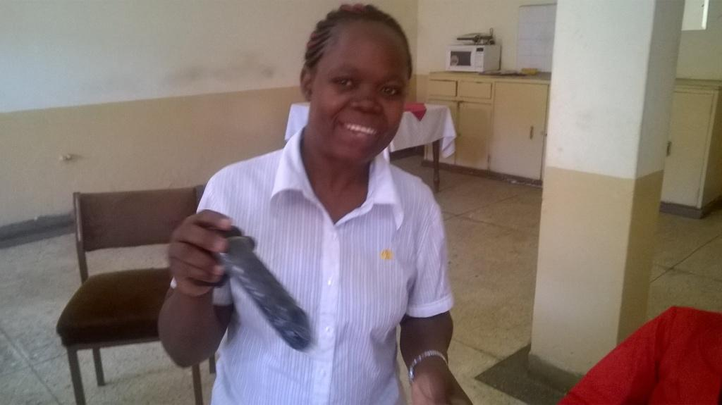

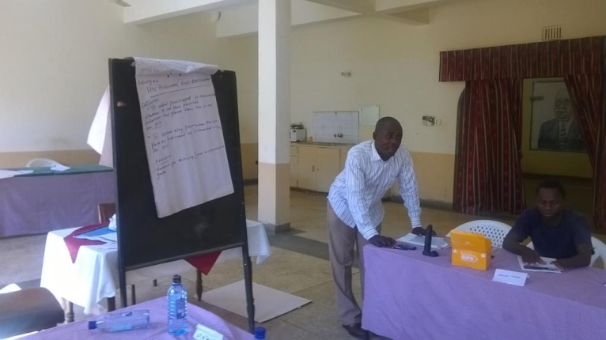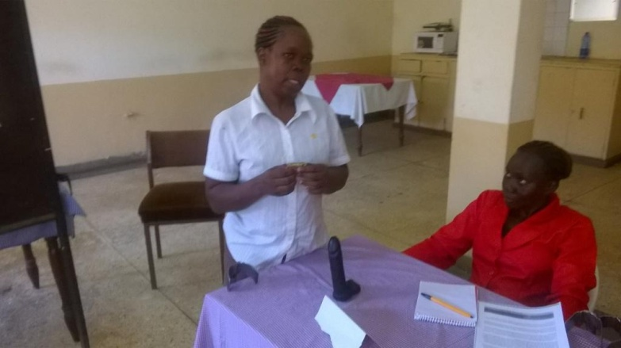
One of participants demonstration proper condom use during peer education training funded by Mercury Phoenix Trust

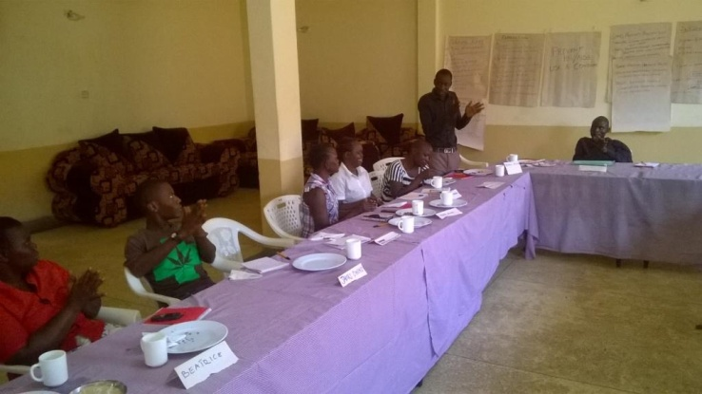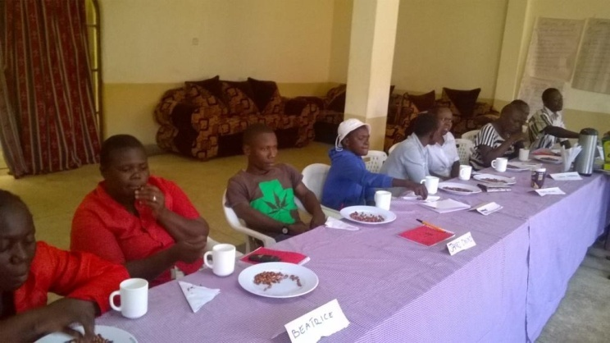

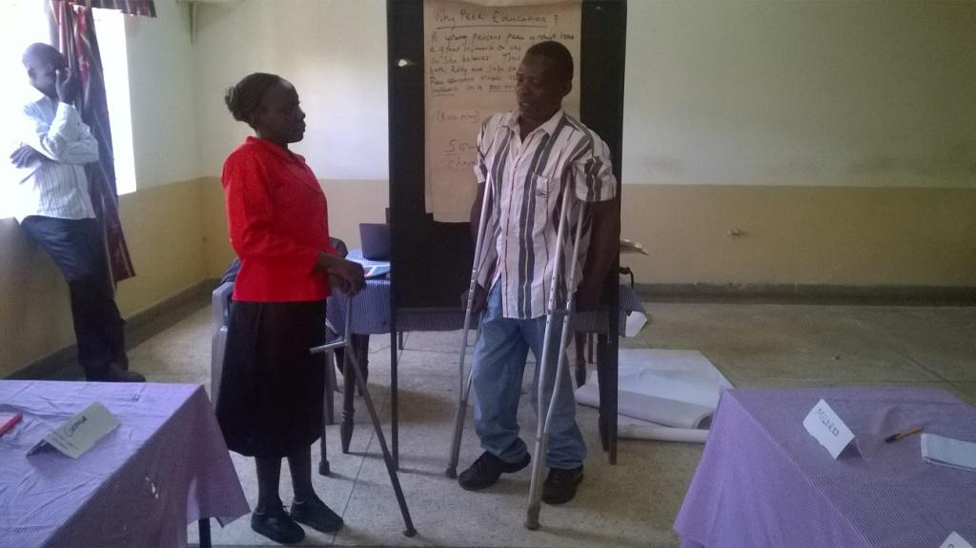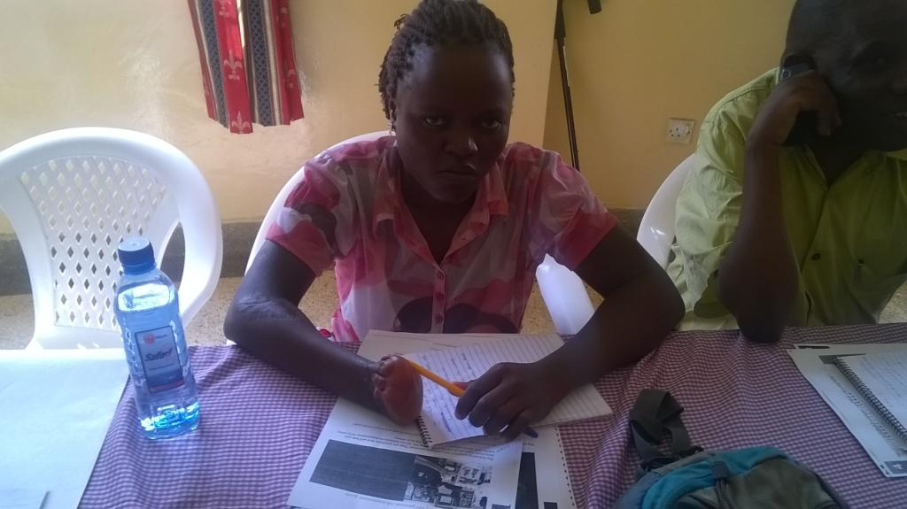

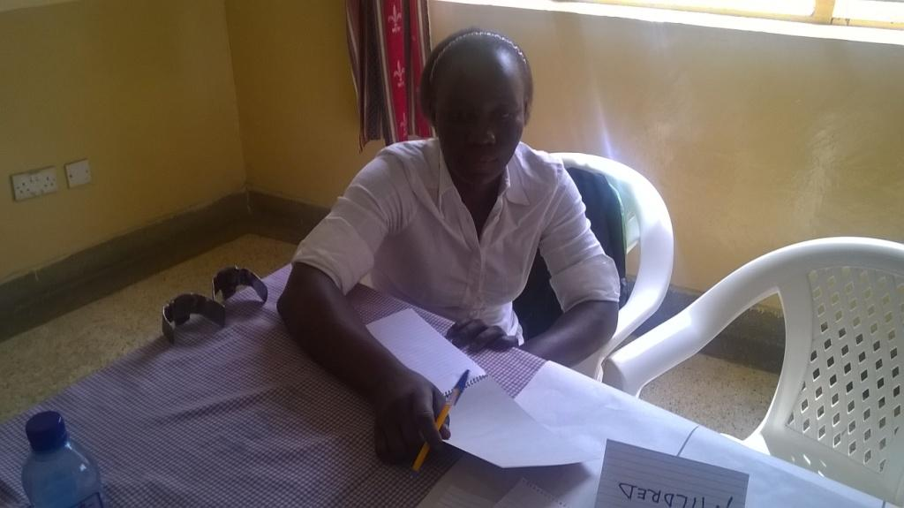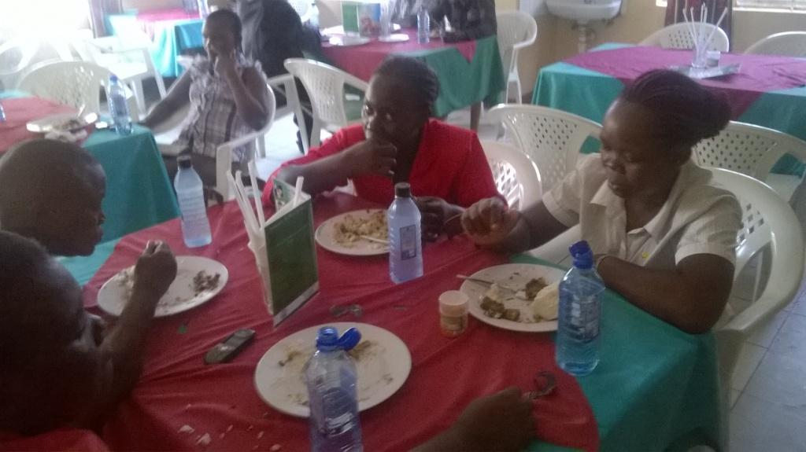

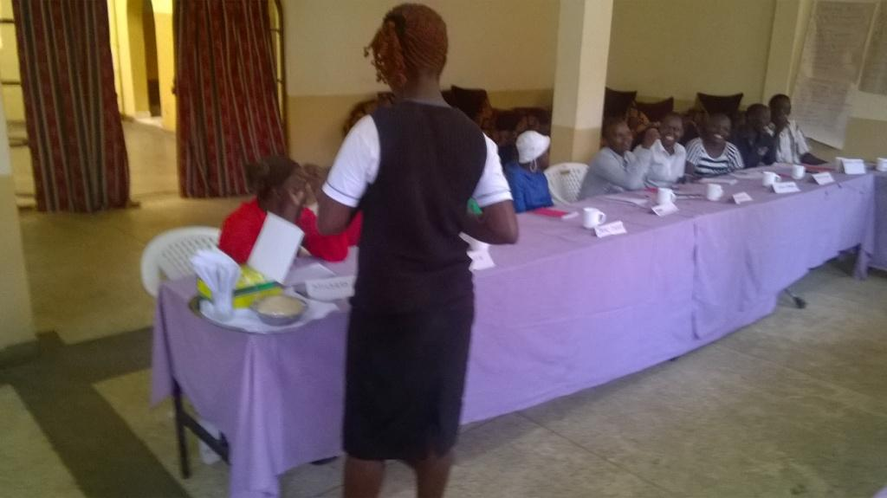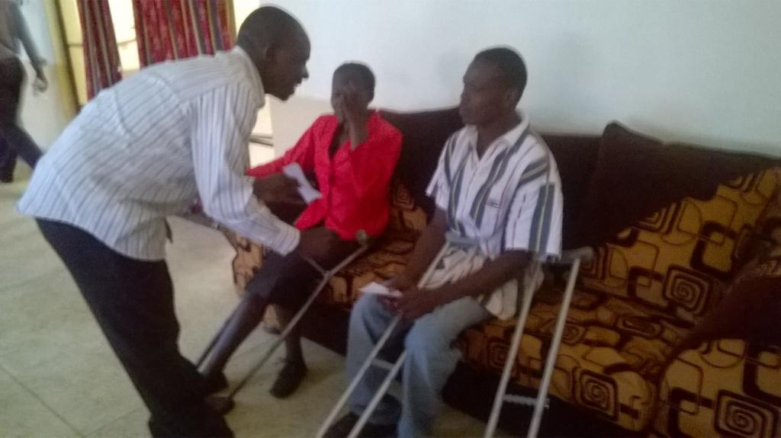
All above was photos taken during peer education training

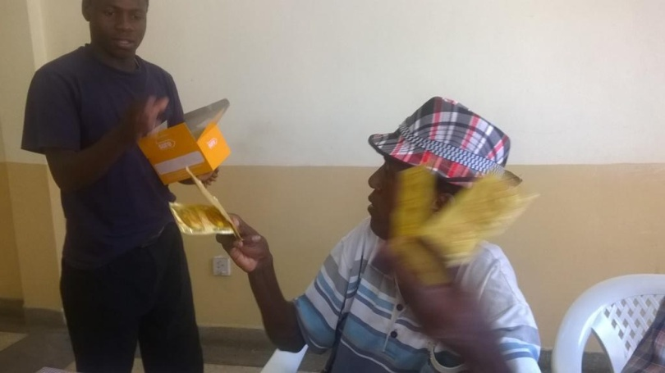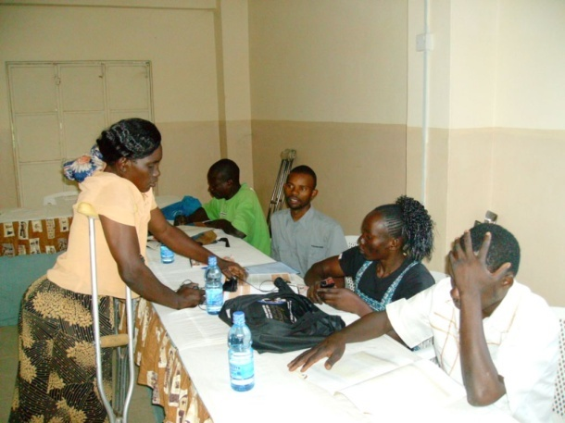
Condoms distribution session Group work

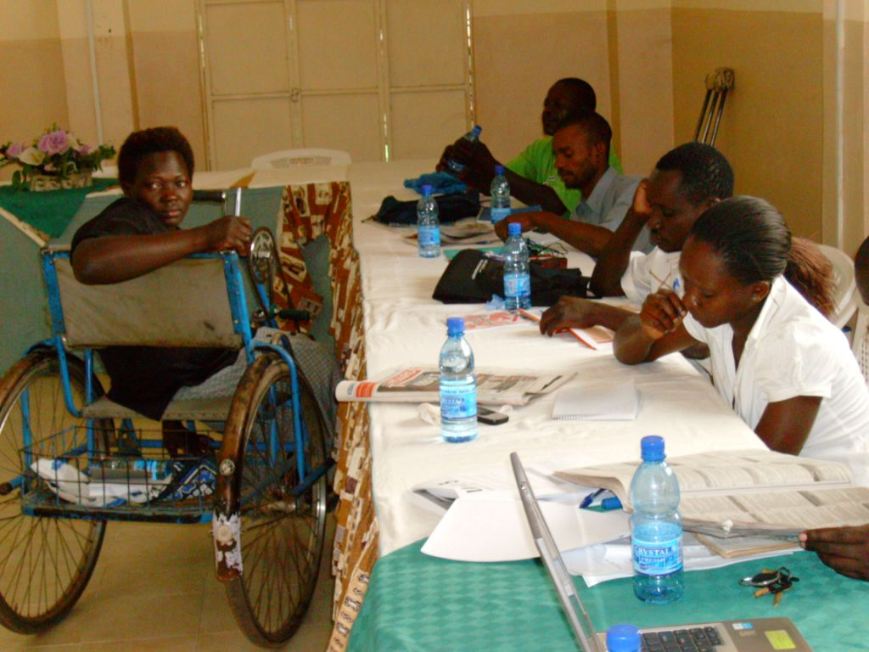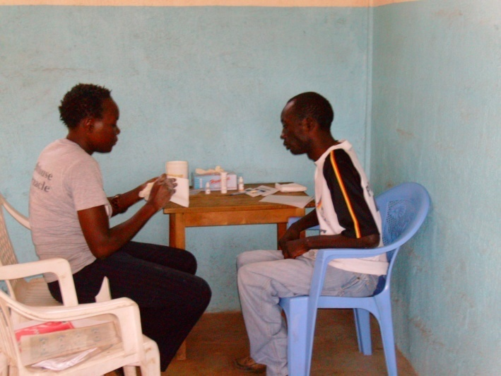
Young disabled man taking HIV test

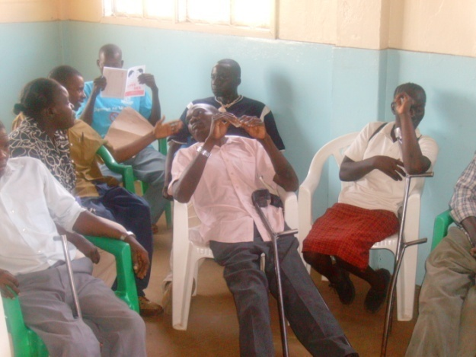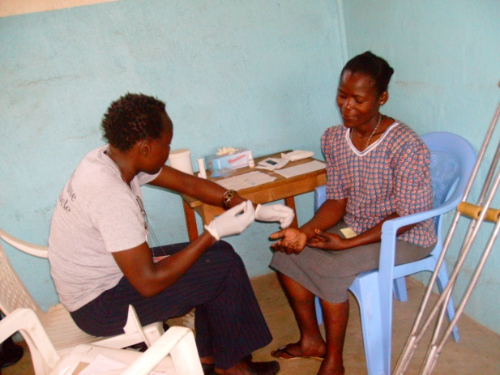
A community outreach session Youth with disability during HIV test
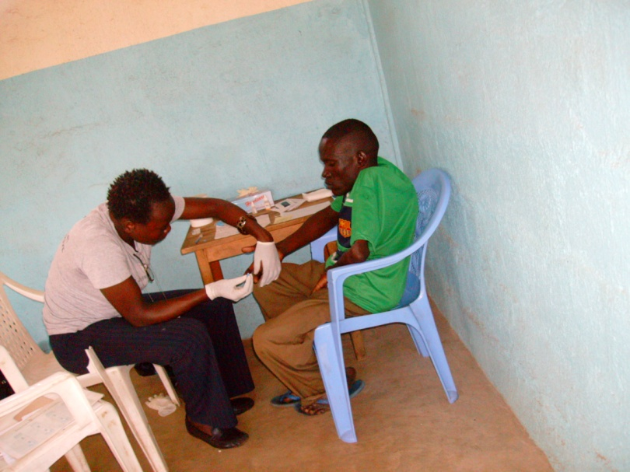
Youth with disability taking HIV test during VCT promotion forum

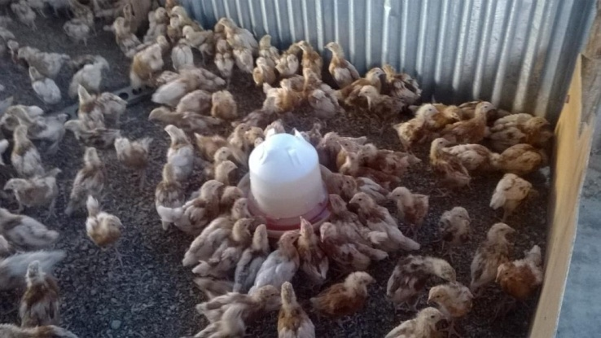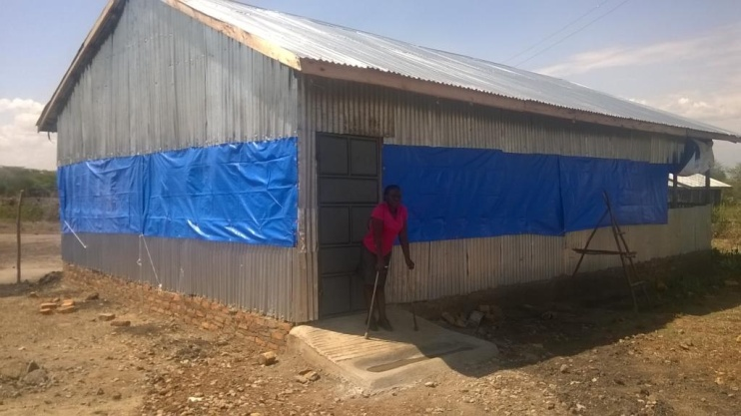

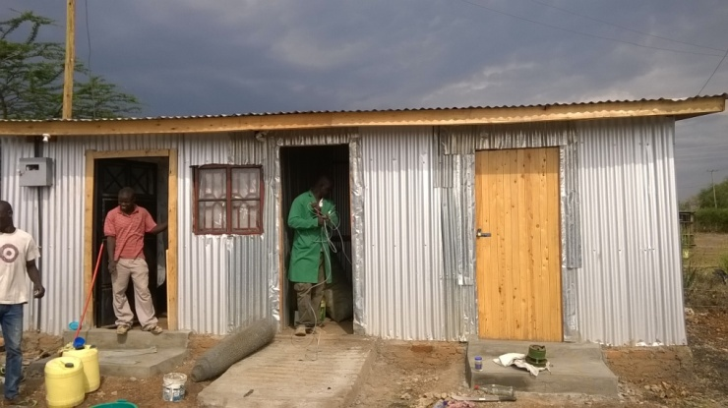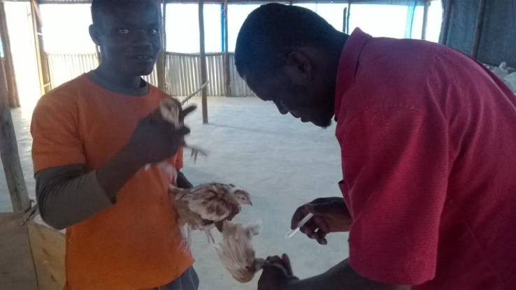

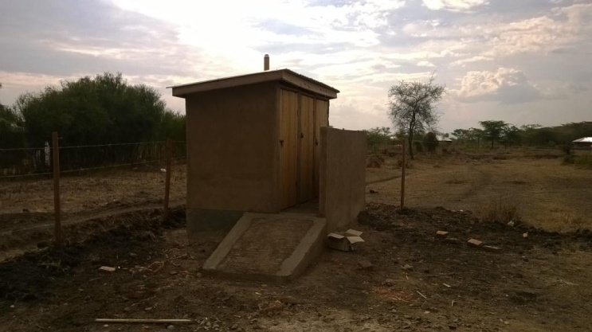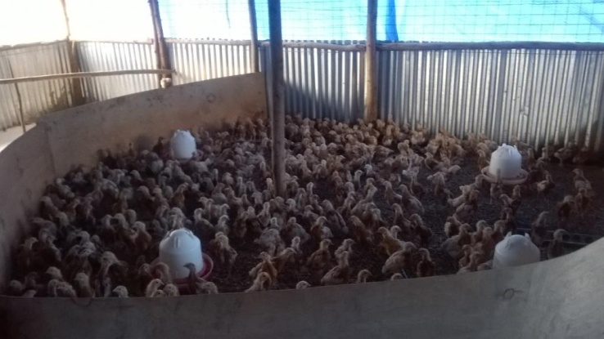
All above are photos of our social enterprise investment project

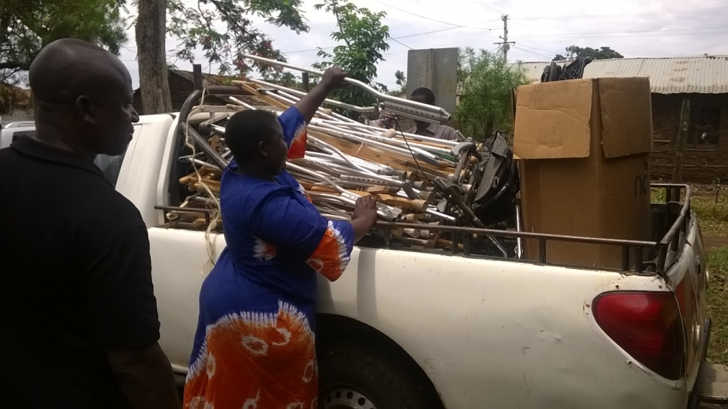
Vehicle donated by Kisumu County Representative for people with special needs, she is assisting in loading the van in preparation of distribution of mobility devices within the County of Kisumu

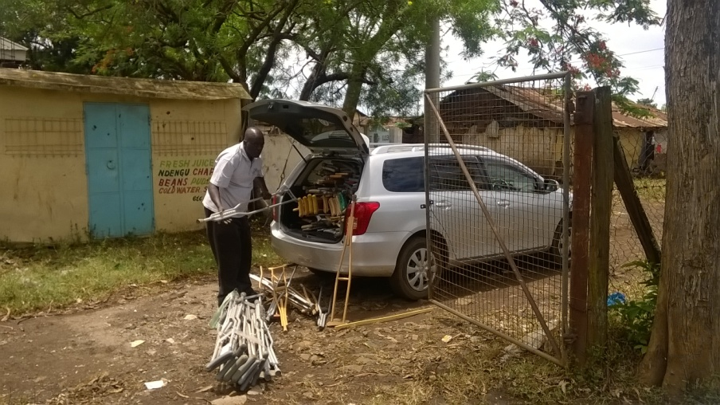
We had to also use small car donated also by the County Representative. This clearly shows the need for van for the organization

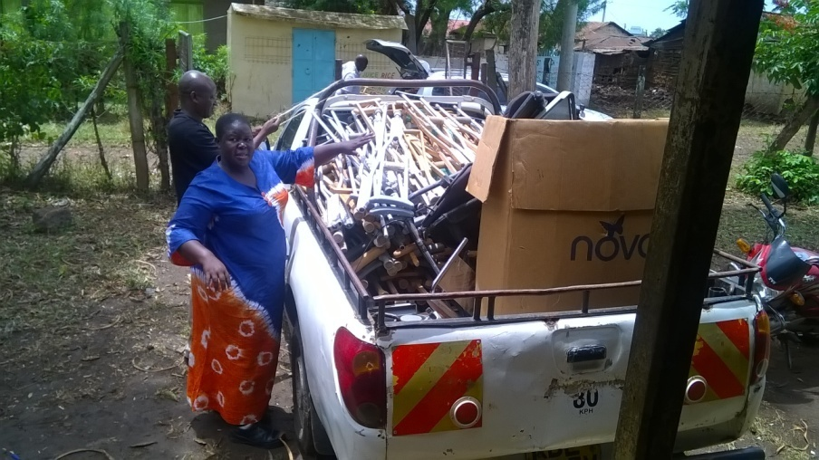

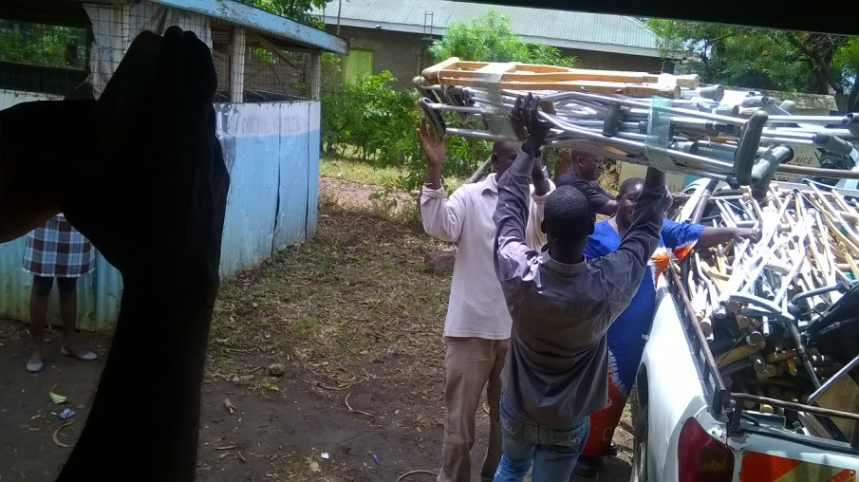

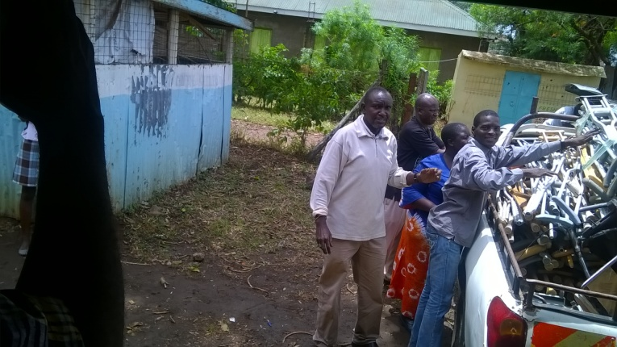
Other members of our organization and the community assist in loading the van

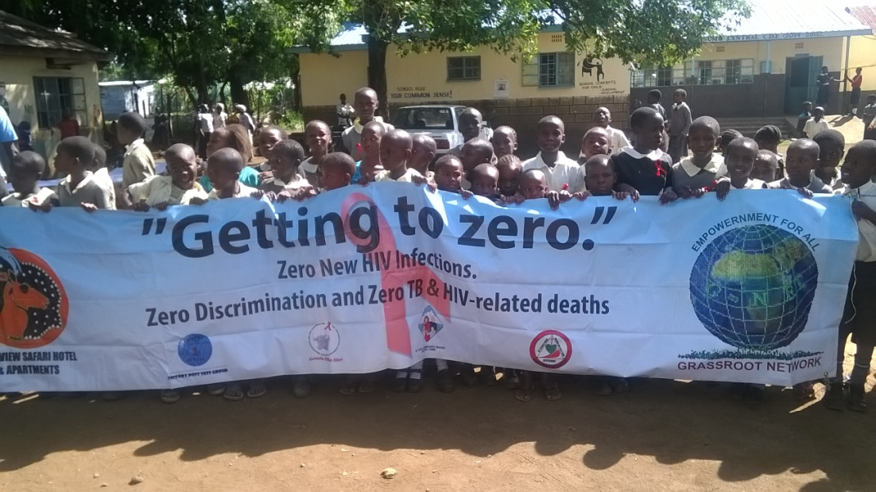

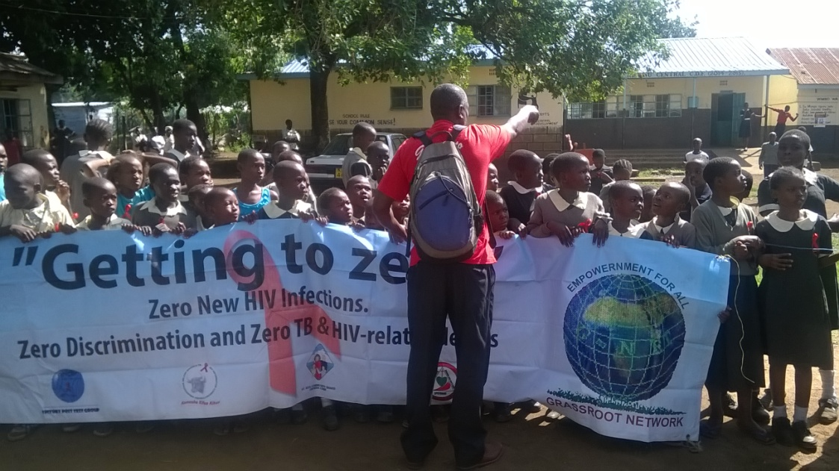

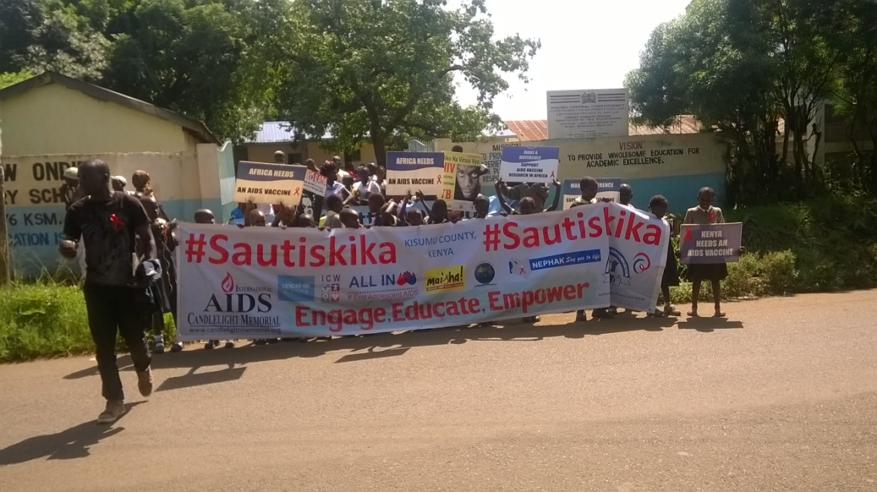
All the three photos above were taken during International Candle Light Memorial celebrations which are done to remember those who succumbed to HIV/AIDS. Our organization participates fully. This event brings together different organizations for a common goal. 2016 celebration was done in a school.

Past projects photo gallery

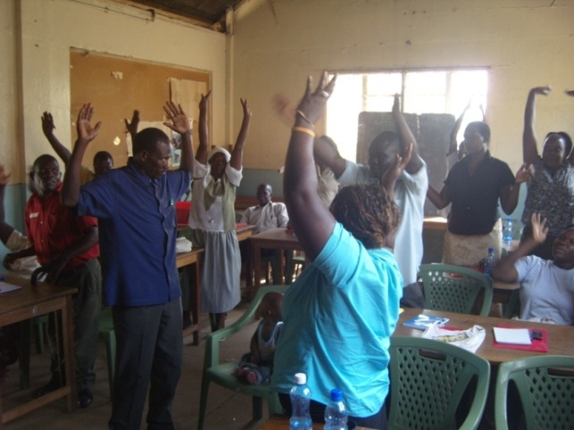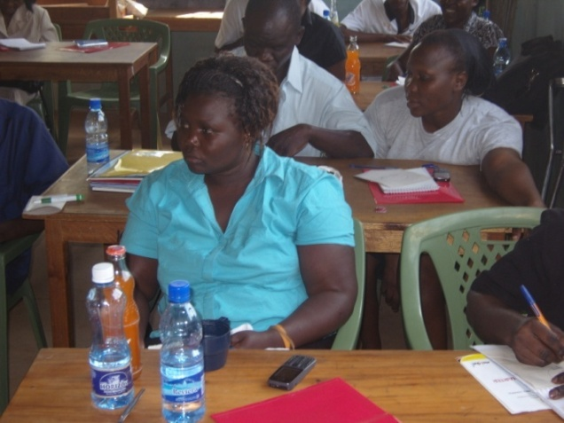

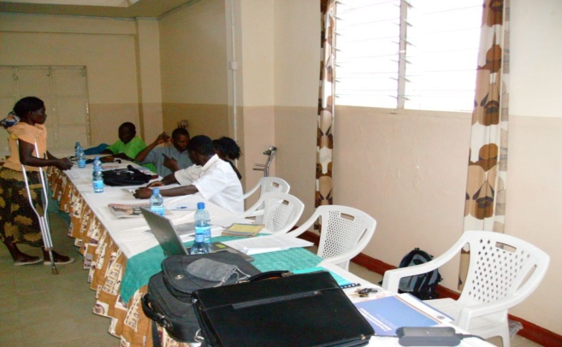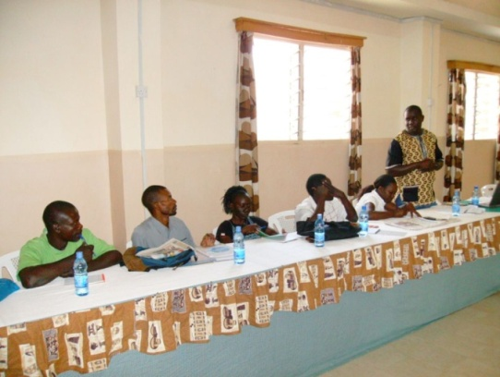

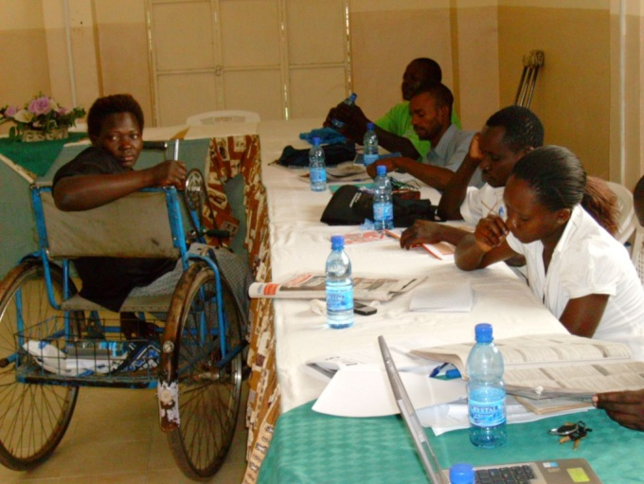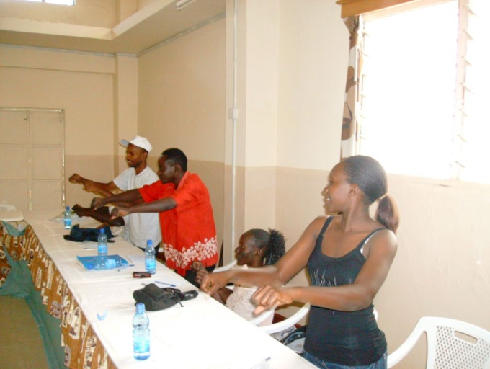
Opinion leaders training in our past programmes

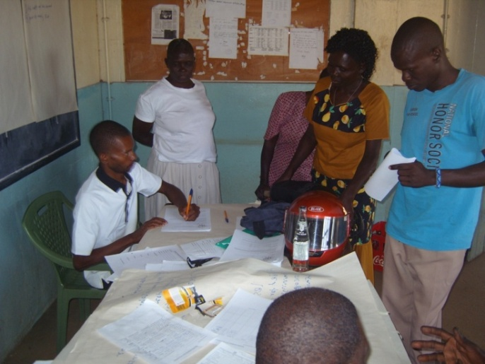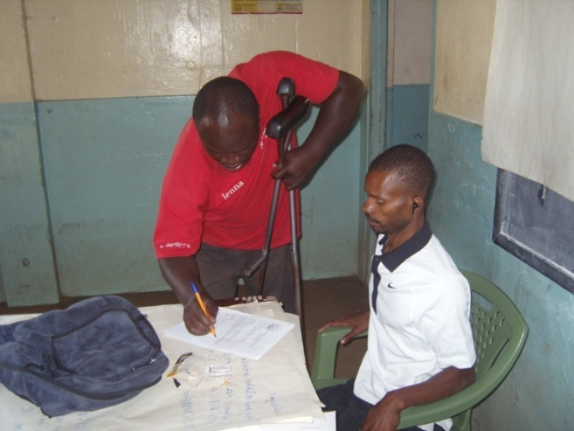

Loaning process

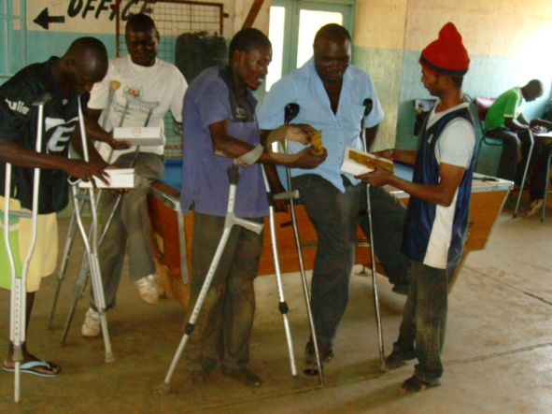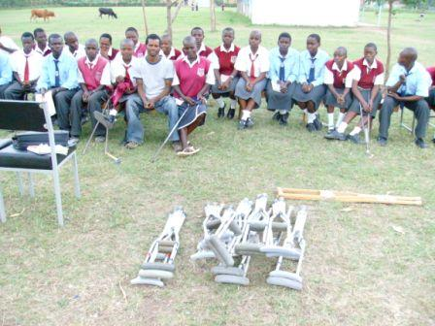
Distribution of condoms Joyland special school health club members

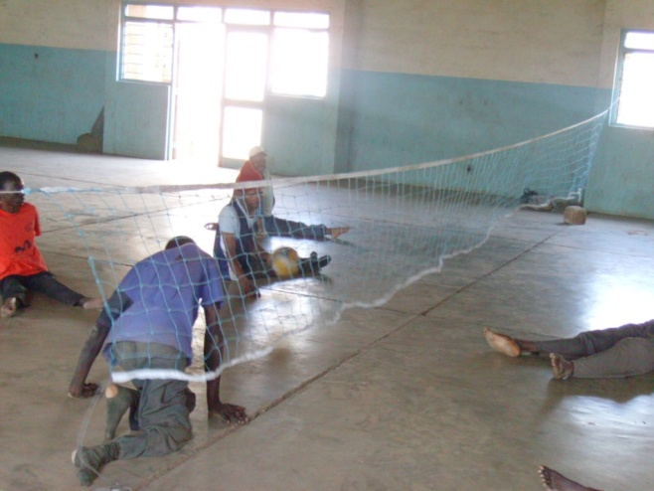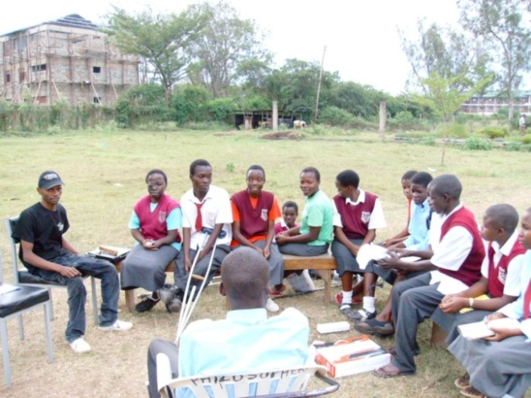
Sitting volley ball match sponsored by KIDSEG Health club members

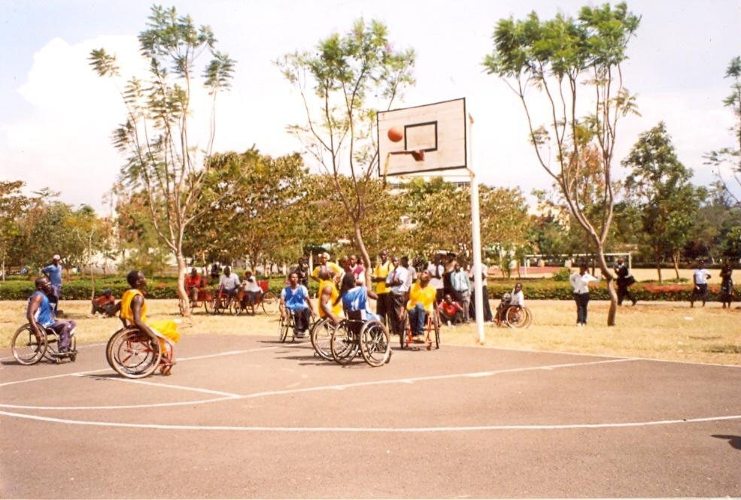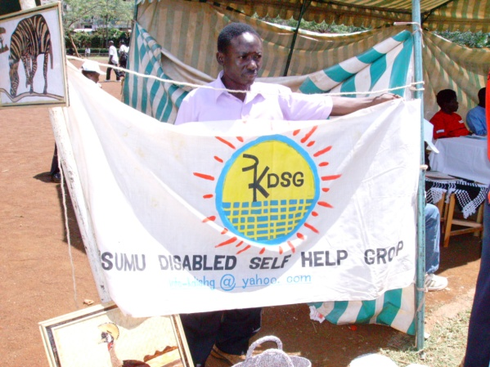
Wheel basketball tournament organized by KIDSEG One of our members during trade fair

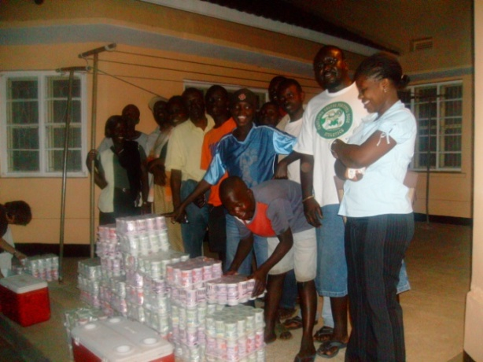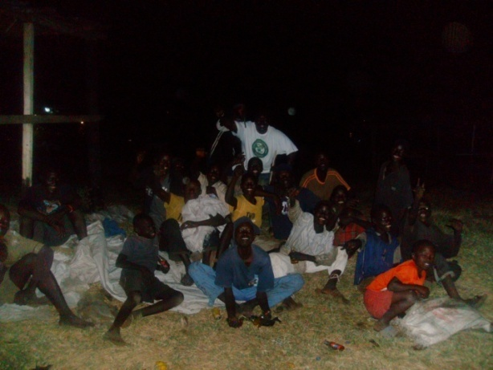
KIDSEG members feeding street children

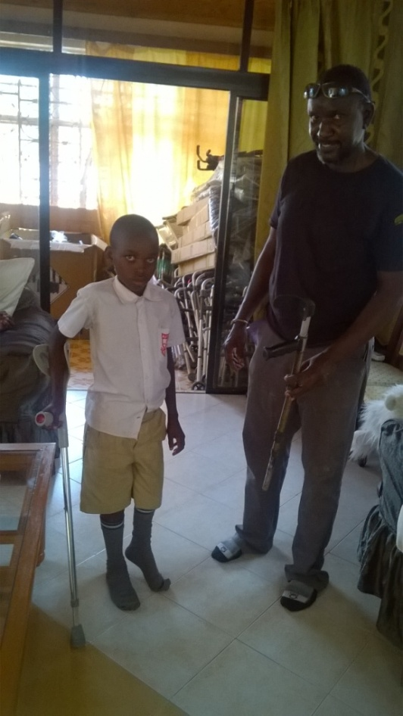
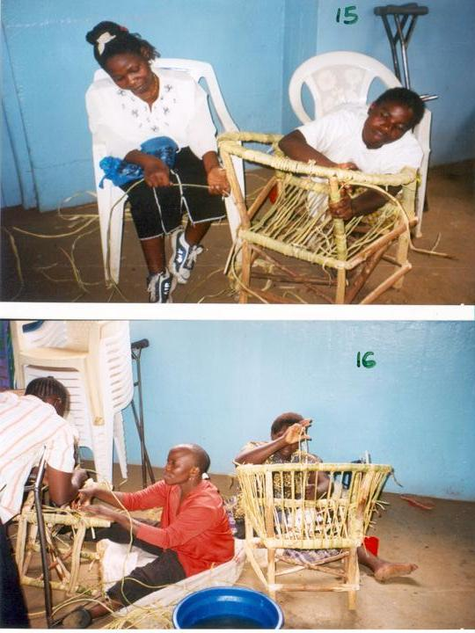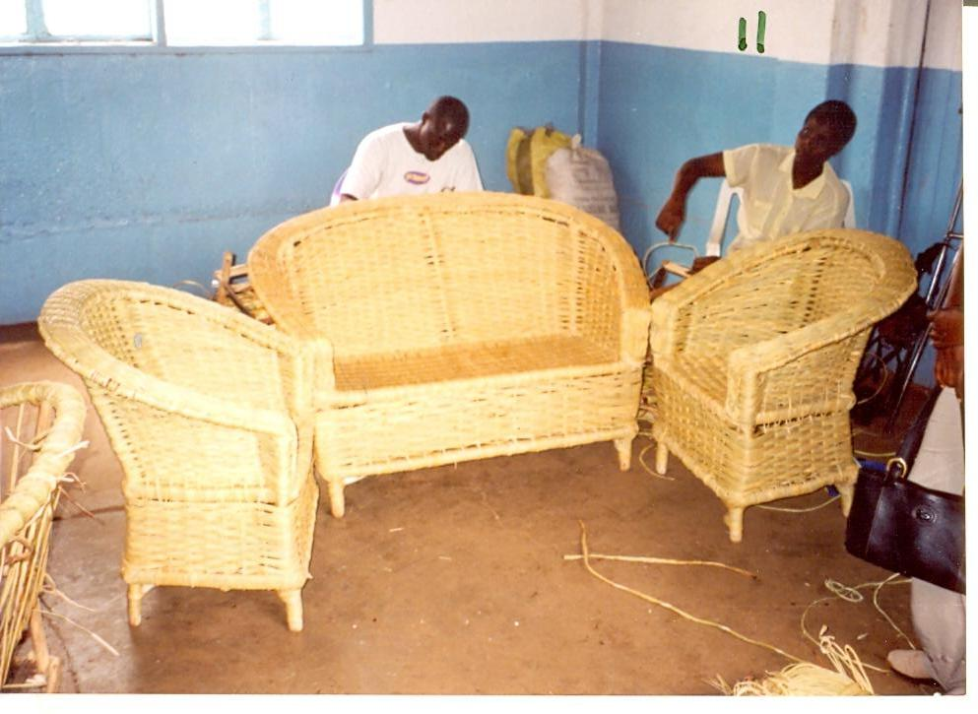

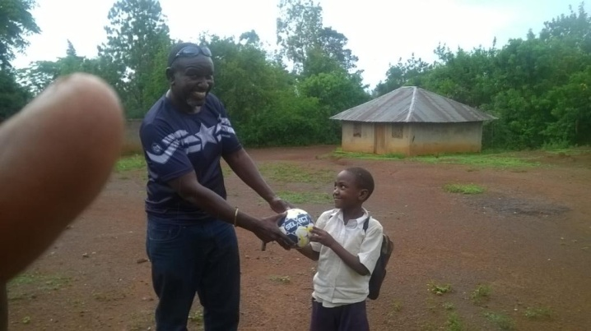
KIDSEG donates balls to children from needy families

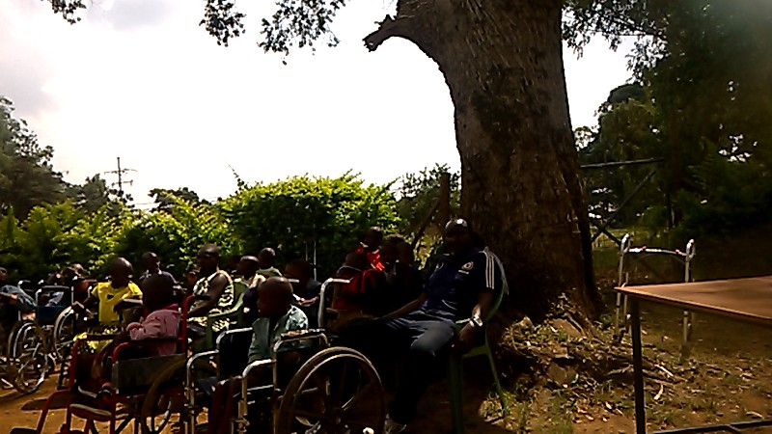
KIDSEG pays a visit to Sigomre Home for Children with Disabilities

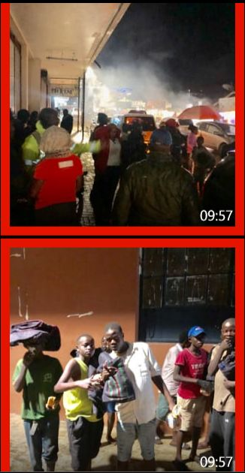
Street children recieving blankets from KIDSEG and EOCF during rainy season

Our income generating activity
Contact:
Kisumu Disabled Self help Group
P.O.Box 8080 – 40142
Kisumu
Kenya
Tel: +254733917683, +254726513002
Email: info@kidseg.co.ke / info_kdishg@yahoo.com
Website: www.kidseg.co.ke

