

CHEDE COOPERATIVE UNION LTD
Reg. No. SW/UC/25/03/3655 TP No. M121000038392C
P.O. Box 20 Bangem . Kupe Muanenguba . South West Region
Food Processing and Marketing: P.O. Box 9743 Douala

Email: chede@chede.org Website: www.chede.org
Tel: +(237)233 390 678/ 679 548 929/653 758 573/671 446 200

TO WHOM IT MAY CONCERN

PHILANTROPIC DEVELOPMENT CENTRE
(PIDEC)

I, the undersigned Dr Michael Njume Ebong, Chair of the Board of Directors of CHEDE COOPERATIVE UNION LTD, which is an umbrella organization of village-based primary farmer cooperative societies with an aggregate membership of over ten thousand farmers in the South West Region of Cameroon, hereby attest that I have known and worked with the Philantropic Development Centre (PIDEC) in Bangem, Kupe Muanenguba Division in the South West Region of Cameroon for several years as executing agency for projects designed to strengthen the technical capacities of women farmers in the production, processing and marketing of cassava products. One common drawback of these projects has been limited availability of efficient cassava processing machines.

I further attest that PIDEC’s performance in all cases has been entirely satisfactory and that the personal and professional integrity of Mr Marcel Ngole, its Executive Director, has been unimpeachable.

The present attestation is issued at the request of PIDEC to serve all intents and purposes consistent with the Law.

Done in Bangem on this day of 27 May 2019
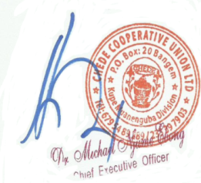

Dr Michael Njume Ebong
Chair of the Board of Directors

