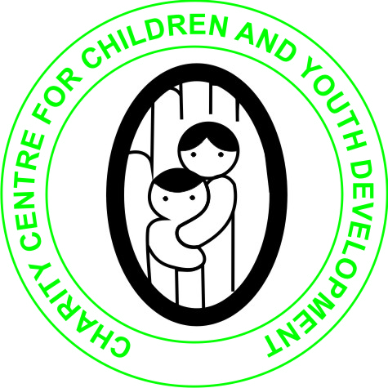

CHARITY CENTRE FOR CHILDREN AND YOUTH DEVELOPMENT

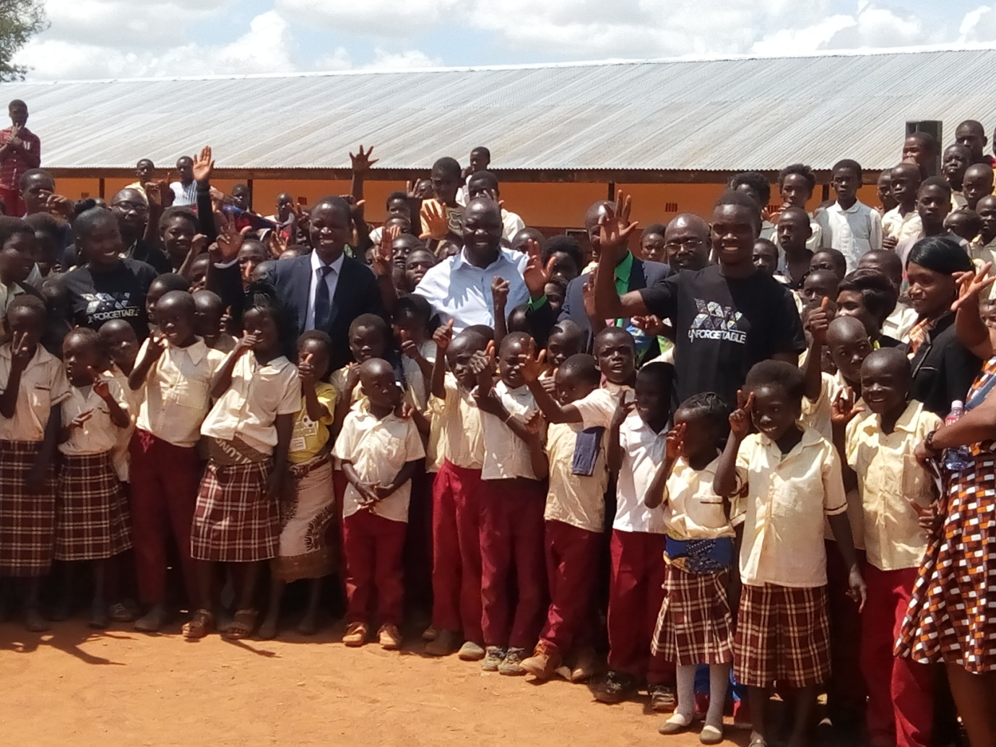

**ORGANIZATION PROFILE**

|  |  |
| --- | --- |
| **NAME OF THE ORGANISATION** | Charity Centre for Children and Youth Development |
| **DATE OF ESTABLISHMENT** | 28th May 2005 (Kasempa District) |
| **REGISTRATION WITH REGISTRAR OF SOCIETIES IN SOLWEZI DISTRICT** | 3rd September 2010, **Registration No. ORS/102/41/434** |
| **DATE OF NEW REGISTRATION WITH THE NGO ACT OF 2009** | 5th May 2014,  The organization is migrated and legally registered with the Zambian Government under the Registrar of NGOs Ministry of Community Development and Social Welfare. **Registration NO. RNGO 101/0253/14** |
| **CONTACT ADDRESS** | Postal Address: P.O BOX 110048  Solwezi  Zambia  10101  Physical Address: Kansanshi Mine smelter Road off Mutanda Road  Plot No. 17686, Humphrey Mulemba Villa Park    Tel/Cell: +260 976 737377 or +260 955 737377  Email: [info@charitycentreforchildren.org](mailto:info@charitycentreforchildren.org)  Website: <http://www.charitycentreforchildren-zambia.org> |
| **CONTACT PERSON** | Alex Bwaluka  Executive Director  +260 976/955- 737377  [alexbwaluka@yahoo.co.uk](mailto:alexbwaluka@yahoo.co.uk)  skype: alex.bwaluka14 |
| **DESCRIPTION OF THE ORGANIZATION** | Charity Centre for Children and Youth Development (CCCYD) is a Non-profit, Non-political and Nonreligious Organizations which was established to help Orphans and vulnerable children (OVCs), Youth, women and persons with physical challenges improve their standards of Living through the provision of several life skills, education support, HIV/AIDS awareness and prevention, provision of micro-entrepreneurship skills and soft loans as well as material support. |
| **VISION OF THE ORGANIZATION** | We envision a society that will work towards eradication of poverty, HIV and AIDS, illiteracy among Orphans and vulnerable children, youths and women in Society. |
| **MISSION OF THE ORGANIZATION** | The Organization's mission is to promote and enhance the capabilities of children, youth and women in Zambia and beyond to effect positive social change that would necessitate the development of their lives, communities and the nation at large |
| **OBJECTIVES OF THE ORGANIZATION** | * 1. To promote access to quality education to the under privileged and empower them for being responsible citizens.   2. To support the orphans, the displaced, widows elderly and the physically hand caped with essential items and provide sustainable source of living.   3. To help young people discover their skills competences and talents that will enable them become responsible citizens.   4. Promoting and encouraging education to families affected by HIV/AIDS especially orphans left through provision of school fees, uniforms, scholastic materials to re-enter formal schoolings.   5. Under take children’s rights and gender awareness campaigns and community sensitization and training on gender issues so as to promote gender equity.   6. To support girl child education by linking them to organization that give scholarships from any part of the world.   7. To train the youth with practical and vocational skills that will help them meet the job market of new technologies. |
| **GOVERNANCE OF THE ORGANIZATION** | * **BOARD OF DIRECTORS**   The organization is made up of all persons who have agreed to promote and foster the aims and objectives of the organization. We have the Board of Directors comprising of five (5) members which is the policy organ of the organization. The Board headed by the Chairperson and seconded by the Vice chairperson. The rest are board members. The Executive Director in an Ex-official in the board.  **Board Chairperson Ms Precious Kasewenta**   * Diploma Zambia Registered Nurse- General Nursing Council of Zambia.   **Vice Chairperson - Mr Peter Mung’omba**   * Grade Twelve (Community Representative)   **Board Member – Ms Diana Mutete Kapende**   * Diploma in Social Work * Certificate in Psycho- social counselling   **Board Member Ms Carine Mafulo Mpande**   * Community Representative   **Board Member – Ms Lydia Malasha**   * Bachelors degree in Development studies * **MANAGEMENT**   The Executive Director who is the founder and Executive Director of the organization is the head of the Secretariat. As such the Chief Executive Officer manage the day-to day operations of the Organization and is in-charge of the Organization’s affairs. CCCYD has at its disposal a pool of human resource (volunteers) with different expertise in counselling, facilitation, advocacy and implementation of different HIV/AIDS activities and care for the orphans and vulnerable children, that could be utilized to provide comprehensive list of services to the community.   1. **Executive Director – Mr Alex Bwaluka**  * Holder of a Bachelors Degree in Development studies, * Diploma in Social Work * Single Subject Diploma in Business Management and Administration. * Certificate in Psycho-social Counselling  1. **Programs Manager – Ms Kapampa Kapeya**  * Diploma in Social Work * Currently pursuing a Bachelors Degree in Development Studies * Certificate in psycho-social counselling  1. **Finance and Human Resource Manager – Mrs Monde Siwale Reischer**  * Bachelors Degree in Business Administration * Diploma in Marketing * Advanced Certificate in Marketing * Certificate in Marketing  1. **Accountant - Mr Given Mulemba**  * Diploma in Auditing  1. **Community Mobilization Facilitator – Miss Rita Kayembe**  * Diploma in Community Development * Senior Trainer in Financial Literacy |
| **ACTIVITIES AND PROJECTS IMPLEMENTED BY THE ORGANIZATION** | * **Educational support and food supplement to Orphans and Vulnerable children (OVC)**   Provision of educational assistance such as uniforms, jerseys and shoes aims at supplementing the efforts of parents and guardians to meet the needs of the children for them to remain in school and contribute to the nation’s economy if they graduate. Education support is considered to be one of the priorities for the support of OVCs identified by the organization. So far, the organization has provided support to over 900 orphans and vulnerable children since 2011.  C:\Users\ALEX\Documents\2017 pictures\SAM_3230.JPG C:\Users\User\Downloads\17547001_498109433646032_8138997425442882473_o.jpg  Orphans after receiving school bags  Electrification and creation of a computer lab at Chamuta primary school. The organization in 2016 sourced for funds from the Australian embassy to fund the electrification and creation of the computer lab at chamuta prmary school in Solwezi District of Zambia  C:\Users\User\Downloads\17854965_498108776979431_7489903920908421692_o.jpg C:\Users\ALEX\Downloads\18671490_1760015900680851_6795189207788784394_o.jpg  Mr Alex Bwaluka delivering a speech during Pupils Learning Computer skills  the official Handover of the computer lab   * Establishment of Fortune Community School   The organization in 2017 established the community school in order to provide primary education and skills training to orphans and vulnerable children. We received the first support for the construction of 1x2 classroom block from the Edinburgh Global Partnerships (EGP) from United Kingdome. In 2018, we received the second support from the Australian Embassy to construct additional 1x4 classroom block. So far, we have enrolled a total of 348 pupils.  C:\Users\ALEX\Documents\2017 pictures\105PHOTO\SAM_2578.JPG C:\Users\User\Downloads\47162474_2480750741940693_6875757374016061440_o.jpg  Fortune Community School funded by EGP Closing Day 30/11/2018!  C:\Users\User\Downloads\41876461_325525514863094_6052915891497074688_n.jpg  New additional 1x4 classroom block funded by the Australian Embassy in 2018     * **HIV/AIDS Prevention**:   HIV/AIDS is mainstreamed into all the core programs of CCCYD. Since the inception of the organization in Solwezi in 2010, provide HIV and AIDS awareness, prevention, counselling and testing. In 2017, the organization provided counselling and testing to over 2800 people and Distributed over 64000 male condoms within markets and bus stations in Solwezi. We have two mobile Tents and 12 volunteer counsellors who provides static and mobile counselling in Western province  ***C:\Users\ALEX\Pictures\Saved Pictures\105PHOTO\SAM_2218.JPG*D:\DCIM\105PHOTO\SAM_3155.JPG**  **Mobile Tents for HIV Counselling 2017, World AIDS Day!**  **and testing**   * **Supporting persons with Disabilities**:   The organization in 2014 partnered with Crutches 4 Africa from United States who have so far donated over 5000 Mobility devices such as wheelchairs, walkers, Cane, Crutches etc for the support of persons with disabilities and public health institutions in North western province of Zambia  C:\Users\ALEX\Documents\ALEX\GENERAL FOLDER 2016\Distribution pictures\Chavuma3.JPG C:\Users\User\Downloads\10981287_287418244715153_6976379510055398225_o.jpg  Distribution of mobility aids Container full of mobility aids   * **Women and youth micro entrepreneurship**   We provide micro-entrepreneurship through the provision of sustainable and profitable means of livelihoods, training of Income Generating Activities and financial management, support to Orphans and Vulnerable Children (OVCs’) to attain vocational skills and provision of basic start up tool kits to the disadvantaged women and the youth in the community. So far, We have provided small loans as well as financial literacy trainings to over 275 women and Youth in North-western province. Savings Bank Foundation for International Cooperation has been supporting us with the provision of Micro Bus  H:\DCIM\105PHOTO\SAM_2997.JPG C:\Users\User\Downloads\17620535_493499807440328_4346645613456446272_o.jpg  Training Women in Financial Literacy education  Our organization in November 2018 partnered with Planet Startup Inc a volunteer charitable organization, listed as a 501(c)(3) public charity by the Federal Government in the United States. The purpose of our partnership is to establish and implement an alliance for supporting emerging entrepreneurs to become leaders in Zambia by starting and growing their own companies through an online and local training and mentoring program on entrepreneurship. The training period is three months and once per week for one to two hours.  C:\Users\User\Downloads\46447546_2464821136866987_8724289101823475712_n.jpg C:\Users\User\Downloads\46453174_2464820950200339_5767121861313822720_n.jpg  Online US based Entrepreneurship training in Mongu District Western province of zambia   * **Vocational Skills Training.**   In addition to primary education, the organization is also providing employable vocational skills. This will help orphans and vulnerable children (OVCs) to continue vocational education and find decent employment opportunities and protect themselves from risky vulnerable situations. Curriculum includes Tailoring, cutting and design, Carpentry and Joinery, Knitting, Computer Skills MS-Office, Internet; Communicative English with reading and writing skills, Photography skills  C:\Users\User\Downloads\25488248_2004070789608693_3091208667241960800_o.jpgC:\Users\User\Downloads\194376_208705719145218_4434519_o.jpg  Knitting Skills student Knitting and Tailoring students  **COMMEMORATION OF GOOD DEEDS DAY AND OFFICIAL LAUNCH OF FORTUNE VOCATIONAL ACADEMY AND COMMUNITY SCHOOL IN SOLWEZI DISTRICT OF ZAMBIA HELD AT FORTUNE COMMUNITY SCHOOL ON 5TH APRIL 2019.**  Good deeds day is an annual tradition of celebrating good deeds. All over the world, scores of people choose to volunteer and help others, putting into practice the simple idea that every single person can do something good, be it large or small, to improve the lives of others and positively change the world.  Good deeds day was initiated in 2007 by a businesswoman and philanthropist, shari arison. She said this; “i believe that if people will think good, speak good and do good, the circles of goodness will grow in the world.”  C:\Users\User\Desktop\Pictures 2019\IMG_20190405_130620.jpg  **Group photo with the quest of Honor Mr Fulwe DAO for Solwezi during the commemoration of good deeds day and official launch of the school.**  **C:\Users\User\Desktop\Pictures 2019\IMG_20190405_122330.jpg**  **Children performing Art and Culture during the commemoration of good deeds day and official launch of the school**  Fortune vocational academy/ Community School is providing primary education from grade one to seven. However, our main purpose for establishing this school is to offer vocation skills training to orphans and vulnerable children such as, tailoring, knitting, carpentry and computer skills. Through these skills, individuals can go on to support their families who currently lack access to basic needs such as adequate food and shelter. The school will also offer online entrepreneurship skills and exchange programs once power and internet is connected.  As part of good deeds day, the organization shared meals with orphans and vulnerable children and part of doing good for others.  C:\Users\User\Desktop\Pictures 2019\IMG_20190405_142201.jpg  **STORY OF THE FOUNDER!**  *I am Alex Bwaluka, I am the founder and executive director of Charity Centre for Children and Youth Development (CCCYD) in Zambia. After my mother gave birth to me when she was 15-years-old, she dropped out of school. Later, my father abandoned her. I came to know my father when I was 15 years old, but he still refused to be responsible for my education or involved in my life. I had decided that I would support myself and began to attend school at the age of twelve. In order for me to raise money for my education, I started running a small business selling chicken and goats. I walked eight days from Kasempa, Zambia to Kipushi in the Democratic Republic of Congo to sell either chicken or goat. In spite of the struggle, I was resolute and did not look back until I finished school in 2004. In December 2016, I completed my bachelor’s degree in development studies at Zambian Open University and graduated on 1st September 2017.*  *My life history led me to form CCCYD in 2005. I was determined to make things different for women and children who shared challenges similar to my mother and me. Since 2005, our team has worked with hundreds of people, sending orphans and vulnerable children to school, and providing vocational training and microloans to local women. In our current project, we are helping more than 275 orphan caregivers and youth with business skills. We have also established a community school and providing basic education to over 300 orphans.*  *We identify the poorest self-employed parents who are unable to earn enough money and live in extreme poverty due to lack of small investment capital or skills. To grow their micro-businesses, we provide these families with hands-on coaching and $50 small loans to grow or start their business. We help them increase productivity and earn higher incomes. It all helps to pull children and families out of extreme poverty in a sustainable way. I am writing this to you so that you can understand why I have offered my time for others and how you can help me continue with this cause. I want to continue building self-reliance and resilience in the most vulnerable children caregivers through the continued provision micro-entrepreneurship and help provide education by paying teachers’ salaries, provide infrastructure at our fortune community school. I have changed my life through education, and I know the potential education has in changing our world. If you feel you are in a position to help, kindly get in touch with me!*  *Plot No 17686, Humphrey Mulemba Villa area, along Kansanshi Mine smelter Road.*  *P.O. Box 110046,*  *Solwezi, Zambia.*  *Email:* [*info@charitycentreforchildren.org*](mailto:info@charitycentreforchildren.org)*, or* [*alexbwaluka@yahoo.co.uk*](mailto:alexbwaluka@yahoo.co.uk) *Website:* [*www.charitycentreforchildren-zambia.org*](http://www.charitycentreforchildren-zambia.org) *Cell +260965737377(Whatsapp line) Skype: alex.bwaluka14 Twitter: @CHARITYCENTRE* |

***We strive to touch lives and creating a better future for children in Zambia!***