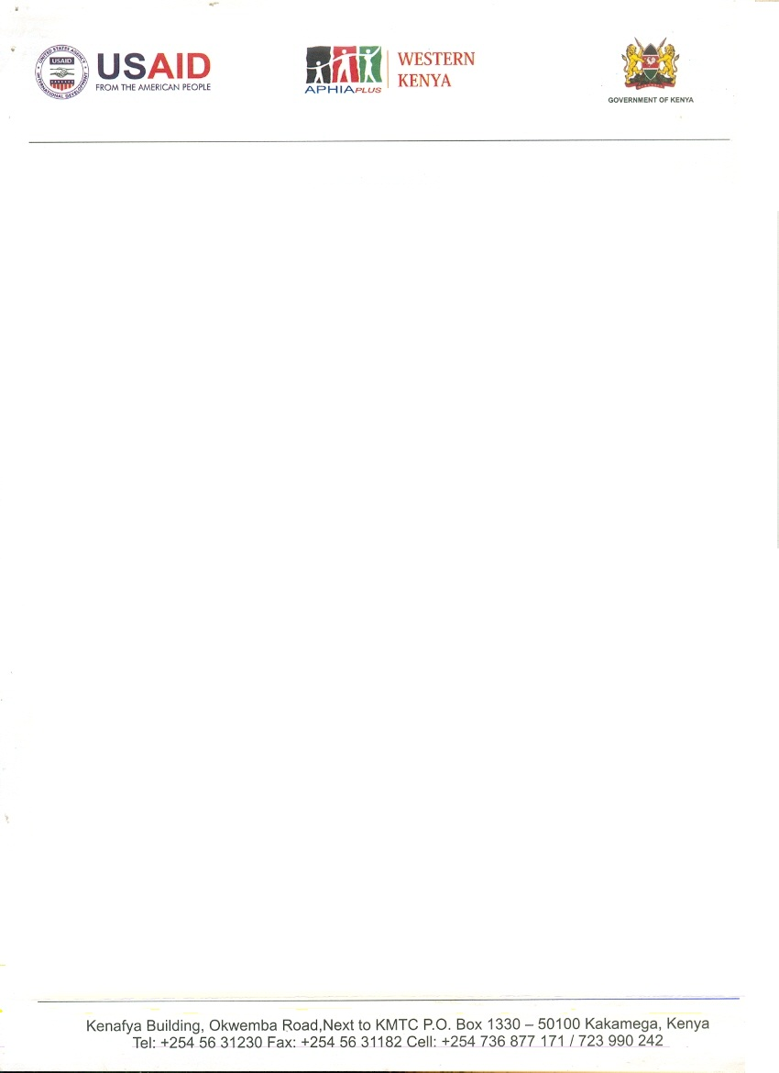

**World Connect 11th/07/2019**

Dear sir/ madam,

**RE: NAMIKHAMA DAIRY SELF HELP GROUP**

I do hereby recommend the above mentioned Organization. They are recognized in the community for their great work and experience in HIV/AIDS and value chain development. We have collaborated with them especially in HIV/AIDS, fruit tree seedlings and value addition of the same in Western Kenya. They are known of their best work in the community.

Kindly support them in any way you can. Should you have any question about them please feel free to contact me.

Respectively yours,

Mrs. Viola J. Ruto,

Technical specialist,

Social Determinants of Health,

APHIA PLUS

Email – [vruto@aphiapluswesternkenya.org](mailto:vruto@aphiapluswesternkenya.org)

Tel: +254721380045