**GREEN UHURU: Environmental Friendly Community and E-waste entrepreneurship**

Working with the community providing services, training & products like fuel eco-briquettes while we protect the local environment.

**Written by**[**Dieudonne Mudekuza**](https://challenges.openideo.com/profiles/greenuhuruorganization)

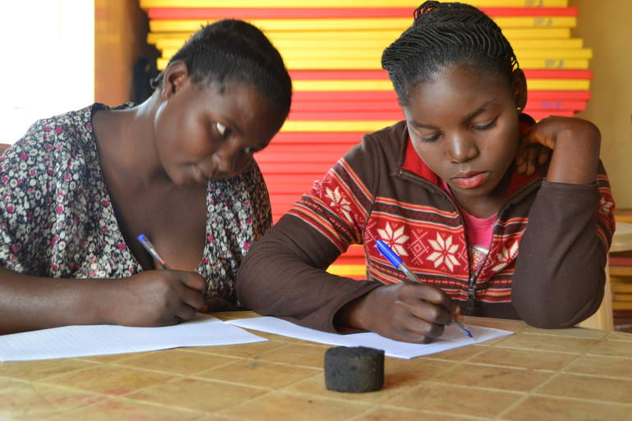

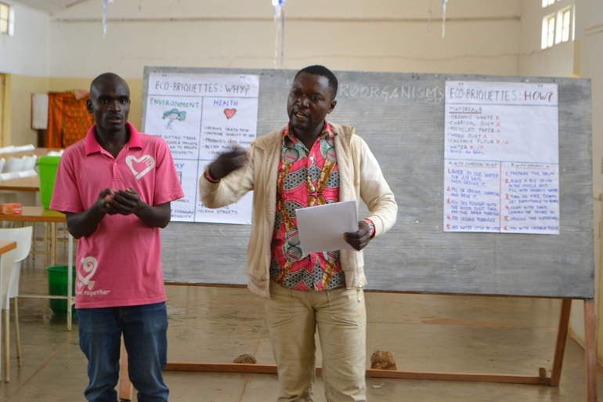

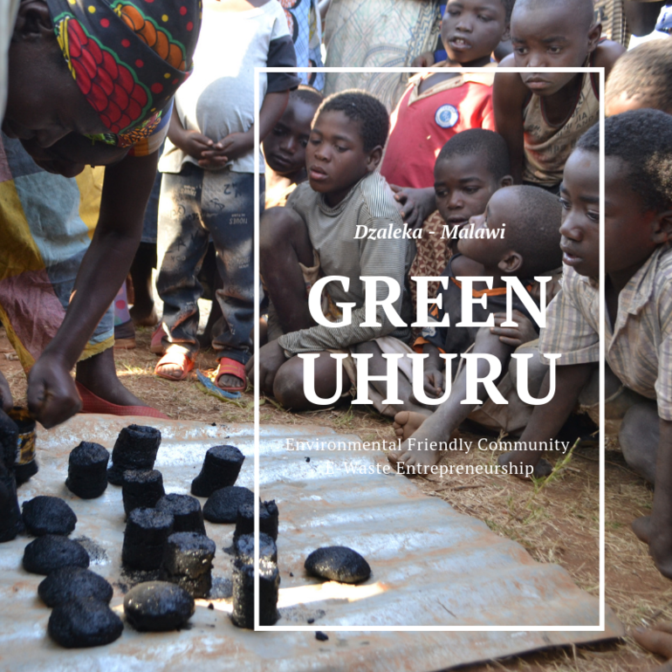

**What problem does the idea help to solve and how does your solution work?**

The problem is not only one, but several, starting from the extreme impacts of Climate Change and deforestation in Malawi, what affects especially the refugees and the people in the rural areas, more especially women. This issue, add to the lack of electricity and charcoal, makes the process of cooking a really hard and long task for thousands of women. From our Community based organisation, some of our solutions we see and we are implementing are: 1. Education and awareness. 2. Recycling project and reusing of waste materials. 3. Production and selling of cheap and accessible fuel for cooking. 4. Creation of jobs and occupation opportunities.

**Geography of focus**

The organisation specifically is found in Dzaleka Refugee Camp (Malawi), home to 38.000 refugees and asylum seekers, coming from the Democratic Republic of Congo (DRC), Burundi, Rwanda, Ethiopia and Somalia... and it is surrounded by other communities. The environment and the land are here essential to survive, and the opportunities to earn a living in the camp or even to access to charcoal to cook are extremely limited. Women are the ones suffering most, and we address them in first place.

**What bridge does your idea build between people on the move and neighbors towards a shared future of stability and promise?**

We build a bridge protecting the local environment of Malawi, and sharing knowledge and services with our hosting neighbours. We bring stability offering different income generating activities, and educating in environment protection. We make the future of malawians and refugees more green and sustainable, ensuring a peaceful coexistence and a healthier future. We work together with all the communities and we train malawian youngsters to work hand with the youth from DRC, Rwanda, Ethiopia...

**What human need is your idea solving for?**

Our organisation provides knowledge and skills for the people to fulfil their needs and their time. And also for income generation and dignity, we solve the big need of jobs and an occupations and the camp. When the people join our organisation they are straight working for the community, and as we experienced, this instantly gives a sense of hope, dignity and joy.

**What will be different within the community of focus as a result of implementing your idea?**

With our services and projects we act in 4 lines: Environment, Health, Economy and Community Development. In the first place, we avoid deforestation and improve the local environment and the air we breath. In second place, we improve the health and sanitation of the community by collecting and recycling, and our products are less harmful for women and men than charcoal. We give an unbeatable price, so the economy of many households can be improved, and finally we create occupation and awareness in all the areas of the camp and the communities around where we organise our courses and demonstrations.

**What is the inspiration behind your idea?**

Our inspiration is to create a better future for all and to stop urgently the impacts of Climate Change working hand in hand with the community to understand together the issues and challenges we face, and where other see problems together we find solutions.

**Describe the dynamics of the community in which the idea is to be implemented.**

Malawi is one of the most vulnerable countries in the world to Climate Change, and this is pushing people further into poverty and women are suffering most. The country is heavily dependent on its natural resources – soils for agriculture, water, fisheries from lakes and fuel wood from forests. Also extensive land use, including the cutting down of trees made that 50% of forests have vanished in the last forty years, resulting in severe land degradation, soil erosion, floods and crop failure. Dzaleka Refugee Camp is located at central region, surrounded by small communities, also very poor on resources. People living inside Dzaleka don't have the right to work outside and find a living, so it's extremely difficult to sustain a family and find dignity. There are small businesses in the camp ans some economy flowing, but all focus on the same areas. In the meanwhile the potential of alternative ideas and green economy has not been deeply explored by others, to cover needs as charcoal.

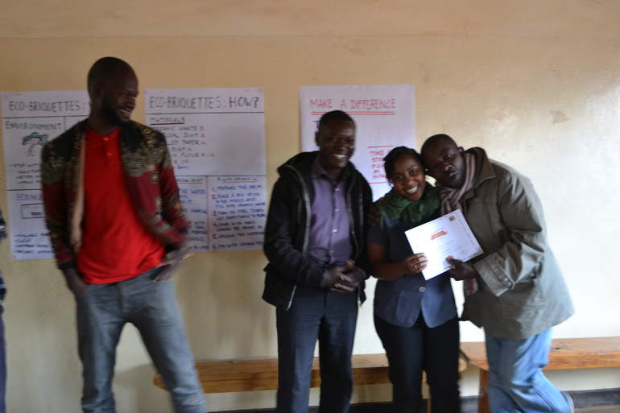**How does your idea leverage and empower community strengths and assets to help create an environment for success?**

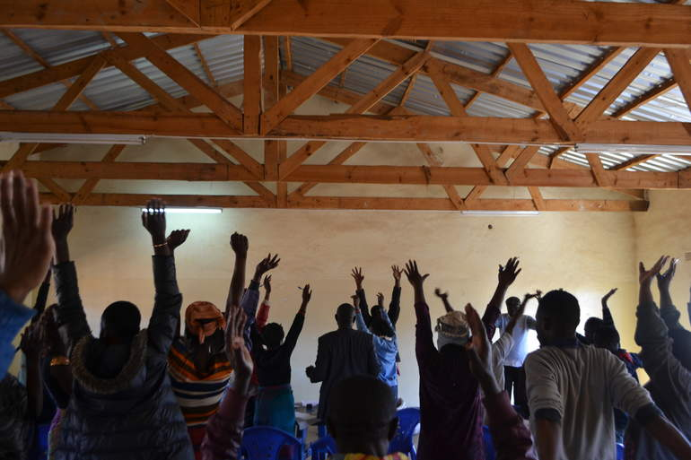

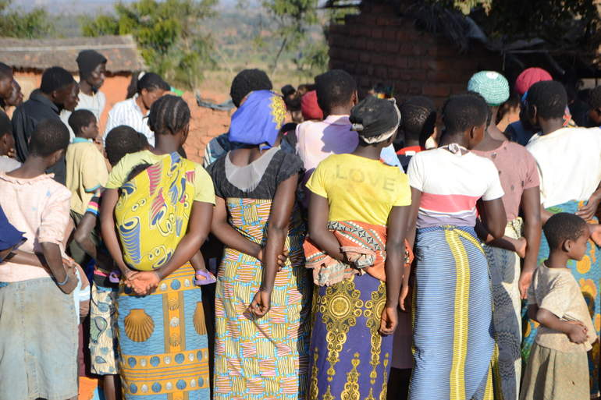

The community where we live is very active and committed with the local environment and other issues, so they need a space where to express themselves and work for the common good of the community. The people here, women as men, young people as elder people, are hardworking and dedicated with everything they do, and they don't give up until the things are done. At the same time, they are creative and social, so they are open to meet always new people from outside and share ideas, and this is also possible because of the many languages we speak here, also Chichewa, the local language of Malawi, our host country.

**What other partners or stakeholders will work alongside you in implementing the idea, if any?**

Two international volunteers work assisting us in different areas like seeking for funds and diverse opportunities. This volunteers are part of DAPP (Development Aid from People to Peopl), and we count with some small collaboration there at the Youth Center, at the College and the community and pres-school projects they have. We have been recently given a prize of coaching from the Social Incubator Malawi to become more professional and make the organisation stronger. At the same time, we are still seeking for support from the different NGOs working in Dzaleka Refugee Camp like JRS, CARD and Plan Malawi, which are studying our proposals, and giving always good feedback to us.

**Tell us more about your group or organization [or lived experience as a displaced person?**

In our group, we are a majority of refugees from the D. R. Congo, but we have been living in Malawi now for many years, and for that reason we met different people, and some of our members, also in the board, are Malawians. We started working two years ago, and we have been always working and finding ways to grow and to reach more people to make a bigger impact. We are always focus on the environment, specifically recycling and upcycling to make a work from waste. With this aim, we always wanted to create an ENVIRONMENTAL FRIENDLY COMMUNITY where different ideas are shared, and where we produce fuel briquettes and other other services for the community while we teach others to do the same. Now, we sell fuel briquettes and home made peanut butter, that we produce, and also we are planning to incorporate other products as eco-bricks and eco-paving tiles made from plastic waste. At the same time we are always rising awareness and training others to have a greener future together.