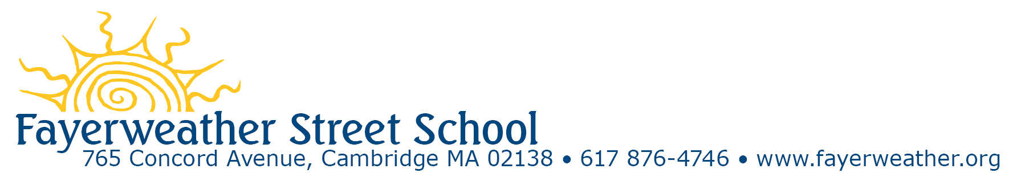

August 1, 2018

Dear Smithsonian Library Literacy Award Committee:

This is a letter of recommendation in support of the Friends of Matènwa’s application for the 2019 Library of Congress Literacy Awards Program. Friends of Matènwa is a US-based non-profit organization that supports education and social justice in Haiti through programs offered by the Matènwa Community Learning Center (MCLC). The Fayerweather Street School (FSS), located in Cambridge, MA has been a sister school of MCLC since 2009. During these years, our schools have collaborated on many projects that have had significant, long term impact on both our students and our teachers. There are two seminal elements of our sister school relationship: writing Mother Tongue Books and the Teacher Exchange program.

The FSS/MCLC collaboration first began with the Mother Tongue Book Project (MTBP). Since 1997 MCLC has been engaging its students in writing their own books in response to the near total absence of age-appropriate books in their native Haitian Creole language. FSS and MCLC knew of one another through a former FSS teacher. Because FSS and MCLC both value student empowerment and emphasize social justice in our curriculums, FSS decided that it too could benefit from writing and sharing Mother Tongue Books and that it was important for both schools to create and benefit from the MTBP, rather than creating a lopsided relationship where FSS as the wealthy white private school gives financial support to MCLC, the poor black school in Haiti. Therefore, each year, various classes in each school write and illustrate books, often with topics suggested by the other school, and have them translated and duplicated for the libraries in each school. These books are written by preschool through 8th graders and written either collaboratively as a class, in smaller groups or individually. Through the process both voice and audience are a main focus. “What do we as the authors need to know about our audience so they will understand the books we are writing for them?” As the Head of School it brings me great joy to see our students reading Mother Tongue Books in our library and seeing our students explain the process to parents and other visitors. Teachers say the books promote cultural curiosity and understanding. In one book it said, “When it doesn’t rain, there is no water.” A preschooler responded, “That’s not true. There is always water when you open the faucet.” “And what if there is no faucet where you live?” replied the teacher. Equally, if not more impressive is to see MCLC students reading these books. I visited MCLC in 2009, 2011 and 2015 to conduct teacher training and on each visit I have been impressed to see the Mother Tongue Books not only being read by children of all ages, but also to see them in pristine condition, stored in plastic bins and treated with great care and respect. Everyone knows how important these books are. While FSS and MCLC have created and shared the most books with each other, from inception, the idea was to scale up the model and disseminate the idea and books in as many schools that wanted to be involved, in both countries. To date, 40 schools on the island of Lagonav, Haiti, a few schools on the mainland of Haiti, and 17 schools in the US, including Puerto Rico, have produced hundreds, if not already a thousand tri-lingual (English, French and Creole) student published books. that are in schools in Haiti and schools in the US.

The second part of our FSS/MCLC sister school relationship is the teacher training program in which teachers from both schools visit each other to learn and share best practices. While FSS teachers have visited MCLC more often because of access to funding and visas, teachers from Matènwa have come to FSS on multiple occasions too. When FSS visits Matènwa, we ask the teachers and leadership team what curricular areas they would like to learn about. After the 2010 earthquake, the Haitian teachers asked us to teach them about the cause of earthquakes and how to be better prepared for them. At the same time, our 3rd and 4th grade teachers added a unit to their geology unit about plate tectonics and earthquakes as well as an engineering unit on how to create quakeproof buildings. When the MCLC teachers visited FSS they shared aspects of daily living as well as the impact the earthquake had on their small village, bringing the curriculum to life. MCLC Teachers found writing their own mother tongue books about their personal experiences during the earthquake very therapeutic. This is just one example of how the MTBP and teacher training program intersect and support one – another. MCLC teachers have asked for books and advice on how to present topics such as sexual education and the positive and negatives of exposure to the Internet and social media.

MCLC just celebrated its 22th anniversary and FSS its 50th; during that time both schools have strived not only to make a difference for our own students, but also to ask our student to go do good in the world. It is with this in mind that I can think of no award more deserving than one that will support and further disseminate this proven, effective tool of literacy and enhanced cultural understanding among young people. I urge you to support Friends of Matènwa’s application.

Sincerely,

Edward Kuh
Head of School

Sincerely,
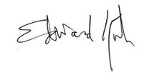
Edward Kuh
Head of School

