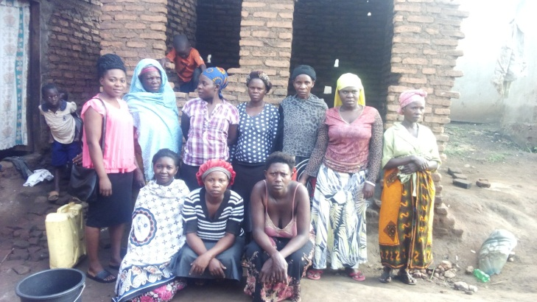
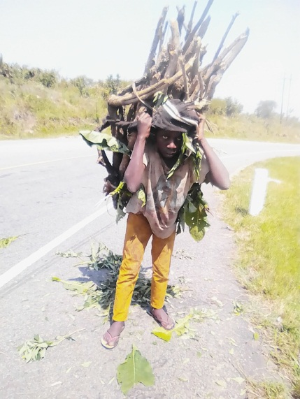
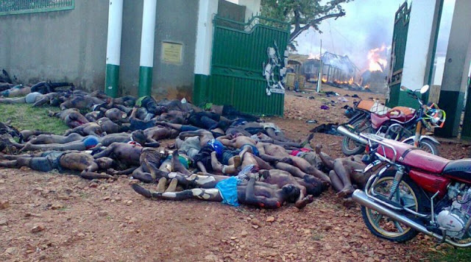
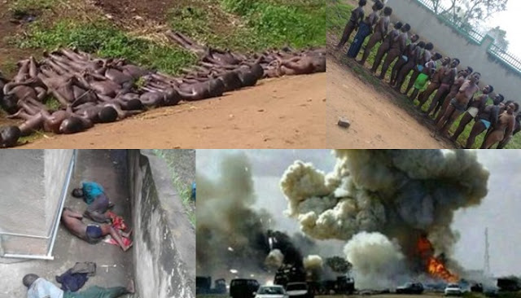
UNDERPRIVILEGED LIVES FUNDING TRUST
(UPLIFT RWENZORI - WOMEN COLLECTIVE) PROFILE
PROJECT MISSION:
Provision of high quality Education and skills to OVCS and OVCYS for better resource exploitation management and control for improved quality of life.
Our Core values:
- SHARING: Share with those who are less fortunate and assist those who are in need of help.
- EDUCATION: Develop ones intelligence and talents through Education and effort.
- RESPECT: Respect the life and property of others.
- CONSERVATION: Conserve and improve the earths natural Environment.
- DIGNITY: Proclaim the natural dignity and inherent worth of all beings.
We feel proud and thanks for having this wonderful vision and opening up a not for profit organization which supports orphans, widows, and girls. Well I'm Irumba Juma Siriwayo together with Mbambu Asiimwe Helen together with other founder members of the Uplift Rwenzori women collective (for Restoration of hope among orphans, widows and young mothers).This is voluntary, non profit, charitable organization, we are found in Uganda, in Africa. Our organization helps AIDS orphans and destitute children in Uganda by supporting them through paying for their formal education, welfare, medical care we have an alarming number of orphans as a result of violent wars and HIV/AIDS scourge in the Sub-Saharan Africa which has been the worst hit so far in the whole world.
You find that most of the children both their parents died and also the immediate relatives and remaining with their grand mothers who are also so old to support and give them the basics of their livelihood.
When you look at them you find that life is meaning less to them and this is what touched us so much that we had to come in with Uplift Rwenzori women collective to create hope for the hopeless Orphans, women widows and Girls who are young mothers.
Our Organization has got different departments which need support; we have needy and orphans department, then we have women department here you will find widows who are HIV/AIDS positive and any time they are dying so we are trying to help them live for at least a longer period of time by supporting them in income generating activities, because they still have to support their children but they are unable and weak to engage in long hours of work.
We have the AIDS awareness and campaign department; here we visit churches, institutions, schools, community’s youth and women leaders, local leaders. This organization works through the Civic leaders and Opinion leaders to fight poverty among women and support the education of needy children. We plan to offer Vocational Training for Teenage Orphans and help others go back to formal education for those who have dropped out due to financial constraints, and help where possible widows affected by HIV/AIDS and other Circumstances like violent wars that had worsened the area in the past.
- Support 110 children and vulnerable youths mainly orphans to directly benefit through school fees and scholastic requirements in their various schools and one-time gifts from this organization and through the widows supported by this organization.
- Train 3o women mainly widows into new skills so that we can now support a lot more orphans indirectly.
- Support 50 women widows and youth with income generating activities.
- Sponsoring Education of Orphans by providing school fees and scholastic, Health care and Nutrition support for orphans in the orphanage Home.
- Supporting Women groups through the women Empowerment Program.
- Mobile Clinic especially in the rural areas for the rural person is really in need.
- Creating Awareness in Communities on AIDS/HIV.
- Lobby and advocate for affordable housing for women widows and members .

Uplift Rwenzori Women Collective supports the UN Global Compact

The Ten Principles of the UN Global Compact
The UN Global Compact's ten principles in the areas of human rights, labour, the environment and anti-corruption enjoy universal consensus and are derived from:
• The Universal Declaration of Human Rights
• The International Labour Organization's Declaration on Fundamental Principles and Rights at Work
• The Rio Declaration on Environment and Development
• The United Nations Convention Against Corruption
The UN Global Compact asks companies to embrace, support and enact, within their sphere of influence, a set of core values in the areas of human rights, labour standards, the environment and anti-corruption:
Human Rights
• Principle 1: Businesses should support and respect the protection of internationally proclaimed human rights; and
• Principle 2: make sure that they are not complicit in human rights abuses.
Labour
• Principle 3: Businesses should uphold the freedom of association and the effective recognition of the right to collective bargaining;
• Principle 4: the elimination of all forms of forced and compulsory labour;
• Principle 5: the effective abolition of child labour; and
• Principle 6: the elimination of discrimination in respect of employment and occupation.
Environment
• Principle 7: Businesses should support a precautionary approach to environmental challenges;
• Principle 8: undertake initiatives to promote greater environmental responsibility; and
• Principle 9: encourage the development and diffusion of environmentally friendly technologies.
Anti-corruption• Principle 10: Businesses should work against corruption in all its forms, including extortion and bribery.
Our contacts:
UPLIFT RWENZORI WOMEN COLLECTIVE
Email:upliftrwenzori2017@gmail.com.
Hope to hear from you soon.
Sincerely :Murungi Zahara Coordinator Tel: +256774851951
Location: Rugendabara Kikongo Town Council Kasese District.
Uplift Rwenzori Women Collective women widows and young mothers.
Abandoned orphan suffering from child labor and can not attend school due to lack of tuition.
s
Men who were shot dead during the Rwenzori massacre on 27th Nov. 2016

The 27th November 2016 massacre in Rwenzori , women and girls were lined up ,un dressed before they were murdered amidst the burnt kings palace in Kasese in the Rwenzori Region where the kings subjects from Bundibugyo and from other places and within Kasese had gathered.
The above situation left a big vacuum affecting the lives of Orphaned Children whose bread winners died and now lack Education, medical care, shelter, food and clothing.

