
ECUMENICAL ORTHODOX-CATHOLIC CHURCH
Office of the International Primate Archbishop
P.O.BOX 423 KASESE-UGANDA,
Tel:+256785395858. Website: http://eocchurch.net Email: eocug1@gmail.com

TO GRANT TEAM
World Connect
RECOMMENDATION FOR KARC SOLAR POWERED IRRIAGTION SYSTEM
Kikumu agriculture research centre (KARC) is located in Kidodo Cell Kasese Municipality Kasese western Uganda founded in 1999 by social workers to address climate and agriculture sectors challenges and involve women and young in innovations for community development. We recommend to establish solar powered irrigation using pumps and solar to improve nutrition through horticultural crops
We request you to cooperate for management of these horticultural crops changes and fund their project.
Hop you shall cooperate
Thank you

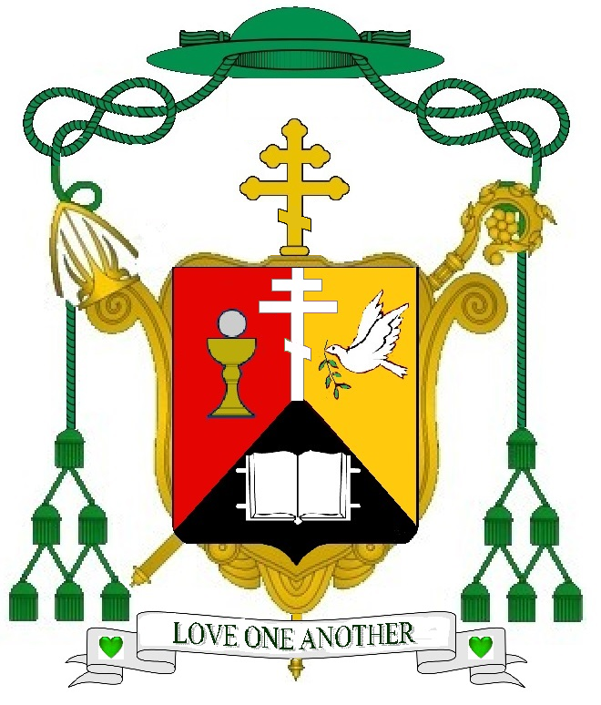
MOST REV.KIIZA THOMAS SIBAYIRWA, PhD
BISHOP.

