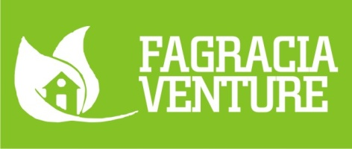**Address:** 11 UGBEJE AKI STREET MENDE MARYLAND, LAGOS STATE

**Email**: *gracianaturalsoap@gmail.com*

**Tel:** *08144116876*

**BN:** 2320443

January 7, 2020

**Re. Recommendation Letter For Mafagra Empowerment Initiative**

We have known Mafagra Empowerment Initiative for several years and we are glad to write recommendation letter for the organization.

Mafagra Empowerment Initiative is an outstanding organization, women and girls have benefited directly and indirectly, Their impact in the lives of women and girls in the society are proven to be beneficial and valuable.

Mafagra Empowerment Initiative operates with highest level of transparency, honesty and integrity, we recommend Mafagra Empowerment Initiative with no hesitation.

Please, feel free to contact us if you have any further questions.

Sincerely,

C:\Users\user\Desktop\IMG-20191207-WA0000.jpg

Fagracia Venture