

THYOLO ACTIVE YOUTH ORGANISATION

JANUARY TO JUNE

and

JULY TO DECEMBER

2018

PROJECT

PROGRESS REPORT

NAME OF PROJECT: WASH

PROJECT IMPACT AREA: Thyolo District

PROJECT FUNDED BY: Watering Malawi US

PROJECT DURATION: 1 Year

Report Compiled by: Willard Mwambo

The Executive Director

Thyolo Active Youth Organisation

P. O. Box 106

Thyolo

Email: [thyoloactiveyouthorganisation@yahoo.com](mailto:thyoloactiveyouthorganisation@yahoo.com) or [wmwambo@gmail.com](mailto:wmwambo@gmail.com)

**ACCRONYMS**

TAYO : Thyolo Active Youth Organisation

DEM : District Education Manager

PTA : Parents Teachers Association

ADC : Area Development Committee

VDC : Village Development Committee

CBO : Community Based Organisation

M : Male

F : Female

GVH : Group Village Headperson

T/A : Traditional Authority

VH : Village Headperson

GGI : Go Girls Initiative

WASH ; Water Sanitation and Hygiene

NGO : Non Governmental Organisation

DACC : District Aids Coordinating Committee

MANASO ; Malawi Network of Aids Service Organisation

PASI ; Paralegal Advisory Services Institute

FP ; Full Primary

**0.01. Introduction**

Thyolo Active Youth Organisation (TAYO) is implementing $30,000.00 WASH Watering Malawi funded project in Thyolo District. TAYO is a Christian and nonprofit making youth Organisation established on 12th December 2000, registered with National Youth Council of Malawi in 2002 and Malawi Government Registrar General under trustee incorporation Act in 2003. The Organisation is also an affiliate of the Malawi AIDS Services Organisation (MANASO), Malawi Human Rights Youth Network, District AIDS Coordinating Committee (DACC), Paralegal Advisory Services Institute (PASI), District Environmental and sanitation Committee and Thyolo District NGO Network.

In the first six months of January to June and July to December 2018 TAYO intensified WATER project in assisting schools of Nanfukwe with an enrolment of 1332 learners which include 444 boys and 438 girls, and Nsuwazi with enrolment of 668 which include 276 boys and 392 girls.

Borehole rehabilitation was done in the following school; Nchima School with enrolment of 1229 which include 631 boys and 598 girls, Nankhulumbo with enrolment of 1180 which include 640 boys 540 girls, Cherewani School with enrolment of 1335 which include 692 boys and 643 girls and Mbandanga school with enrolment of 1927 learners which include 929 boys and 998 girls.

Furthermore several schools including the Community Based Child Care Centres CBCCCs benefited from 50 litre hand washing beckets.

**SELECTION CRITERIA FOR CHOOSING SCHOOLS**

Schools were selected through needs assessment exercise by using a simple questionnaire. The exercise was slated to look into the following areas.

* Name of school
* Name of Education zone
* Traditional Authority
* The enrollment
* The mechanism put in place by school itself to deal with current problem
* Activeness of school structures/communities
* Levels of coordination among communities
* Availability of space/land for building of bathrooms
* School contribution in terms of sand, water ,bricks

After visiting selected schools it was noticed that schools in the districts are facing challenges of bathrooms/toilets, making a choice on where to start was very critical as the situation was very common in different schools, Namfukwe primary school was one of the school in Thyolo that was having the poorest toilets compared to other schools.

The active school structures are School Management Committee, Parents Teachers Association and Mother Group. They actually meet twice a month; the levels of collaboration for these structures are very good hence they meet regularly. A space for Construction of toilets was available and the contributions they managed as school were Sand, Water, Land and Bricks.

**NEEDS ASSESSIMENT ACTIVITY TO FIND OUT AVAILABILITY OF MATERIALS IN SCHOOLS**

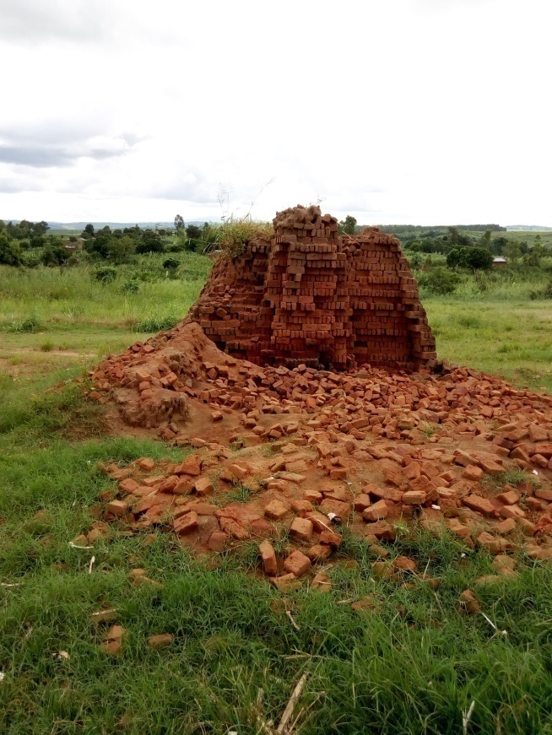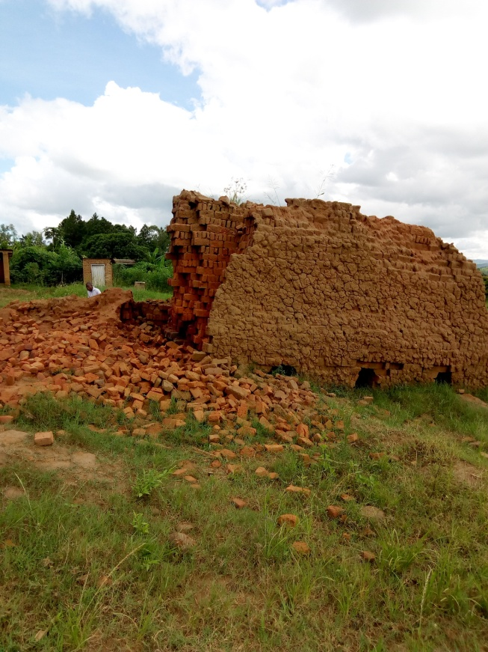

**CONDUCTING MEETINGS WITH THE COMMUNITY**

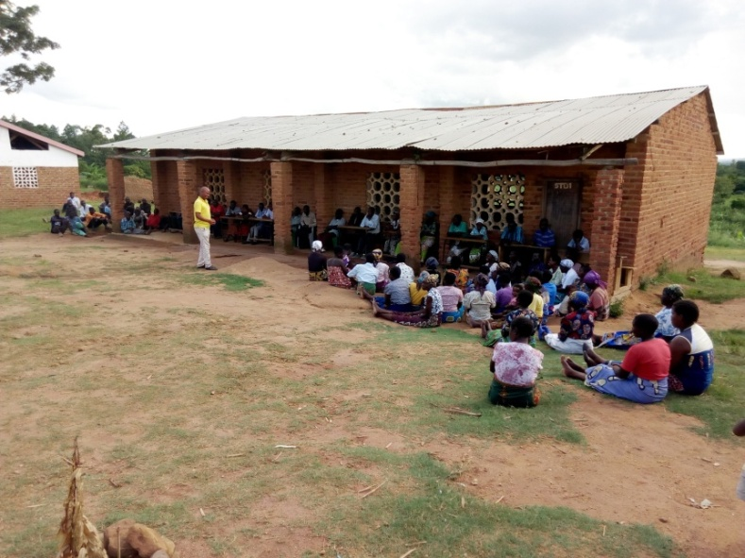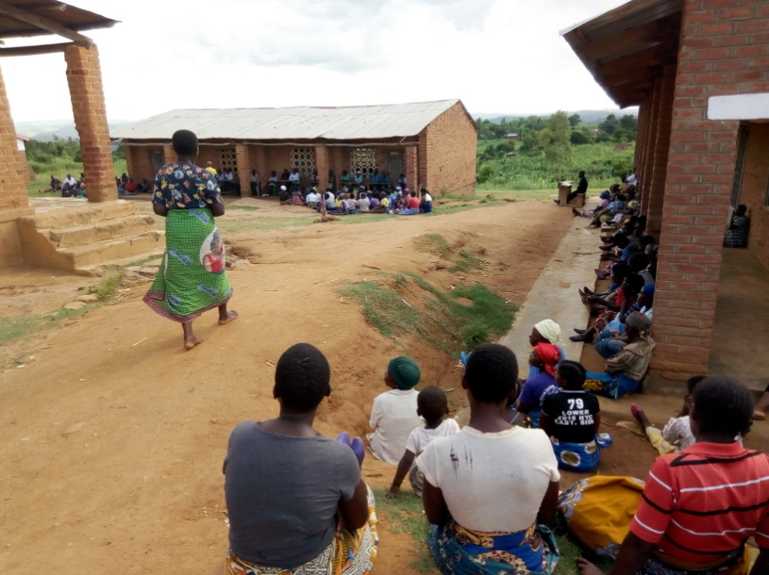

**DELIVERY OF MATERIALS**

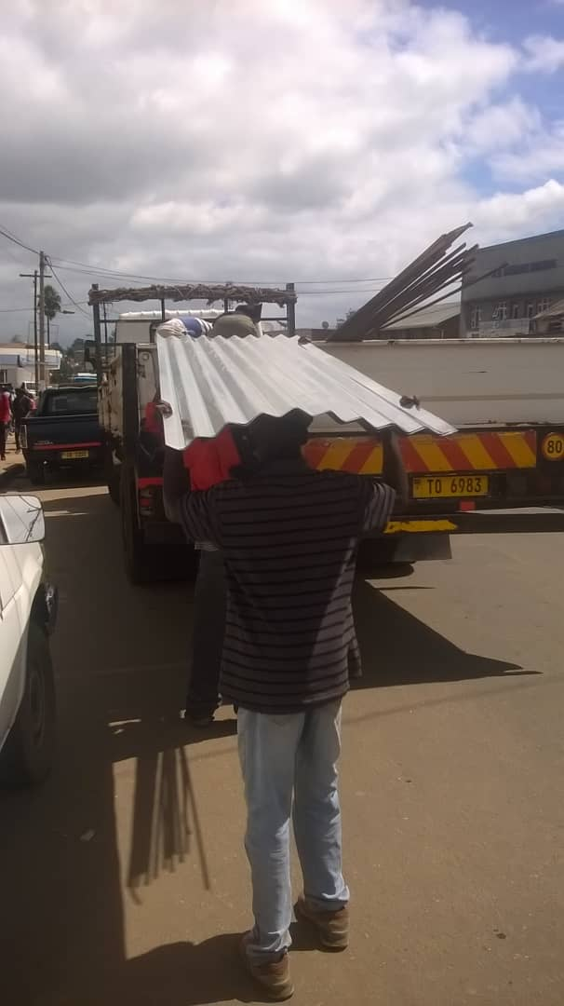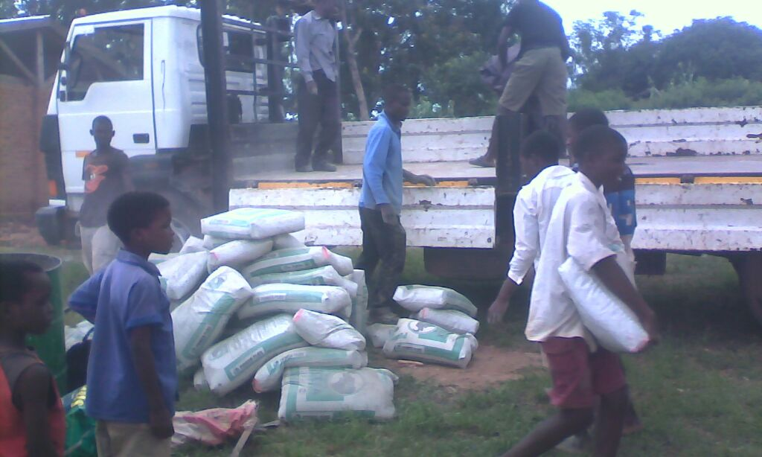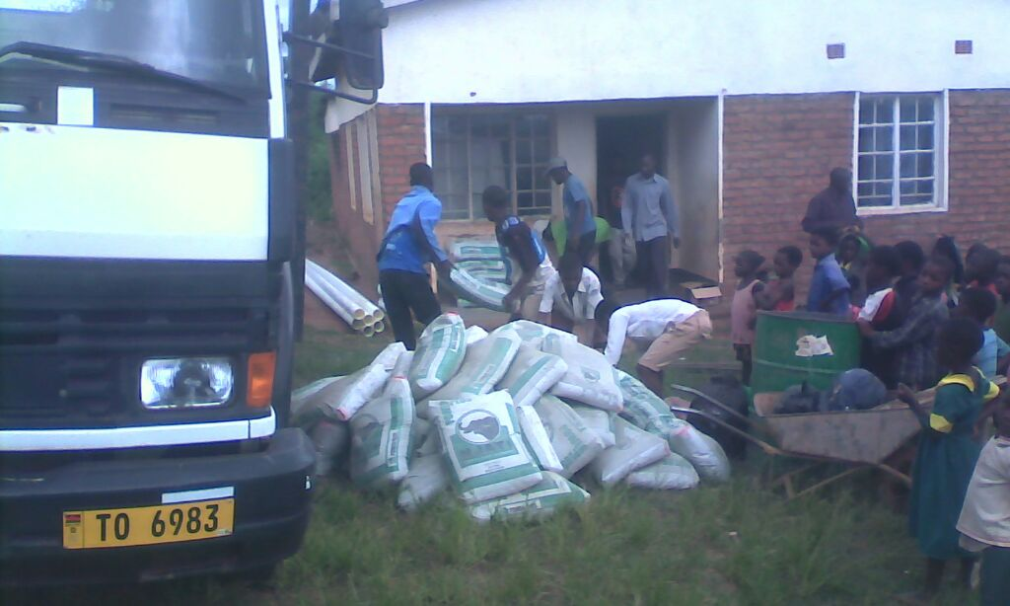

**WORK PROGRESS**

*DIGGING STAGE*

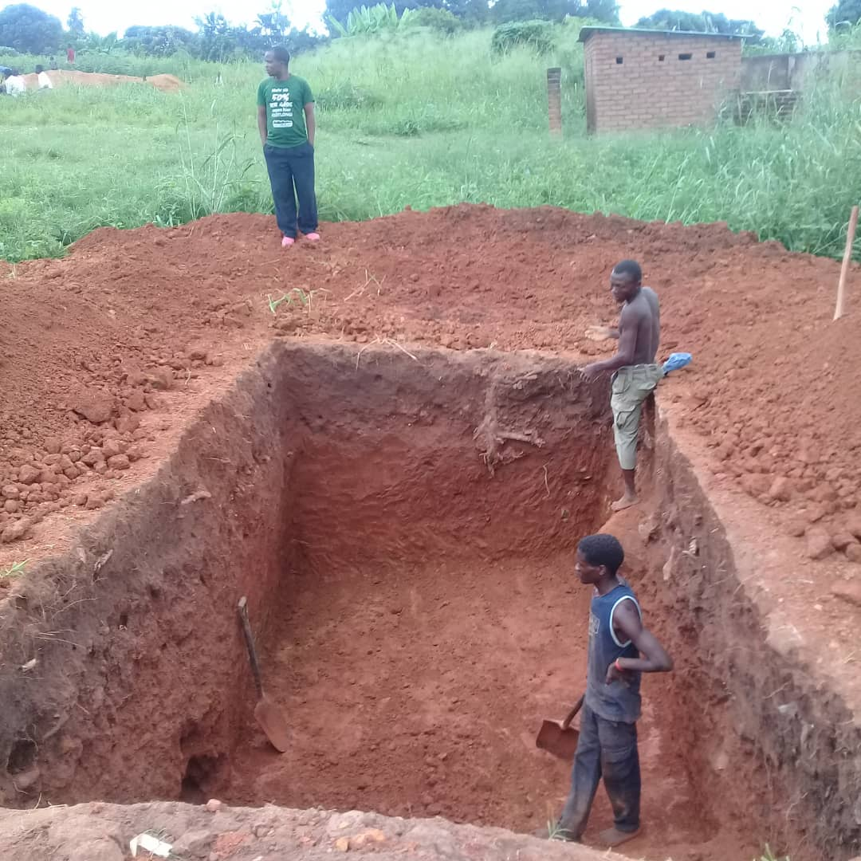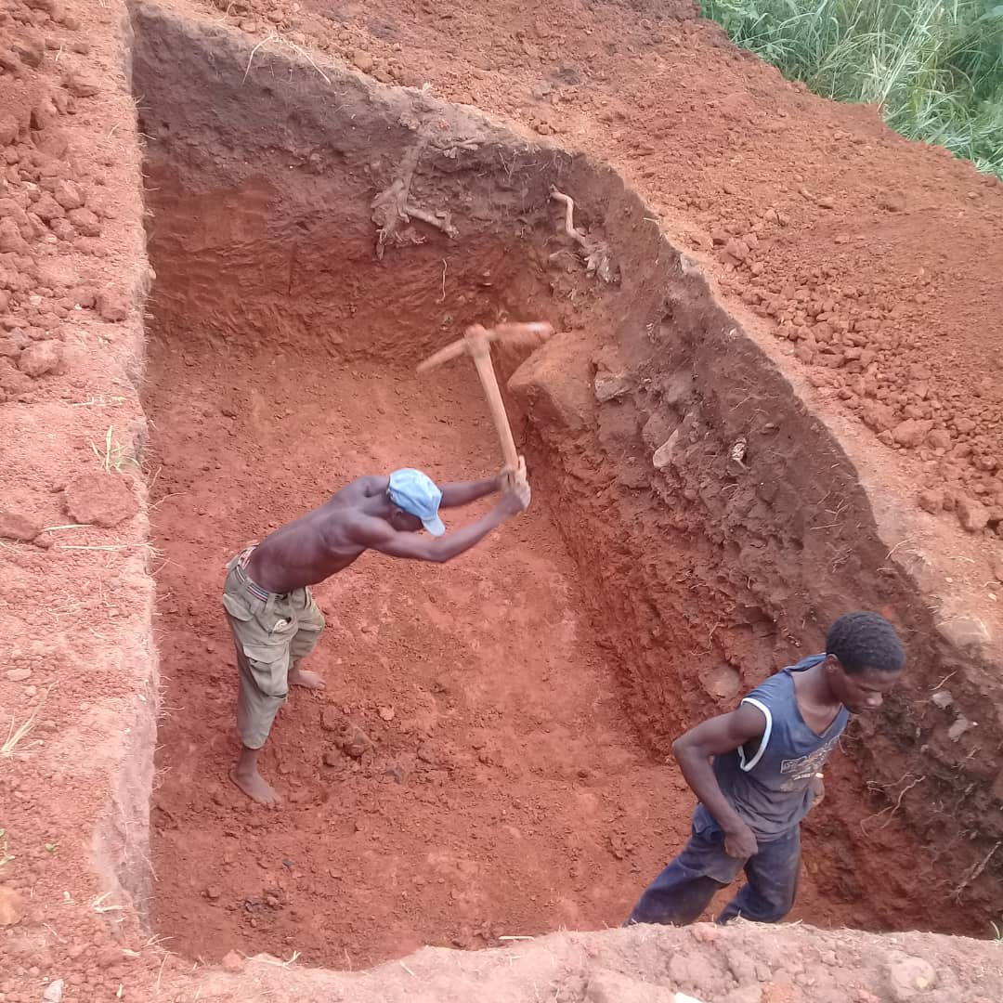

**UNDERGROUND BRICK WORK**

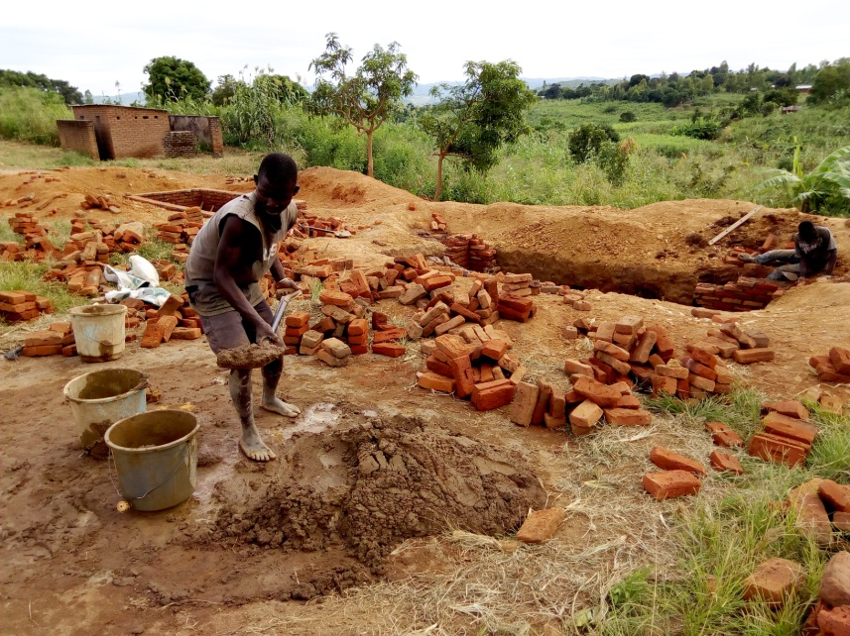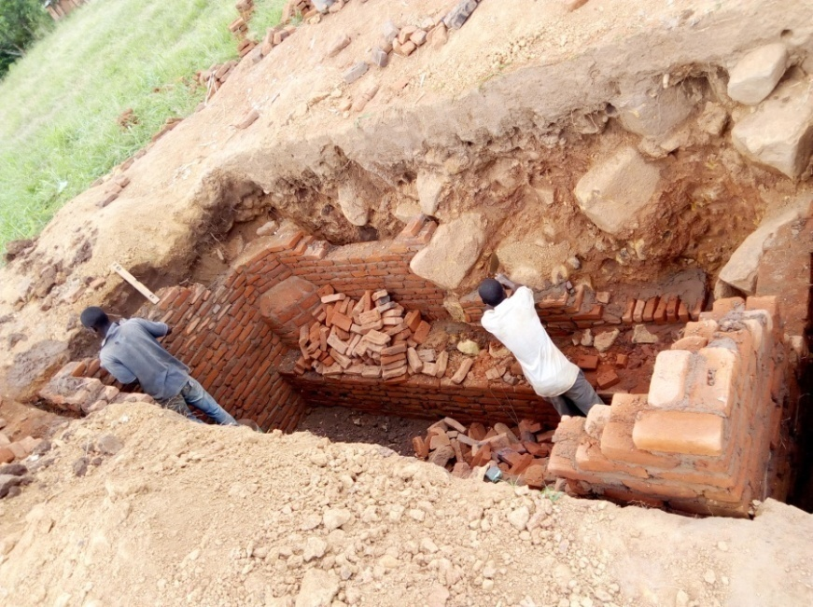

**CONCRETE SLAB STAGE AND BRICK WALL**

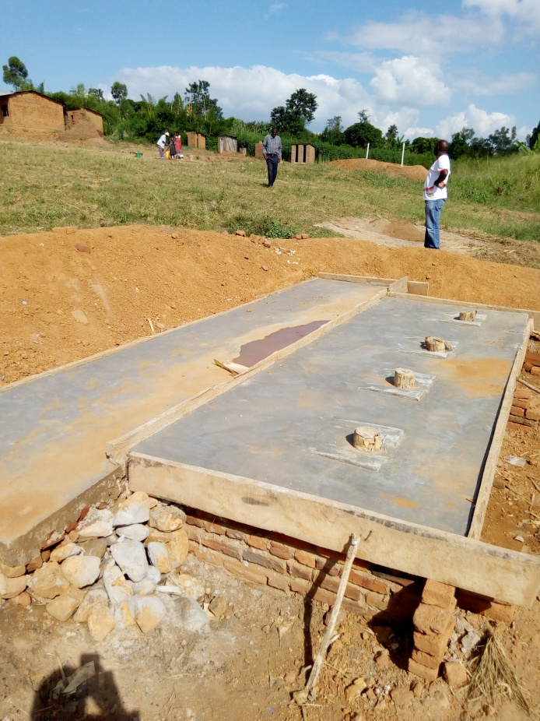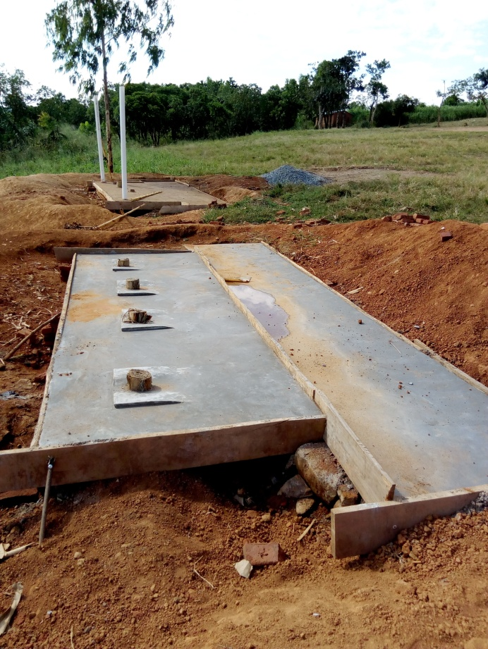

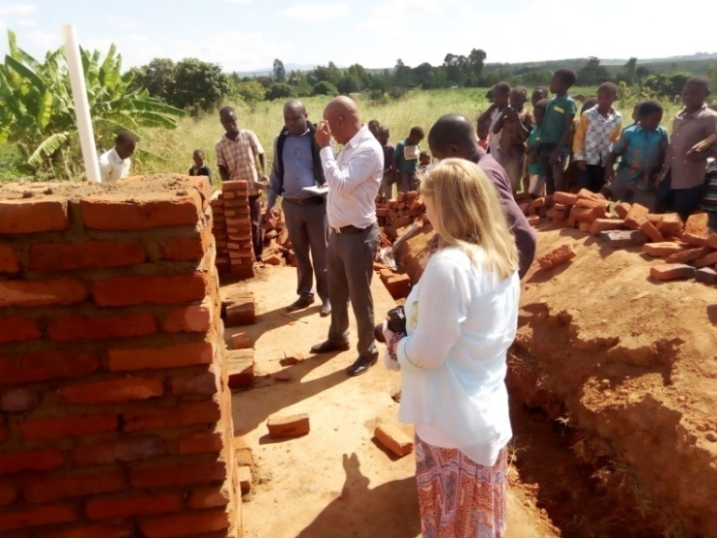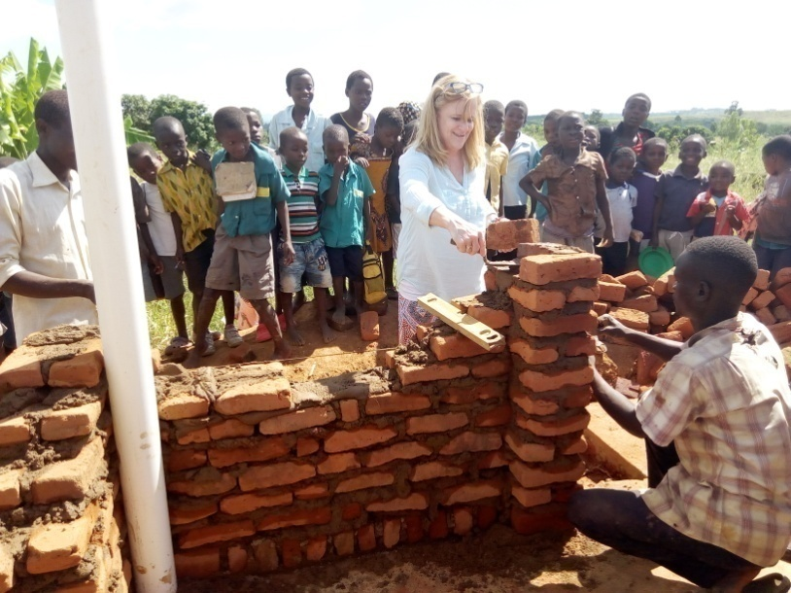

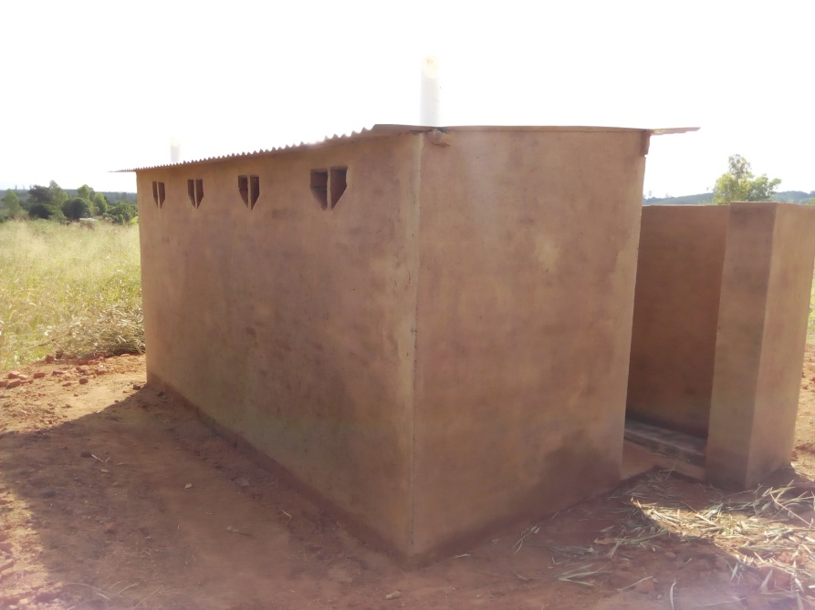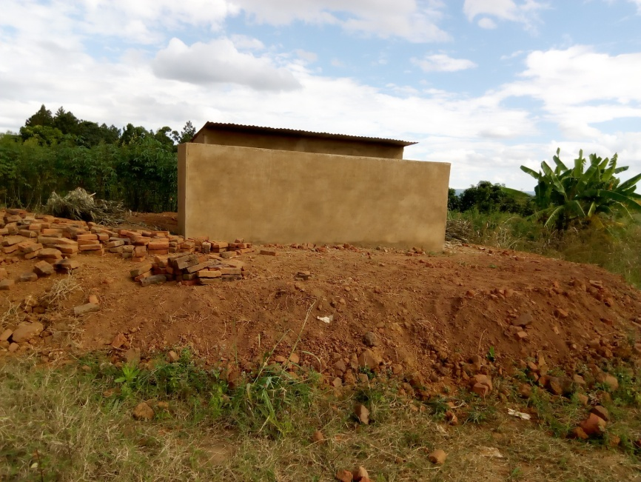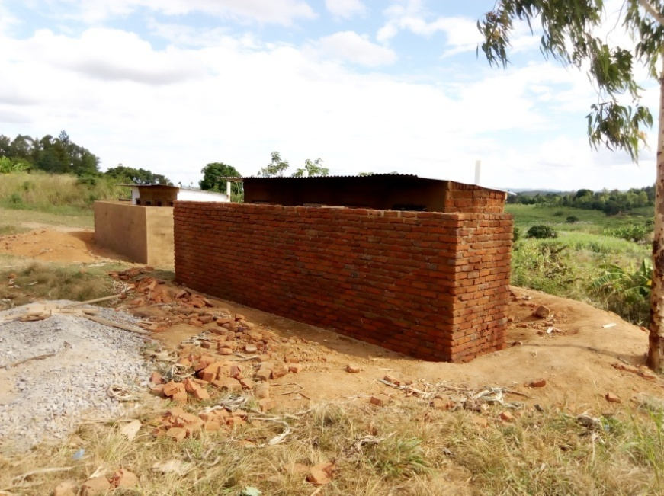**PLASTERING AND ROOFING STAGE**

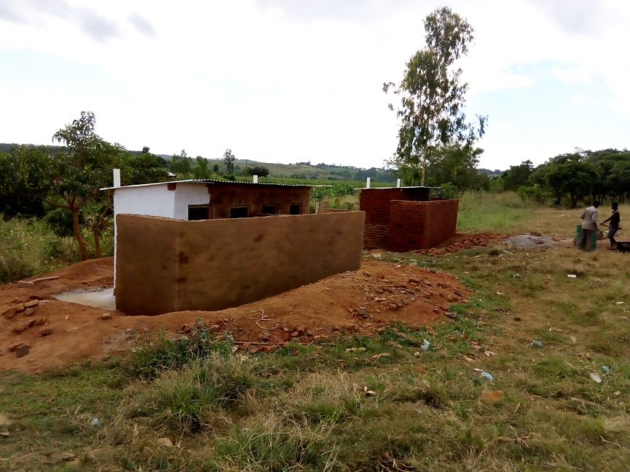

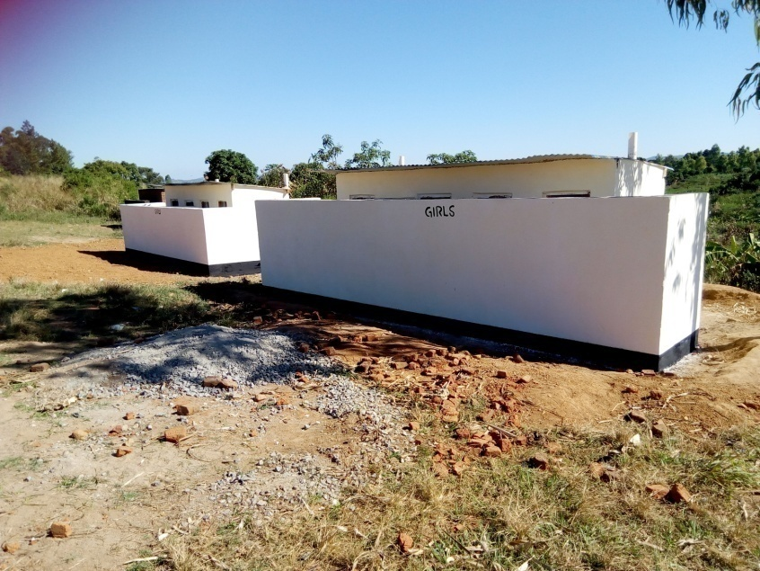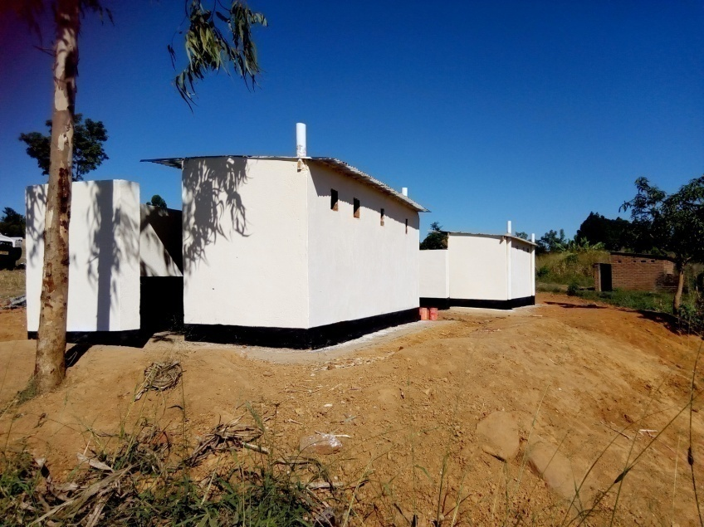**NEW FACE FOR NAMFUKWE PRIMARY SCHOOL BATHROOMS/TOILETS**

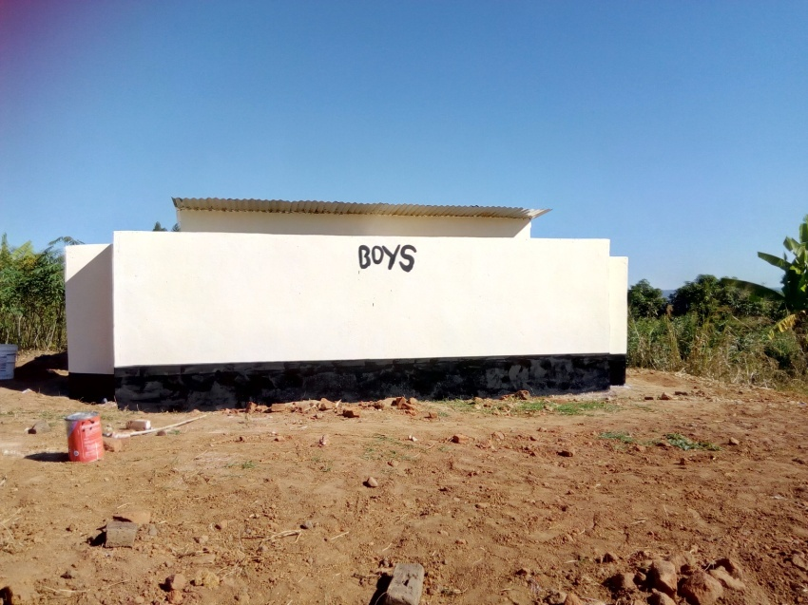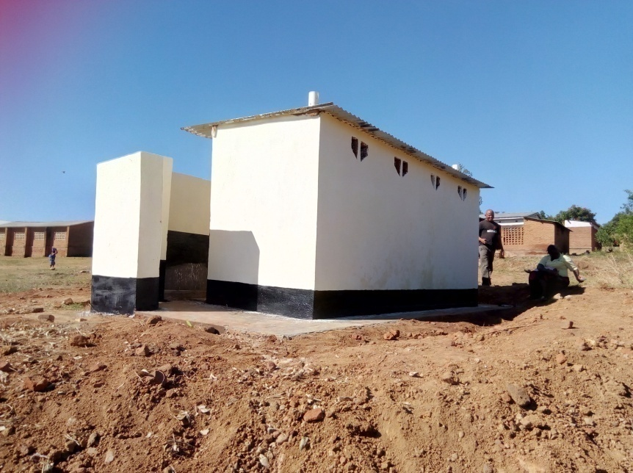

**HAND OVER CEREMONY**

Prior to the handover ceremony of the newly built toilets/bathrooms at Namfukwe primary school,TAYO

The handover ceremony brought together the District Commissioner,the District Education Manager, the Officer in Charge (OC),Primary Education Adviser( PEA), Community leaders were GVH Ngamwan,VH Muriba,VH Namuonjeza and VH Kadaya 2,VH Maganiza and VH Kavunye ,Counselor Representative, the School Management Committee, Mothergroup and Media Coveragethere was Rainbow TV,MBC TV and Radio ,ZODIAK,Living Waters Church Radio and District Information Officer.

**SPEECH FROM THE DISTRICT OFFICIALS**

All of them were appreciating the bathrooms/toilets since they have never had toilets at the school and it has also decreased the rate of cholera at school and learners will now start working hard for a betterment of their lives.

**SPEECH FROM THE DIRECTOR**

The Director thanked the committee who were making much effort for the work to be effective this work it has took 30 days to complete work, in these toilets there is also a changing privacy room for the girls who started menstruating within classes, he also emphasize that these toilets will help out the learners to have a conducive environment he concluded that in future” would like to see the nurses, police and doctors through these toilets.

**HAND OVER CEREMONY PICTURES BELOW**

**The Primary Education Adviser (PEA) speaking to audience**

**The Director of TAYO speaking to the audience**

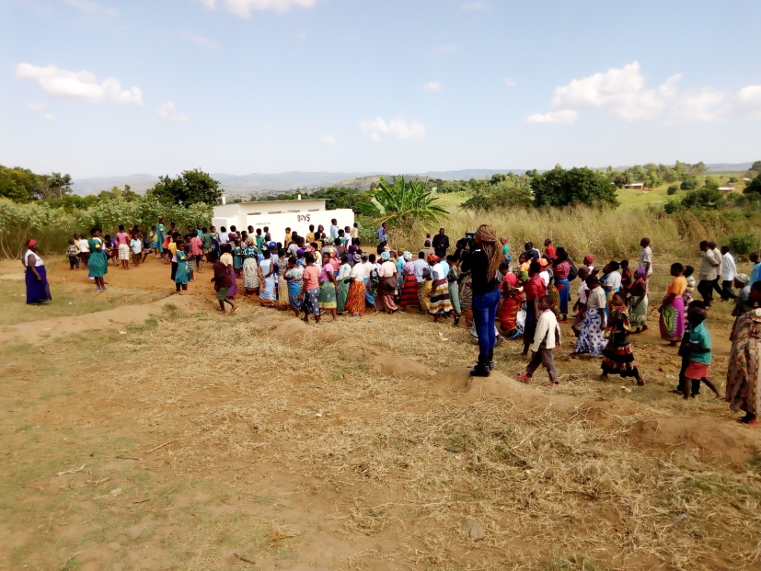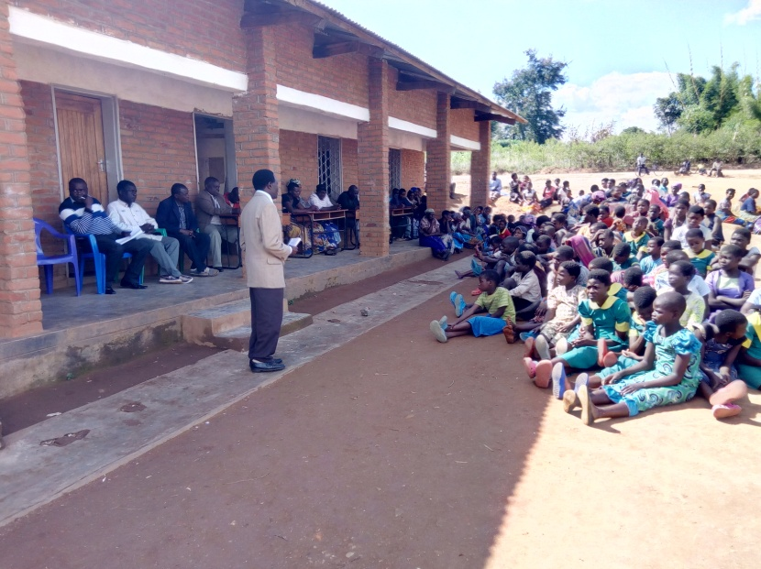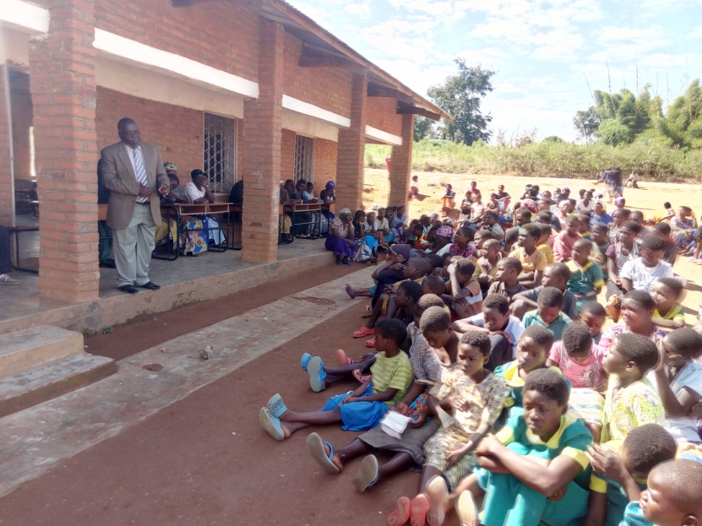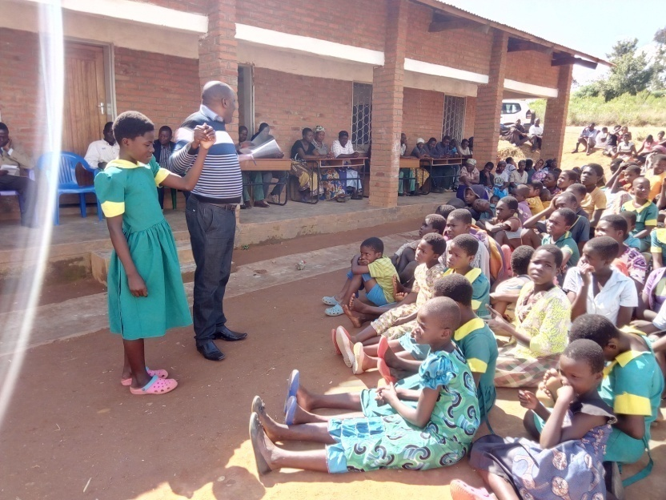

**The community and visitors make an assign to the opening of toilets**

**The District Education Manager ( DEM) speaking to the audience**

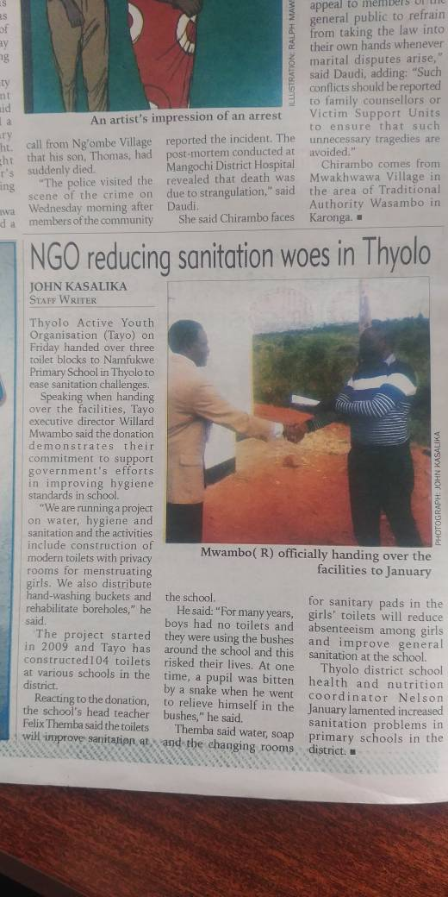

Nsuwazi Progress

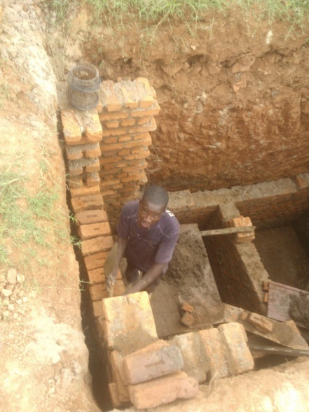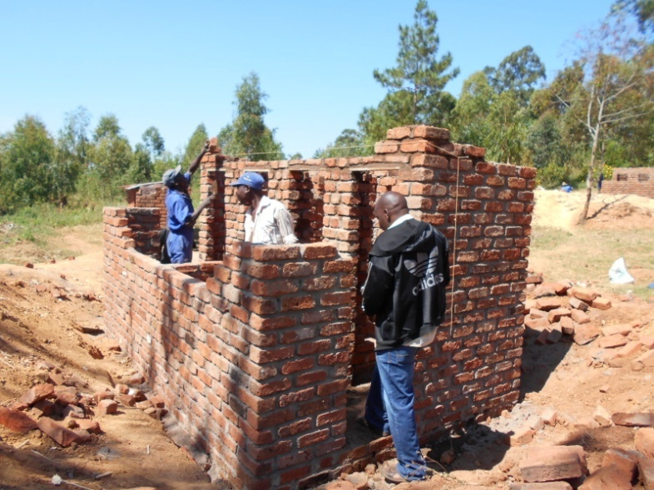

Water issues at one of the schools (Milongera primary school)

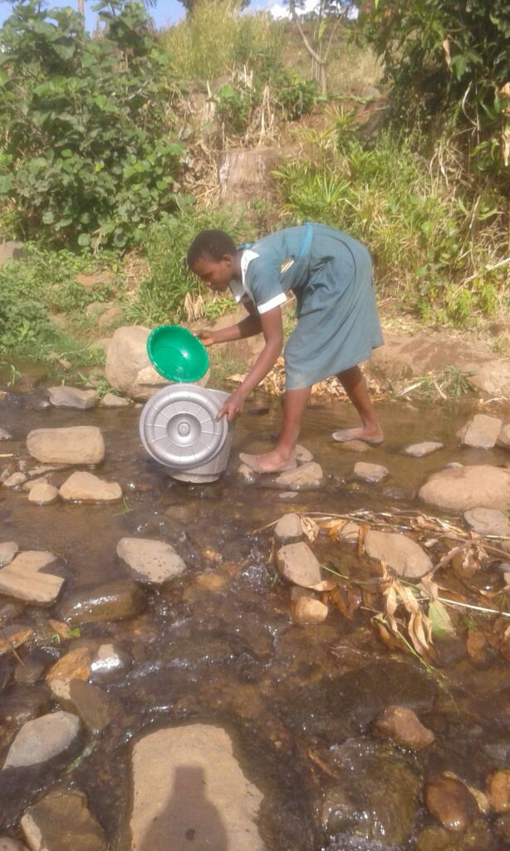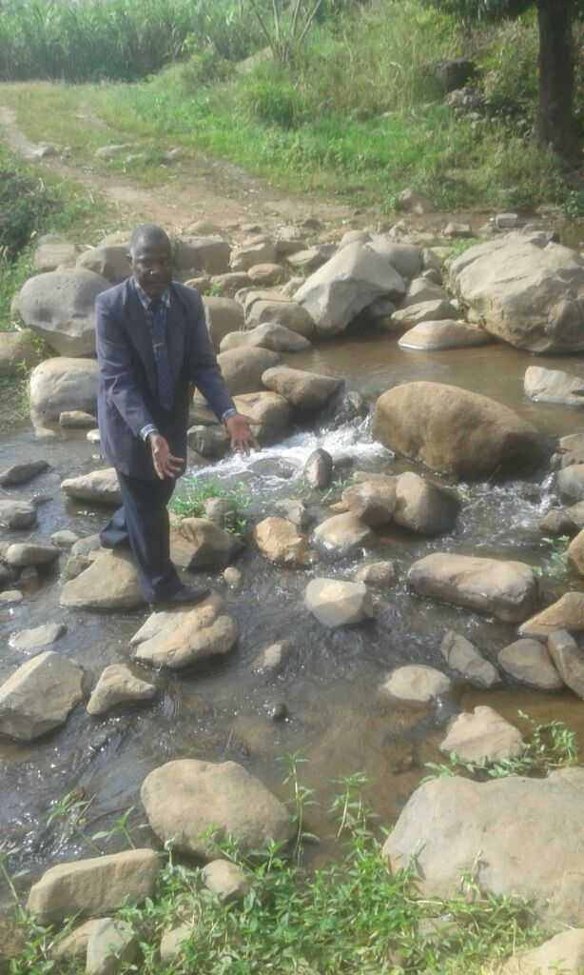

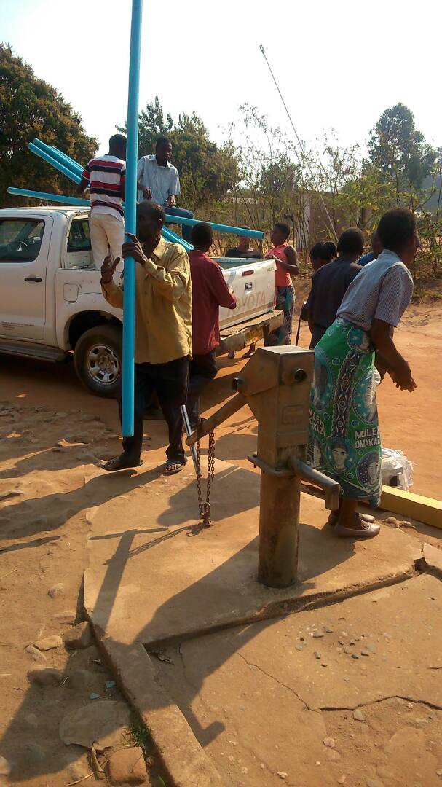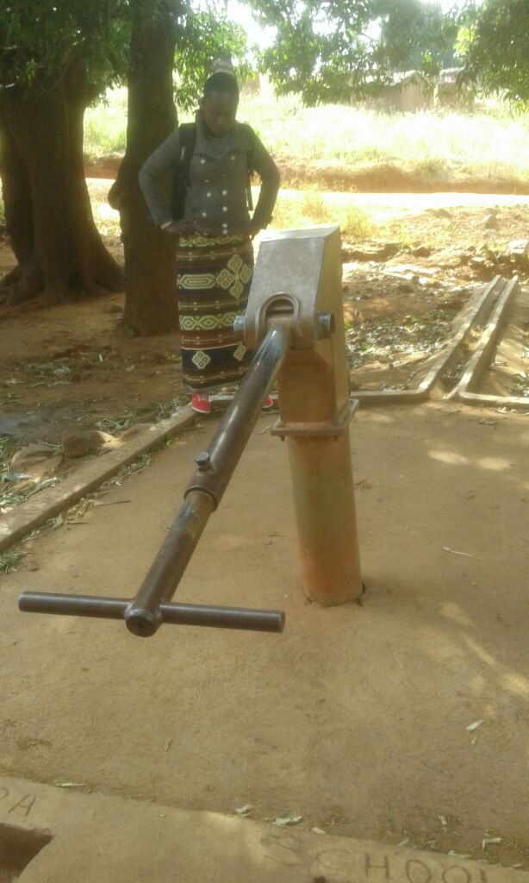

**Value for money**

* Borehole rehabilitation in four schools used the sum of USD2,580 targeting 5671 learners altogether which represent USD0.5 per learner.
* Nsuwazi school bathrooms used the sum of > USD7,094, the school has 668 total number of learners which represent > USD10.6 per person
* Nanfukwe school bathrooms used USD7,094 for 1332 learners which represent USD5.3 per learner.