PROJECT PROGRESS
(JULY TO DECEMBER 2017)

BOREHOLE REHABILITATION COMPONENT

0.1. MPIYAMA VILLAGE
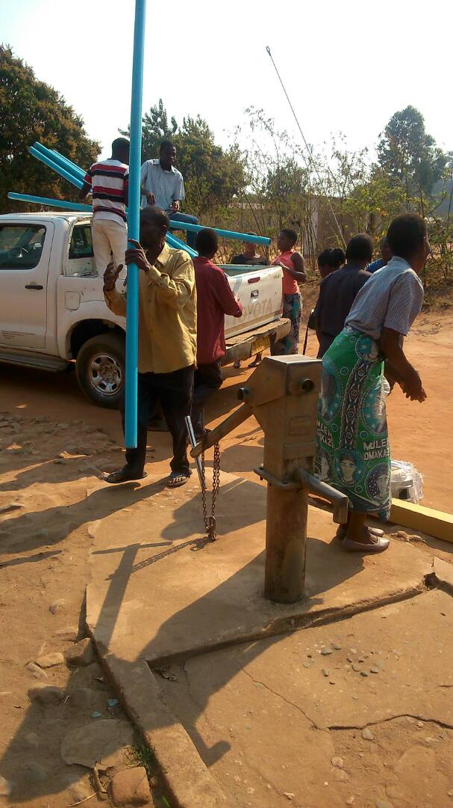
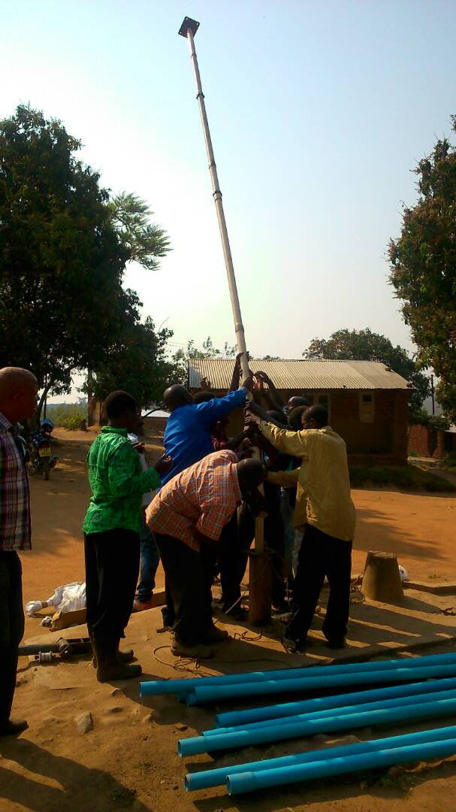
The village is located near Nachipere Primary School after their borehole was broken and the community members started put pressure to Nachipere School borehole hence TAYO had to fix it.

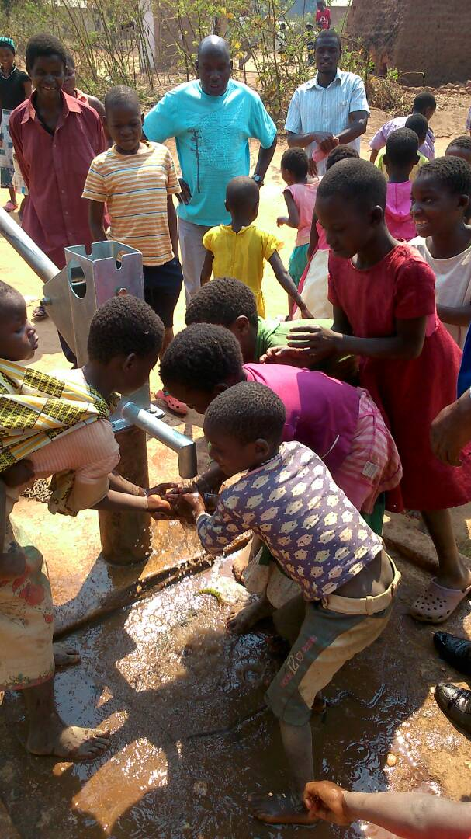
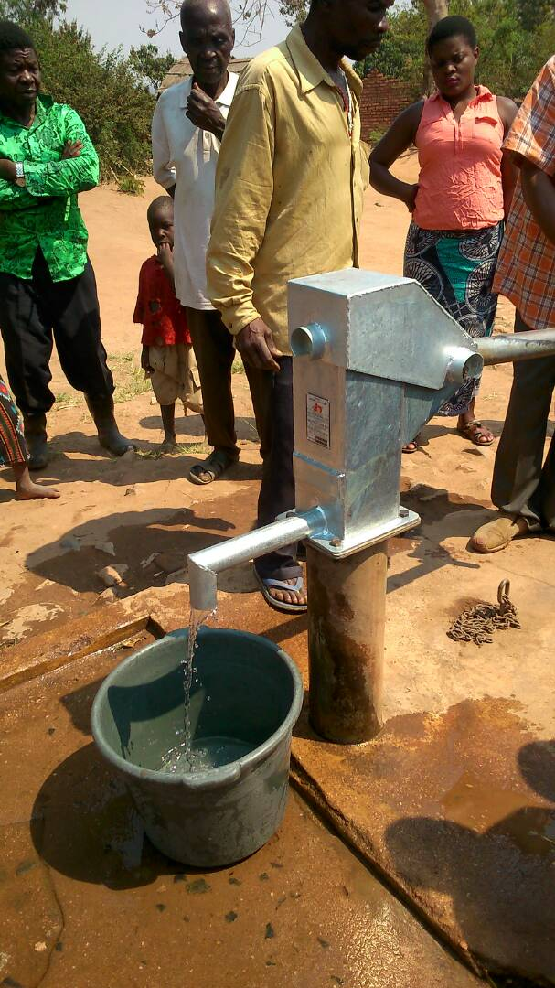

0.2. GOMBWA PRIMARY SCHOOL

The school has an enrollment of 771 learners which include 433 boy and 338 girl learners respectively

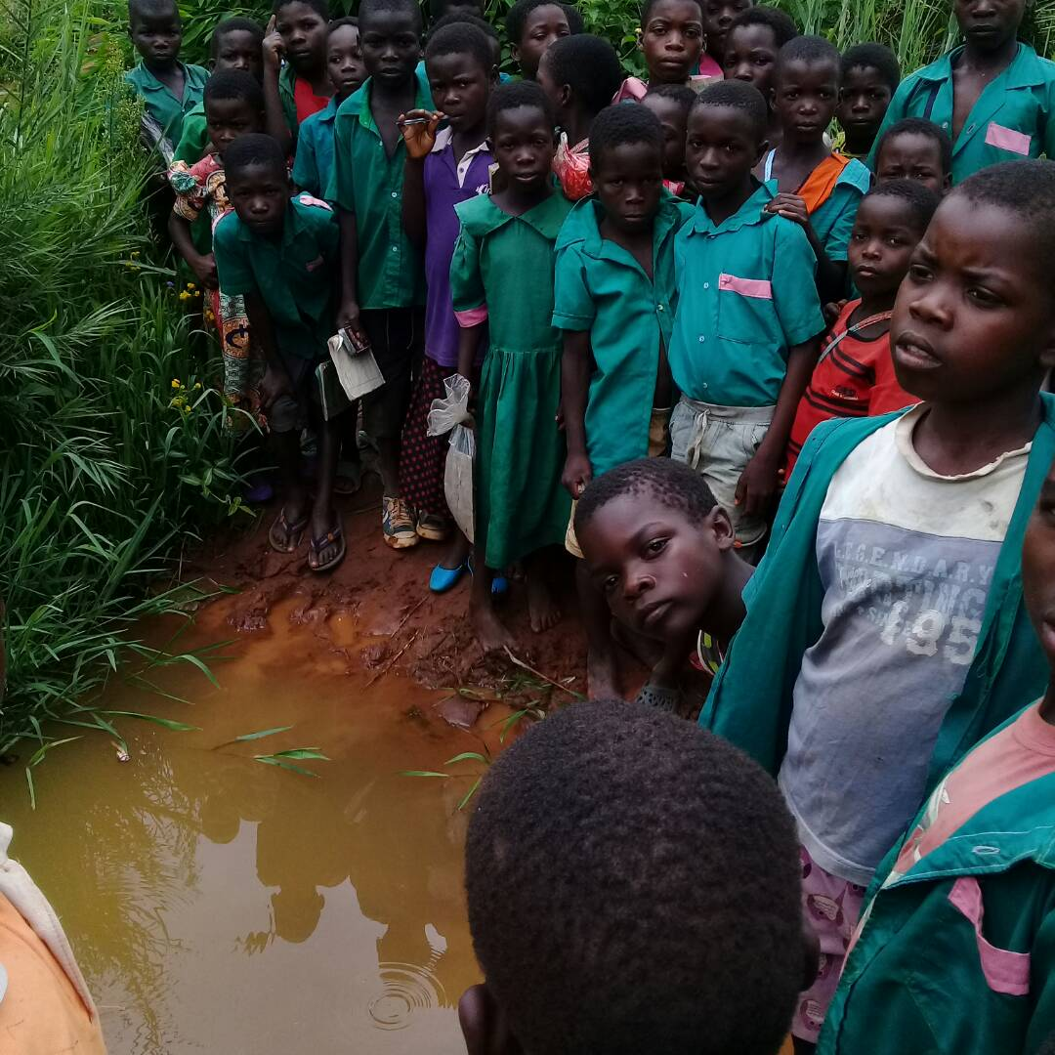

Learners were using unprotected source of water before the rehabilitation of the borehole

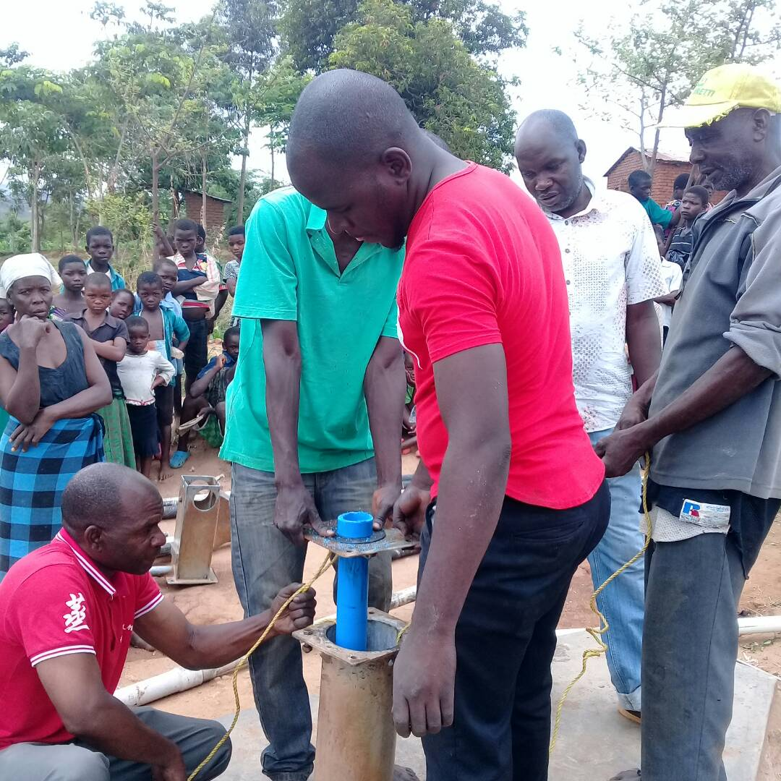
TAYO team, District Officials and the community members working together to fix the borehole at Gombwa primary School

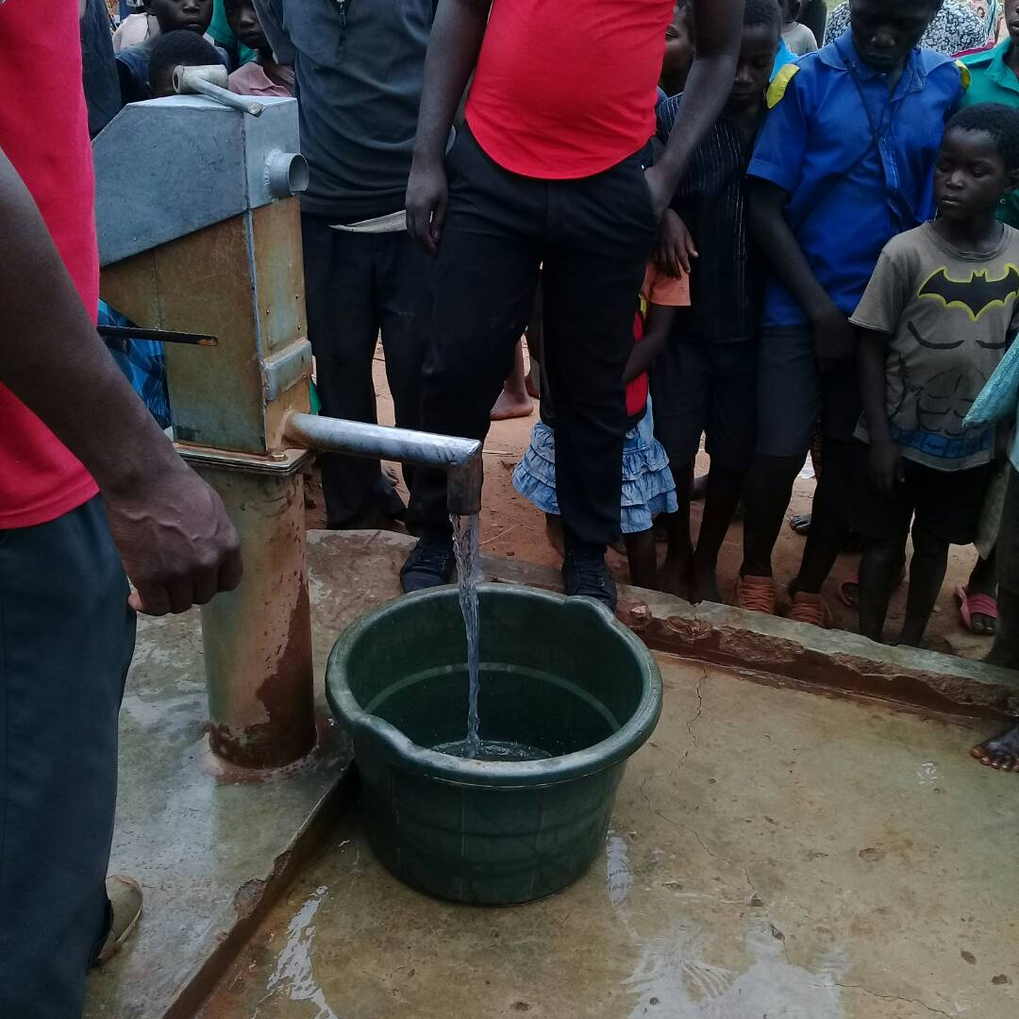

Clean water coming out after a long time….

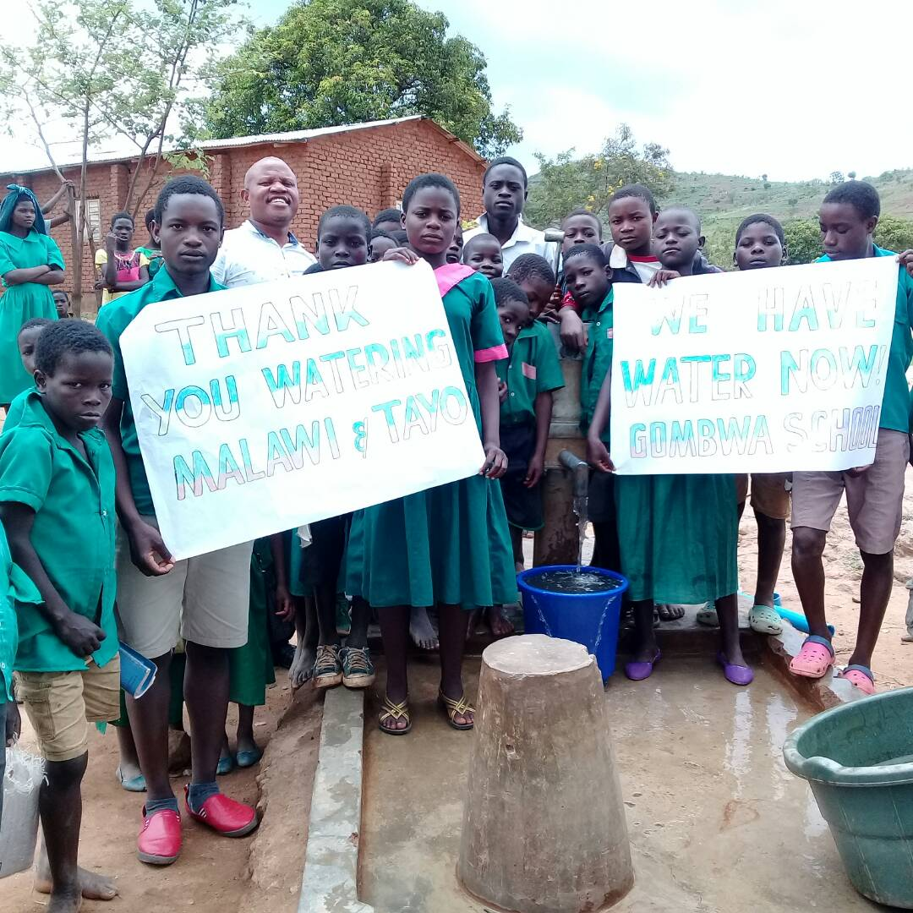

Learners holding flip charts thanking Watering Malawi for the timely support

Other Schools benefited on the rehabilitation are Mbalanguzi and Motheriwa. Motheriwa has an enrollment of 967 learners of which 502 are girl learners while 465 are boy learners. Mbalanguzi has an enrollment of 1391 out of this 631 are girls while 760 are boys.

We failed to fix the borehole at Namfukwe because of the water table (The borehole has dried up) as it needs a drilling at a new place.

BATHROOMS COMPONENT

  - Namitete Bathrooms hand-over event

The event was attended by the Government officials which include; The Director of Planning and Development who was the Guest of Hounor, The Councillor for the area, The Primary Education Advisor (PEA), The Traditional Leaders for the area and the leadership of Namitete school plus TAYO team.

Among other activities that spice the day were as follows:
    - Opening prayer
    - Drama performed by learners
    - Poems
    - Choir
    - Cutting of the ribbon to mark the official opening of the bathrooms
    - Speeches by: The Head Teacher, Director TAYO (Willard Mwambo) The traditional leader, The PEA, The Councellor, and finally The Director of Planning and Development
    - 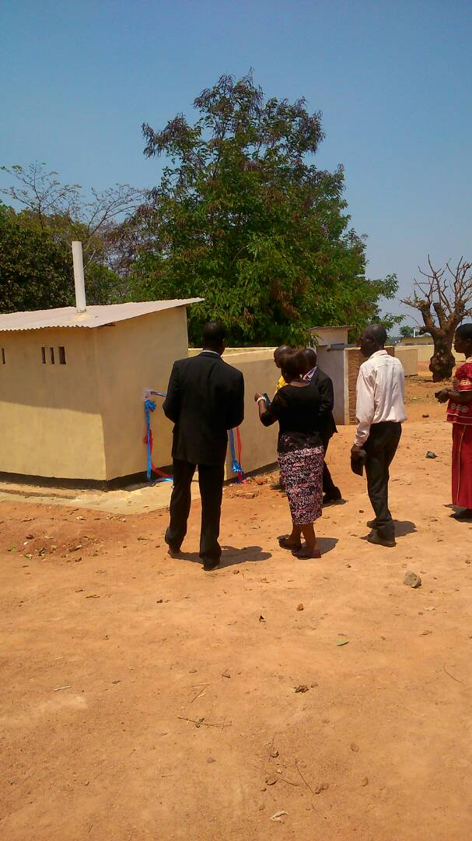Closing Prayer

The Director of Planning and Development cutting ribbon to mark the official opening of bathrooms

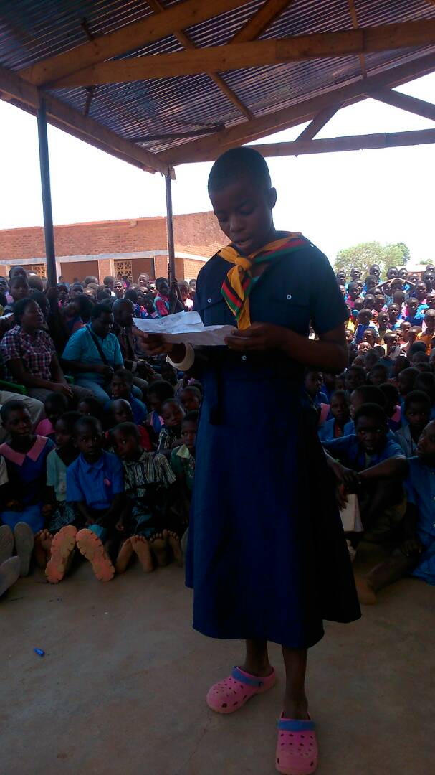
One of the girl learners singing a poem during the official handover of bathrooms

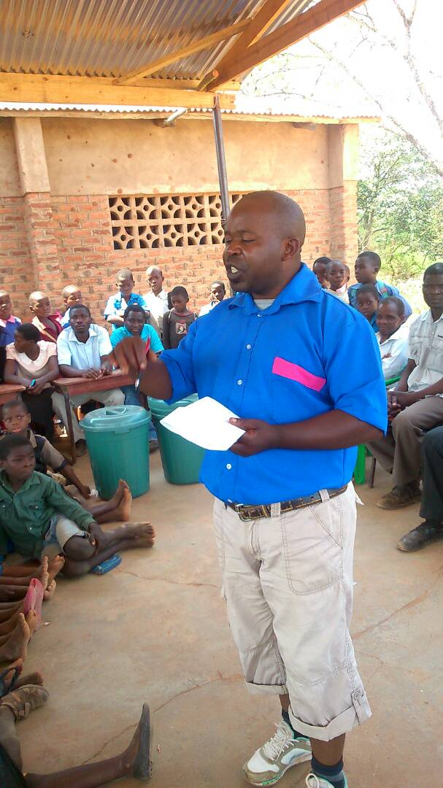
The Ward Councillor putting on a school uniform as a way of encouraging the learners to work hard in class

  - NCHENGA GIRLS BATHROOMS AND TEACHER’S BATHROOMS

There was a dire need to construct the bathrooms at Nchenga Primary School as the last funding was just to address bathrooms for boys which were damaged by torrential rain by then.

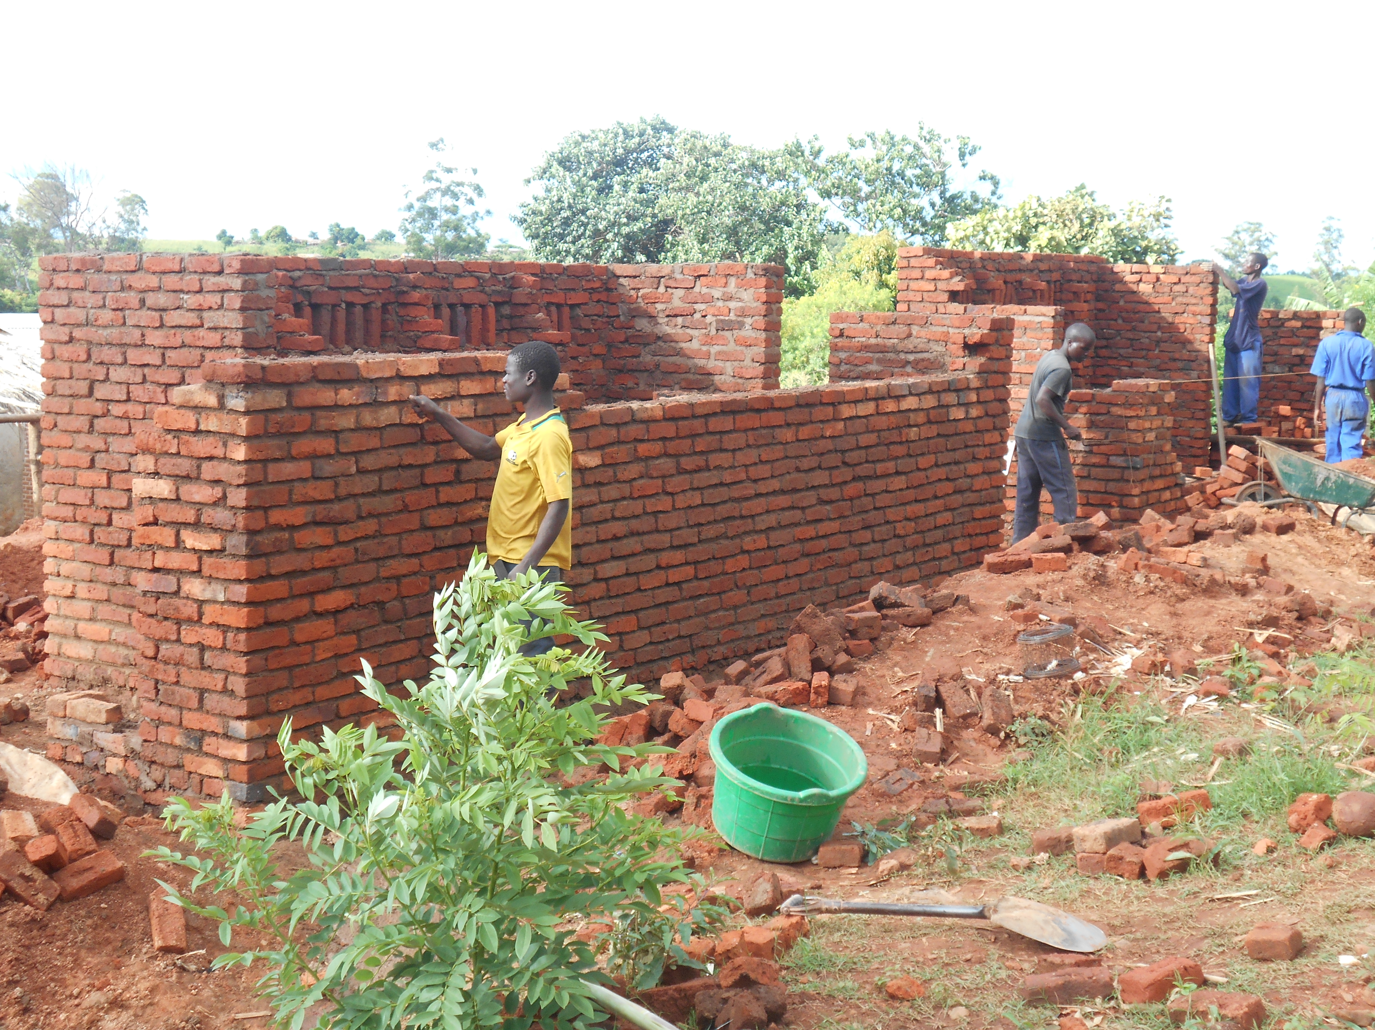The picture below shows the work in progress

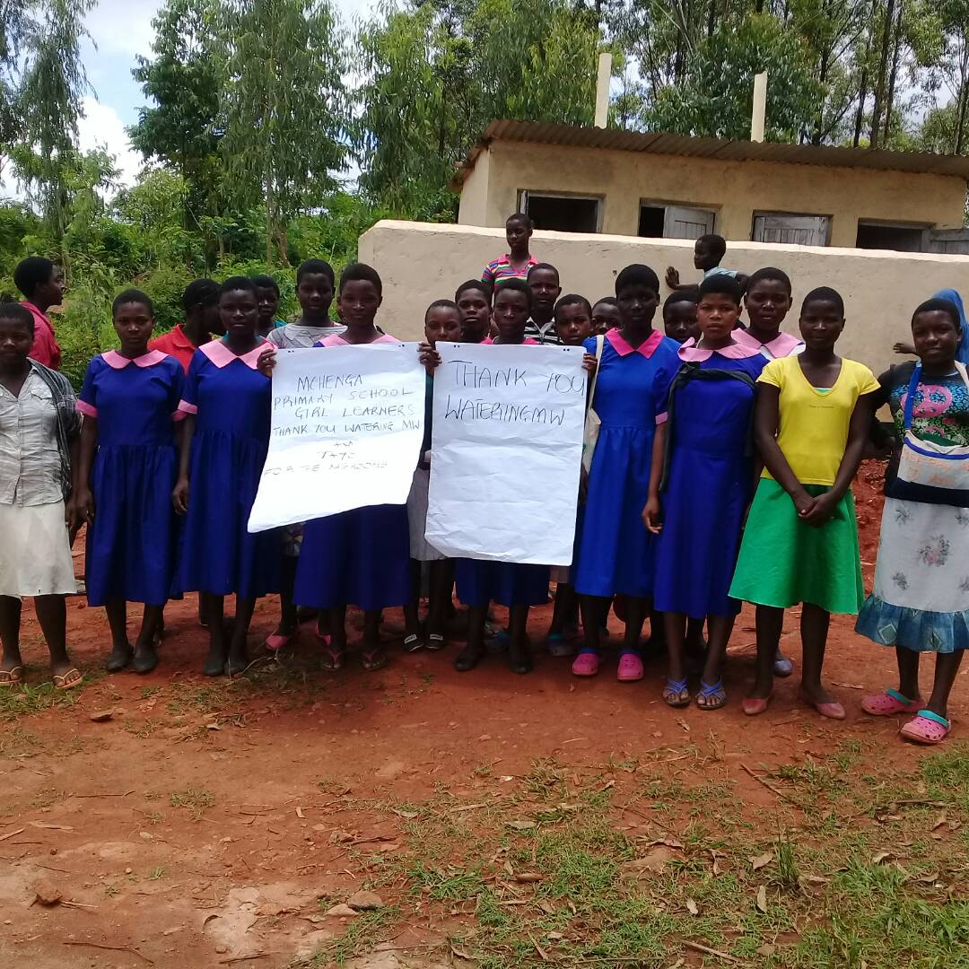

Girls of Nchenga School have all reasons to cerebrate for the good bathrooms constructed with funding from Watering Malawi

Thyolo Active Youth Organisation is so grateful for the financial support given from Watering Malawi and for the working relationship with the Government officials and the community leaders .

