**SOUTHERN AFRICAN AIDS TRUST**

**NAYUCHI AIDS NETWORK SERVICES**

**Project Financial Statements**

**Community SRHR**

**Grant Number: NAY-CDC-8/19-PN-00063**

**For the Year Ended 31 March 2016**

INDEX Page

Management’s Responsibilities 3

Independent Auditors' Report 4

Project Financial Statements 6

Accounting Policies to the Project Financial Statements 8

Supplementary Information 10

The Management of Nayuchi AIDS Network Services (NANES) is required to prepare Project Financial Statements that provide Southern African AIDS Trust with assurance on the proper use of the funds provided to NANES in line with the provisions of the Project Cooperation Agreement Number: NAY-CDC-8/19-PN-00063 known as “*Community SRHR*”

Management is also required to ensure the Project keeps proper accounting records, which disclose with reasonable accuracy at any time the financial position of the Project and enable it ensure that the Project Financial Statements comply with the Cooperative agreement and relevant statutes.

In preparing these Project Financial Statements, Management accepts responsibility for the following:

* Maintenance of proper accounting records;
* Selection of suitable accounting policies and applying them consistently;
* Making judgments and estimates that are reasonable and prudent;
* Compliance with applicable accounting standards, when preparing Project Financial Statements, subject to any material departures being disclosed and explained in the Project Financial Statements; and

Management also accepts responsibility for taking such steps as are reasonably open to it to safeguard the assets of the Project and to maintain adequate systems of internal controls to prevent and detect fraud and other irregularities.

Management is of the opinion that the Project Financial Statements show that the Southern African AIDS Trust funds were properly used.

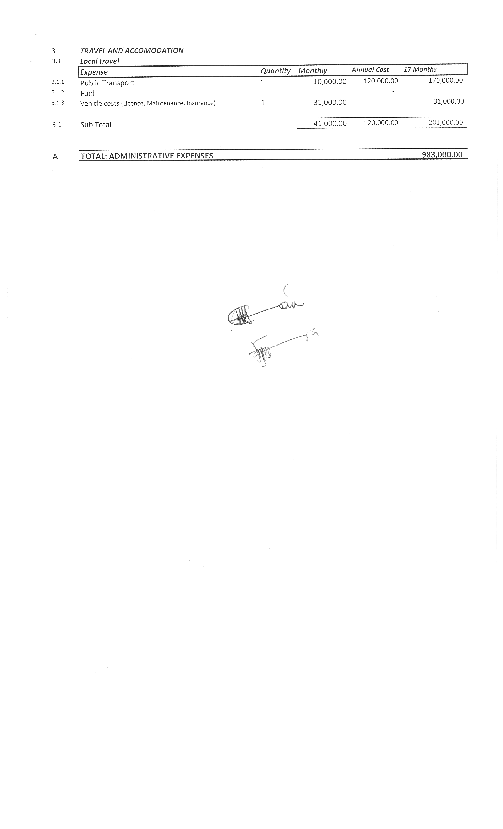

**……………………… -------------------------**

**Southern African AIDS Trust Representative Executive Director**

**………………… …………………**

**Date Date**

**INDEPENDENT AUDITOR’S REPORT TO**

**THE EXECUTIVE DIRECTOR AND**

**THE SOUTHERN AFRICAN AIDS TRUST REPRESENTATIVE**

**Scope**

We have audited the accompanying Project Financial Statements (“the statements”) of the project *Grant Number: NAY-CDC-8/19-PN-00063 Community SRHR* which comprise statement of expenditure for the year ended 31 March 2016, statement of cash and bank as at 31 March 2016 and a summary of significant accounting policies and other explanatory information.

**Management’s** **Responsibility for the Financial Statements**

Management of Nayuchi AIDS Network Services (NANES) is responsible for the preparation of the statements for *Grant Number: NAY-CDC-8/19-PN-00063 Community SRHR* project and for such internal control as management determines is necessary to enable the preparation of statements that are free from material misstatement, whether due to fraud or error.

**Auditor’s Responsibility**

Our responsibility is to express an opinion on the statements based on our audit. We conducted our audit in accordance with International Standards on Auditing (ISA). Those standards require that we comply with ethical requirements and plan and perform the audit to obtain reasonable assurance about whether the statements are free from material misstatement.

An audit involves performing procedures to obtain audit evidence about the amounts and disclosures in the statement. The procedures selected depend on the auditor’s judgment, including the assessment of the risks of material misstatement of the statement, whether due to fraud or error. In making those risk assessments, the auditor considers internal controls relevant to the project’s preparation of the statements in order to design audit procedures that are appropriate in the circumstances, but not for the purpose of expressing an opinion on the effectiveness of the project’s internal controls. An audit also includes evaluating the appropriateness of accounting policies used and the reasonableness of accounting estimates made by management, as well as evaluating the presentation of the statement

We believe that the audit evidence we have obtained is sufficient and appropriate to provide a basis for our audit opinion

**Clean Opinion**

In our opinion, the attached statements of expenditure and cash and bank balance presents fairly, in all material respects, the expenditure of K10,324,479 incurred by the project *Grant Number: NAY-CDC-8/19-PN-00063Community SRHR* for the year ended 31 March 2016 and the project’s cash and bank balance of K1,394,216 as at 31 March 2016. These statements were in conformity with agreed upon accounting policies and the expenditures were: (i) in conformity with the approved project budgets; (ii) for the approved purposes of the project; (iii) in compliance with the Southern Africa AIDS Trust regulations and rules, policies and procedures; and (iv) supported by properly approved vouchers and other supporting documents.

This report is intended solely for the information and use of Southern Africa AIDS Trust and NANES.



**_____________________**

**Aleksandr Consulting**

**Certified Public Accountants and Business Advisors**

**P.O Box 1424**

**Lilongwe (Malawi)**

**Cell:** +266 999 830 332

Name of Auditor: Aleksandr-Alain Kalanda

**Date : 18 April 2016**

|  |  |  |  |  |  |  |
| --- | --- | --- | --- | --- | --- | --- |
|  |  |  |  |  |  |  |
|  | **Project No.** | **Amount audited and certified (Malawi Kwacha)** | **Audit opinion** | **Total amount of qualification of audit opinion** | **Reason(s) for qualification of audit opinion and breakdown of amount** (**Malawi Kwacha**) | **Observation(s) that had impact on qualification of audit opinion (list observation number(s) and page of audit report/management letter)** |
|  |  |  |  |  |  |  |
|  | Grant Number: NAY-CDC-8/19-PN-00063Community SRHR | 10,324,479 | Unqualified | not applicable | not applicable | not applicable |

|  |  |  |  |  |
| --- | --- | --- | --- | --- |
|  |  |  |  |  |
|  | **Project No.** | **Value of Cash as at 31 March 2016 (Malawi Kwacha)** | **Audit Opinion** | **Total amount of qualification** |
|  |  |  |  |  |
|  | Grant Number: NAY-CDC-8/19-PN-00063Community SRHR | 1,394,216 | Unqualified | Not applicable |
|  |  |  |  |  |

*These Project Financial Statements were approved on 18 April 2016 and signed on behalf of the project by:*



***……………………………………….. ………..……………………….***

**Southern African AIDS Trust Representative Executive Director**

*The accounting policies and the notes on page 8 to 9 form part of the Project’s financial statements. The Independent auditor’s report is on page 4 to 6.*

**1.** **Project Background**

Nayuchi AIDS Network Services (NANES) is a Non-Governmental Organization that was established in April 2003 and registered as a Non-Governmental Organization in December 2008 under the Trustees Incorporation Act. It operates from Chief Kawinga area in Machinga District.

The secretariat is at Ntaja trading centre, in Machinga district.

The organization works in the HIV and AIDS, gender, economic empowerment and other development fields to ensure that the people of Machinga District particularly Orphans Vulnerable Children, People Living with HIV, youth, girls, women, chronically ill persons, persons with disabilities and children have quality and productive life through advocacy, livelihood improvements, early child education and capacity building.

Its mission is to facilitate empowerment of vulnerable community groups in realization of improved living standards, equal access to HIV prevention, treatment, care and support and the achievement of socio-economic development in Machinga district.

**2. Basis of Preparation**

The Project Financial Statements is prepared on a cash basis.

The Project Financial Statements reflects the activities of the Grant Number: NAY-CDC-8/19-PN-00063 Community SRHR project as transacted through the following bank account maintained by the Nayuchi AIDS Network Services (NANES) on behalf of the Project:

NBS Bank: 006-039-062-6013

1. **Grants**

Grants represent funds received by Nayuchi AIDS Network Services from Southern African AIDS Trust into the designated bank account.

1. **Expenditure**

Payments made represent expenditure in line with the Southern African AIDS Trust financing agreement. All payments are in Malawi Kwacha.

1. **Related Programme Activities**

The Project Financial Statements represents the Grant Income and Utilization of funds received from Southern African AIDS Trust only.

The project received K12, 203,868 **(**budget: K12, 203,868) and spent K10, 324,479 representing under spend of K2, 074,217 of the money available for project activities. The bank balance of K1, 394,216 is after accounting for a committed expenditure of K680, 000 for the procurement of T-shirts.

We verified NANES’s advances received from the Southern Africa AIDS Trust and project expenditures, which are defined as including all disbursements listed in the monthly financial reports submitted by NANES.

Further, we verified the mathematical accuracy of the Grant Project Financial Statement Reports and that the expenditure for a selected item was properly classified and actually incurred by and pertains to the project/NANES as per supporting documents including proof of payment, goods received and physically verified assets. The expenditure was incurred during the period under review. All expenditure was budgeted for and necessary for the action. Applicable Generally Accepted Accounting Principles were applied when recording the expenditure items and items were fully supported by evidence.

**SUPPLEMENTARY INFORMATION**

*The following pages do not form part of the statutory financial statements.*

