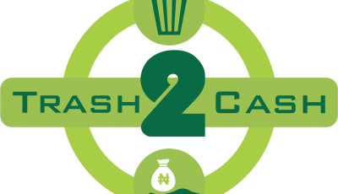***http://etrash2cash.com***

**Plot 44A, Dakata, Nassarawa, Kano State, Nigeria.**

Thursday 5th March, 2020

The Executive Director

World Connect, Inc.

632 Broadway

12th Floor

New York, NY 10012.

**RECOMMENDATION LETTER**

I write to introduce you to the organization MEDMUM AND INFANT CARE as a local community organization that engage on tackling the rate of maternal mortality and morbidity in local communiies in Nigeria. Furthermore to confirm that the above-mentioned organization was once our partner with etrash2cash Nigeria. The applicant has applied for your support and is recommended for your kind consideration to enable them continue their projects.

Kindly accord them with all recognition you deemed fit.

Thank you.

Yours Faithfully

Salisu Abdullahi

Co-founder etrash2cash Nigeria

salisuaabdu@gmail.com

+2347066744074

Our Partners

