2018
Prepared by Deovia Conity EMPOWERMENT FOUNDeovia Community Empowerment Foundation

ANNUAL REPORT OF
INTEGRATED DEVELOPMENT FOR MARGINALISED
COMMUNITY (IDMC)

Prepared by
Integrated Development For
Marginalised Community

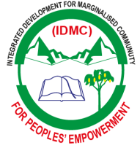
ANNUAL REPORT OF
IDMC
Integrated Development For Marginalised Community
ANNUAL REPORT OF
ANNUAL REPORT OF

BRIEF DESCRIPTION OF THE ORGANIZATION

Name of the organization: Integrated Development for marginalized community (WIPOA) is a non-profit making voluntary organization and it started in 2010. WIPOA is registered with Kasese District community development office with REG NO: 1106 and also incorporated at National level as nonprofit with REG No: 8002001404179 with registrar of companies – Kampala and also registered with the NGO board with registration No: MIA/NB/2018/12/1716, having our head office in the Kasese District.

On 14th February 2014, Integrated Development For Marginalised Community
–Uganda was joined by 23 Human and environmental activist members. The organisation this non- profit and non-political organization and was also established to participate actively as advocates of the voiceless and protectors of environment to realize sustainable development concept .

Our major goal is to help to foster unity and make communities aware of dangers that affect human social development.

In order to achieve sustainable future and strong worldwide recognition, WIPOAworks with different range of stakeholders.

Range of Activities:

Our work is divided into four programmes:

- Education and Capacity Building
- Advocacy for the marginalized and those in calamity
- Energy
- Environment
- Disaster preparedness

Cooperation/Membership

We consider cooperation as necessary tool for development processes. Therefore, we maintain partnerships with different stakeholders, being aware of the importance of every single pillar: local communities, authorities, other organizations and individuals at national and international level.

Cooperation/Membership at the district level

- Kasese district Farmers Association
- Institute of Ecology –Kasese
- Irma Pfeiffer Foundation
- MENODA

ANNUR
IDMC
Integrated Development For Marginalised Community

T OF THE 2010
NUAL REPORT OF THE NGO DEOVIA COMMUNITY 2010
DESCRIPTION OF PROJECTS REALISED IN THE SCOPE OF PROGRAMMES

Education and Capacity Development Programme

1. Strengthening capacities of civil society sector

PROJECT DURATION | January 2018 – December 2018
TECHNICAL SUPPORT | UWA
APPROVED FUNDS | USD 2,500

\
THE AIM OF THE PROJECT:

Support the capacity building and activities of Civil Societies in line with environmental protection in Kasese to enable them to select ,plan and implement pro-poor projects.

IMPLEMENTED ACTIVITIES:
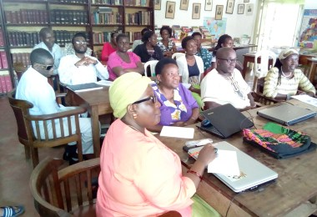
Workshop of Strengthening capacities of civil society sector

In cooperation with Uganda UWA and schools , the WIPOA held workshop on how to protect the eco-system of Mount Ruwenzori which has suffered deforestation due to tree felling for timber and quest for land for cultivation.
The presentation on two day workshop of nature protection by 17 CSOs and 4 schools yielded good results . Beekeeping and bats protection ranked number one project for restoration of natural forests on mount Ruwenzori.

Integrated Development For Marginalised Community
IDMC

Partnership actions for biodiversity protection in Bugoma Forest –Kasese

PROJECT DURATION January 2018 – March 2018

DONOR | UWA

APPROVED FUNDS
from UWA USD 2,300

THE AIM OF THE PROJECT:

Raise the awareness of the killings of chimpanzees in Bugoma Forest and the importance of innovative environmental policies to protect them and regional campaigns to protect the natural resources of the region;

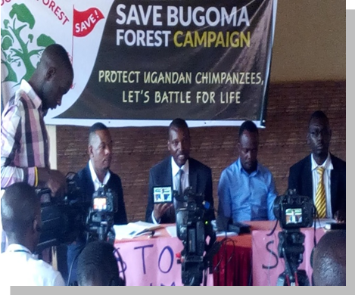
Share and learn from participants the best practices of nature conservation

IMPLEMENTED ACTIVITIES:

In collaboration with local representatives, WIPOA and members of social media, we agreed and organized a workshop to set up a campaign through media to protect the 117 chimpanzees remaining in the Bugoma forest.

Results:
On 18th June 2018, government stepped up its protection measures to protect the chimpanzees not only in Bugoma Forest reserve but also forest chimpanzees living in the forests outside Mount Ruwenzori National Park.
Three anti-poaching organizations were formed by environmental activists to convince poachers to stop destroying nature but instead protect it.

IDMC participating in Save Bugoma Forest chimpanzees

Integrated Development For Marginalised Community FOUNDATION
IDMC

Preventing Ihandiro Natural forest from illegal cutting

INITIATIVE DURATION | Sept 2018 – December 2018
Supporter | IRMA PFEIFFER FOUNDATION
APPROVED FUNDS | USD 1,520

THE AIM OF THE INITIATIVE:

- To Stop illegal forest cutting and request local government to put measures to preserve the 10 square kilometers of Ihandiro Natural forest until proclaiming the area as nationally and internationally protected area.

- Stop nature violation by forestry sector and miscellaneous usage of collisions between law procedures and concessionaires and controversial management from Directorate of Forests.

IMPLEMENTED ACTIVITIES:

- The Committee for defending Ihandiro Natural forest which gathered local citizens, NGOs and scientific organizations were created;

- Meetings were organized and established collaboration with Uganda Wild Life(UWA)

- Results achieved were:

  - Forest cutting was stopped temporarily and forest concessionaire was punished because of creating illegal forest road in the forest
  - Feasibility study for highest level of the protection for area was created;
  - Feasibility Study for enlarging the NP border was finalized by UWA and sent to the relevant ministries.

GO DEOV Integrated Development For Marginalised Community
IDMC

Energy programme

Let us illuminate energy efficiency

PROJECT DURATION | JUNE 2018- December 2018
Support from | LUND NATURE ASSOCIATES
APPROVED FUNDS | 3,111.1 USD

THE AIM OF THE PROJECT:

The main aim of the project was establishing good energy efficiency practices which makes an economic and energy savings contribution and has an influence on
development of off grid mountain population .

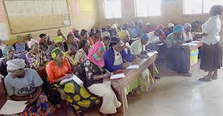
SPECIFIC OBJECTIVES:

- Promotion of energy efficiency solutions in private and public institutions;
- Enhancement of knowledge and information about energy efficiency to employers in public institutions and citizens
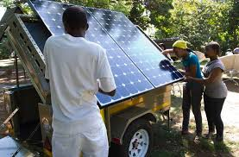
- Promotion of energy efficiency light bulbs.
Renewable Energy efficiency workshop

IMPLEMENTED ACTIVITIES:
The meetings were organized with representatives of private and Public Institutions, NGOs and business sector with aim of familiarize with energy efficiency topic and possibilities to be part of the project realization;
Participants getting familiarized with different solar panels

Survey for employees in private and public institutions and private companies in the field of energy efficiency that were meant to determine the knowledge and application of energy efficiency measures;
Round table “Implementation of energy efficiency measures in private and public institutions was organized. There were presented the current situation in Montenegro in this field when speaking about legislation as well as implementation of simple measures for rational use of energy;
Press conference was organized;
The brochure “Energy efficiency diet” which contains simple instruction for implementation of energy efficiency measures in privates companies and public institutions was prepared and printed;

Performance “Fight of bulbs “was realized in cooperation with children and teachers from kindergartens.

The project was supported by Friends of the Earth International through Green action
ANNUAL REPORT OF YEAR 2010
IDMC

Integrated Development For Marginalised Community
HE

4.4. Support to people in Great need

PROJECT DURATION | 30 days 2018
Support from | Members of WIPOA
APPROVED FUNDS | Ug shs 3,200,000

THE AIM OF THE PROJECT:

The aim of the project is to support people of Kasese in River Nyamwamba water flood calamity . River Nyamwamba flooded its banks and over 21 people lost their lives. Many houses were shattered and over 250 people remained without shelter food..

THE SPECIFIC OBJECTIVES:
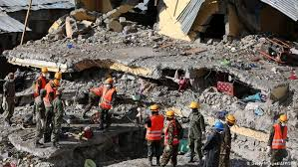
- Provide necessary support to the flood victims ;

- Educate people about global warming ;
- Create awareness of people in danger ;

IDMC staff rescuing flood victims from shattered buildings
IMPLEMENTED ACTIVITIES:


- The food ratios were given to the flood victims

- Rescue specialists were hired to rescue people in shattering houses
- Two Vehicles were hired to take victims in critical situation to Kilembe Hospital.

IDMC Aid to flood victims

ANNUAL REPORT

Integrated Development For Marginalised Community
IDMC
HE

PROJECT PARTNERS IN 2018

- UWA

- Irma Pfeiffer Foundation
- Lund Nature Associates

CONTACT DETAILS

Name of the organization: INTEGRATED DEVELOPMENT FOR MARGINALISED COMMUNITY

Address: P.O. BOX 65
Phone: +256 7823621

ANNUAL
Integrated Development For Marginalised Community
IDMC

REPORT 2010

FINANCIAL REPORT FOR 2018

BALANCE SHEET taken from Final Financial Report for 2018

Exchange Rate : 1 € = Ug shs 4,000
Assets |  | (In Ug shs)
1.Subscribed capital unpaid
2. Fixed assets |  | 94,048,000
2.1 Intangible fixed assets |  | 10,660,000
2.2 Tangible fixed assets |  | 83,388,000
2.3 Financial assets
3. Current assets |  | 18,420,550
3.1 Stocks
3.2.1 Debtors due after one year
3.2.2 Debtors due within one years |  | 5,920,000
3.3 Cash at bank and in hand |  | 12,500,550
3.4 Other current assets
Total assets |  | 112,468,550
Liabilities |  | (in Ug shs)
4. Capital and reserves |  | 0
 | 4.1 Subcribed capital |  | -
 | 4.2 Reserves |  | -
 | 4.3. Profit and loss brought forward |  | 4,619,004
 | 4.4. Profit and loss for the financial year |  | -
 |  | 850,250
5. Creditors
5.1.1 short term non-bank debt(accrued utility bills ) |  | 850,250
5.1.2 Long term bank debt |  | -
5.2.1 Short term non-bank debt |  | -
5.2.2 Short term bank debt |  | -
Total liabilities |  | 850,250
Capital worth |  | 106,999,296
Total capital worth and liabilities |  | 112,468,550

IDMC
Integrated Development For Marginalised Community
Revenue :
Revenue: | 31ST DECEMBER , 2018
UWA Grant |  | 9,000,000
UWA grant II phase |  | 8,280,000
Grant from DCEF-U |  | 5,472,000
Donation From Lund Nature Associates |  | 11,199,960,
Member donations |  | 3,200,000
Own incomes |  | 44,733,860
TOTAL Revenue |  | 81,885,820
EXPENDITURE:
Project activities |  | 47,182,100
Capacity building (beneficiaries) |  | 4,500,000
Board meeting expense |  | 272000
Travelling and subsistence |  | 1,491,700
Staff allowances |  | 8,594,900
Staff training/development |  | 458265
Publicity |  | 132918
Incidentals |  | 26021
Stationery |  | 604,000
Utilities (Electricity and water) |  | 127,200
Vehicle Hire |  | 3,200,000
Rent |  | 1,034,600
Telephone and communication |  | 133,551
Radio announcements |  | 495149
Consultancy |  | 251600
Office expenses |  | 327,800
Bank Charges |  | 405400
Permits |  | 92900
Mobilization |  | 2,144,982
Performance incentives and awards |  | 149440
Repairs and maintenance |  | 1,175,050
Audit fees and expenses (2013) |  | 2,150,010
Subscription |  | 45000
Legal fees |  | 160,830
General insurance |  | 2,111400
TOTAL EXPENDITURE |  | 77,266,816
Surplus carried forward |  | 4,619004

