

**WOMEN RIGHTS INSTITUTE**

**PROJECT REPORT**

**Project Name/Title: MAYI- MWANA**

**Reporting period: DECEMBER 2018 TO NOVEMBER 2019**

**Prepared by: Women Rights Institute (WORI)**

**Reporting to: PACF- ViiV Health Care**

 

**NOVEMBER 2019**

**LIST OF ACRONYMS AND ABBREVIATIONS**

ADC Area Development Committee

ART Anti-retroviral Treatment

ANC Antenatal care

C3 CBO, Clinic and Community collaboration

CBO Community Based Organization

CHAM Christian Health Association of Malawi

DEC District Executive Committee

DBS Dry Blood Spot

DHMT District Health Management Team

DHO District Health Office

EID Early Infant Diagnosis

HIV Human Immunodeficiency Virus

HTC HIV Testing and Counseling

HAS Health Surveillance Assistant

M and E Monitoring and Evaluation

MTCT Mother to child Transmission

NASO Nkhotakota Aids Support Organization

PACF Positive Action for Children’s Fund

PMTCT Protection of Mother to Child Transmission

PLWHIV People living with HIV

PIH Partners in Hope

T/A Traditional authority

TBA Traditional Birth Attendants

VDC Village Development Committees

WORI Women Rights Institute

WLHIV Women Living with HIV

YONECO Youth-net and Counseling

**Executive summary**

Due to a number of challenges namely fear of stigma and discrimination, distance brought about due to a lack of and inadequate finances and attitudes by HIV positive mothers (parents) whose infants are exposed to HIV, most of these parents shun away from testing and bringing their exposed infants for testing. As such, this has led to a rise in number of infant default cases, where infants no longer test and are lost from care, especially after the first testing milestone (6 weeks). With funding from Positive Action for Children Fund (PACF), Women Rights Institute (WORI) is implementing a 2 year, “Mayi-Mwana” project, which seeks to address the problem of loss to follow-up, by mainly focusing on Early Infant Diagnosis (EID). Mayi-Mwana project aims at ensuring that there’s improved tracing, testing and treatment for over 90% of exposed infants and children at 6 weeks, 12 and 24 months in the project’s catchment area; T/A Mwadzama- B, by November 2020. WORI is implementing the project with Kapiri Health Centre which is a private mission hospital under CHAM. Maternal, HTC and ART services at the Health facility are accessed for free however, pertaining to an agreement between CHAM and the government of Malawi that people surrounding some CHAM facilities access such services for free.

To realize its purpose, the project has the following objectives;

1. **To increase uptake of early infant diagnosis services, by 90%, by November 2020.**
2. **To increase retention of 3000 pregnant women to ANC in the Mwadzama B area in Nkhotakota district.**

To achieve the objectives of the project, a number of activities were undertaken and successfully implemented from December 2018 to November 2019. During this period, messages on the importance of attending antenatal clinics, testing of HIV, ART treatment adherence, male involvement and EID were disseminated. Follow-ups on HIV positive pregnant mothers and exposed infants to receive PMTCT services have also been taking place.

Project inception activities such as the DHMT, DEC, ADC and VDC meetings were first conducted. 15 expert clients and mentor mothers were trained, C3 engagement meetings between Clinic, Communities and CBO, Bi-Monthly focus group discussions between mentor mothers and WLHIV, Community mobilization and talk shows, engagement meetings with PLWHIV and project review meetings with stakeholders have successfully been conducted. Weekly, monthly and quarterly supervisory and monitoring activities were also conducted. These are; one on one sessions and follow-up on defaulters by volunteers, monthly supervisory meetings and quarterly joint case review meetings.

Through these activities, a lot of people in Mwadzama B area are now equipped with information of PMTCT and EID , HIV and the project has registered a number of successes which include; a rise in number of women going for ANC and HTC, a rise in number of HIV exposed infants who have been traced, led back to care and currently enrolled in EID, increased male participation in EID and PMTCT, improvement in the number of women delivering at health facilities and reviewing and re-strengthening of EID enabling by-laws by communities. This has been so because of the good working relationship between mentor mothers, health workers, WORI and the communities at large.

There however have been a number of challenges that have met the implementation of these activities, and these include late implementation due to changes in meeting schedules by influential committees like the DHMT and the DEC as such activity implementation started in January. Distance has been a demotivating factor to Mentor mothers, as they have been walking long distances to reach clients as they do not have bicycles, clients have also been complaining about distance to and from the clinic. Some HIV positive women are facing stigma from relatives and some clients have also been complaining about poor reception at the health facilities when due to deliver.

* 1. **SUMMARY OF ACCOMPLISHED ACTIVITIES AND RESULTS**
  2. **CONDUCT INCEPTION MEETINGS WITH THE DHMT**

A meeting was successfully conducted between the DHMT and WORI with the aim of introducing the project and seeking a go ahead to implement the project from the DHMT and to seek technical advice on how to successfully and efficiently implement the project. 16 people attended the meeting where 10 were males and 6 were females. The DHMT welcomed the project and appreciated the male involvement aspect of the project as it would encourage more women to take part in EID.

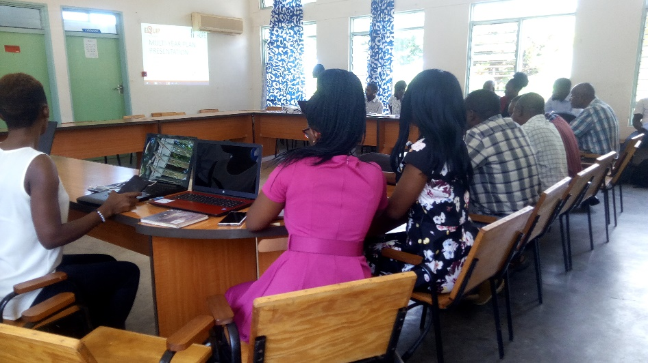

***DHMT meeting in progress***

* 1. **CONDUCT INCEPTION MEETING WITH DEC**

The aim of this meeting was to introduce the project at district level to the District Executive Committee which comprises of all government and non -governmental stakeholders working and doing various programmes and projects in the district of and seeking a go ahead to implement the project in the district. The meeting was attended by 64 people among which 17 were females and 47 were males. The DEC welcomed the project to be implemented in the district and asked for special consideration of mothers with disabilities who will be involved in the project.

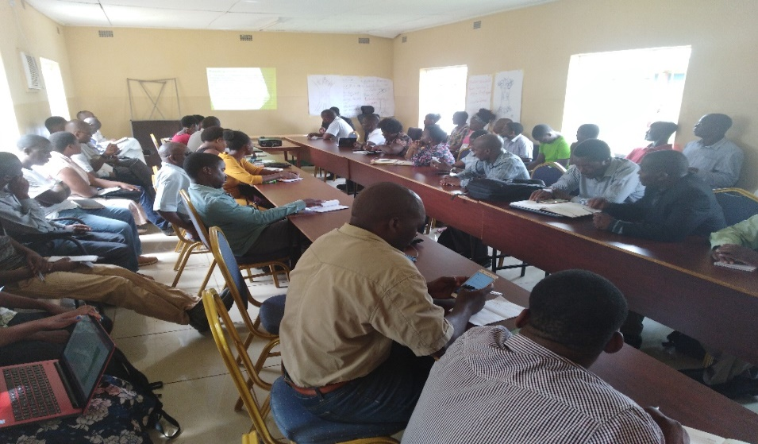

***DEC members following presentation of Mayi-Mwana Project***

* 1. **CONDUCT ENTRY MEETINGS WITH ADC AND VDCS**

ADC and VDC (local government structures) members were briefed on the project with the aim of ensuring that there is collaboration and involvement from all community members in the project. Members of these 2 forums welcomed the project in their area. The meeting was attended by 64 people, of whom 25 were males and 38 were females. The ADC provided WORI with 5 VDCs that are in the Mwadzama B area to be working with, and these are: Ngwata, Damba, Msamala and Mankhwazi.

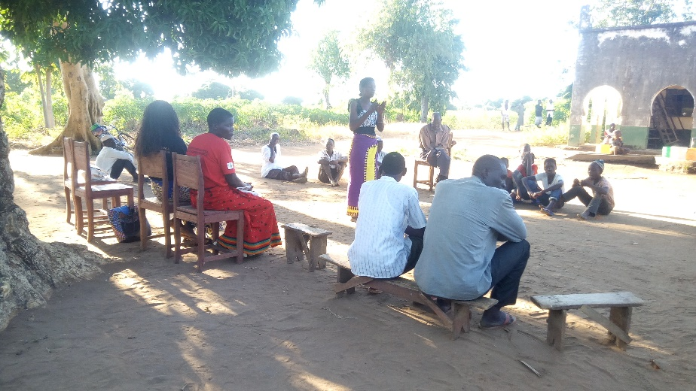

***WORI community volunteer speaking during ADC and VDC briefing***

* 1. **CONDUCT REVIEW MEETING WITH KEY STAKEHOLDERS**

This meeting brought together different organizations and players implementing health related projects in the district. This was essential as it helped in identifying other organizations to work collaboratively with for successful retention of pregnant mothers to ANC, HIV testing, ART provision and access as well as DBS handling. By the end of the meeting a number of organizations implementing HIV testing and counseling related projects, organizations implementing ART provision and access related projects as well as organizations implementing projects related to handling and transportation of DBS of exposed infants from health centers to the DHO for testing were identified and are working hand in hand with to achieve successful results. Stakeholders from Partners in Hope (PIH), YONECO, NASO, Nkhotakota DHO, Oxfam, among others attended the 37 participants’ meeting and 27 were males and 10 were females.

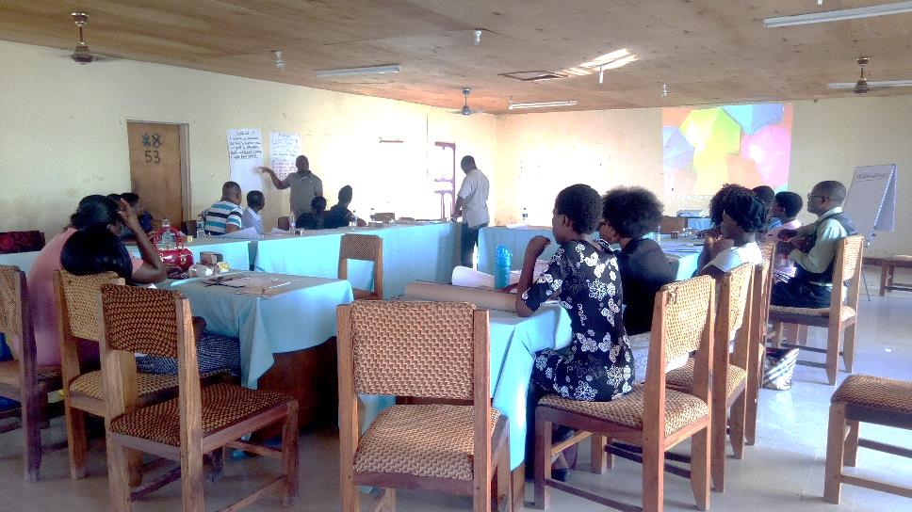

***Review meeting with stakeholders in progress***

* 1. **TRAINING FOR 15 EXPERT CLIENTS AND MENTOR MOTHERS**

Training of the 15 mentor mothers who were identified before starting the implementation of the project was the very first activity for this month. These mentor mothers already had previous experience in following up on defaulters from the previous initiatives that they were being involved in. The training was conducted however to drill with knowledge, those that were new to the concept of defaulter follow-up as well as to equip all of them with thorough knowledge on the same. This ensured that proper ways of client reach and approach are employed by the mentor mothers in their course of work so that the project amasses quality results in the end. The training was attended by 22 participants, among which, 2 were men.

**At the end of the training women were imparted with knowledge in;**

* HIV/ AIDs
* PMTCT and option B+ (The core foundations of PMTCT)
* Early Infant Diagnosis (EID) concept
* ART - (reasons why people become defaulters and the importance of adherence)
* Counseling, peer education and follow-up- (qualities of a good councilor, case and scenario demonstrations and follow-up techniques).

At the end of the training mentor mothers understood their roles as councilors as well as their responsibility and requirement to respect privacy of their clients in the course of their duties.Thewomen were also oriented on data collection tools.

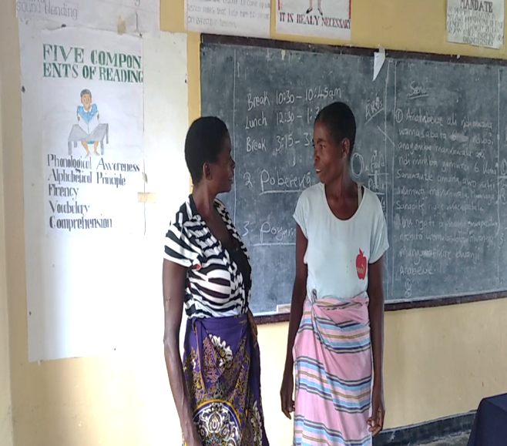 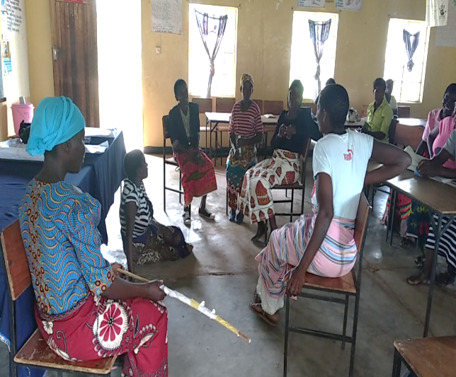

***Mentor mothers demonstrating peer approach through drama during the training***

**1.6 C3 ENGAGEMENT MEETING BETWEEN CBO, COMMUNITY AND KAPIRI HEALTH CENTER (HSAS, MENTOR MOTHERS, AND LOCAL LEADERS)**

C3 engagement meetings provided an opportunity for mentor mothers, expert clients, community leaders, Kapiri health centre and WORI to discussion issues of HIV, EID and the state of default cases to ensure that negative issues surrounding EID, Option B+ and PMTCT are addressed. This was to ensure that issues that can prevent women and all people living with HIV in the communities to access these services are discussed and addressed.

During the meetings Kapiri Health Centre HSA gave talks on EID and PMTCT to ensure that mentor mothers and community leaders understand the importance of early enrollment into ANC, adherence to ARTs, delivering at health centres instead of at home, as well as testing and re-testing exposed infants, so that they are able to mobilize people in their communities to take part in EID. The HSA also gave reasons why people become defaulters which were; the fear that marriages will break after discovery of HIV status of the woman. It was also discovered during the meeting that some HIV positive parents prefer to keep the status of their infants unknown by not getting them tested because they feel sorry for the infants to start treatments at their ages should they or when they are found positive. It was also discovered that distance to health centers brought about by inadequate finance resources was also one problem hindering women to bring their infants for retesting after the first test. These are the problems that were raised during the meetings as contributing factors to default cases and deterring people from getting tested to know their status in-order to protect infants from HIV.

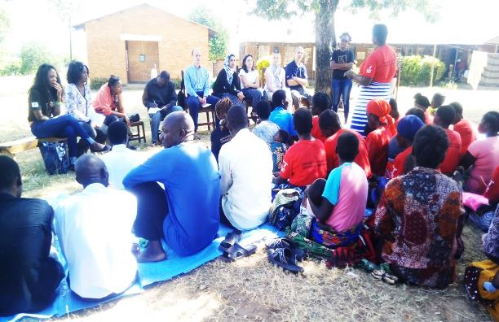 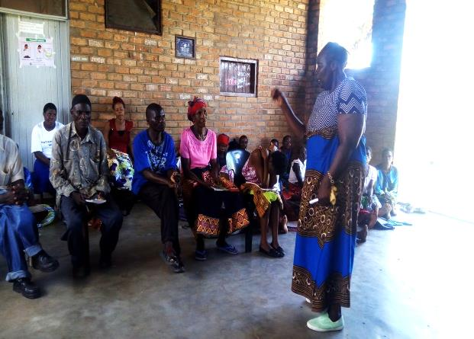

***Mentor mother speaking dirung a C3 :Kapiri Health Centre HSA giving a talk on EID***

Community leaders therefore responded actively to the initiate and they pledged to give full support to the programme to ensure that their subjects are fully aware of the presence of mentor mothers in their community and that all concerned people in the community are actively involved in EID and option B+ services uptake. Community leaders agreed to strengthen bylaws to take to task women and couples who shun away from antenatal, as well as bringing their infants back into the programme of test and re-tests. Bylaws were also agreed upon to be take effect on women who do not deliver at health facilities to ensure that infants are not infected with HIV by their mothers during birth. It was also agreed during the meeting that mentor mothers intensify information of the importance of attending antenatal ART adherence, as well as testing and retesting exposed infants when they are following up on clients as some people in the community do not have thorough knowledge about EID.

**1.7** **CONDUCT MOBILE INFORMATION CARNIVALS**

Mobile information carnivals were conducted to help raise awareness to all the communities around Mwadzama B area, at different spots in 5 VDCs namely Mankhwazi, Khwapu, Msamala, Chongole and Damba. This was done to equip people in these areas with more information and knowledge on the importance of HIV testing before and during pregnancy, delivering at the nearest health facility, ART adherence and EID, in order to prevent HIV transmission from mother to child. 2551 people were reached through the mobile information carnivals.1250 of these people were men and 1301 were women.

+

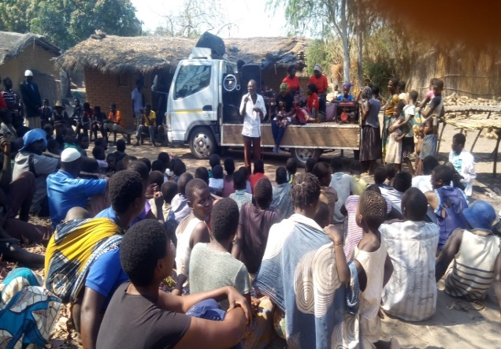 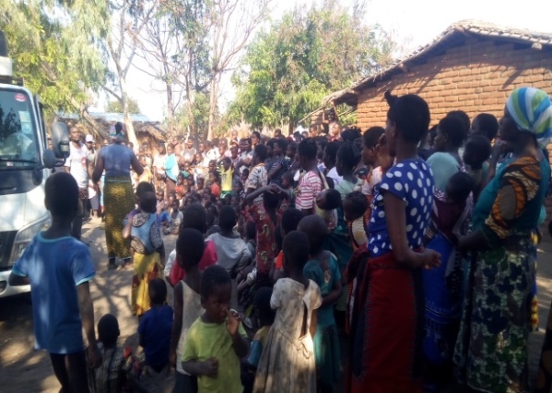

During the activity, a health worker provided expertise information on the topics. Linga drama group was also hired to help highlight the messages through theatre. People were able to ask questions on the topics and this showed a positive response to the messages being advocated for. These carnivals also helped to mobilise men to take responsibility in PMTCT by testing for HIV together with their spouses in order to protect their expected infants from HIV.

**1.8 ENGAGEMENT MEETING WITH WOMEN AND MEN LIVING WITH HIV, HSAS AND MENTOR MOTHERS.**

These meetings brought together mentor mothers, men and women living with HIV,HSAs and WORI, to build capacity of PLWHIV in EID, discuss issues that PLWHIV have and to collaboratively come up with workable solutions that would empower them in successful PMTCT. The output of the meeting was a cadre of mothers who are well equipped with knowledge on the importance of Starting ARTs, continued adherence, postnatal care, labour and delivery management, preventative service for HIV patients (condom use and family planning) infant feeding counseling. The meetings were attended by 81 people of which 68 were females and 13 were males. During the meetings, both lactating and pregnant women living with HIV were reminded of the importance of ART adherence and observing healthy habits both during and after pregnancy to achieve HIV free infants.

It also transpired during the meetings that a lot of people in the project’s target communities are expressing gratitude for the messages being advocated for by mentor mothers as their lives are being saved. Kapiri Health Centre personnel also lauded the efforts of WORI and mentor mothers as now default cases have receded and they suggested that follow-up be scaled up to other age groups including men, women and teen mothers.

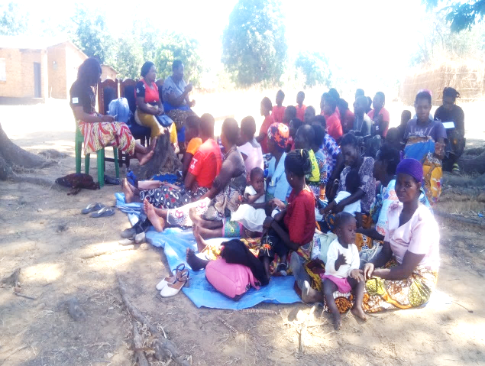 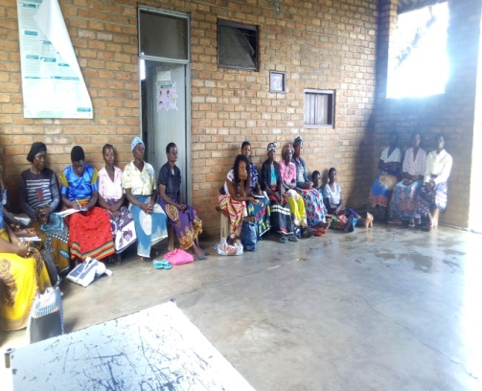

***Kapiri Health Centre nurse in-charge addressing the gathering on EID during the meeting***

During the meetings, a number of issues were also raised and ways forward were also discussed;

* Some HIV positive women have not yet revealed their status to their spouses and this is impacting on their ability to adhere to treatment and also raising a concern on their ability to care for their infant.
* Some women continue to deliver at home than health facilities, posing the risk of HIV transmission from mother to child.
* Long distance to Kapiri and surrounding health centers
* Poor reception of pregnant mothers at the health centers, especially during delivery
* Stigma that some HIV positive women encounter from their family members and relatives.

**Participants present at the meeting agreed therefore that;**

* HIV positive women be encouraged and counseled to reveal their status to their spouses to ensure that they do not confine themselves to privacy when accessing as well as taking treatment.
* Pregnant mothers should be sensitized to be saving some money that they can use as transport for their schedules to the health centers to access services, as a solution to the problem of distance.
* The house also agreed that relatives and families of women living with HIV should be followed in their areas to be sensitized to curb stigma and discrimination.
* Mentor mothers, being people who directly reach and follow-up clients in their communities, were also asked to elaborate clearly to pregnant mothers procedures of Kapiri health Centre, as being a private clinic, which is also small, the facility has some guidelines on access to Antenatal and maternal services, in accordance with guidelines by the government of Malawi. These guidelines are that women giving birth for the first time and for more than 3 times should be referred to the District Health Centre (DHO).
* The health facility agreed to sensitize and remind its personnel of their responsibility to patients and also to elaborate more clearly to women, the terms of accessing services as per the agreement between the government of Malawi and CHAM.
* Issue of continued delivery at home to be taken to the senior Traditional Authority leader of the area.

**1.9 BI-MONTHLY FOCUS GROUP DISCUSSIONS BETWEEN MENTOR MOTHERS AND WOMEN LIVING WITH HIV ON BREAST FEEDING, PMTCT EDUCATION, ART ADHERENCE AND EID.**

Bi-monthly focus group discussions were conducted to evaluate how mentor mothers are incorporating and helping women living with HIV in their support groups on PMTCT and EID to ensure that they are able to follow counsel from the hospital on the importance of adhering to ARTs and delivering at health facilities rather than at home or at a TBA. These forums also helped WLHIV acquire information on prenatal and postnatal mother-infant care and proper infant feeding techniques. In attendance were 38 people and among these 5 were men and 33 were females.By the end of these meetings women living with HIV were able to understand EID and its importance and now they are able to see the benefit of ART adherence as they expect or breastfeed their infants. The pregnant women understood the importance of PMTCT, EID, option B+ and the importance of ART adherence messages advocated by mentor mothers. Many of these pregnant women and infant defaulter reached are currently following counsel from the hospital and are going for second and third tests (mentor mothers make follow-ups to ensure the clients went to the health centers after initially reaching them).

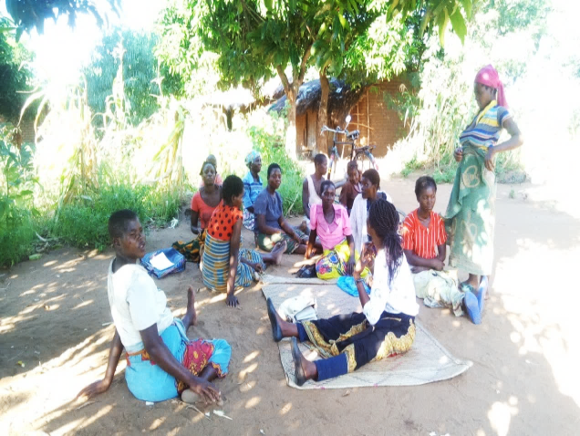 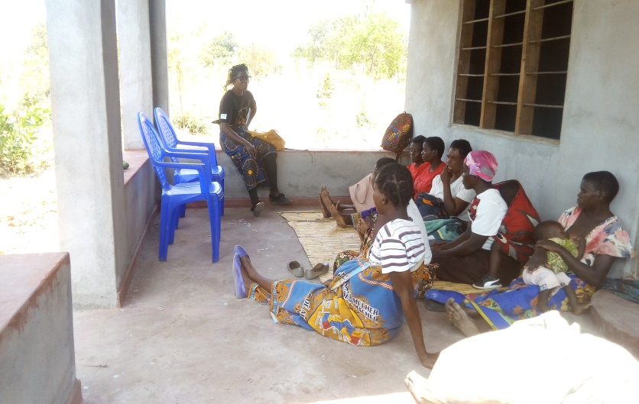

***Bi-Monthly focus group discussions in session***

**2.0 M AND E ACTIVITIES**

**2.0.1. ONE ON ONE SESSION BY VOLUNTEERS AND FOLLOW-UP ON DEFAULTERS**

These progress supervisory visits have been taking place since follow-ups inception. These visits have been conducted with the aim to track progress and supervise how mentor mothers are following up on defaulters and pregnant mothers. Infants who have defaulted care, and generally all women who are pregnant and have been reached by mentor mothers to share with them PMTCT education have been the targets of these visits. The essence has been to bring back into care infant defaulters and also to emphasize to pregnant women PMTCT education. This was done to ensure that all pregnant women, (HIV positive, HIV negative and unknown statuses) are knowledgeable of PMTCT and EID to minimize the risk of MTCT considering that some clients have their HIV status rather be kept private. A Total of 111 pregnant women were reached through one on one sessions. A number of issues have been subjects of discussion during these one on one sessions and these are;

* The importance of early and timely ANC and VTC to pregnant mothers
* The importance and need for adherence to ARTs to HIV positive pregnant and lactating mothers
* The importance of delivering at the hospital/ health centres to pregnant mothers.

The outputs have been positive at the end of the sessions as pregnant mothers have been showing that they understood the importance of timely ANC visits so that they know their statuses and start ARTs in time once found HIV positive, to ensure their infants are protected. They also understood the importance of ART adherence as well as delivering at a health facility.

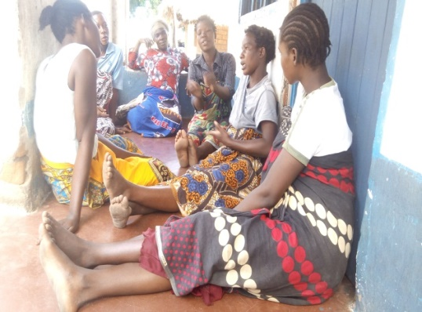 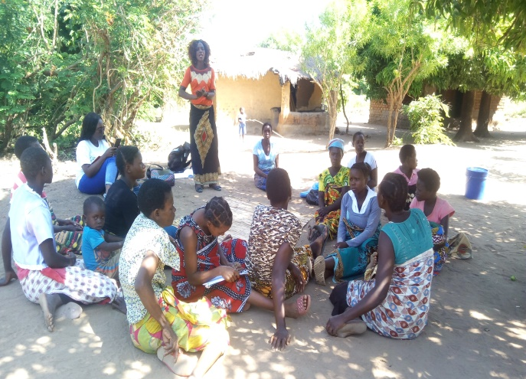

***Pregnant women taking part in one on one sessions: Mentor mother talking during a session***

**2.2** **QUARTERLY JOINT CASE REVIEW BETWEEN EXPERT CLIENTS, HEALTH WORKERS AND COMMUNITY LEADERS.**

These meetings brought together mentor mothers, health personnel, community leaders and WORI, to discuss and review cases and project progress registered since mentor mothers started follow-ups on defaulters and returning mothers to option B+. The meetings were attended by 28 people, among which 7 were men.

During the meetings, community leaders explained that the project has been so beneficial as HIV positive pregnant mothers were equipped with PMTCT information and as a result this has seen a good number of women starting ANC as early as possible and delivering at Health facilities. The leaders also pointed out that the project has helped in tracing the mothers and their babies who were lost to follow up and they have been now referred to the health centres for on-going treatment, care as well as support. They also appreciated the health personnel who are helping the mothers being referred to the hospital by the mentor mothers.

Though the successes however, mentor mothers raised a concern about lack of political will from some community leaders, to fine some women who deliver at home instead of a health facility, and this is a demotivating factor to other women who follow bylaws.

Mentor mothers also raised a complaint from some pregnant women, of poor reception by health personnel from Kapiri health centre as this could lead to a decrease in access of maternal as well as PMTCT and ANC services.

**The house therefore agreed that;**

**-**Awareness campaigns to be intensified to ensure more people are aware of the importance of accessing ANC, PMTCT and maternal services, as well as delivering at health facilities to protect infants from HIV infections.

-Community leaders were also asked to intensify bylaws and take initiative to fine women delivering at home, to deter others from doing the same, in order to protect infants from HIV infections at home.

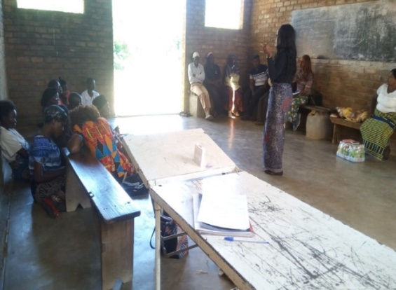 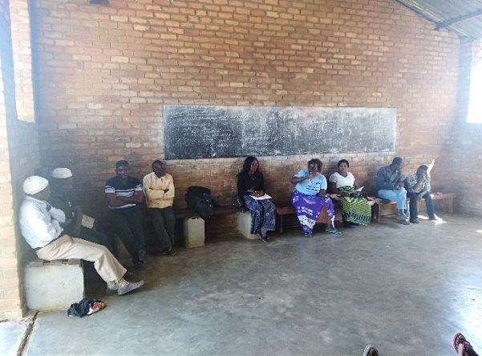

***Joint Case review meeting in progress***

**2.3** **MONTHLY JOINT PROJECT SUPERVISORY, DATA AND PROGRESS REVIEW MEETING.**

These meetings have been bringing together project stuff and mentor mothers, to review progress made and also to map the way forward towards successful implementation of other activities for the success of the project. Each mentor mother presented progress of her work and submitted data collection forms. During the meetings, mentor mothers explained that a lot of women who had not yet enrolled into antenatal and did not know their status yet had now realized the importance of early antenatal as well as testing for HIV. The mothers also mentioned that the HIV positive women and parents of infants exposed to HIV whom they have been visiting and following up appreciated the encouragement and counsel given to them as they promised to continue adhering to ARTs and re-testing infants to protect them from HIV. Mentor mothers also explained that a lot of women were now delivering at the health facilities. During the meeting, mentor mothers were encouraged and reminded to be working hard so that they reach out to as more pregnant women as possible to ensure that they start treatment early if they are found HIV positive. They were also reminded to make follow up visits on women who had not yet enrolled into antenatal to encourage them to do so.

**NB* Malawi’s PMTCT guidelines champions counseling pregnant women coming to antenatal visits to test for HIV, know their status and plan accordingly for the expected infants, thus the emphasis on early ANC.**

Mentor mothers were also reminded to observe secrecy and to respect privacy of clients and to be working hand in hand with expert clients and community leaders to ensure that more people take part in EID. The mothers were also reminded to reach out to spouses of pregnant women with PMTCT education as much as possible to ensure that they attend HTC together.

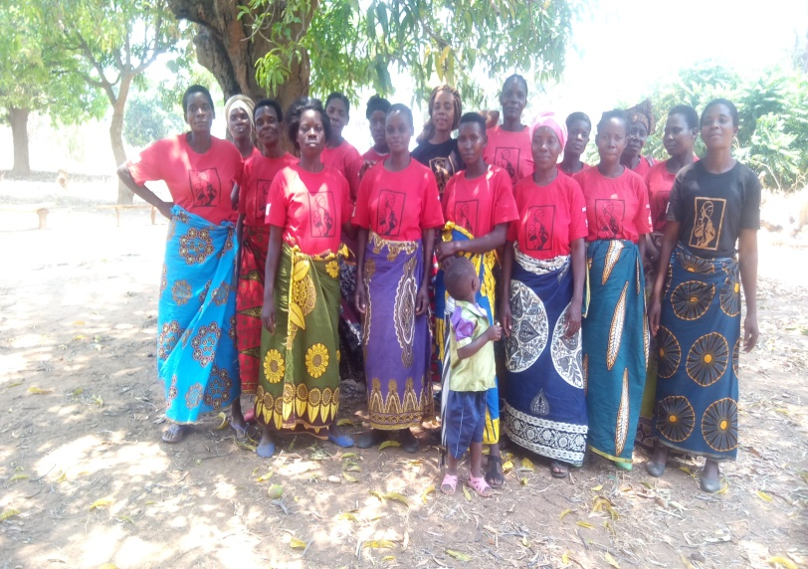 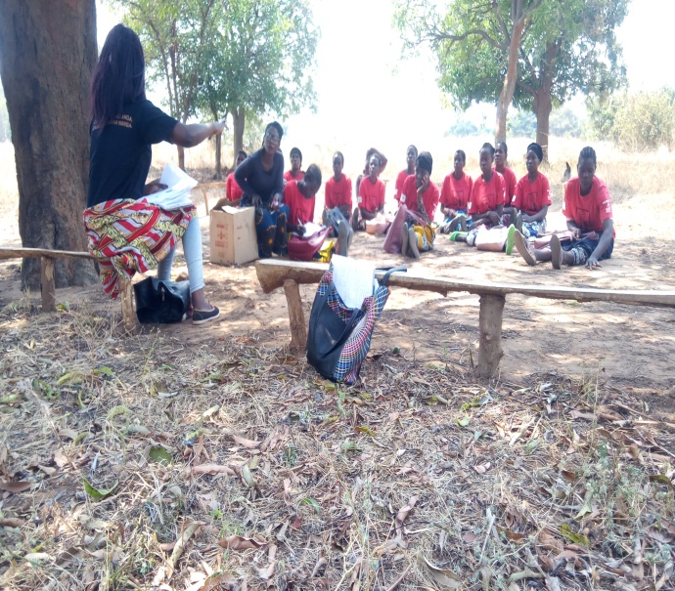

***Monthly joint da*t*a and progress review meetings***

* + 1. **RETENTION OF PREGNANT WOMEN IN ANC**

|  |  |
| --- | --- |
| Month | Number of women attending ANC |
| March | **170** |
| April | **191** |
| May | **152** |
| June | **184** |
| July | **200** |
| August | **137** |
| September | **178** |
| October | **149** |
| Total percentage | **1362= 45.4 percent** |

***Table 1: below are indicators that are used to track progress of the intended purpose;***

|  |  |  |  |  |
| --- | --- | --- | --- | --- |
| # | Indicator Definition | Number of people reached by sex | | |
| **Males** | **Female** | **Totals** |
| 1 | Total number of people reached directly | 131 | 1184 | 1315 |
| 2 | Total number of people reached indirectly | 122 | 178 | 300 |
| 3 | Number of pregnant women aged 25+ years targeted |  | 3000 | 1362 |
| 4 | Number of children aged 2-4 years targeted | 5 | 10 | 15 |
| 5 | Number of children aged 6 months-1 year targeted | 13 | 18 | 31 |
| 6 | Number of children aged 6 months targeted | 11 | 11 | 22 |
| 7 | Number of men targeted | 433 |  | 433 |
| 8 | Number of targeted pregnant women aged 25+ years tested for HIV, who have received their results and know their status |  | 1,362 | 1362 |
| 9 | Number of targeted children aged 2-4 years tested for HIV who have received their results and know their status | 3 | 8 | 11 |
| 10 | Number of targeted children aged 6 months-1 year tested for HIV, who have received their results and know their status | 18 | 20 | 38 |
| 11 | Number of targeted children aged 6 months tested for HIV, who have received their results and know their status | 7 | 9 | 16 |
| 12 | Number of targeted pregnant women aged 25+ years re-tested within 1 year |  | 156 | 156 |
| 13 | Number of children aged 2-4 years re-tested within 1 year | 0 | 3 | 3 |
| 14 | Number of targeted children aged 6 months- 1years re-tested within 1 year | 4 | 4 | 8 |
| 15 | Number of targeted children aged 6 months re-tested within 1 year | 2 | 3 | 5 |
| 16 | Number of targeted children aged 2-4 years testing positive | 1 | 0 | 1 |
| 17 | Number of targeted children aged 6 months-1 year testing HIV positive | 1 | 1 | 2 |
| 18 | Number of targeted children aged < 6months testing HIV positive | 0 | 1 | 1 |
| 19 | Number of targeted children aged 2-4 years testing negative | 4 | 8 | 14 |
| 20 | Number of targeted children aged 6 months-1 year testing HIV negative | 17 | 20 | 37 |
| 21 | Number of targeted children aged < 6months testing HIV negative | 6 | 8 | 14 |
| 22 | Number of targeted children aged 2-4 years on treatment | 1 | 0 | 1 |
| 23 | Number of targeted children aged 6 months-2 years on treatment | 1 | 0 | 1 |
| 24 | Number of targeted children aged <6 months on treatment | 0 | 0 | 0 |
| 25 | Number HIV positive pregnant women, young women and adolescents attending ANC and PMTCT VISIT 1 |  | 8 | 8 |
| 26 | Number HIV positive pregnant women, young women and adolescents attending ANC AND PMTCT VISIT 2 |  | 2 | 2 |
| 27 | Number HIV positive pregnant women, young women and adolescents attending ANC and PMTCT VISIT 3 |  | 0 | 0 |
| 28 | Number HIV positive pregnant women, young women and adolescents attending ANC and PMTCT VISIT 4 |  | 1 | 1 |
| 29 | Number of targeted women aged 25+ years adhering to treatment |  | 0 | 0 |
| 30 | Number of targeted children aged 2-4 months years adhering to treatment | 1 | 0 | 1 |
| 31 | Number of targeted children aged 6 months-1 year adhering to treatment | 1 | 0 | 1 |
| 32 | Number of targeted children aged <6 months adhering to treatment | 0 | 1 | 1 |
| 33 | Number of targeted children immunized | 429 | 522 | 951 |
| 34 | Number of targeted women aged 25+ years virally suppressed |  | 7 | 7 |
| 35 | Number of targeted pregnant women ,young women and adolescent actively breastfeeding their child at 6 months and adhering to treatment |  | 0 | 0 |
| 36 | Number of male partner attending ANC/ PMTCT visits |  | 253 | 253 |
|  |  |  |  |  |

**SUCCESSES**

* A lot of pregnant women who were not aware of their HIV status have been reached and are now aware of their status.
* **9** HIV positive pregnant women are currently being followed-up.
* **8** infants who were exposed have successfully been let out of the programme and are HIV negative and 30 infants are still in care and being followed up.
* Community leaders’ capacity was re-strengthened for EID and option B+ effectiveness in the communities.
* Maternal health in Mwadzama B area has improved as more women are now delivering at health facilities than at home following bylaws that were reviewed since the start of the project.
* Mobilization of men in EID has led into behavior change in men as now more men are participating in health care with their spouses.

**CHALLENGES**

* Distance is a problem to mentor mothers as they have to walk long distances to reach clients as they do not have bicycles, and this could limit the number of pregnant women and infants enrolled both in EID and option B+.
* Clients also singled out distance as a demotivating factor in efforts to access PMTCT and HTC and EID services.
* Project implementation started late due to changes in meeting schedules by influential committees like the DHMT and the DEC.
* Some HIV positive women are facing stigma from relatives.
* Some HIV positive women have not yet revealed their status to their spouses and this is impacting on their ability to adhere to treatment and also raising a concern on their ability to care for their infant.

**LESSONS LEARNT**

* Intense involvement of expert clients to be peer educators to fellow males can increase male involvement in EID and PMTCT
* Providing pregnant mothers and parents of exposed infants with incentives could help return more people to care and access to required services.

**RECOMMENDATIONS**

* Transport incentives should be considered for mentor mothers so that they may be able to bring more pregnant mothers and exposed infants to care. This could also help mentor mothers to follow-up on identified pregnant women who have not yet been enrolled into antenatal to ensure that they enroll, test for HIV and know their status.
* Setting up temporary clinics in the targeted areas could help ease access to HTC and EID services.

**SUCCESS STORIES**

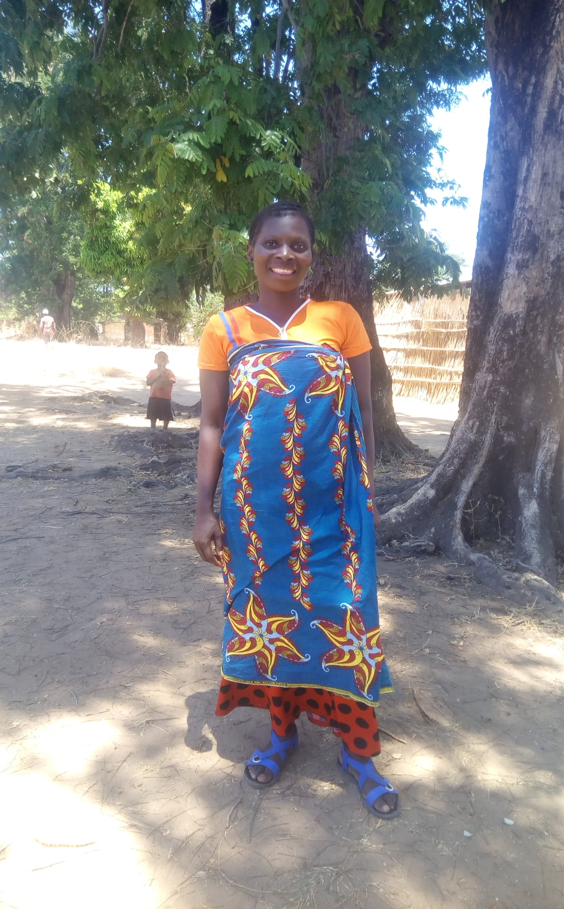

Ida Banda, 27 from Kanyangale village, Ngwata VDC was a defaulter, but now, being reached and encouraged by a mentor mother on EID and the importance of adhering to treatment ,she is now back into care. Despite her being pregnant and HIV positive, she stopped taking ARTs when she got married and became her husband’s second wife, because her husband was also not on treatment. After being reached by a mentor mother through “mayi-mwana” project, Ida is now back on ARTs and is following counsel from mentor mothers. Mentor mothers still follow her up to encourage her to continue her treatment to protect her infant from HIV.

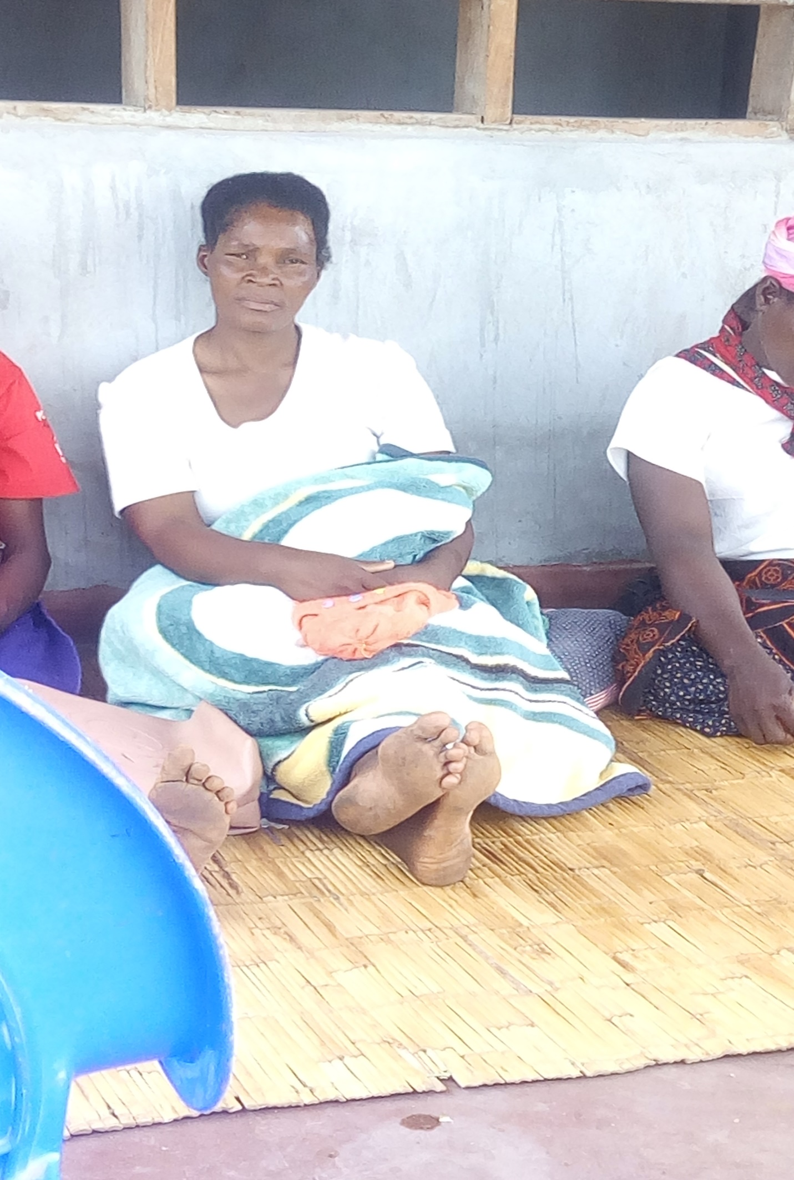

This is Judith Katanga, 35; she now proudly carries her infant after being reached through “mayi-mwana” project. She was getting her medication at a distant health facility for privacy sake and when she delivered her baby, she had little knowledge about EID and was past the time for the first test of her infant. Judith had not yet revealed her status to her husband and this had an impact on her adherence to medication because she was afraid of being found out. Through mentor mothers, Judith was reached and was shared PMTCT education. She was also encouraged to transfer to a nearest health facility to be able to access ARTs in time. Mentor mothers, WORI and health personnel encouraged and counseled her to disclose her status to her husband to ensure that she does not impact her adherence to treatment.