COMPLETION REPORT
Organisation name: NTOROKO APIARY ASSOCIATION

Accounting officer: Patience Mbambu

Date: 10th December, 2019

SECTION A

Project Title: NAA BEEKEEPING PROJECT
Funded by KRC-Kabarole Research Centre
Period Covered By the Report: From 7th January to 10th December 2019.
TYPE OF REPORT
END OF PROJECT REPORT

SECTION B
FINANCIAL ACTIVITY
1. CURRENCY CONVERSION
Telegraphic Transfer | Date  14TH January 2019 | amount  € 4202 | Exchange rate  1€ =Ug 4,000 | Uganda shillings  16,808,000
SECTION C
2. Expenditures
ACTIVITY | INPUTS/ITEMS | Planned  € | Actual  €
Setting up a good beekeeping demonstration unit where all beekeepers will be coming | Setting up a Garden with a variety of flowering crops and trees | 500 | 650
 | 30 Feeders | 150 | 350
 | 25 Catch boxes | 428 | 428
 | 90 hives | 2,857 | 2,857
3 day Training of trainers course -TOT in Beekeeping (Training 100 cadres in beekeeping who in turn will train cadres in beekeeping) . | Facilitation fees | 470 | 470
 | Eats and refreshments | 380 | 250
 | Transport refund | 428.6 | 428.6
Hands-on training, Monitoring and evaluation | Per diem | 1,500 | 500
Total |  | 6,713.6 | 5,933.6

Funded 4,202
Local contribution 1,731.6

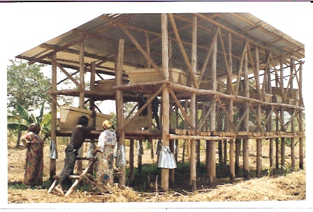
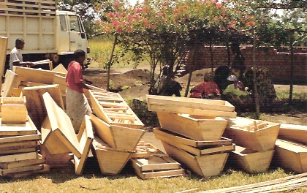
Top bar beehives ready for transport to the demonstration unit

Ntoroko Apiary Association beekeeping Demonstration Unit

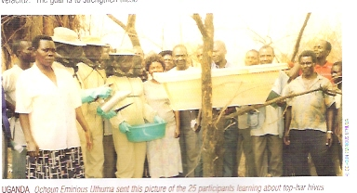
Ntoroko Apiary Association Workshop .Trainees being trained on honey harvest.

D Status of Project Relative to expected outcome
Anticipated project results | Current status
- Increased crop production | 135 out of 150 testified that their crop harvest increased .The range was from 2 % to 15%
- More trees growing due increased flower pollination by bees | There was already bigger vegetation cover on 18 mountain ranges .All the 650 gardens where pyrethrum crop was being cultivated were all covered by young wild trees
- Increased domestic incomes from sale of honey and propolis | Twenty three women bee keepers had already opened personal bank accounts for their beekeeping projects
- Candle making | Candle making has not yet started .

