**GG**

PROJECT OF CERAMIC PRODUCTION EXPANSION AND YOUTH TRAINING

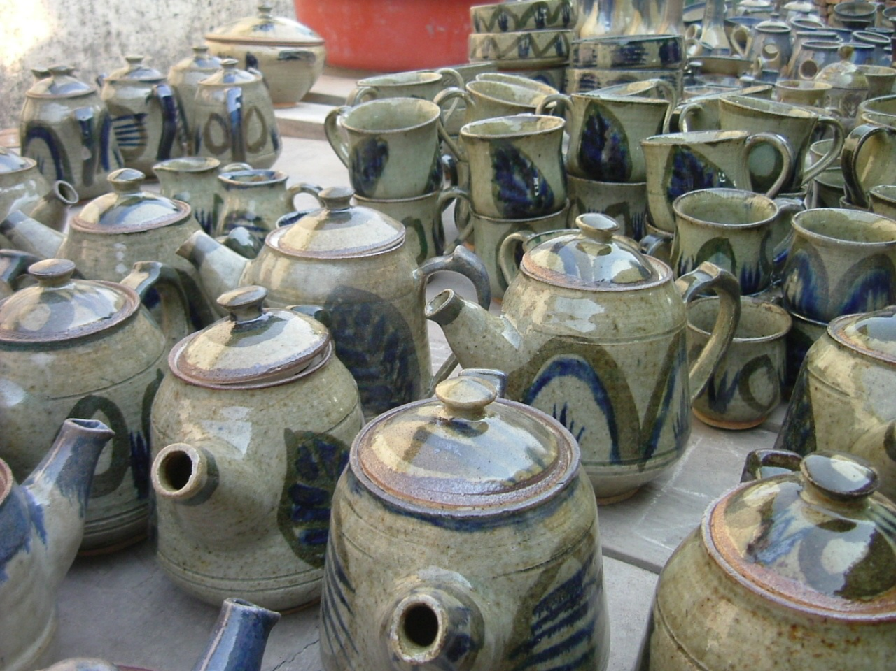

1. **IDENTIFICATION OF THE COOPERATIVE:**

Name of the cooperative: Poterie locale de Gatagara

Address: P.O.BOX 3218 - Kigali - Rwanda

Mail: gatagarapoterie@gmail.com

- Jean Pierre Nshunguyinka

Phone : (+250) 07 88 65 62 71

Legal status: Cooperative approved by RCA (Rwanda Cooperative Association)

Person Responsible for monitoring the program: Jean Pierre Nshunguyinka

1. **GENERAL INTRODUCTION**

Poterie locale de Gatagara (Gatagara local Pottery) is a cooperative approved by RCA (Rwanda Cooperative Association) which began since the founding of HVP Gatagara (Home de la Vierge de Pauvres Gatagara) back in 1977 by Father Joseph Adrien Julien Fraipont NDAGIJIMANA from Belgium after he found that there was a group of people overlooked according to the Rwanda's history. Initially this group of people was living in extreme poverty and Father Fraipont helped them and formed a cooperative through which he gave them a place to work in order to improve their living standards. They started in 1977 as a 21 association but they later became an official cooperative which is currently made up of 12 members.

The cooperative mission is:

- Improve the living conditions of cooperative members and their communities

- Ensure the quality of ceramic products

- Changing the mindset of the people on the development of cooperative members.

**2. ACTIVITIES SUMMARY PLANNED IN PROJECT**

* Training the young people on how to make ceramic products
* Allow the young people in practice of making ceramic products
* Integrate the new trainees in Poterie Locale de Gatagara
* Jobs creation and supply the large market with the Rwanda ceramic products

**3. PROJECT OBJECTIVE**

**3.1. General objective:**

Creating job to the youth and increase their living conditions

**3.2. Specific objectives:**

- Teach the youth how to make ceramic products

- Increase the number of members and staff in cooperative

- Reduce the number of jobless in the “Twa community” and in the country as a whole

**4. ISSUES AND PROJECT DESCRIPTION**

Before the arrival of Father Fraipont who helped us to put ourselves into a much modern ceramic products cooperative, our pottery was very traditional and less productive. Since his arrival, the living standards of the cooperative members improved a lot a long with a much profitable productivity but now the cooperative has some challenges which include:

1. A lack of sufficient and more experienced staff whose some die in the 1994 genocide that took place in Rwanda and which took many people’s lives away, some being members of pottery.
2. Lack and insufficiency of the equipemts
3. Lack of enough place to work in
4. Lack of transportation mean that would facilitate the cooperative to save and make more money to benefit its members and its long time growth.
5. Less skilled staff who need to be trained in their various work domains.

To cope with those above mentioned challenges we need to :

1. Train 25 young people in order to increase the number of qualified staff in the cooperative who may even replace the older members in the near future.
2. Purchase new equipment/materials, especially electric machines to increase timely and quality productivity
3. Buy an extra pierce of land for the pottery expansion
4. Purchase a vehicle that will facilitate the transportation of both low materials to the pottery and distribute the final products to the market, especialy Kigali market

Note: To solve these problems and find possible solutions, the support from our internal and external collaborators will be great importance.

**5. BENEFICIARIES OF THE PROJECT:**

**5.1. Direct:**

The youth especially those whose parents are members of the poterie locale de Gatagara cooperative (Gatagara local pottery).

**5.2. Indirect:**

- The youth community at large, unemployed women and others from all over the country

- The neighbors of the cooperative.

**6. AREA OF WORKING**

This project will be implemented:

Cell: Gatagara, Sectur: Mukingo, district: Nyanza, Province: SOUTH in Country: RWANDA

**7. ESTIMATED PROJECT BUDGET**

1. **STAFF**

|  |  |  |  |
| --- | --- | --- | --- |
| **NEEDS** | **QUANTITY** | **UNIT PRICE** | **TOTAL PRICE** |
| Trainers for 12 months | 3 | 1 800 000Rwfs | 5 400 000Rwfs |
| Superviser | 1 | 720 000Rwfs | 720 000Rwfs |
| **S/Total** |  |  | **6 120 000Rwfs** |

1. **MATERIALS**

|  |  |  |  |
| --- | --- | --- | --- |
| **NEEDS** | **QUANTITY** | **UNIT PRICE** | **TOTAL PRICE** |
| Machines | 3 | 1 000 000Rwfs | 3 000 000Rwfs |
| Wood for cooking | 1000 Piles of woods | 8 000Rwfs | 8 000 000Rwfs |
| Clay | 15 Tracks | 70 000Rwfs | 1 050 000Rwfs |
| Kaolin | 15 Tracks | 45 000Rwfs | 675 000Rwfs |
| Coloring | FF | FF | 1 000 000Frs |
| Sands | 10 Tracks | 30 000 Rwfs | 600 000Rwfs |
| Toyota Hillux (Transport) | 1 | 12,000,000Rwfs | 12,000,000Rwfs |
| **S/Total** |  |  | **14 825 000 Rwfs** |
| **GENERAL TOTAL** |  |  | **32,445,000 Rwfs** |

Total cost of the project is twenty million nine hundred forty five thousand Rwandan francs

(**32,445,000 Rwfs**) or **($38,171).**

**8. EXPECTED RESULTS**

We expect that this project will bring the new producer of ceramic production in different ways, within the pottery here in Gatagara or outside the cooperative; it ensures the sustainability of the cooperative.

**9. INDICATORS**

- Number of staff in Poterie locale de Gatagara (increase)

- The quantity and quality of products in pottery

- The job creation to the youth trained in making ceramic products

**10. IMPACT OF THE PROJECT**

The implementation of financing for this project will be a great contribution to the problems solving of lack of job to the youth surrounding the cooperative poterie locale de Gatagara, it will inter in government policy of creating jobs to the youth.

**11. CONCLUSION**

All activities related to the project will be coordinated by the Committee of the cooperative Poterie locale Gatagara represented by its president Jean Pierre Nshunguyinka. The management of the funds will be decided by all members of the cooperative and donors. The monitoring and evaluation will be done by members of the cooperative and donors.

Done at Gatagara , on Dec 3, 2017

Jean Pierre Nshunguyinka

President of cooperative “poterie locale de Gatagara”