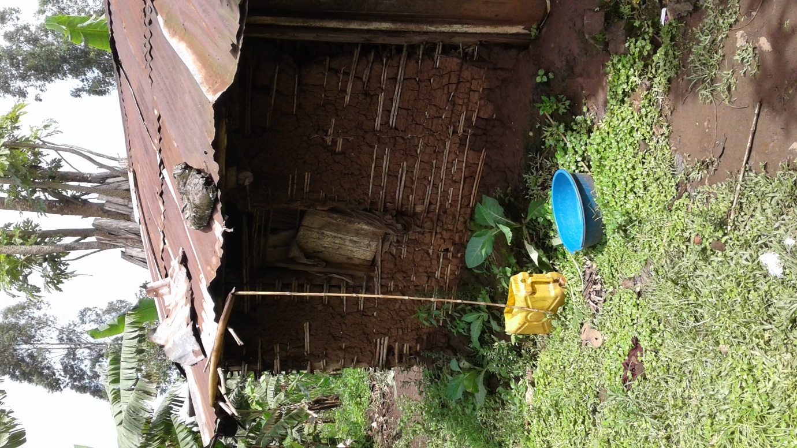

One of the homesteads in our area of intervention in Kyamukoka Ruteete subcounty, Kabarole District, Western Uganda and in a sensitization meeting below

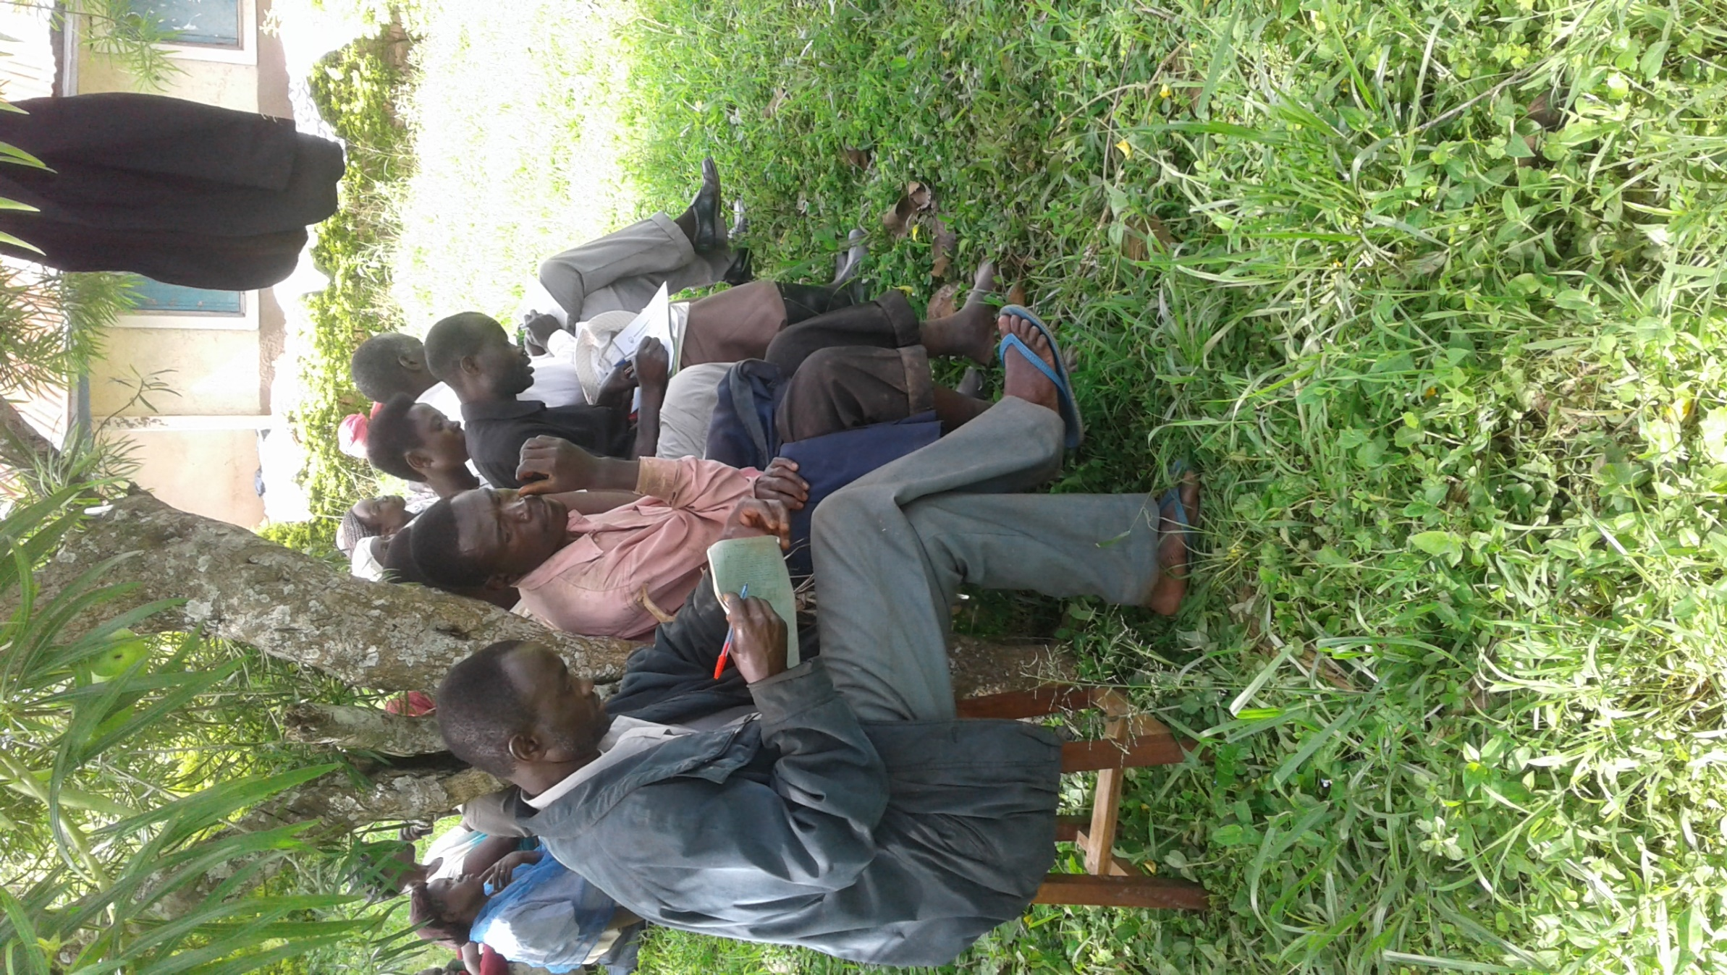

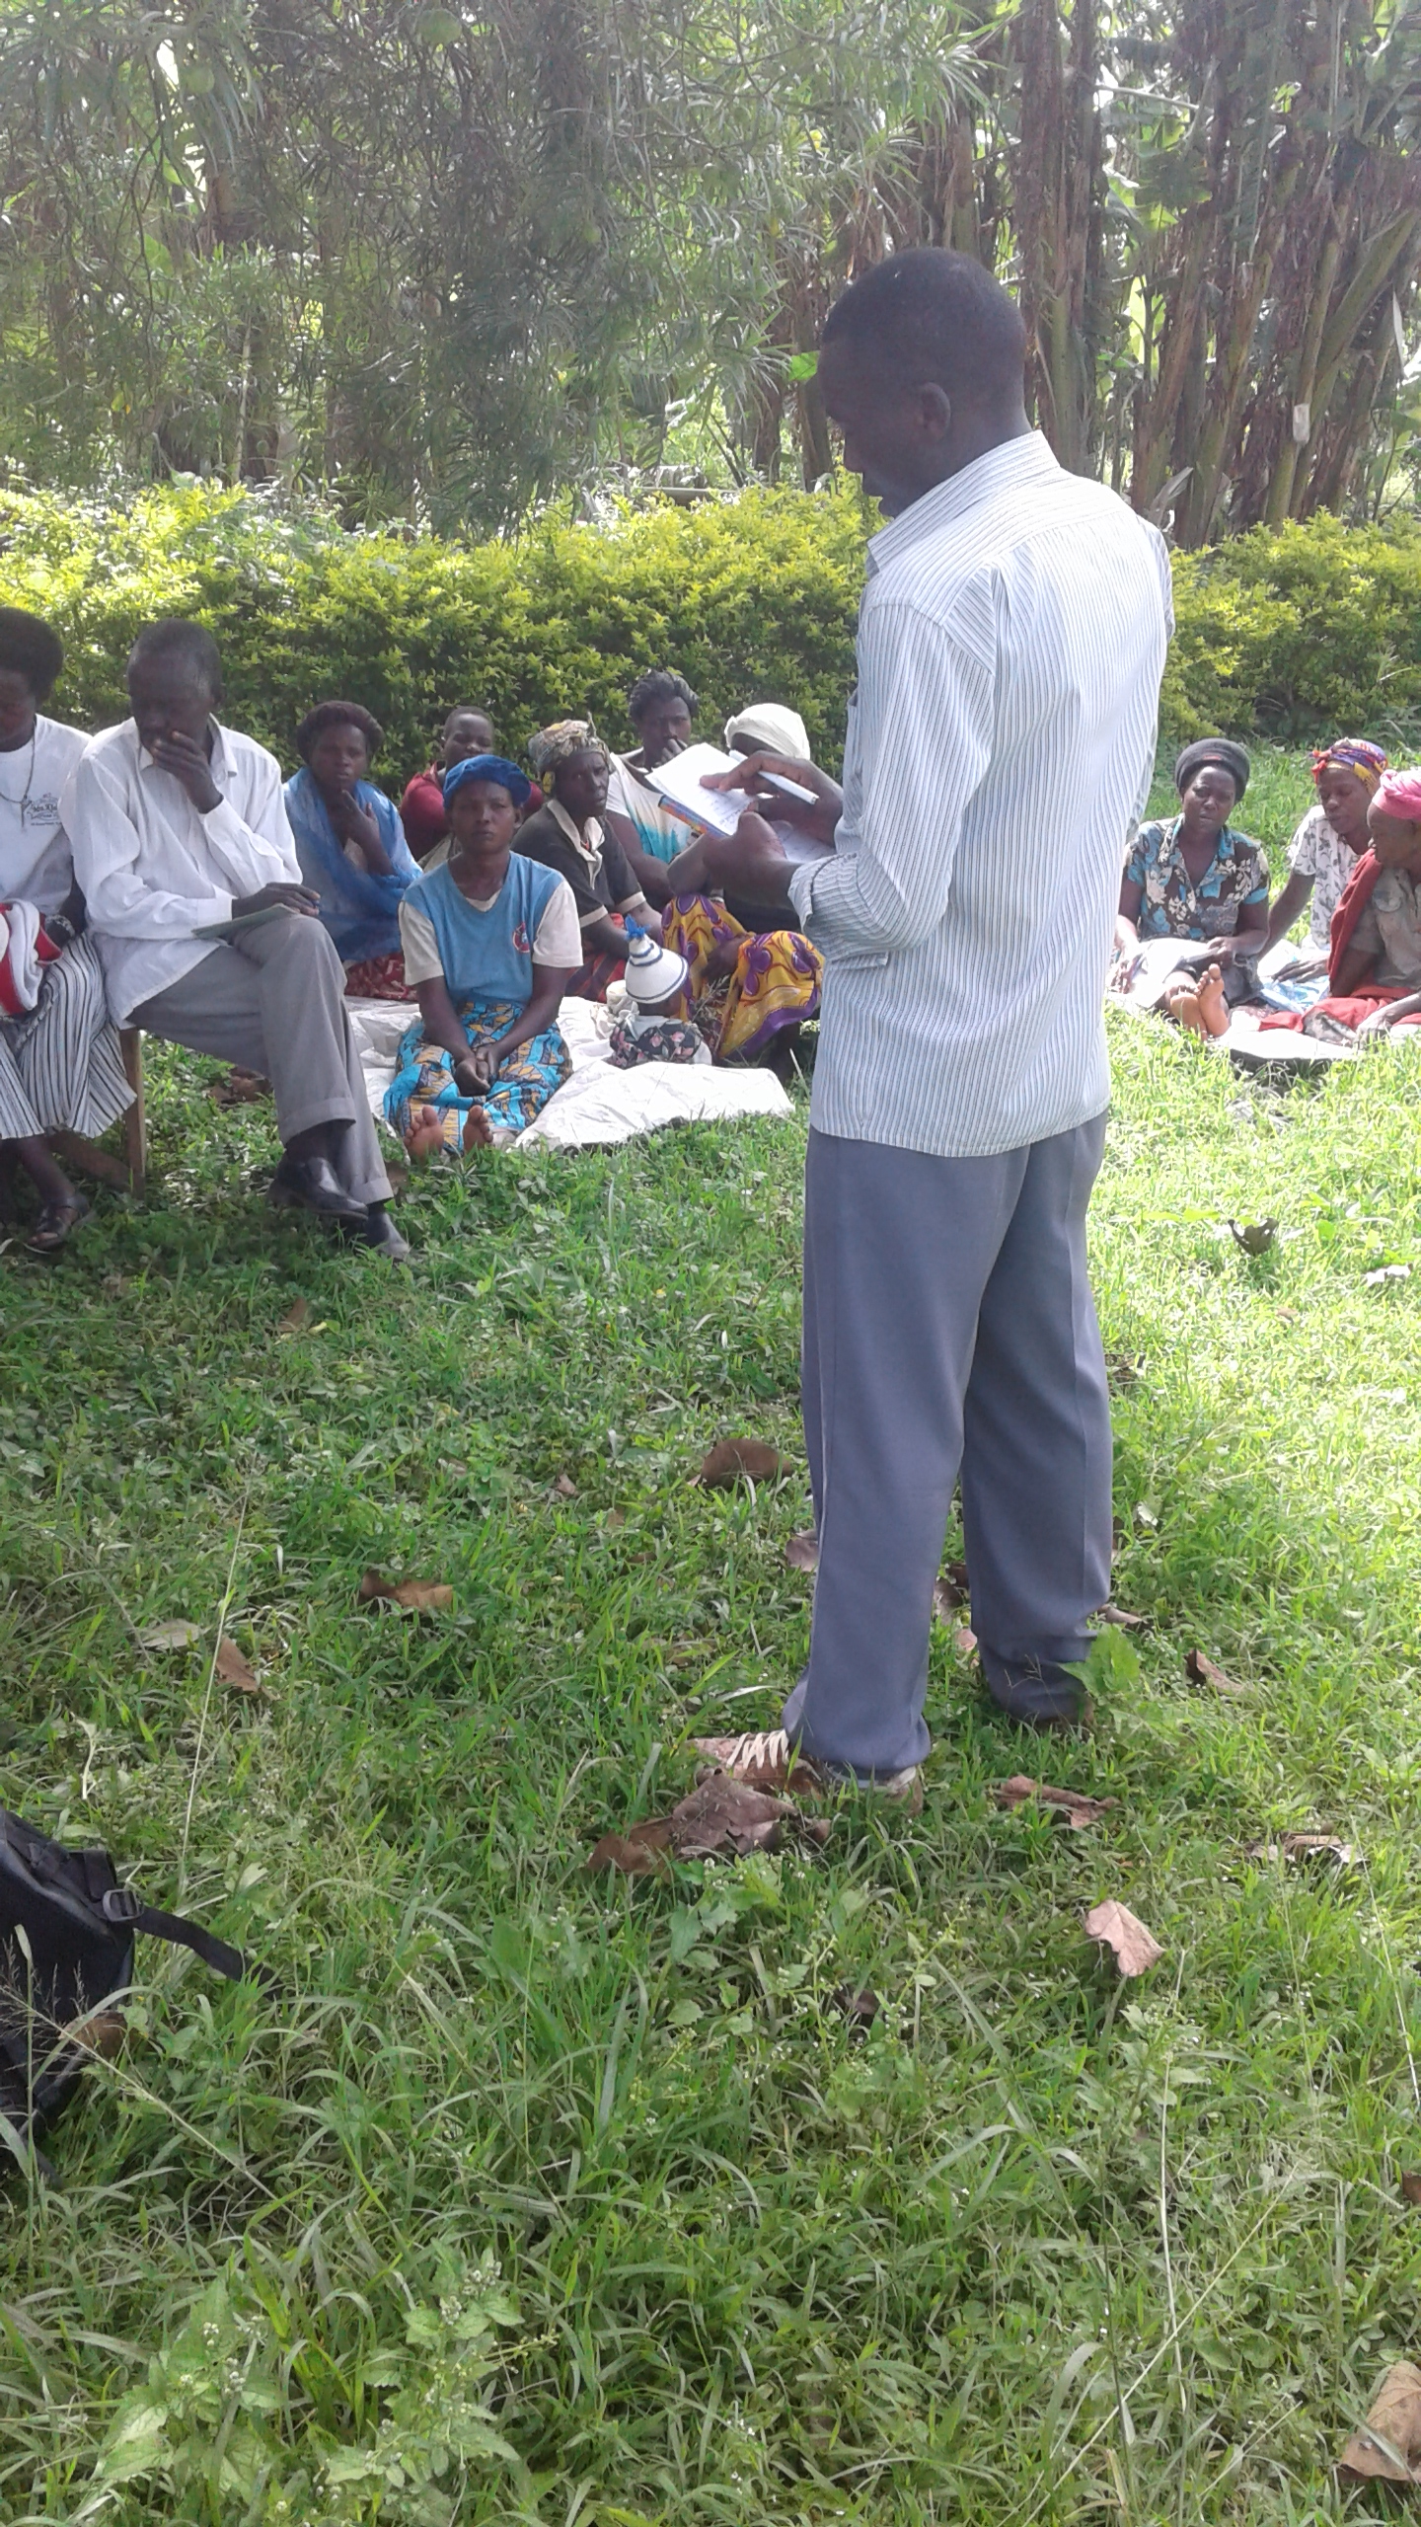

Volunteer Project Coordinator, Richard facilitating a community meeting on hygiene, health and income generating projects in Kyakatemba, Ruteete subcounty

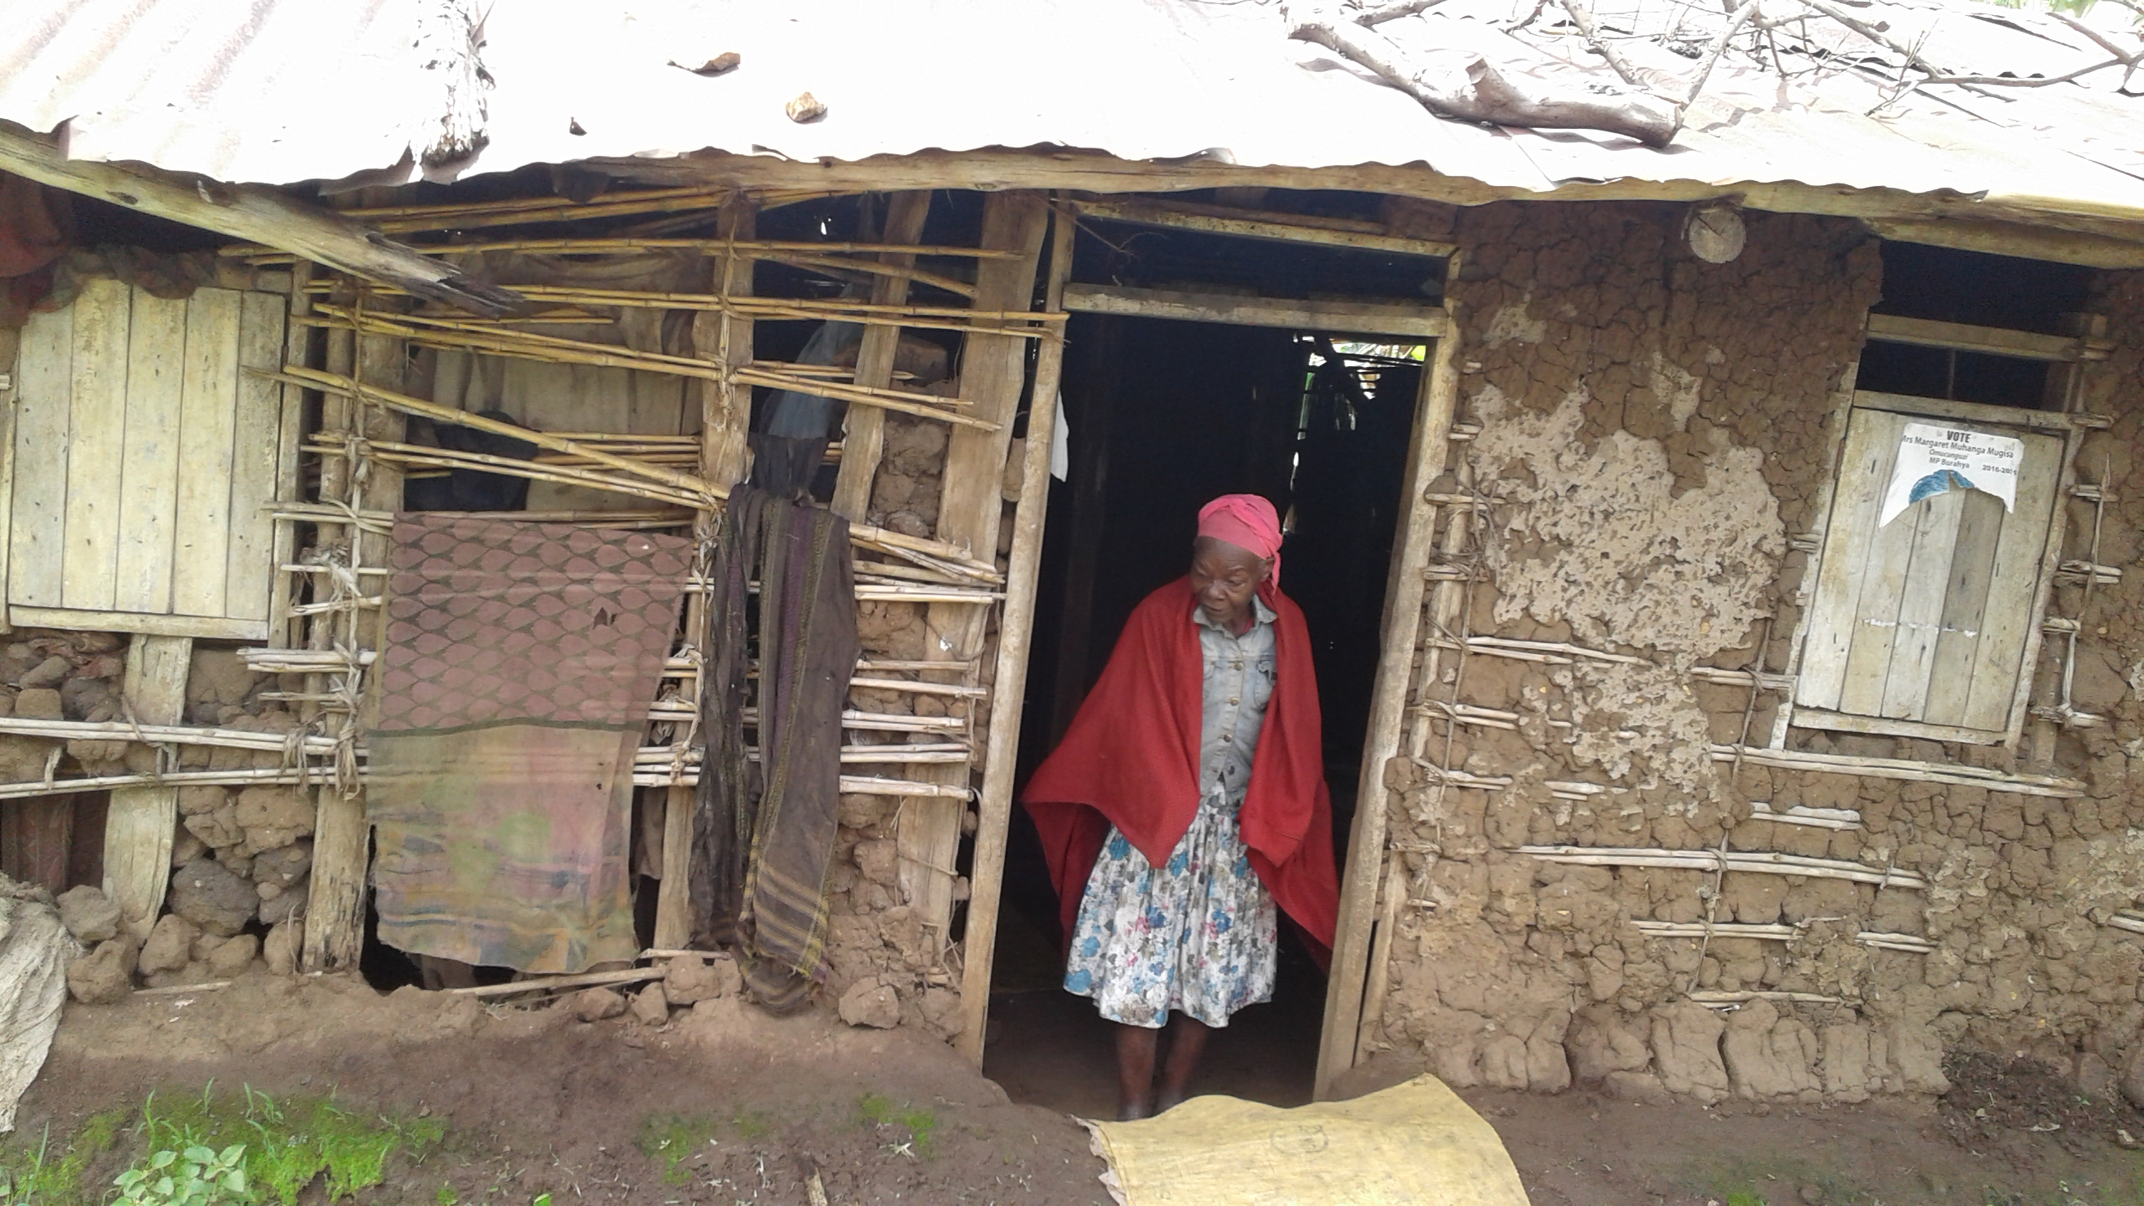

An elderly woman at her at Kyamusa, Rwaihamba Parish. The Coordinator visited her during his field visit