**SUMMARY**

**0.1. Name of the Centre**

( **SATCHI - TRUST CENTRE**)

* 1. The Name of the Organization shall be **SATCHI (Save For The Children).**
  2. The Registration Office of the Organization shall be in Arusha, Tanzania. The Organization shall be a Non- Profit Organization and shall be registered under section 12(I), The Non-Governmental Organizations Act, No.24 of 2002.

**2.0 Vision Statement**

Our Vision is an equal world where everyone has access to a quality education and good life.

**2.1. Mission Statement**

Bringing positive change to the most vulnerable people in Tanzania by providing access to quality education and social skill. **SATCHI TRUST** will be committed to offer holistic education focusing on the mental, spiritual, physical and social faculties of a child. Education should be the power to change the lives of vulnerable group.

**2.2 Project Concept**

The Centre concept encourages all parents, Stakeholders, social workers provide life skills and social studies and academic excellence. Entails submission of the Centre Project Proposal to the Friends of Education and Human Rights, Social affairs requesting for support in the aim of helping children especially Underprivileged by giving them quality education in social affairs and Pre –Primary Education.

**2.3 Main Objectives / Goal**

To provide high quality and basic services is including education to all children living under poverty and underprivileged. To build capacities of children emotionally, psychologically, self-esteem, self-reliant, spiritually and intellectually. To support Orphans and Vulnerable Children linked to different stakeholders support and to facilitate children in developing various talents and skills. To sustain community development through provision of quality of education and social skills.

**3.0 Ownership**

SATCHI-TRUSTEES

**3.1.1 Main stakeholders**

Board of Trustees (four members); Leonard Massawe, Joseph Leonard, Maria Massawe, and Jerome Joseph.

**3.1.2 Location**

The Permanent centre compound will be situated at Babati town in Manyara. The centre is expected operating in Ngarenaro temporarily, then to Babati –Manyara in Main Campus.

**3.1.3 Project Implemented Status.**

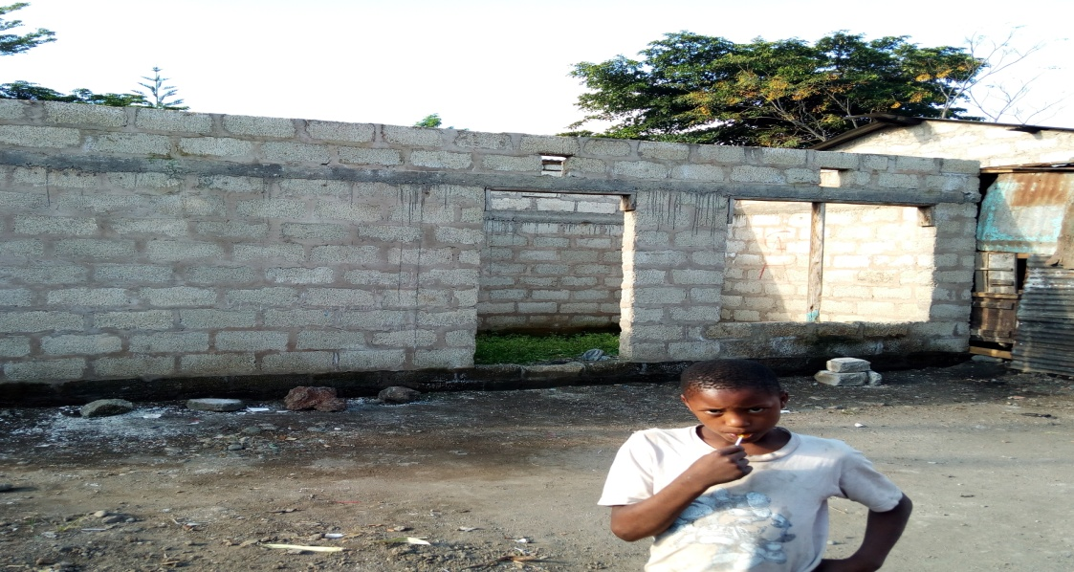

Social Centre project will be assumed to take off any time after completion of this Building.

**4.0 The Arusha Social Class**

The class will be categorized into 2 groups.

1st group- 3-4 year old Kids

2nd group - 5 –6 year old Kids

**4.1 Size of the Class**

The proposed Class will be divided into two streams, 30 Kids each class, Pre School and a Social Class.

**4.2 Catchment Area**

The Centre will register all Identified Children from the areas of Ngarenare, Matejoo, Shamsi, Kambi ya Fisi, Mbauda and Sombetini. About 50 disadvantaged children and Orphans have been identified.

**4.3 Accessibility**

There is a road from Majengo suburb joining the road from Kilimanjaro which connects the Centre of the District.

**4.4 Social Service**

The school will provide different social services to the Kids from nearby villagers.

1. Electricity (solar energy and Tanesco)
2. Tap water
3. Transport of students
4. Postal service
5. Health facilities and sports field
6. Meals for the pupils
7. Telephone services

**4.5:** **Benefits:**

The Centre will provide employment for people around the Centre and the Campus e.g Ngarenaro, Mbauda, Majengo, Matejoo, Sombetini, Shamsi, and other Arusha subrbs and by doing so, will help to fight against poverty.

The centre will enlighten in children the basic use of the latest technology computers to prepare them for the 21st century. The centre will teach health education to children right from the earliest age 6 years and above.

The centre will assist and identify children who have been orphaned from the unprivileged Society. Street children and other such victims who greatly miss ways of developing their talents.

The centre will provide education to the children living in hard conditions (which include orphans, children living with disabilities, children affected with **HIV/AIDS**, street children and communities conducting seminar through community. The centre will try to create awareness to remove or reduce discrimination and humiliation within the society especially for children.

**4.6: General observations/ Recommendations**

**General observations:**

This write up demonstrates that the Centre is not established for profit maximization but rather as a social service provision entity.

Efforts have been already taken by the Centre Founders in terms of land acquisition at Babati town. The Trust is determined to implement the project as proposed in the write- up.

The project is likely to improve the standard of living and knowledge on how to conserve and improve the Social skills and free environment.

**4.7: Recommendations**

Being guided by the contents of this proposed the following recommendations are made:

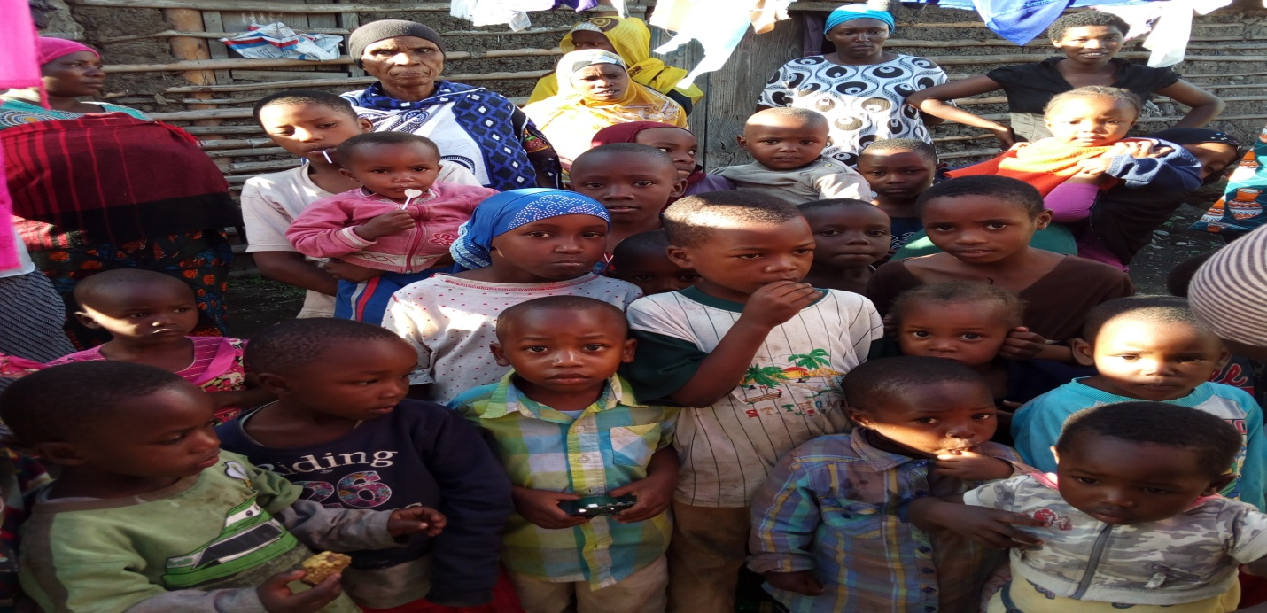

To help the future of these Children, we need to put much effort on improving vulnerable group socially and academically.

The Organization would like to invite all friends, Volunteers, External and internal Donors and Social Stakeholders to save our **KIDS,** we are welcome all to facilitate the mission. To save the children by providing them the real foundation for their Future by working with communities affected by low quality education and building working relationships partnerships with other local, national and International education practitioners and experts.

**5.0: THE PROPOSSED BUILDINGS FOR THE SATCHI PROJECT (US. Dollars), (Phase One)**

|  |  |  |  |  |
| --- | --- | --- | --- | --- |
| **1** | **CLASSROOMS** | **2** | **$ 10936@** | **$ 21872=** |
| **2** | **TOILETS** | **3** | **$ 5249@** | **$ 15747=** |
| **3** | **ADMINISTRATION BLOCK** | **1** | **$ 34995@** | **$ 34995=** |
| **4** | **KITCHEN** | **1** | **$ 8748@** | **$ 17496=** |
| **5** | **STORE** | **2** | **$ 4375@** | **$ 8748 =** |
| **6** | **FIRST AID KIT** | **1** | **$ 4375@** | **$ 4375=** |
| **7** | **DORMITORIES** | **2** | **$103233=** | **$ 201,657=** |

**May God bless you All.**

**Prepared by;**

*Mr Leonard.J. Massawe*

Founder of "**SATCHI TRUST**”

***JUNE 2018****.*