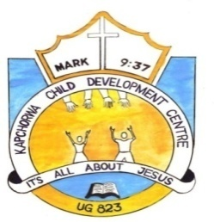KAPCHORWA CHILD DEVELOPMENT CENTRE UG823

P.O.BOX.43, KAPCHORWA- UGANDA

TEL: 0717928823/0758235343 Email: kapchorwacdc@yahoo.com

|  |
| --- |
|  |

**7/5/2017**

World Connect's Accelerator Grants Competition

Dear sir/madam

**RE: Recomendation for change Lives Now Africa for a grant**

Receive greetings from kapchorwa CDC in Jesus’ name. we appreciate you for the good work your doing the lives of people around the world to see that they receive hope for the future.

Upon the above subject, iam glad to say that change lives Now Africa since it time whem it commenced in kapchorwa in th year of 2012, we have witnessed a number changes in our communities as shown the activities of their coverage

1. Reproductive health training
2. Positive parenting
3. Early childhood trainings
4. Career guidance and managing adolescent life cycle
5. Enterprenurship training
6. Servant leadership training
7. Alpha training
8. Discipleship training
9. Computer training
10. Nutrition and agricultural training
11. Family and marriage training

The have taught people who to become selfreliant in all ways and its upon this background that I rcommend them to have a grant so that people in kapchorwa can continue to benefit with a clear mind of ending poverty for community transformation. Your positive respose towards this matter is highly welcome.

Thank you

**Esther Cheromoi . Project Director**

**UG823**

**0782828573**